If your request was denied by a court staff person (not a judge or judicial officer), you must give the ADA coordinator or the court a letter objecting to the denial within 10 days of the date the denial was handed to you or sent in the mail. Give or mail your request for another review to the same court.
If your request was denied by a judge or judicial officer, you must file a Petition for Writ of Mandate in the appellate division of that court or with the Court of Appeal within 10 days of the date the denial was personally delivered or sent.
Warning! Even if you received the denial by mail, you do not get any extra time to file for review or petition.
You may copy and share this document freely.

Resources
U.S. Department of Justice website, ADA section
The full text of the Americans with Disabilities Act (ADA or 42 U.S.C., §12101 et seq.) is available at www.ada.gov/ada_req_ta.htm

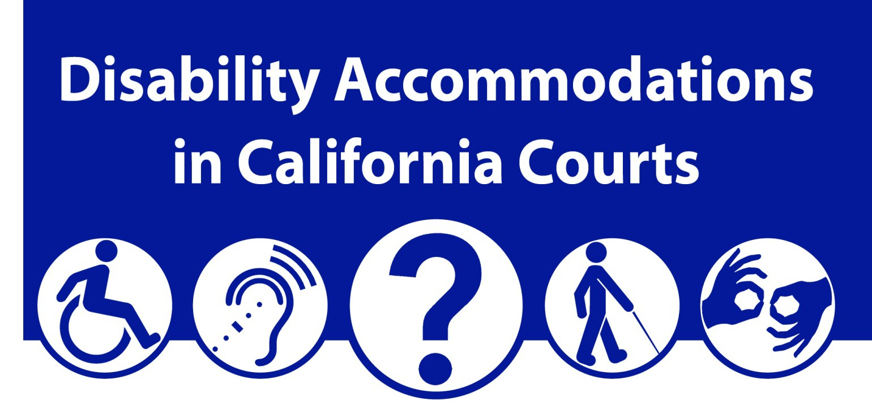
The Americans with Disabilities Act (ADA) requires all state and local government agencies to provide reasonable accommodations for people with disabilities.
Rule 1.100 of the California Rules of Court spells out how the courts in our state meet the ADA requirements for court activities, programs, and services.
California Courts website
The full text of Rule 1.100 of the California Rules of Court is available at www.courts.ca.gov/cms/rules/index.cfm?title=one&linkid=rule1_100

Most county courts provide information on accommodations, including ADA or access coordinators’ contact information, online. Access your court’s website through www.courts.ca.gov/superiorcourts.htm

Prepared by the Center for Judicial Education and Research (CJER)
© 2016 Judicial Council of California
Disability Accommodations in California Courts

[Court name and contact information goes here]
Here are answers to common questions about disability accommodations at court.
1. Who has the right to get an accommodation?
Any court user with a disability can ask for an accommodation. The disability must limit at least one major life activity such as:
- Walking, seeing, hearing, speaking, or breathing;
- Caring for oneself; or
Doing a manual task.
The accommodation must be for a court service, program, or activity, including going to court to:
- Testify,
- Appear in a case, or
Serve on jury duty.
2. What kinds of accommodations does the court provide?
There are many different kinds of accommodations. However, the court must give a “reasonable” accommodation under the circumstances. The kind of accommodation depends on the needs of the person with the disability.

The court may…
Make changes to procedures
- Reassign a hearing to an accessible site, or
Adjust schedules (as long as legal deadlines are not missed).
Provide assistive devices
- Assistive listening devices, or
Computer-assisted real-time transcription (CART).
Assign assistive services
- Reader for someone with vision loss, or
- Sign language interpreter for someone with hearing loss.
3. Are the court’s accommodations free?
Yes. The court does not charge for the accommodations it provides.
4. How do I ask for an accommodation?
The California courts have a system that allows people with a disability to ask for an accommodation in advance. Every county court has at least one ADA Coordinator to handle accommodation requests.
You may:
- Call and ask for the ADA Coordinator,
- Send a letter, or
- Fill out form MC-410 (Request for
Disability Accommodation).
Note: The form may be easiest, because you can list all the information the court needs to consider your request.
5. Where can I get a request form?
The form MC-410 is available at
- The ADA Coordinator,
- A law library, or
The courts’ website: http://www.courts.ca.gov/documents/mc410.pdf.
6. When should I ask for an accommodation?
Mail or take your form to court at least 5 business days before the date you need the accommodation. If you can do it sooner, please do so.
The courts prefer advance requests so there will be time to understand and respond to your particular needs. Sometimes the ADA Coordinator may need more information, such as a letter from a healthcare provider.
7. What if I cannot ask for the accommodation in advance?
You should still ask. There still may be things the court can do to accommodate your needs. You can:
- Ask to speak to the ADA Coordinator when you arrive at court, or
Tell the judge you need an accommodation because of a disability.
Caution! When you are with the judge, you must not talk about your case.
8. What happens after I submit my request for accommodation?
Some accommodations, such as assistive listening devices or wheelchair access in
the courtroom, can be arranged easily, sometimes on the same day. Others may take more time to prepare. The court will give you a written decision if it cannot accommodate you.
9. What information is required to ask for an accommodation?
- The date of your hearing or other proceeding,
- The type of court case,
- Why you need the accommodation for your disability, and
Any other important information about the accommodation you need.
10. Will the court give me the accommodation I ask for?
The court will give you an accommodation that lets you participate effectively in court programs, activities, and services. But it may not be exactly what you asked for.
11. If I am involved in a court case, do I have to tell the other people in my case about my disability or my accommodation request?
No, unless you request a continuance of your case as an accommodation for your disability. For a continuance, you must give notice and share the request and supporting information with the opposing party.
12. Is my request for an accommodation kept private?
Yes, the court will keep your information private unless you request a continuance in your case. See question no. 11 above.
13. Do I have to accept alternative accommodations?
The court is allowed to offer effective alternatives. If you are not able to use the alternative offered, let the court know. For example, if assistive listening devices do not help because of severe hearing loss, computer-aided transcription may be available.
14. Does the court ever turn down a request for accommodation?
Yes. The court can deny your request if:
- You are not eligible or
Your request would cause too much of a financial or administrative burden on the court, or if it would change the basic nature of the service, program, or activity.
The court must explain the reason for denying your request. It cannot ignore any requests for accommodations.
15. Does the court have to pay for or provide medical equipment or services I may need at court?
No. The court does not have to provide or pay for personal needs, including:
- A personal care assistant to help someone eat or use the bathroom.
- Personal hearing aids, prescription eyeglasses, or walkers.
A free lawyer, paralegal, or assistant.
16. What if I disagree with the decision to deny my request?
You are allowed to ask for another review of your request. (continued on the back)

