**ADMINISTRATIVE OFFICE OF THE COURTS**

**QUESTIONS AND ANSWERS**

**RFP Number: ADR-032814-RB**

**RFP Translation of Videos for Self-Represented Litigants**

**April 10, 2014**

1. Regarding 3.6.1 – Is a time coded script provided in source English?

Answer: Yes, an English script that has been chunked and time coded for the captioning is available. Please note, however, that in our prior experience with translations of these videos to date, the timing for the English-language video has not always been the same as for the translated versions.

1. Regarding 3.6.1 –Does screen text refer to all graphics that appear on screen? Because current localized versions maintain English screen text for graphics.

Answer: Screen text refers to the graphic text that appears on the screen. The screen text was not translated from English in the videos regarding resolving small claims and unlawful detainer cases, but it was translated in the Spanish-language video regarding resolving civil harassment and the soon-to-be-posted Spanish-language video regarding resolving debt collection cases and Vietnamese-language versions of both of these videos.

1. Regarding 3.6.1 –Is the reference to Captions a reference to Subtitles? If so, the videos for viewing on www.courts.ca.gov/20614.htm already have subtitles in the languages of this RFP, specifically Korean, Chinese (T/S) and Russian. Please confirm that we are creating new subtitles in Korean, Chinese and Russian.

Answer: Captions refers to the text at the bottom of the video screen that shows the narration in written form, sometimes referred to as closed captioning. The captions you accessed in Korean and Chinese, and for the videos regarding resolving civil harassment and debt collection, in Russian, are created by a Google translation function. In our experience, this literal translation function does not always convey the correct meaning, particularly with respect to legal terminology. In addition, this Google translation function is not available when the video is being viewed via a DVD rather than on the web. Therefore, in all the existing videos in this series, captions were created by the vendor using the script of the narration in each language in which the video is available. Such captions have been prepared in English, Spanish, and soon to be Vietnamese for all the videos and in Russian for the videos regarding resolving small claims and unlawful detainer cases, but not for the videos regarding resolving civil harassment and or debt collection cases. Videos with this type of captions in Korean and Mandarin have not been produced. The selected vendor will be creating new subtitles in Korean, Mandarin and Russian.

1. Regarding 3.7.1.3. DVD and Cover Art – Can we receive a PDF of both the DVD disc label and the cover art to see the extent of design in order to calculate cost?

Answer: Yes. Here are samples:

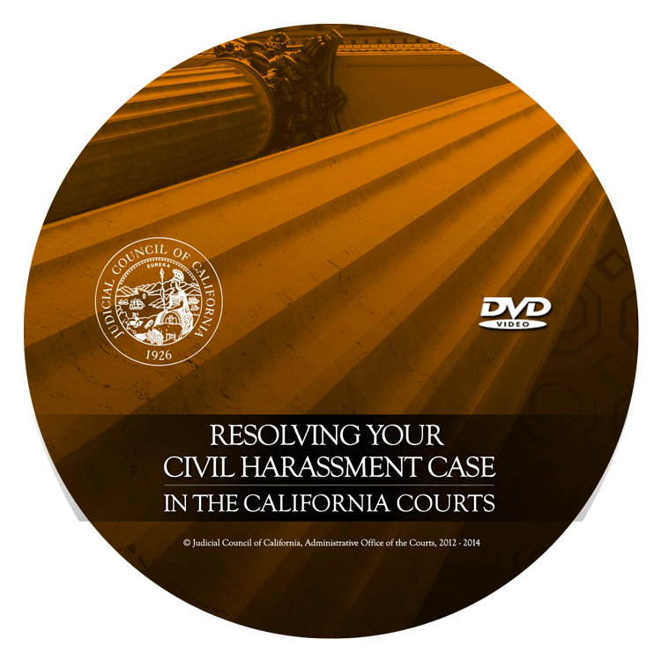

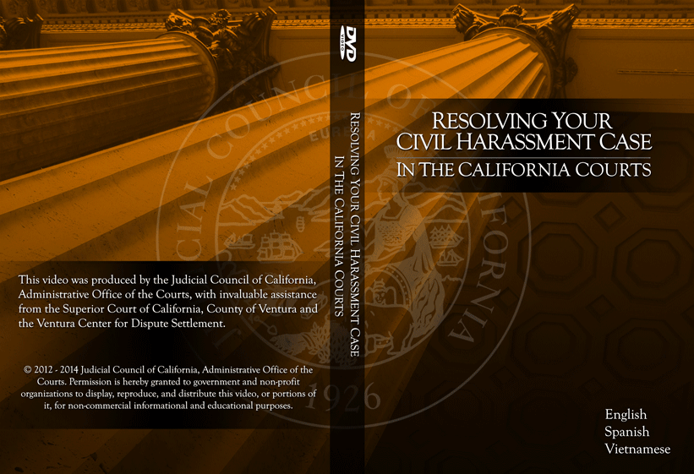

1. Regarding 3.7.2.2   DVD case – What type of case – clear plastic, plastic sleeve, wallet, 4-color, shrink wrapped

Answer: A full DVD case with the DVD Case Artwork is required – see sample artwork above. See Addendum Number 1.

1. Regarding the contract end date: The contract end date on page 5, Table 1, specifies June 30, 2015 (estimate only) is different from Section 3 Description of Services on page 2 of 13 that states “The work is expected to begin on June 29, 2014 and be completed by December 30, 2015.

Answer: The contract end date (estimate only) in Table 1 on Page 5 should be December 30, 2015. See Addendum Number 1.

1. In what format will we receive the English language videos?

Answer: The videos are available in the following formats:

* AVI 4:3 SD
* MP4 4:3 SD
* MP4 16:9 SD
* **MP4 16:9 HD** This is the best quality version of rendered video and the one that we will ultimately use for uploading to our website.

1. Will we receive full broadcast quality original videos in English of all four videos?

Answer: Yes. See response to question 7.

1. Do you have the original editing files (Final Cut Pro, etc.) of these videos when they were originally produced? If so, will you make those available to the winning vendor?

Answer: The videos were produced using Adobe Premiere. The original project files will be available to the selected vendor.

1. Will you want to audition different voices for the voice over before recording?

Answer: No.

1. Will you want to see various options for cover art?  If so, how many options maximum will we have to present?

Answer: There is a standard format for the cover art – see sample above. We will need to approve the cover art.

1. Will you want to approve the DVD menu art?  If so, how many options maximum will we have to present?

Answer: There is a standard format for the DVD menu art; a sample is provided below. We will need to approve the DVD menu and art.

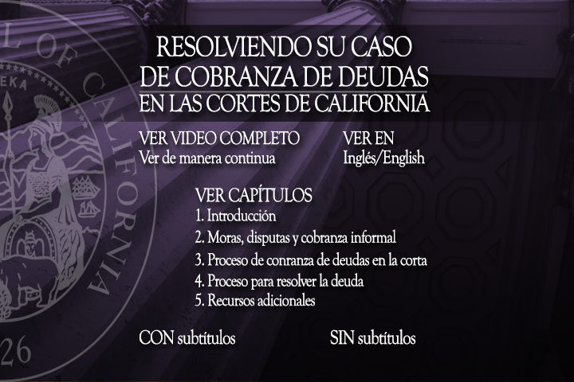

*[END OF QUESTIONS AND ANSWERS]*