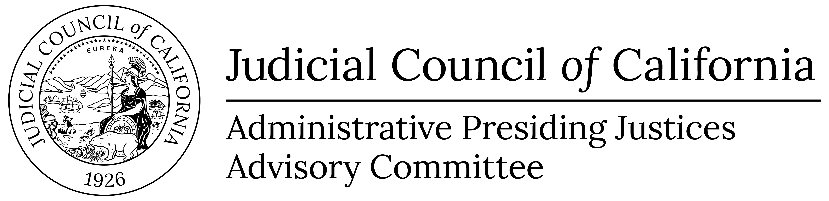 | www.courts.ca.gov/apjac.htm  apjac@jud.ca.gov
Administrative Presiding Justices Advisory Committee Open Meeting Agenda
Open to the Public (Cal. Rules of Court, rule 10.75(c)(1))
THIS MEETING IS BEING CONDUCTED BY ELECTRONIC MEANS
THIS MEETING IS BEING RECORDED
Date: | Wednesday, February 7, 2024
Time: | 3:00 p.m. – 3:30 p.m.
Public Call-in Number: | 1-310-372-7549; Conference Code – 249283
Meeting materials will be posted on the advisory body web page on the California Courts website at least three business days before the meeting.
Agenda items are numbered for identification purposes only and will not necessarily be considered in the indicated order.
- Open meeting (Cal. Rules of Court, Rule 10.75(c)(1))
Call to Order and Roll Call
- Public Comment (Cal. Rules of Court, Rule 10.75(k)(1))
Written Comment
This meeting will be conducted by electronic means with a listen only conference line available for the public. As such, the public may submit comments for this meeting in writing. In accordance with California Rules of Court, rule 10.75(k)(1), written comments pertaining to any agenda item of a regularly noticed open meeting can be submitted up to one complete business day before the meeting. For this specific meeting, comments should be e-mailed to apjac@jud.ca.gov or mailed or delivered to Judicial Council of California, 455 Golden Gate Avenue, San Francisco, CA 94102, attention: Bernadine M. Adams. Only written comments received by Tuesday, February 6, 2024 will be provided to advisory body members prior to the start of the meeting.
- Discussion and Possible Action Items (Item1)
Item 1
Appellate Courts Budget Change Proposals (Action Required
The Administrative Presiding Justices Advisory Committee (APJAC) will consider concepts for potential appellate related Budget Change Proposals (BCPs) to be developed for Fiscal Year 25-26 funding. The approved BCP concepts will be submitted to the Judicial Branch Budget Committee.
Presenters: Ms. Laura Speed and Ms. Deborah Collier-Tucker
- Adjournment
Adjourn

