ADMINISTRATIVE OFFICE OF THE COURTS

QUESTIONS AND ANSWERS

RFP Number: RFP# CJER 05-13-RB

AV VIDEO SYSTEMS MODIFICATION AND INTEGRATION SERVICES

May 23, 2013

- Is the source code available for the control systems?

ANSWER: Yes, un-compiled Crestron source code is available for both the Judicial Council Boardroom and Supreme Courtroom control systems.

- Can the vendor add new rack(s) for assembly/wiring of new equipment at vendor’s location?

ANSWER: No, new equipment must be installed on existing racks located on-site at AV rooms for Judicial Council Boardroom and Supreme Courtroom.

- Is a mult-box (press box) needed for press?

ANSWER: . Yes, please see Addendum 1. A mult-box needs to be provided for each of the press rooms, quantity two (2), with the following requirements:
- Digital signal (SD-SDI,HD-SDI) with1 input and at least 8 outputs
- Analog video signal with1 input and at least 8 outputs
- Analog audio signal with1 input and at least 8 outputs

- Is a timer (clock) needed for the lectern in the Supreme Courtroom?

ANSWER: Yes, the timer must mirror the timer on the bench and must also be controlled via control system touchpanel.

- Can the monitor for the security x-ray scanner be 16:9?

ANSWER: Yes.

- Is this a prevailing wage project?

ANSWER: It is the contractor’s responsibility to make the determination if the work in this RFP requires the contractor to pay its employees an amount not less than the Prevailing Rates of Wage. Please refer to Attachment 2, Exhibit B, Special Provisions, paragraph 27 entitled “Public Works/Prevailing Wages”.

- Would you like the AV contractor to provide a performance Bond?

ANSWER: No.

- Is the “profit” mentioned on the contract needed? If so, in percentage, dollar figure, or other?

ANSWER: For labor, please show hours and rates and what percentage of the deliverable amount is labor. For the following items: benefits, expenses, markups, overhead, and profit; please show what percentage of the deliverable amount is for each item. Please use the revised Attachment 7, Cost Pricing Form.

- Would the AOC grant a 3 day extension for the proposal due date and allow proposals to be turned in on May 31, 2013?

ANSWER: No. The deadline is Tuesday, May 28, 2013 at 3pm PDT.

- Are you willing to consider taking advantage of a different control system?

ANSWER: No. The current Crestron control system shall remain installed with modifications to existing programming only.

- If not are you interested in upgrading the current control system equipment to eliminate product failure?

ANSWER: No.

- Would it be possible for our crews to work during the evening/night hours around court schedule?

ANSWER: With advanced notice, project planning, and approval by the AOC’s Project Manager, the Supreme Courtroom may be made available for a period of one seven-day period during the last week in October 2013 during standard business hours with three additional business day periods on Oct 10-14 and Oct 17-21. No evening or weekend work is anticipated. However, if necessary and approved by the AOC Project Manager, any such evening and weekend work performed by the vendor shall be provided at no additional cost. The deliverable price shall remain unchanged whether or not evening or weekend work is performed.

- Is the FTR recording for audio only or is audio/video required?

ANSWER: Audio only

- RFP mentions 5 channel recording, FTR does up to 4 channel recording. Please clarify what is required.

ANSWER: 4 channel recording will suffice. See Addendum 1 under 5. Supreme Courtroom Work To Be Performed,.B. xii.

- The RFP mentions FTR hardware. Is this referring to the cable and driver for the audio card or is there other hardware that is required?

ANSWER: This includes cable and driver for the audio card and current FTR hardware/software on the market. The State will provide a new computer and operating system to the Contractor to load the FTR software and will coordinate the specifications to accommodate the FTR software and audio card requirements.

- Please clarify the functionality required for the audio mixer with 3 outputs (letter I).

ANSWER: Audio Mixer with 3 outputs: broadcast, record, and monitor feed (each mic must be able to adjust volume and mute without affecting PA or ancillary room feeds)

- At the walk through the availability of this room was discussed and it seemed that access will be limited to a day here and there and perhaps a few hours on different days. Please clarify what availability can be expected for this room and if after hours or weekend work will be allowed.

ANSWER: Please see the answer to question 12.

- Is the Vestibule microphone still being used?

ANSWER: Vestibule microphone does not need to be incorporated into system, but can be left terminated at the patch bay (as currently).

- Does the system require POTS or VOIP phone line connections?

ANSWER: The system requires POTS for both the Judicial Council Boardroom and Supreme Courtroom.

- Do the Marantz and Toshiba recorders stay in the Courtroom system?

ANSWER: Toshiba will go away (replaced by solid state recorder), Marantz will be kept and can be a patchable record only device that will not need to be incorporated into signal path for normal operation.

- Do the aux microphone inputs at all justice locations need to be connected?

ANSWER: Yes

- Do the aux microphone inputs in the Judicial Council Boardroom need to be connected?

ANSWER: Aux mic inputs in Judicial Council Boardroom table will be abandoned; Podium mic and staff tables need to be kept

- Is there a drawing that shows the amplifiers and speakers for the Judicial Council Boardroom? – The current set does not show speakers and amplifiers

ANSWER: Boardroom speakers are fed from two TOA amplifiers with Peavey (amp 1: ceiling; amp 2: panel) Online drawings are updated. Please see revised Attachment 8a, Boardroom Audio drawing.

- Does the Assisted Listening System in the Judicial Council Boardroom need to be replaced?

ANSWER: Yes

- Are the speakers in both of either space to be replaced?

ANSWER: No, speakers will remain in both spaces

- Can you provide pictures of racks in the Judicial Council Boardroom?

ANSWER: Yes, please see the following 7 pictures.

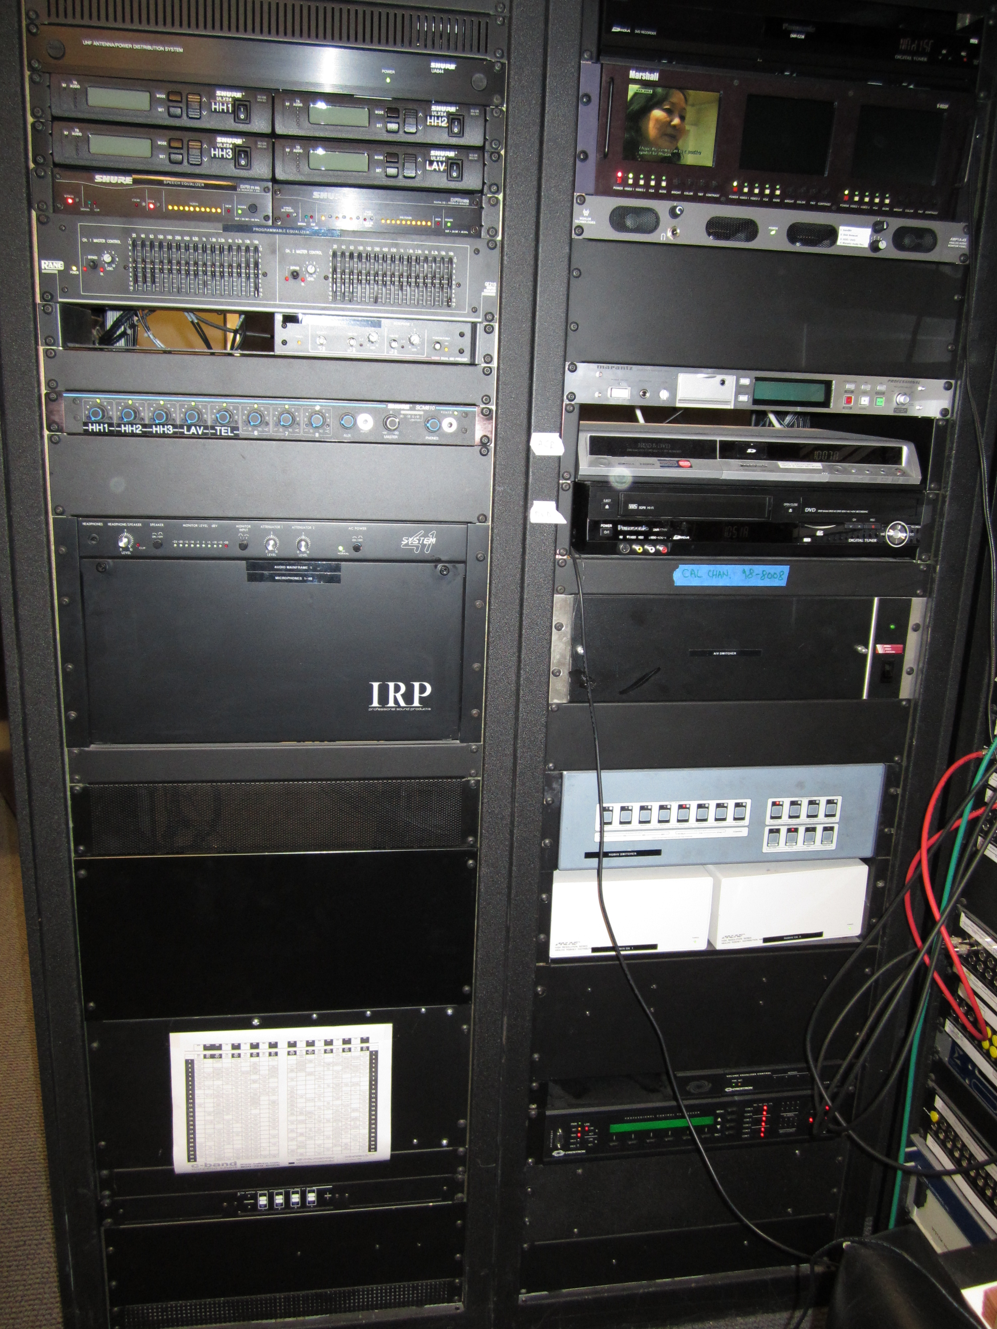
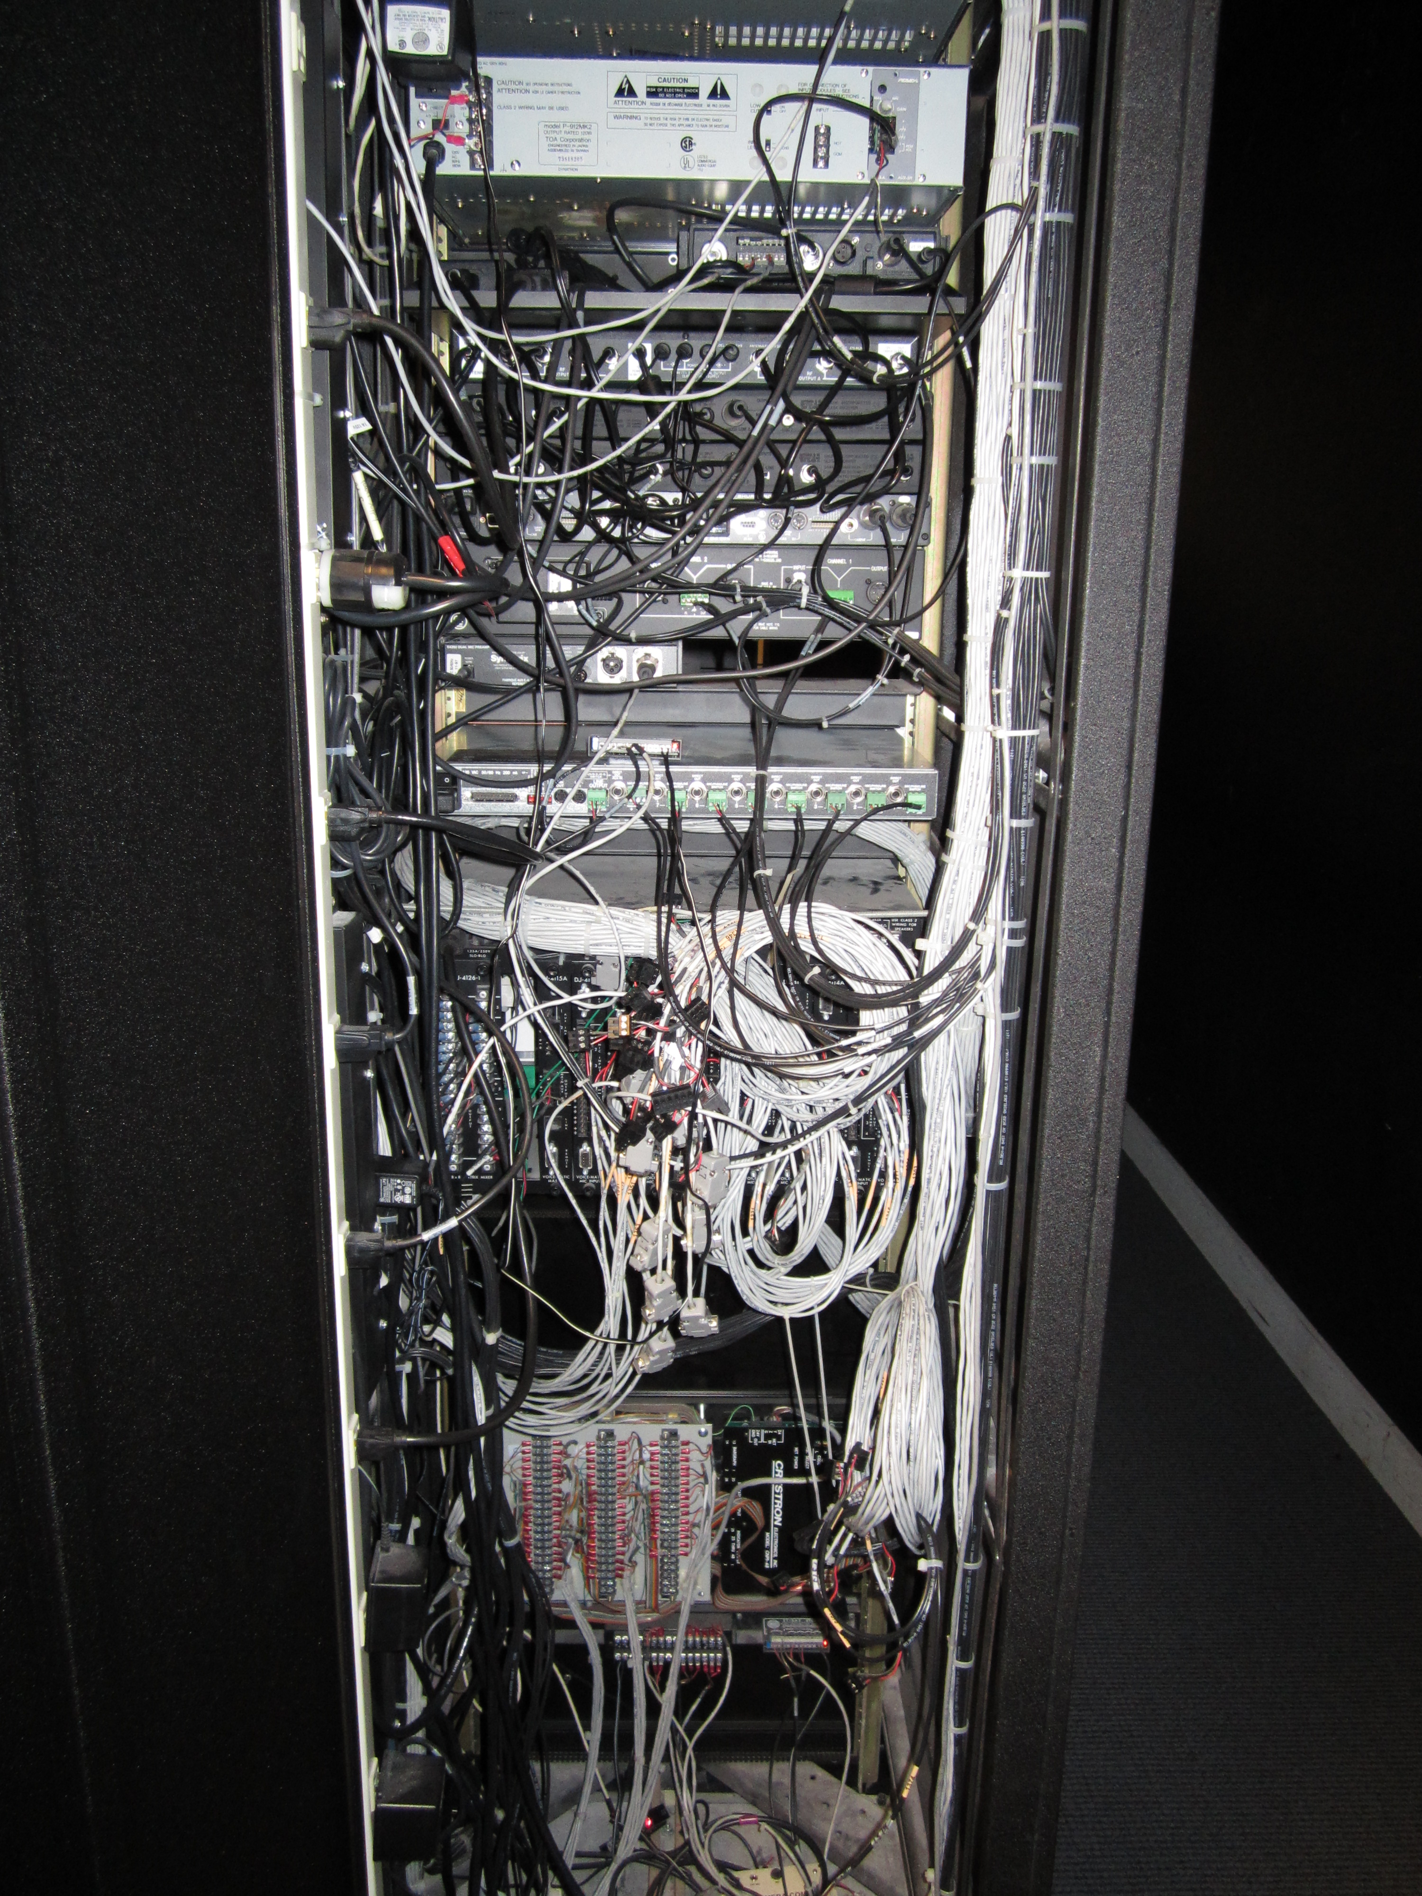
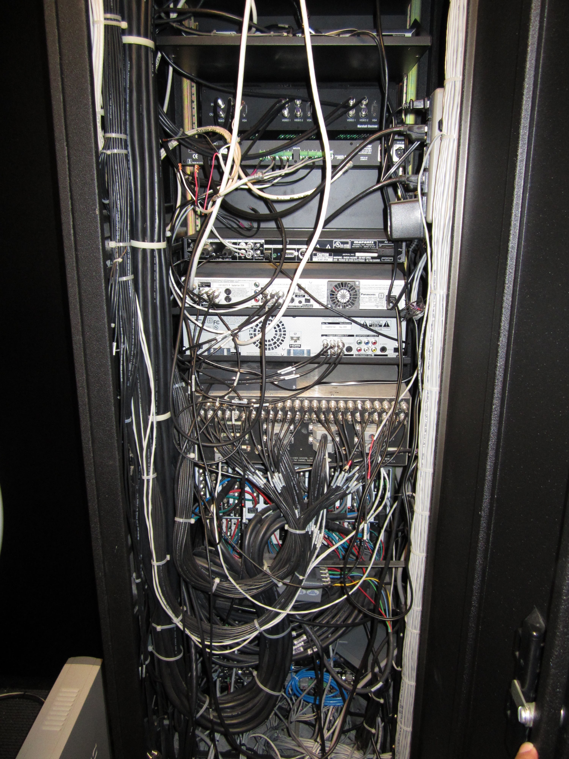

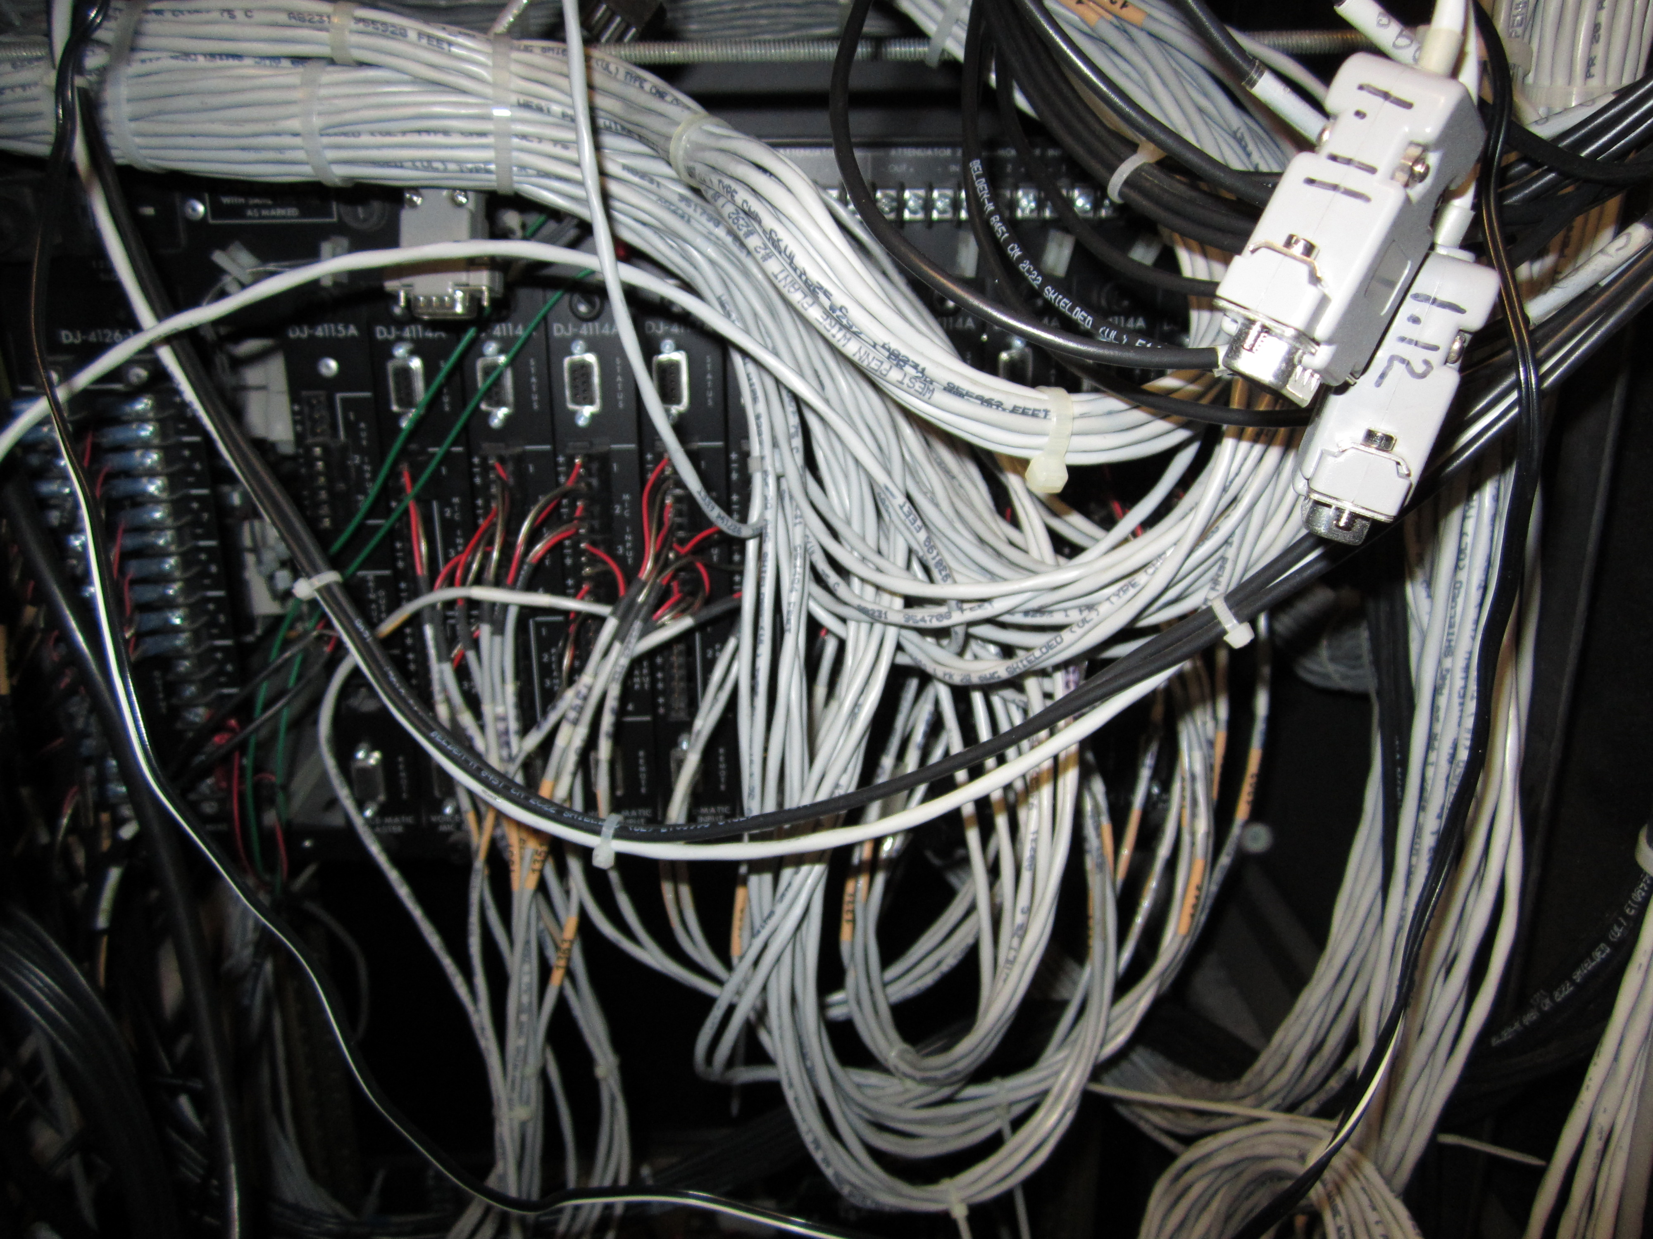

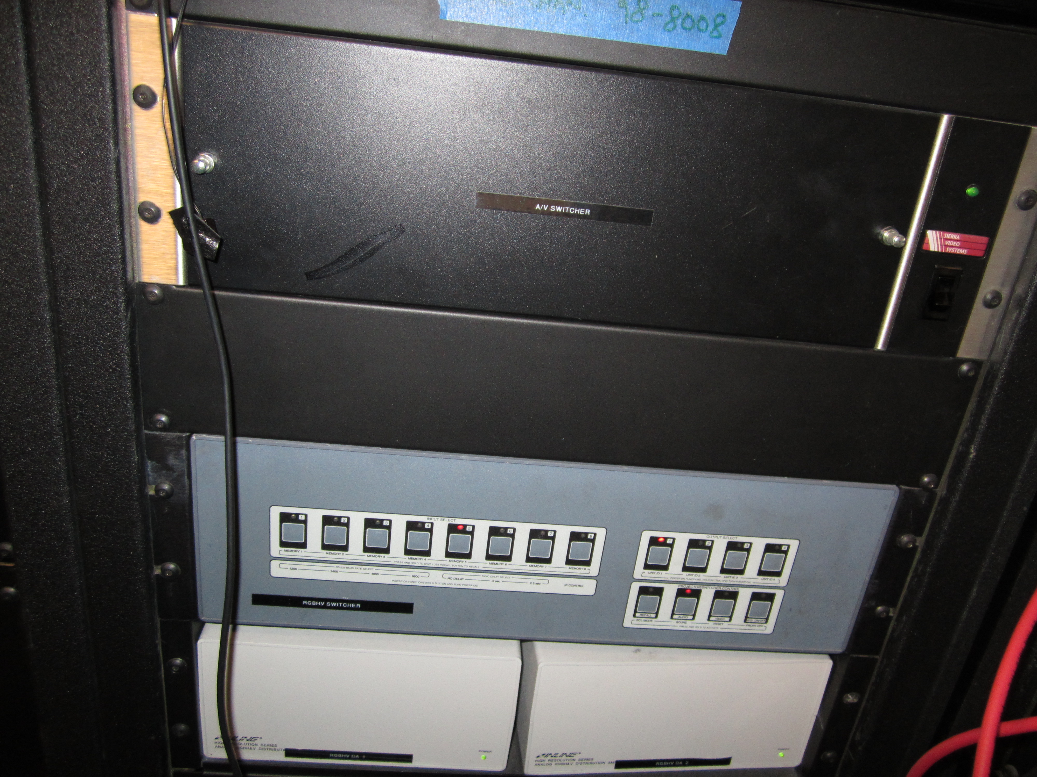

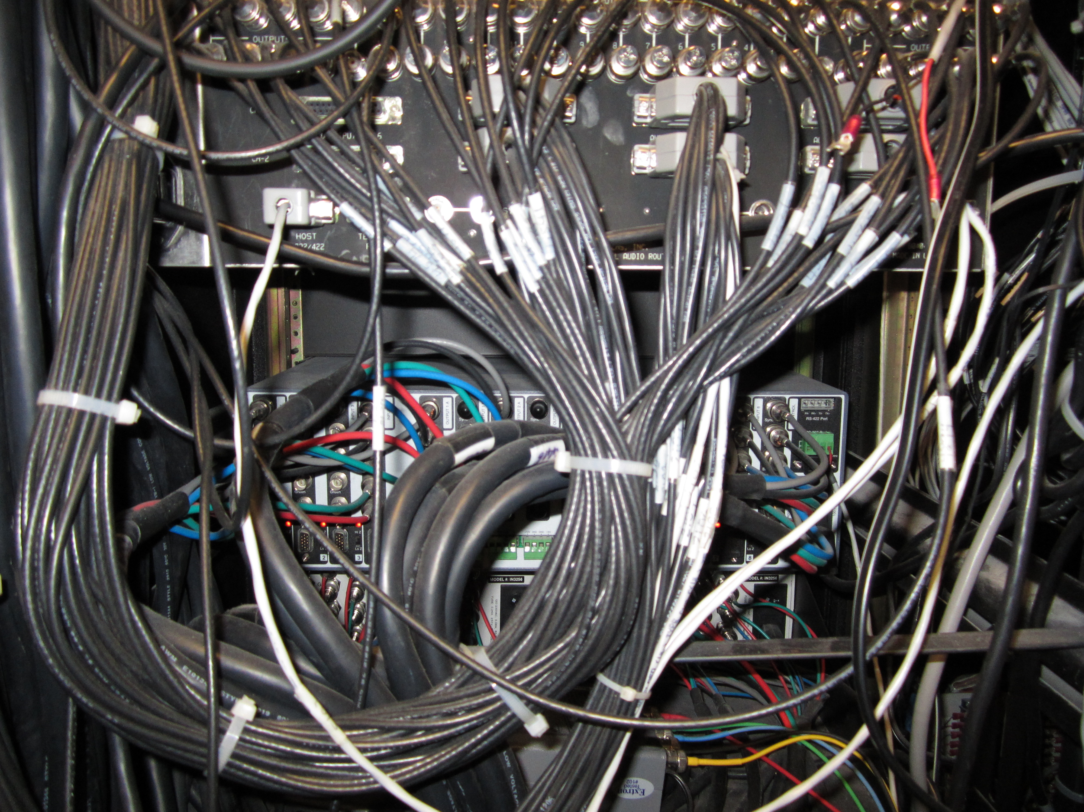

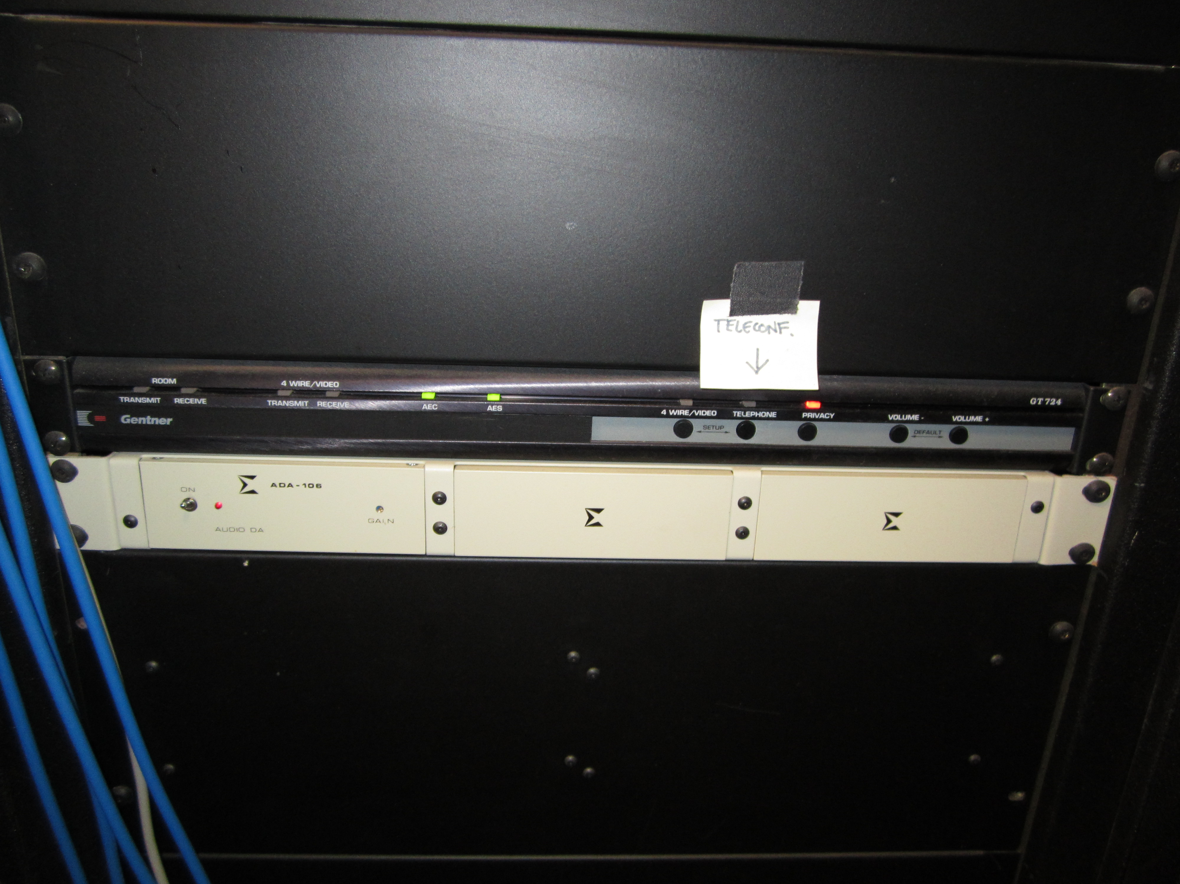

End of Questions and Answers

