ATTACHMENT B
SERVICE REGIONS FORM / MAP

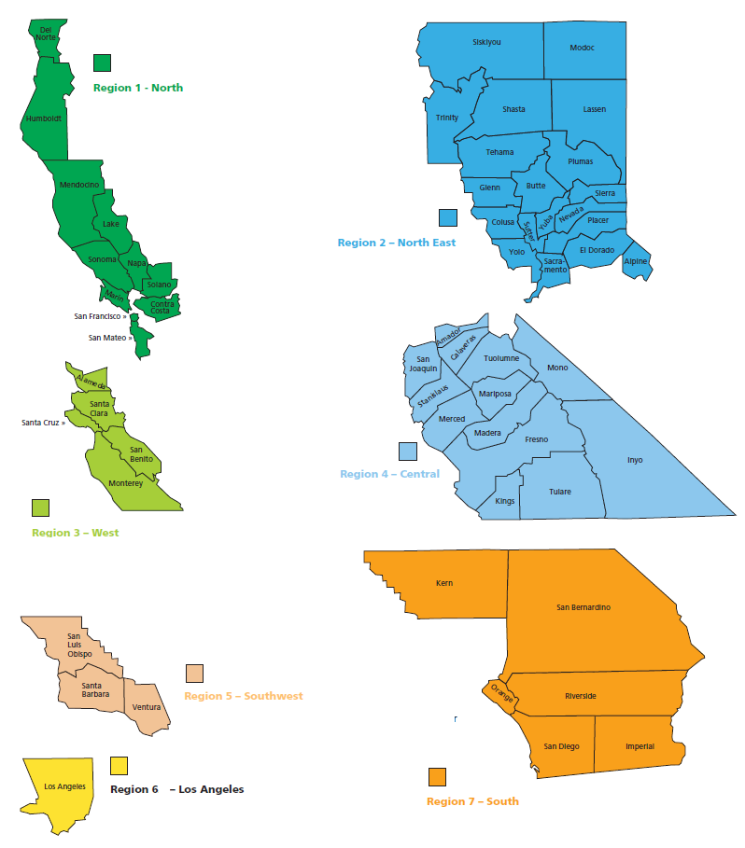

In the table below, indicate (by marking with an “X” where applicable) all of the following: (i) all service regions in which Consultant has performed services substantially similar to those being requested by this RFP over the past twelve (12) months and the scope of those performed services; (ii) all service regions in which, yes, the Consultant does propose to provide some or all of the Services being requested by this RFP; and (iii) all service regions in which, no, Consultant does not propose or is unable to provide the Services being requested by this RFP.

Service Region | Mark Box If Services Previously Provided and Briefly Describe Scope Thereof |  | Yes, Proposing Services | No, Not Proposing Services
- North | ☐ |  | ☐ | ☐
- North East | ☐ |  | ☐ | ☐
- West | ☐ |  | ☐ | ☐
- Central | ☐ |  | ☐ | ☐
- Southwest | ☐ |  | ☐ | ☐
- Los Angeles | ☐ |  | ☐ | ☐
- South | ☐ |  | ☐ | ☐

END OF ATTACHMENT B

