**Questions and Answers for IFB-ISD-021606-AA**

**For: SAP BusinessObjects BI Suite and SAP Enterprise**

**Question 1.**

My SAP rep and I are a little confused on this request.  Could you please clarify if these are all renewal items, or does this include a new license purchase?

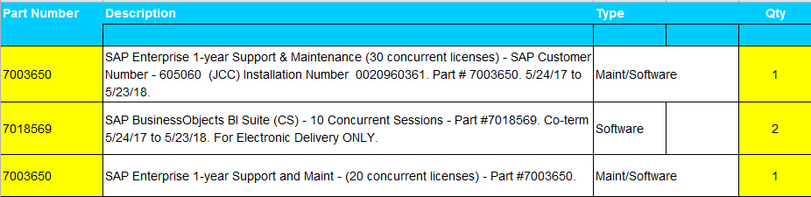

**Answer for Question 1.**

We currently have 30 concurrent licenses purchased last year.  Item 7018569 is for 20 additional concurrent licenses.  Item 7003650 is for the 1st year of support and maintenance of the requested 20 new concurrent licenses.  Item 7003650 is for the 2nd year of support and maintenance of our existing 30 licenses.  We would like all 50 concurrent licenses (30 current, 20 new) to be on the same support and maintenance cycle.