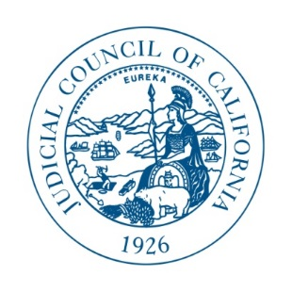

JUDICIAL COUNCIL OF CALIFORNIA
455 Golden Gate Avenue . San Francisco, CA 94102-3688
Telephone 415-865-4200 . Fax 415-865-4205 . TDD 415-865-4272

NOTICE OF INTENT TO AWARD

Environmental Services Consultants

RFq# REFM-2016-03-MS

July 28, 2016
______________________________________________________________________
It is the intent of Judicial Council of California, Real Estate Facilities Management, to enter into a contract with the following firms for services set forth in the Request for Proposal.

- Alta Environmental & Safety Consultants
- Amec Foster Wheeler
- Bureau Veritas North America, Inc.
- Converse Consultants
- Fugro Consultants, Inc.
- Geoncon Incorporated
- NCE Engineering & Environmental Services
- Ninyo & Moore
- Professional Service Industries, Inc. (PSI)
- Rincon Consultants
- Terracon

Final selection is pending contract negotiations.
We would like to extend our sincere thanks for the participation of submitting teams.

