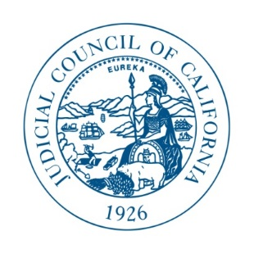

JUDICIAL COUNCIL OF CALIFORNIA
455 Golden Gate Avenue . San Francisco, CA 94102-3688
Telephone 415-865-4200 . Fax 415-865-4205 . TDD 415-865-4272

ADDENDUM #1

UPDATE TO RFQ #REFM-2016-03-MS
Environmental Services Consultants

The Judicial Council will not post answers to Clarifications, Modifications or Questions this week.

The Judicial Council will issue a modified RFQ at a later date.

The deadline for submission of hard copy proposals will be revised, the exact date is to be determined. Please check the Judicial Council Solicitation website (http://www.courts.ca.gov/34558.htm ) for further notice.

