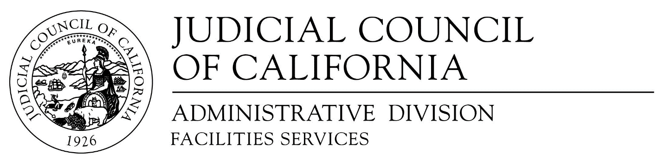

455 Golden Gate Avenue . San Francisco, CA 94102-3688
Telephone 415-865-8826 . Fax 415-865-4205 . TDD 415-865-4272

NOTICE OF INTENT TO AWARD
Audio Visual Maintenance and Repair Services RFP
RFQ-FS-2019-09-BD

June 23rd, 2020
______________________________________________________________________
It is the intent of Judicial Council of California, Facilities Services Office, to enter into contracts with the following firms for services set forth in the Request for Proposal at Judicial Council Locations in Sacramento, San Francisco, and Los Angeles, CA.

Sacramento
Exhibit One Corporation
Better Presentation Systems, Inc.
San Francisco
Exhibit One Corporation
EIDIM Group
Los Angeles
EIDIM Group
AV Spaces, Inc.

We would like to extend our sincere thanks for the participation of submitting firms.

