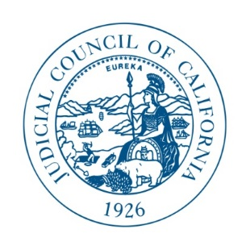

JUDICIAL COUNCIL OF CALIFORNIA
455 Golden Gate Avenue . San Francisco, CA 94102-3688
Telephone 415-865-4200 . Fax 415-865-4205 . TDD 415-865-4272

NOTICE OF INTENT TO AWARD
Publication of the Official Reports
RFP-Supreme-032717-Official-Reports-WV

May 18, 2017

______________________________________________________________________
It is the intent of the Supreme Court of California to enter into a contract with the following vendor:

LexisNexis

Provided contract negotiations can be finalized, the above named vendor will be awarded a contract for the services set forth in the above Request for Proposal.
We would like to extend our sincere gratitude to all participants.

