California Supreme Court

Advisory Committee on Rules for

Publication of Court of Appeal Opinions

Report and Recommendations

November 2006



Supreme Court of California
350 McAllister Street
San Francisco, California 94102-4797
Supreme Court of California
350 McAllister Street
San Francisco, CA 94102-4797

Copyright © 2006 by the Supreme Court of California. All rights reserved.

Except as permitted under the Copyright Act of 1976 and as otherwise expressly provided herein, no part of this publication may be reproduced in any form or by any means, electronic, online, or mechanical, including the use of information storage and retrieval systems, without permission in writing from the copyright holder. Permission is hereby granted to nonprofit institutions to reproduce and distribute this publication for educational purposes if the copies are distributed at or below cost and credit the copyright holder.

This report is available on the California Courts Web site:
www.courtinfo.ca.gov/courts/supreme/comm/#opin

Printed on recycled paper

Supreme Court of California

Chief Justice

Ronald M. George

Associate Justices

Joyce L. Kennard

Marvin R. Baxter

Kathryn Mickle Werdegar

Ming W. Chin

Carlos R. Moreno

Carol A. Corrigan

California Supreme Court

Advisory Committee on Rules for

Publication of Court of Appeal Opinions

Chair

Hon. Kathryn Mickle Werdegar, Associate Justice, California Supreme Court

Members

Hon. Joanne Parrilli, Associate Justice of the California Court of Appeal, First Appellate District, Division Three

Hon. Kathryn Doi Todd, Associate Justice of the California Court of Appeal, Second Appellate District, Division Two

Hon. Fred K. Morrison, Associate Justice of the California Court of Appeal, Third Appellate District, Division One

Hon. Patricia D. Benke, Associate Justice of the California Court of Appeal, Fourth Appellate District

Hon. Gene M. Gomes, Associate Justice of the California Court of Appeal, Fifth Appellate District

Hon. Richard J. McAdams, Associate Justice of the California Court of Appeal, Sixth Appellate District

Ms. Victoria J. DeGoff, DeGoff & Sherman

Mr. Dennis A. Fischer, Law Offices of Dennis A. Fischer

Mr. Richard Frank, Chief Deputy Attorney General, California Department of Justice

Mr. Ellis J. Horvitz, Horvitz & Levy

Ms. Beth J. Jay, Principal Attorney to the Chief Justice, California Supreme Court

Mr. Edward Jessen, Reporter of Decisions, California Supreme Court

Staff

Ms. Heather Anderson, Senior Attorney, Office of the General Counsel, Administrative Office of the Courts

Ms. Lyn Hinegardner, Attorney, Office of the General Counsel, Administrative Office of the Courts

Mr. Clifford Alumno, Court Services Analyst, Office of the General Counsel, Administrative Office of the Courts

Mr. Chris Belloli, Senior Research Analyst, Office of Court Research, Administrative Office of the Courts

CONTENTS

I. Executive Summary 1

II. Introduction and Form of This Report 4

III. The Advisory Committee and Its Process 6

A. The Advisory Committee Charge 6

B. Composition of the Advisory Committee 7

C. Meetings of the Advisory Committee 7

D. Information Gathering and Analysis 7

IV. Background and Current Rules and Practices Regarding Publication 9

A. Brief Summary of the History of Publication in California 9

B. Work of Prior Committees on Publication in California 10

C. Current Rules and Practices Regarding Publication in California 11

D. Practices Regarding Unpublished Opinions in California 12
1. Online availability of unpublished opinions 12
2. Tracking of unpublished opinions 13

E. Publication Rules and Practices in Other Jurisdictions 13
1. Summary of rules and practices 13
2. Practical distinctions between California and other jurisdictions 14
3. Comparison to New York State 14

V. California Publication Data 16

A. Statewide Statistics on Publication 16
1. Statewide publication rates 16
2. Depublication orders 17
3. Requests for publication 17
4. Granting review of published/unpublished opinions 18

B. Publication Statistics by Appellate District and Division 19
- Overall publication rate in each district and division 19
2. Factors affecting publication rates 24
a. Case-type mix 25
b. Workload 27
c. Other factors 30

VI. Surveys of Court of Appeal Justices and Appellate Attorneys 32

A. Survey Drafting, Distribution, and Response Rates 32
1. Justices of the Court of Appeal 32
2. Appellate attorneys 33

B. Survey Results 33
1. Importance of the rule 8.1105(c) criteria 33
2. Publication process 37
3. The influence of other factors on publication 38
4. Unpublished opinions 39
5. Limited citation to unpublished opinions 41
6. Partial publication 42
7. Potential changes to rule 8.1105 44

VII. Committee Discussion and Preliminary Recommendations 47

A. Proposed Rule Revisions Recommended in Preliminary Report 48

1. Amendments to existing criteria recommended in
preliminary report 49
2. New criteria recommended in preliminary report 49
3. Factors not to consider recommended in preliminary report 50

- Presumption Against Publication 50

- Other Preliminary Recommendations 51
1. Future monitoring 51
2. Judicial education 51

3. Consider asking committee to address additional issues
a. Partial publication or depublication 51
b. Unpublished opinions 52
c. Appellate divisions of the superior court and other
unfinished matters 52

VIII. Public Comment on Preliminary Report and Recommendations 53

A. Circulation of Preliminary Report and Recommendations 53
1. The invitation to comment 53
2. Summary of comments received 53
3. Eliminating the presumption against publication and other
changes made in response to the public comments 54

B. Circulation of Revised Recommendations for Amendment to

Rule 8.1105 of the California Rules of Court 55
1. The invitation to comment 55
2. Summary of comments received 55
3. Changes made in response to the public comments 55

IX. Conclusion and Final Recommendations 57

X. Appendixes

A. California Rules of Court, rules 8.1100 through 8.1125

B. 1971 Report of the Committee on Selective Publication of Appellate Court Opinions

C. 1979 Judicial Council Report on Proposed Rule Amendments for Publication of Appellate Opinions

D. 2001 White Paper on Unpublished Opinions of the Court of Appeal

E. Analysis of Data on Publication Rates for the Courts of Appeal

F. Survey of Justices of the Courts of Appeal

G. Survey of Appellate Attorneys

H. List of Attorneys and Organizations Contacted for Survey

I. Results of Surveys of Justice of the Courts of Appeal and Appellate Attorneys

J. October 2005 Preliminary Report and Recommendations of the Supreme Court Advisory Committee on Rules for Publication of Court of Appeal Opinions

- 2005 Invitation to Comment on the Preliminary Report and Recommendations of the Supreme Court Advisory Committee on Rules for Publication of Court of Appeal Opinions

- Chart summarizing public comments received in response to 2005 Invitation to Comment

- 2006 Invitation to Comment on Revised Recommendation for Amendment to California Rules of Court, Rule 976 (now rule 8.1105)

- Chart summarizing public comments received in response to 2006 Invitation to Comment

I. Executive Summary

The California Supreme Court appointed the California Supreme Court Advisory Committee on Rules for Publication of Court of Appeal Opinions (the committee) to review the rules for the publication of Court of Appeal opinions and recommend whether the rules should be changed to better ensure the publication of those opinions that may assist in the reasoned and orderly development of the law. The committee reviewed practices in other jurisdictions, relevant literature, and recent statistical information on the publication rates of the California Courts of Appeal. It also surveyed the justices of the Courts of Appeal and appellate attorneys concerning the current criteria for publication in rule 8.1105 (former rule 976), the courts’ publication practices, and various potential changes in publication procedures.

The information gathered and analyzed by the committee suggests that, by and large, the current publication rules and practices have been successful in creating and managing an accessible body of precedential appellate opinions that provide useful guidance for litigants and the public. While the committee found that certain appellate districts and divisions within districts do have higher publication rates than others, the committee’s statistical analysis and, to a lesser extent, the survey results suggest several neutral factors that explain most of those differences. When analyzed over time and controlled for case type and judicial workload, publication rates appear to be relatively consistent across most of the districts and divisions. The information gathered by the committee, particularly the responses to the surveys, also suggests, however, that some important adjustments should be made in the publication rules to better ensure the publication of all those opinions that may assist in the reasoned and orderly development of the law and to improve public confidence in the publication process.

Based on the information it collected, the committee prepared a preliminary report and recommendations. This preliminary report concluded that rule 8.1105 could be modified to further encourage the publication of all cases that might provide helpful guidance to the lower courts and practitioners and to increase public confidence in the publication process. To achieve this, the committee preliminarily recommended clarifying and expanding the criteria for publication of Court of Appeal opinions in rule 8.1105 and adding a provision identifying factors that should not affect the decision whether to certify an opinion for publication. This preliminary report did not, however, recommend changing the presumption against publication in rule 8.1105.

The preliminary report and recommendations were circulated for public comment in the winter of 2005–2006. Many commentators suggested that, to more fully achieve the committee’s goals of better ensuring the publication of those opinions that may assist in the reasoned and orderly development of the law and improving public confidence in the publication process, the committee should consider additional changes to rule 8.1105. In particular, a significant number of commentators urged eliminating the presumption against publication.

Based on these comments, the committee modified its recommendations to include replacing the current presumption against publication in rule 8.1105 with a presumption in favor of publication if an opinion meets one or more of the criteria specified in the rule. The committee’s modified recommendations were circulated for further public comment in April 2006. The majority of those who commented on the modified recommendations supported these proposed amendments to rule 8.1105.

Based on all of the information that it gathered and analyzed concerning the standards for the publication of Courts of Appeal opinions and the comments received on both its preliminary report and the revised proposal to amend rule 8.1105, the committee recommends that the Supreme Court take the following actions:

1. Adopt proposed amendments to rule 8.1105 of the California Rules of Court, effective April 1, 2007, to:

(a) Replace the presumption against publication with a presumption in favor of publication if the opinion meets one or more of the criteria specified in the rule;

(b) Clarify and expand the criteria that the Courts of Appeal and the appellate divisions of the superior courts should consider when deciding whether to certify an opinion for publication; and

(c) Identify factors that should not be considered in deciding whether to certify an opinion for publication.

2. Assuming the court adopts the proposed amendments, provision should be made to periodically evaluate their impact and whether additional changes should be recommended.

3. Encourage further judicial education regarding the publication rules and related practices.

4. Consider having a committee:

(a) Evaluate the feasibility of procedures whereby the Supreme Court could order the partial publication or partial depublication of a Court of Appeal opinion.

(b) Evaluate the possibility of expanding the circumstances under which parties may draw the attention of the Court or Appeal or Supreme Court to unpublished opinions.

(c) Review and make recommendations concerning the publication of opinions of the appellate divisions of the superior court and other matters within the committee’s charge that were not addressed in this report.

The full text of the amendments to rule 8.1105 recommended by the committee is attached beginning on page 59. The committee believes that making these recommended changes and implementing the committee’s other recommendations will clarify the criteria for publication for both justices and attorneys, better ensure the publication of all those opinions that may assist in the reasoned and orderly development of the law, and improve public confidence in the publication process.
II. Introduction and Form of This Report

The California Constitution gives the Supreme Court the authority and responsibility to decide which appellate opinions are published. Under that authority, the court has established standards for publication of appellate opinions, set forth in rule 8.1100 et seq. of the California Rules of Court. These rules currently provide that all opinions of the Supreme Court are published but that an opinion of the Courts of Appeal or the appellate divisions of the superior courts may not be published unless it meets one of four specified criteria, i.e., the opinion:

(1) Establishes a new rule of law, applies an existing rule to a set of facts significantly different from those stated in published opinions, or modifies or criticizes, with reasons given, an existing rule;

(2) Resolves or creates an apparent conflict in the law;

(3) Involves a legal issue of continuing public interest; or

(4) Makes a significant contribution to legal literature by reviewing either the development of a common law rule or the legislative or judicial history of a provision of a constitution, statute, or other written law. (Rule 8.1105(c).)

Court of Appeal opinions that meet these criteria and are published are citable; those that are not published are not citable but are available to the public from a variety of sources.

These rules for selective publication of intermediate appellate court opinions are designed to create and manage an accessible body of precedential appellate opinions that provide useful guidance while avoiding overwhelming litigants and the public with thousands of opinions that are of limited value as precedent. Some members of the California legal community, however, have long advocated that all opinions of the Courts of Appeal should be published or, in the alternative, that all opinions should be made citable. Proponents of unlimited publication argue that unpublished opinions may be used to suppress certain types of decisions or to discourage Supreme Court review. Opponents of unlimited publication note that a very large number of opinions are issued by the Courts of Appeal in California because, unlike in most other jurisdictions, the California Constitution requires that all causes be decided in writing with reasons stated. Publishing all of these opinions, they argue, will make it more difficult and expensive for litigants and the public to find the opinions that provide useful guidance. The debate about whether all opinions should be published or citable is not unique to California. For example, the United States Supreme recently approved new rule 32.1 of the Federal Rules of Appellate Procedure, which will allow citation to all unpublished federal decisions issued on or after effect January 1, 2007.

After various legislators expressed interest in ensuring that all appropriate opinions be readily available, Chief Justice Ronald M. George consulted with the Supreme Court and appointed the committee in November 2004. Associate Justice Kathryn M. Werdegar was named committee chair. As discussed more fully in part III of this report, the court charged the committee with reviewing the rules for publication of opinions of the Courts of Appeal and with recommending to the court whether the existing criteria or procedures set forth in the rules should be changed to better ensure the publication of those opinions that may assist in the reasoned and orderly development of the law.

This report describes the committee and its process (part III) and the background and history of selective publication in California and in certain other jurisdictions (part IV). It describes the statistics and surveys upon which the committee relied (parts V and VI). It then describes the committee’s preliminary recommendations for amending rule 8.1105, the public comments received on the preliminary recommendations, and the changes that the committee made in its recommendations in response to those comments (parts VII and VIII). In its conclusion, the committee makes its final recommendations for amending rule 8.1105 and also recommends areas for future inquiry (part IX). All of the supporting documents regarding the publication statistics and surveys are included as appendixes to this report (part X).

III. The Advisory Committee and Its Process

As discussed above, Chief Justice Ronald M. George appointed the committee in November 2004.

A. The Advisory Committee Charge

The Supreme Court charged the committee with the task of reviewing the existing rules for the publication of opinions of the Courts of Appeal and with recommending to the Supreme Court whether the criteria or procedures set forth in the rules should be changed to better ensure the publication of those opinions that may assist in the reasoned and orderly development of the law. The committee was specifically asked to determine whether a disparity in publication practices exists among the six appellate districts and within their divisions and to consider whether the existing publication rules should be amended to better assist the courts in making their initial determination of whether to certify an opinion for publication. The committee was also asked to consider several other specific items, including the criteria applied by the Supreme Court in ordering publication and depublication and the treatment of opinions published by the appellate divisions of the superior court. The committee was not asked to consider the question of allowing citation or publication of all opinions; rather, the committee’s charge was to consider whether the existing standards for publication could be improved so that all the opinions that may provide useful guidance to litigants and the public are published. In carrying out this charge, the committee focused on rule 8.1105 and on how the Courts of Appeal decide to certify opinions for publication.

B. Composition of the Advisory Committee

The 13 members of the committee include one justice from each of the six appellate court districts, several attorneys with extensive appellate practice experience, the Reporter of Decisions, and the Principal Attorney to the Chief Justice (a roster of the committee appears at the beginning of this report on page iv). The committee is supported by staff from the Administrative Office of the Courts’ Office of the General Counsel and Office of Court Research.

C. Meetings of the Advisory Committee

The committee met twice before developing its preliminary report and recommendations, once in January 2005 and again in May 2005. The January meeting was primarily devoted to presentations on the background and status of the publication of Court of Appeal opinions. Additionally, the committee reviewed a draft of the survey that was later sent out to all Court of Appeal justices and that served as the basis for the survey of appellate attorneys. At its May meeting, the committee reviewed the results of the justices’ survey and the preliminary results of the attorney survey. The committee formulated tentative preliminary recommendations, which were finalized after it reviewed the final results of the attorney survey.

The committee also met twice after its preliminary report was circulated for public comment, in person in February 2006 and by conference call in August 2006. The February meeting was devoted to considering the public comments on the committee’s preliminary report and revising the proposal for amending rule 8.1105 to address those comments. At its August meeting, the committee considered the public comments on this revised rule proposal.

In addition, the committee communicated via e-mail and telephone conferences.

D. Information Gathering and Analysis

To assist in fulfilling its charge, the committee reviewed publication practices in other jurisdictions, relevant literature concerning publication of appellate court opinions, and recent statistical information on the publication practices of the California Courts of Appeal (this information is discussed in parts IV and V below). Additionally, the committee solicited the views of justices of the Courts of Appeal and attorneys through two surveys. As more fully discussed in part VI below, the committee circulated a comprehensive survey regarding publication rules and practices to all 101 justices in the Courts of Appeal and received 86 responses (a response rate of 86 percent). A similar survey was distributed to attorneys, particularly those having substantial appellate practices, and made available online. Approximately 600 attorneys viewed or completed at least a portion of that survey. Finally, as discussed in part VIII, the committee solicited the views of the public on both its preliminary report and recommendations and on its revised recommendations.

IV. Background and Current Rules and Practices Regarding Publication

A. Brief Summary of the History of Publication in California

The history of the publication rules in California dates back to Houston v. Williams (1859) 13 Cal. 24. In that case, the Supreme Court held that the Legislature lacked the authority to compel the court to document its opinions in writing with reasons stated. The California Constitution of 1849 included a provision allowing the Legislature to provide for the publication of statutes and judicial decisions as it deemed appropriate. The court concluded that the provision did not authorize the Legislature to require that all decisions be rendered by written opinion. In response to Houston v. Williams, at the Constitutional Convention of 1879, a clause was adopted requiring that the decisions of the Supreme Court be made in writing with grounds stated. In 1904, the clause was amended to include a provision concerning the publication of Court of Appeal opinions that gave the Supreme Court the power to determine which appellate opinions would be published. This provision concerning the Supreme Court’s authority over publication is now contained in article VI, section 14 of the California Constitution and echoed in section 68902 of the Government Code.

All opinions of the Supreme Court and the Courts of Appeal were published until the middle of the last century. The concept of selective publication emerged in the early 1960’s when the number of opinions began rapidly increasing. During the 1950’s, the courts annually produced an average of about 10 volumes of Court of Appeal opinions, with each volume averaging about two-thirds of the number of pages of modern volumes. This increased to an average of approximately 13 volumes a year in the early 1960’s. The increase in the number of volumes raised concerns that the bench and the bar were being inundated by the volume of Court of Appeal opinions.

In 1964, the first rule providing for selective publication—rule 976 of the California Rules of Court —was adopted. This original rule contained a presumption that all Court of Appeal opinions were publishable. For an opinion not to be published, the rule required the appellate panel to certify that the opinion failed to satisfy the criteria for publication specified in the rule. These original publication criteria were similar to, but narrower than, the criteria that are now in rule 8.1105: An opinion was to be published if it involved “a new and important issue of law, a change in an established principle of law, or a matter of general public interest.”

After the adoption of this rule, the courts issued an average of nine volumes annually over the next several years.

B. Work of Prior Committees on Publication in California

Rule 976 was first revisited in 1971, seven years after its adoption. Chief Justice Donald R. Wright appointed a committee (the 1971 committee) that surveyed all Court of Appeal justices and encouraged public comment on the impact of rule 976. After considering the input received, the 1971 committee recommended that the rule be retained, but that the publication criteria be clarified and expanded. Specific recommendations included adding “criticizes existing law” as a new criterion for publication and changing the original criterion from “involves…a matter of general public interest” to “involves a legal issue of continuing public interest.” The 1971 committee also recommended that the rule’s presumption in favor of publication be removed and replaced by the presumption that opinions are not publishable unless they fall within the stated criteria. The 1971 committee’s report notes that changing the presumption favoring publication would eliminate the publication of any opinions that were being published merely because the court did not take the affirmative steps necessary under the rule to certify that the opinion did not meet the standards for publication. The court accepted the 1971 committee’s recommendations and adopted these changes.

Eight years later, in 1979, a committee appointed by Chief Justice Rose Bird (the 1979 committee) again reviewed rule 976. It conducted an extensive study that included public hearings and circulation of draft proposals for public comment, leading to the submission of a report to the court and the Judicial Council. This committee recommended the adoption of a new rule—rule 976.5—allowing partial publication as a one-year experiment. The 1979 committee also recommended further expanding the criteria for publication to include an opinion that (1) applies an existing rule of law to a significantly different set of facts, (2) resolves or creates an apparent conflict in the law, or (3) makes a significant contribution to the legal literature by reviewing the history of a law. The court adopted all of these recommended rule changes. Several of the 1979 committee’s recommendations for changes to rule 976 were not adopted, however. For example, the 1979 committee recommended expanding the publication criteria to provide for publication if there is a dissenting or concurring opinion in which the reasons are stated. The principal objection to this proposal was that, in most cases, whether a decision has precedential value is unrelated to whether it has a dissenting or concurring opinion. Many dissenting and concurring opinions are devoted exclusively to factual disagreements and therefore publishing these opinions would not assist in the development of the law.

More recently, in 1989, the Supreme Court approved new rule 979, establishing procedures for making requests for depublication.

In March 2001, the Judicial Council’s Appellate Process Task Force authored a white paper on unpublished opinions of the Court of Appeal. The paper discussed the value of making all unpublished opinions available electronically. Opinions not certified for publication have always been available to the public at the clerks’ offices in the Courts of Appeal, but, at that time, they were not available in electronic form. The report also discussed whether the rule prohibiting citation to unpublished opinions should be modified. Ultimately, the task force recommended that unpublished opinions should be posted on the Judicial Council’s Web site for a reasonable period of time (e.g., 60 days), but the general proscription against citation of unpublished opinions should remain in place without change. As discussed more fully in part IV.D below, after this report was issued, the Supreme Court made unpublished opinions accessible on the California Courts Web site.

C. Current Rules and Practices Regarding Publication in California

The current Supreme Court rules governing publication of appellate opinions are set out in rules 8.1100 through 8.1125 of the California Rules of Court. Subdivision (a) of rule 8.1105 (formerly rule 976) provides that all Supreme Court opinions are published. Subdivisions (b) through (e) of rule 8.1105 address publication of Court of Appeal and superior court appellate division opinions. Subdivision (b) provides that, unless otherwise ordered by the Supreme Court, Court of Appeal and superior court appellate division opinions are published if a majority of the rendering court certifies the opinion for publication. Subdivision (c) then specifically provides that opinions of the Courts of Appeal and superior court appellate divisions may not be certified for publication unless they meet at least one of four specified criteria:

“No opinion of a Court of Appeal or a superior court appellate division may be certified for publication in the Official Reports unless the opinion:

“(1) Establishes a new rule of law, applies an existing rule to a set of facts significantly different from those stated in published opinions, or modifies, or criticizes with reasons given, an existing rule;

“(2) Resolves or creates an apparent conflict in the law;

“(3) Involves a legal issue of continuing public interest; or

“(4) Makes a significant contribution to legal literature by reviewing either the development of a common law rule or the legislative or judicial history of a provision of a constitution, statute, or other written law.”

Rule 8.1110 provides that the Court of Appeal rendering the decision may also certify only selected portions of an opinion for publication.

Subdivision (d) of rule 8.1105 establishes that the Supreme Court may order a Court of Appeal or appellate division opinion to be or not to be published, regardless of whether the court that rendered the opinion certified it for publication. Rules 8.1120 and 8.1125 establish procedures for making requests to depublish a published opinion and publish an unpublished opinion, respectively. Depublication orders may be filed after opinions appear in the Official Reports advance pamphlets but before final editing work for the bound volume. (See Cal. Rules of Court, rule 8.1120(e).) Depublished opinions are not included in the bound volumes of the Official Reports.

Rule 8.1115 addresses citation of opinions. Subdivision (a) of this rule provides that, in general, opinions “not certified for publication or ordered published must not be cited or relied on by a court or a party in any other action.” Subdivision (b) addresses the limited circumstances under which parties may cite to unpublished opinions: when the opinion is relevant (1) under the doctrines of law of the case, res judicata, or collateral estoppel; or (2) to a criminal or disciplinary action because it states reasons for a decision affecting the same defendant or respondent in another such action.

D. Practices Regarding Unpublished Opinions in California

1. Online availability of unpublished opinions

Although unpublished opinions may not be cited or relied upon by a court or a party in another action, these opinions are readily available to courts, litigants, and the public. As noted above, these opinions have always been available to the public at the clerk’s office in the Court of Appeal that rendered the opinion. Starting October 1, 2001, all Court of Appeal opinions filed without publication certification have also been made available on the California Courts Web site at www.courtinfo.ca.gov/opinions/nonpub. With few exceptions, opinions are received and posted to the site the day of filing. Opinions remain available there for 60 days, except that opinions in cases in which the Supreme Court grants review remain on the site until the Supreme Court’s disposition is final. All unpublished opinions posted to the site include a conspicuous notice and explanation that unpublished opinions are not precedential and generally are uncitable.

Both LexisNexis and Westlaw, the two major providers of online legal research materials for the California bench and bar, integrate every unpublished Court of Appeal opinion into their respective services, and each has done so since October 1, 2001. Both services allow users to limit research only to California published opinions. For LexisNexis users, the “CA Published Cases” database excludes unpublished Court of Appeal opinions from search results, and, for Westlaw users, “West’s California Reported Cases” database excludes unpublished opinions from search results.

Other LexisNexis and Westlaw databases include both published and unpublished California opinions, but the search result listings in both services differentiate between published and unpublished opinions. For example the “CA State Cases” and “CA Federal & State Cases” databases in LexisNexis include published and unpublished opinions, and Westlaw’s “West’s California State Cases” and “California State & Federal Cases” databases include both; both publishers’ databases retain the conspicuous notice and explanation that unpublished opinions are not precedential and generally uncitable.

2. Tracking of unpublished opinions

The committee learned that, to assist the Supreme Court in fulfilling its role under the California Rules of Court governing the court’s grant of discretionary review (rules 8.500–8.512, former rules 28–28.2), the Supreme Court’s criminal and civil central staffs internally track issues in cases seeking review, whether published or unpublished, in order to identify inconsistencies among districts and between published and unpublished opinions. Internal computer programs, along with a numerical system for identifying issues, assist the court in tracking issues presented in cases in which a petition for review is filed in order to determine if conflicts are developing or if particular questions or claims warrant the court’s full-scale review.

E. Publication Rules and Practices in Other Jurisdictions

1. Summary of rules and practices

California was the first state to enact selective publication measures, but almost all states now have such rules. As of 2003, only nine states published all of their appellate opinions, had no rules against citation to unpublished opinions, or allowed citation of unpublished opinions as precedent. Twelve other states allowed citation to unpublished opinions for persuasive value only.

Jurisdictions that differentiate between opinions that have precedential value and those that do not use similar criteria. Some courts phrase the presumption in favor of publication rather than against. Some courts allow publication upon the request of a single judge of the panel, as opposed to California’s requirement of a majority request.

In jurisdictions other than California, depublication and partial publication are rare, especially depublication by the state’s highest court. Research found only one other jurisdiction (Arizona), whose rules provide that its Supreme Court has the authority to order depublication of an opinion.

2. Practical distinctions between California and other jurisdictions

Because of differences in the requirements concerning appellate opinions, California Courts of Appeal issue a proportionally larger number of opinions than other jurisdictions.

California is virtually unique in its constitutional requirement that decisions by Courts of Appeal that determine causes “shall be in writing with reasons stated.” (Cal. Const., art. VI, § 14.) All other jurisdictions surveyed, except the State of Washington, provide intermediate appellate courts with some discretion to decide causes on appeal summarily, without issuing opinions in writing and stating the reasons. For example, intermediate appellate courts in New York have discretion to make summary dispositions of causes on appeal, particularly where appellate judgments merely affirm the rulings of trial courts, and the reasons for those trial court rulings are found to be without error. In these circumstances, the appellate court need not issue an opinion, but may issue an order merely stating: “Affirmed. No opinion” or “Affirmed for the reasons stated [in the memorandum of the lower court or in the opinion of a judge of the lower court].”

In the federal courts, rule 36 of the Federal Rules of Appellate Procedure and related local rules for the various circuits give the United States Courts of Appeals discretion to decide cases on appeal without written opinions. The First Circuit’s local rule 36 states: “The volume of filings is such that the court cannot dispose of each case by opinion. Rather it makes a choice, reasonably accommodated to the particular case, whether to use an order, memorandum and order, or opinion.”

As noted above, new rule 32.1 of the Federal Rules of Appellate Procedure, which will allow citation to all unpublished federal decisions, was approved by the United States Supreme Court on April 12, 2006, and will take effect January 1, 2007. Even when this rule takes effect, however, the federal intermediate appellate courts will retain discretion to summarily dispose of causes on appeal by orders not stating reasons.

3. Comparison to New York State

The committee was particularly interested in publication practices in New York because the volume of intermediate appellate court opinions issued in New York appears to be roughly comparable to that in California. In 2002, 10,674 appeals filed in the Appellate Division in New York (New York’s intermediate appellate court) were disposed of by opinion after submission and in fiscal year 2002-2003, 12, 543 matters were disposed of by written opinion in the California Courts of Appeal.. New York state law provides that, except for Appellate Division causes that the issuing court directs not to be reported, all written opinions of the Appellate Division must be delivered to the State Reporter, and the Law Reporting Bureau must report every cause determined in the Appellate Division, unless otherwise directed by the court deciding the cause. In practice, unlike in California, virtually all written opinions of New York’s intermediate appellate courts are published.

The vast majority of the appellate opinions issued by the intermediate appellate courts in New York are, however, qualitatively different from those issued in California. When an appellate court in New York is required to or elects to issue a written opinion, rather than an order summarily disposing of the matter, it may do so in the form of an unsigned memorandum opinion. This is the most frequently used form of written decision in New York. These typically very brief memoranda may not even address the facts but may merely resolve the legal issues raised in the appeal.

The frequent use of memorandum opinions in New York creates a significant distinction between New York and California practices. Most full opinions generated by the New York appellate courts are roughly comparable in length to California appellate opinions, but the memorandum opinions are very short. In 2003, New York published 301 full opinions in 1,988 printed book pages and 10,085 memorandum opinions in 10,132 printed book pages, or slightly less than one memorandum opinion per page. These numbers do not vary greatly from year to year. In one volume of opinions examined by the committee (volume 290), 39 cases in which full opinions were written produced 200 pages of material. Six hundred sixty-nine cases resolved in memorandum opinions resulted in 732 pages of text. In contrast, in the experience of the members of the committee, confirmed by review of a sampling of these matters, unpublished opinions in California (other than Wende matters) while generally shorter than published opinions, are considerably longer than one page. Thus, in terms of numbers of pages, the total volume of opinions issued by the intermediate appellate courts in California is actually much larger than in New York.

Although appellate courts in California can prepare short opinions that meet our state’s constitutional requirement for an opinion in writing with reasons stated, it is not clear whether the kind of very abbreviated memoranda issued by New York would meet this constitutional requirement. Furthermore, the view of the experienced appellate practitioners on the committee was that New York’s practice and procedure, which relies heavily upon the use of very brief memorandum opinions, would not likely be a satisfactory alternative for a California bench and bar long accustomed to receiving fully reasoned appellate dispositions of causes, regardless of publication status.

V. California Publication Data

A. Statewide Statistics on Publication

The committee studied the statistics collected by the Judicial Council on the publication of Court of Appeal opinions in fiscal years 1999–2000 through 2004–2005. The committee also examined statewide statistics on depublication of opinions, requests for publication of opinions, and petitions for review of both published and unpublished opinions.

1. Statewide publication rates

The committee initially examined the statewide average publication rate—the proportion of all Court of Appeal opinions issued in a particular year that are published. As table 1 below indicates, both the average publication rate and the absolute number of opinions published has grown steadily over the last five years. Since 2000-2001, the publication rate has increased by almost 40 percent.

Table 1
Publication rate by year

Fiscal Year | Total Number of Opinions | Total Number of Opinions Published | Average Publication Rate
1999-2000 | 13,370 | 882 | 6.6%
2000-2001 | 13,240 | 848 | 6.4%
2001-2002 | 12,204 | 906 | 7.4%
2002-2003 | 12,460 | 949 | 7.6%
2003-2004 | 12,187 | 972 | 8.0%
2004-2005 | 11,852 | 1,047 | 8.8%
Total | 75,313 | 5,604 | 7.4%
2. Depublication orders
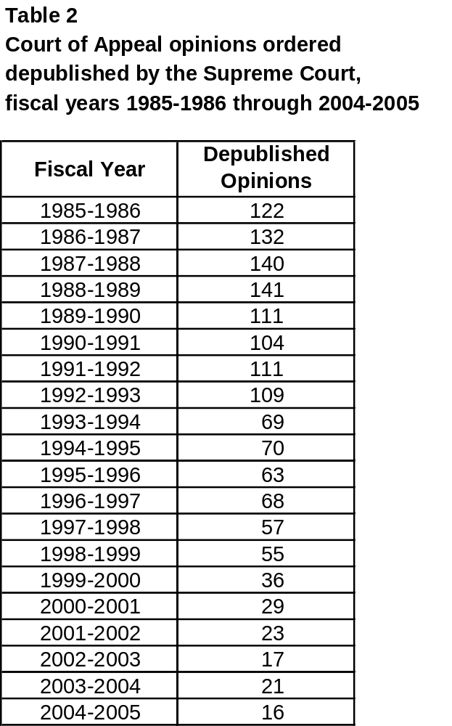
The committee also examined the number of cases ordered depublished by the Supreme Court each year. As table 2 indicates, in recent years (2000-2001 through 2004-2005) relatively few cases have been depublished; the average has been about 22 depublication orders per calendar year.

3. Requests for publication

The committee examined the numbers of requests and orders to publish opinions that initially were not certified for publication by the rendering court. Table 3 (next page) shows the combined totals of publication requests (from both parties and nonparties) that the Supreme Court’s criminal and civil central staffs evaluated each year from 1998 to 2005. It also shows the number of opinions ordered published during this same period by both the Courts of Appeal and the Supreme Court after an initial decision not to certify for publication.

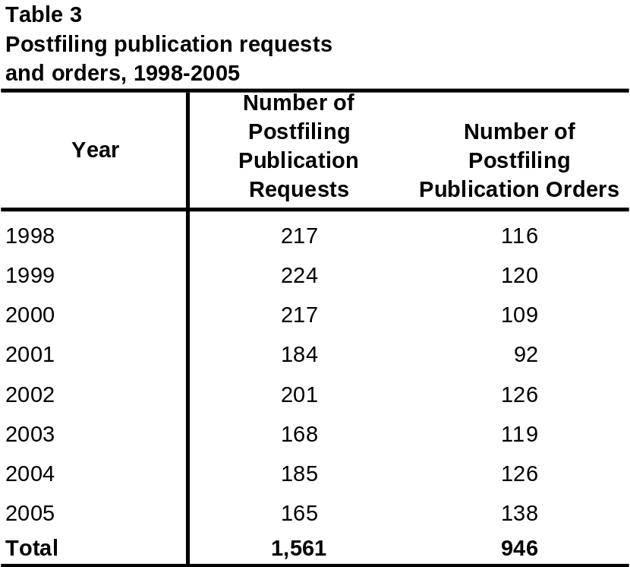
It is interesting to note that, notwithstanding the availability of unpublished opinions on the Internet since October 2001, making these opinions more readily available to individuals who are not parties to the cases, there has been no discernible increase in requests to the Courts of Appeal and the Supreme Court to publish opinions originally filed without certification for publication. In fact, in 2003 and 2004 the number of publication requests filed in the Supreme Court declined from the historical average.

4. Granting review of published/unpublished opinions

Between January 1, 2001, and December 30, 2005, the Supreme Court granted review in 602 cases in which there had been a published opinion and 303 cases in which the opinion was not certified for publication. Only about 8 percent of opinions overall are published (see table 1 at page 16), but 67 percent of total grants were from published opinions.

The Supreme Court’s grant of a petition for review may be an outright grant, usually followed by briefing, argument, and an opinion, or it may be a “grant and hold,” which occurs when the Supreme Court already has granted review in a case concerning the same issue or issues and anticipates deciding the controlling issues in the lead case. Briefing is deferred in the latter matters, and “grant and hold” cases typically are disposed of by order and not by an opinion of the Supreme Court. Briefing was deferred at the time review was granted in 161 of the 602 grants of review from published opinions described above and in 205 of the 303 grants of review from unpublished opinions. Between 2001 and 2005, the Supreme Court issued a total of 452 opinions; 369 of these arose out of cases in which the Court of Appeal decision was certified for publication and 83 out of cases in which it was not certified. Cases in which the Court of Appeal opinion was certified for publication thus accounted for about 82 percent of the matters in which the Supreme Court issued an opinion. Of the approximately 92 percent of cases overall that were not certified for publication, only one-tenth of 1 percent resulted in opinions issued by the Supreme Court. Of the approximately 8 percent of cases in which the opinion had been certified for publication, about 7 percent resulted in a Supreme Court opinion.

B. Publication Statistics by Appellate District and Division

As directed in its charge, the committee also analyzed the publication data by district and, for the three districts that have separate appellate divisions, by division. The objective of the committee’s analysis was to compare the publication rates in the different appellate districts and divisions and to evaluate factors that might affect these rates. There were some statistically significant differences in the overall average publication rates in different districts and between some of the divisions within the districts. However, the committee found that if case type, variations in workload, and other factors discussed below are taken into account, the publication rates are actually quite similar across most of the districts and divisions.

1. Overall publication rate in each district and division

The committee first examined the overall publication rate in each of the six districts and in the divisions within districts. Table 4 below shows the average, low, and high publication rates in each appellate district over the last six years.

Table 4

Publication rate by appellate district—six-year average,

fiscal years 1999–2000 through 2004–2005

Appellate District | Average Number of Opinions per Year | Average Number of Opinions Published per Year | Average Publication Rate | Low | High
District 1 | 1,759 | 163 | 9.3% | 8.3% | 10.4%
District 2 | 4,061 | 331 | 8.1% | 6.9% | 9.8%
District 3 | 1,325 | 106 | 8.0% | 6.5% | 9.4%
District 4 | 3,159 | 235 | 7.4% | 5.9% | 8.7%
District 5 | 1,372 | 54 | 3.9% | 3.2% | 5.3%
District 6 | 878 | 46 | 5.2% | 4.0% | 7.7%
This table shows that, in absolute terms, the average publication rates in Districts 5 and 6 during the last six years were noticeably lower than those in the other districts, while the publication rate in District 1 was higher than the rates in other districts.

The committee also examined whether these differences in publication rates by district were the same across the entire six-year period from 1999–2000 through 2004–2005. Graph 1 below shows the publication rates in each district from year to year.

Graph 1

Publication rate by appellate district,

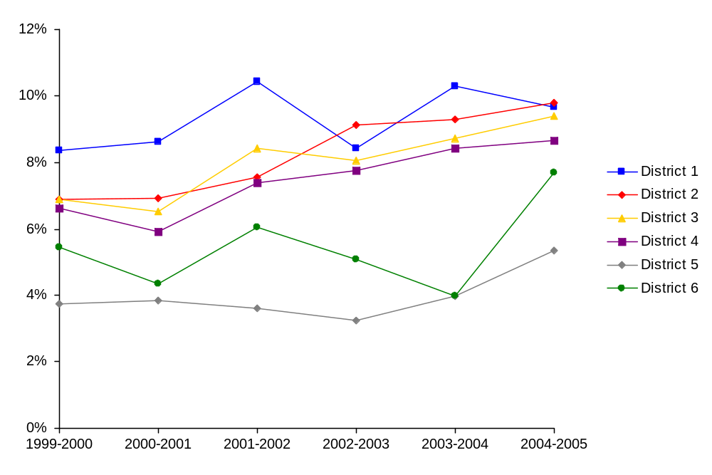
fiscal years 1999-2000 through 2004-2005

This graph shows that the overall publication rates for Districts 5 and 6 have been consistently below those in the other districts across this six-year period. It also shows that the publication rates in Districts 2, 3, and 4 have been rising fairly steadily during this period. As a result, while the publication rate for District 1 was considerably higher than the rate in other districts during the first three years examined, in the last three years the publication rates in Districts 1, 2, 3, and 4 have all been fairly close.

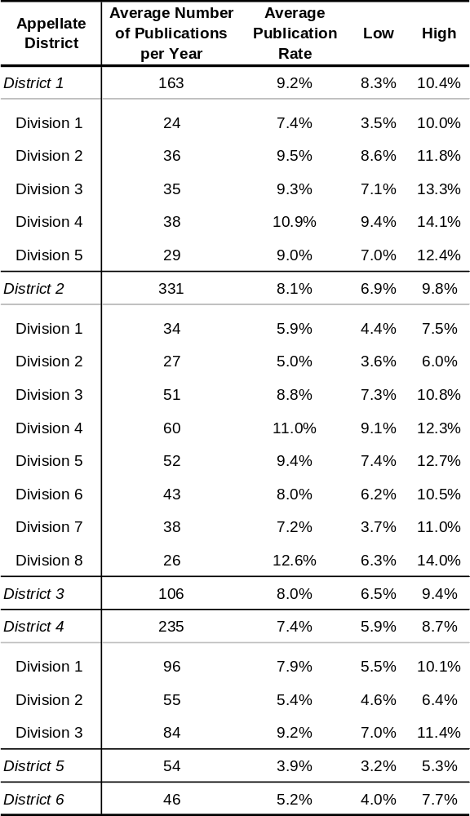
Table 5 shows the average, low, and high publication rates for each division in Districts 1, 2, and 4 over the last six years. This table shows that in District 1, the overall average publication rate for Division 1 during the last six years was noticeably lower than those for the other divisions in the district, while the overall average publication rate for Division 4 was higher than the rates in other divisions in the district. In District 2, the table shows that during the last six years the overall average publication rates for Divisions 1 and 2 were noticeably lower than those in the other divisions in the district, while the overall average publication rates for Divisions 4 and 8 were noticeably higher than the rates in other divisions in the district. In District 4, Table 5 shows that there was a range among the overall average publication rates of the three divisions, with Division 2 having the lowest average publication rate during this six-year period and Division 3 having the highest publication rate.
Table 5
Publication rate by appellate district and division—
six-year average, fiscal years 1999–2000 through
2004–2005

As with the publication rates in each district, the committee also examined whether these differences in publication rates among the divisions within these districts were the same across the entire six-year period. Graphs 2, 3, and 4 display the publication rates in the divisions within Districts 1, 2, and 4 from 1999–2000 through 2004–2005.

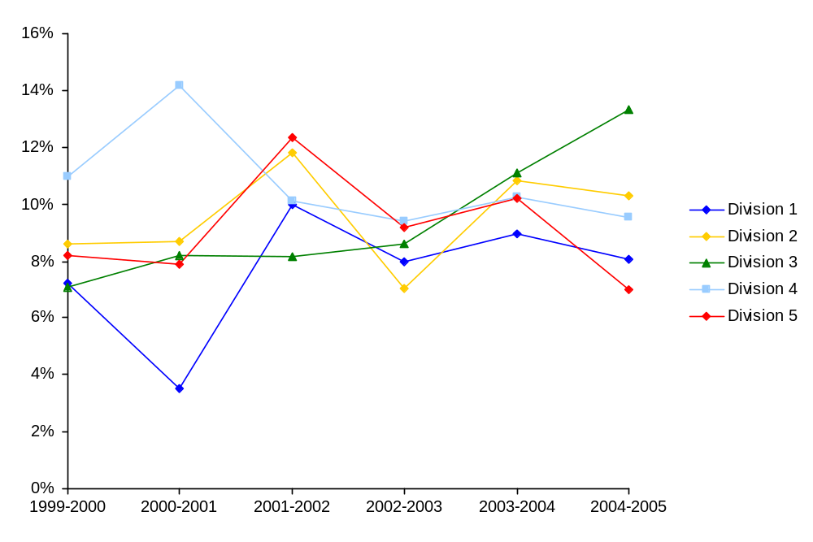
Graph 2
Publication rate for First Appellate District by division,
fiscal years 1999–2000 through 2004–2005

As would be expected given that the total number of matters at the division level is much smaller than at the district level, the publication rates for the individual divisions tended to fluctuate more from year to year than the rates for the districts as a whole. At the division level, natural fluctuations in the qualities of individual cases—such as whether a case raises a new question of law—have a much greater effect on the overall publication rate in each year.

In District 1, for example, graph 2 shows that, other than very large fluctuations in 2000–2001, the publication rates in Division 1 (which had the lowest average over the six-year period) and Division 4 (which had the highest average over the six-year period) have been fairly close to those in the other divisions. Within the six-year period, three different divisions in District 1 had the highest publication rate and four different divisions had the lowest publication rate in different years.

In District 2, graph 3 shows that, although for the first three years examined Division 4’s publication rate was considerably higher than in the other divisions, for the last three years the publication rates in Divisions 3, 4, 5, 6, and 7 have all been quite similar. Within the six-year period, Division 4 ranged from having the highest publication rate to having the third lowest rate, and Division 7 ranged from having the lowest publication rate to having the second highest.

Graph 3
Publication rate for Second Appellate District by division,
fiscal years 1999–2000 through 2004–2005
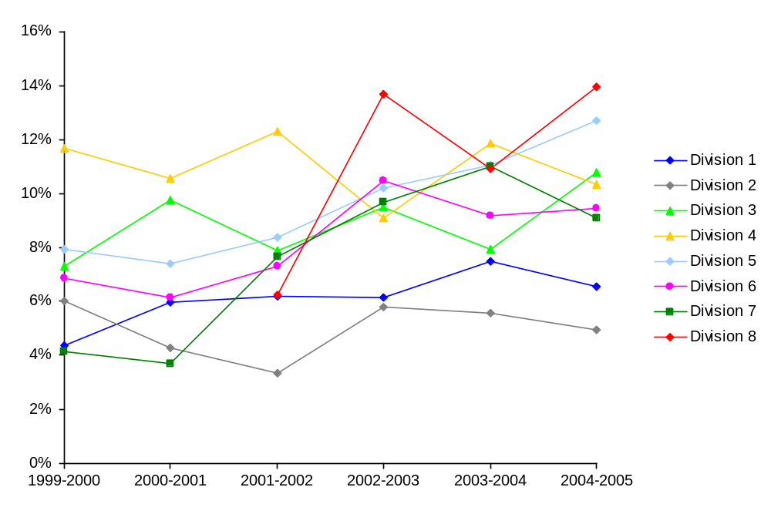

Similarly, within District 4, graph 4 shows that while Division 3’s publication rate was higher than the other divisions in the first three years, it has been similar to the rate in Division 1 for the last three years during this period.

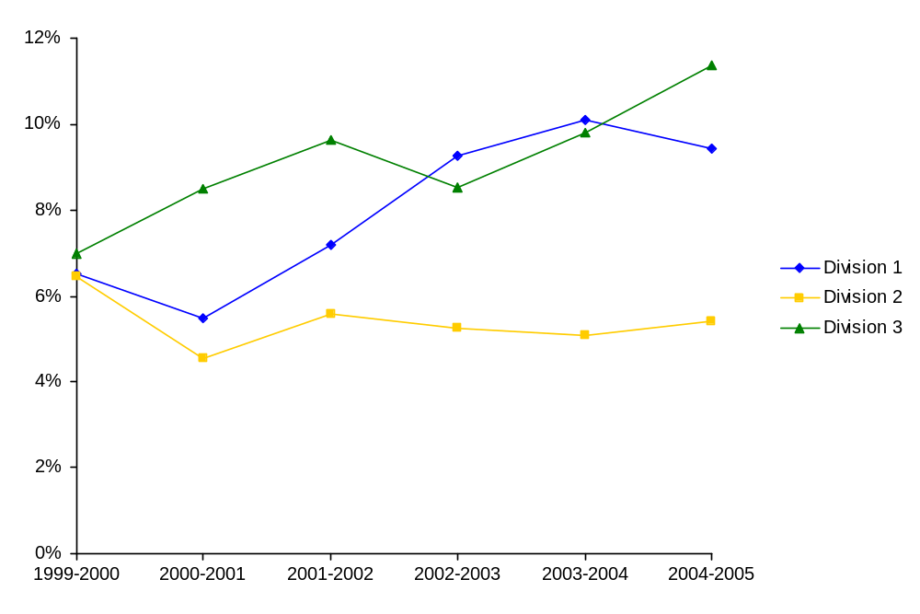
Graph 4
Publication rate for Fourth Appellate District by division,
fiscal years 1999–2000 through 2004–2005

These graphs do show a few consistent trends in terms of overall publication rates within the period examined, however. Within District 2, the publication rates in Divisions 1 and 2, while not always the lowest, have remained relatively low. Similarly, within District 4, the publication rate in Division 2 has remained consistently lower than in Divisions 1 and 3.

2. Factors affecting publication rates

The committee examined several factors that may explain, at least in part, the differences in publication rates across the appellate districts and divisions, including the mix of civil, criminal, and juvenile matters in each district’s and division’s caseload and the workload of the justices in the districts and divisions. Overall, the committee found that if these factors were taken into account, the publication rates are actually quite similar across most of the districts and divisions.

a. Case-type mix

Case-type mix appears to have an important impact on overall publication rates.
Table 6 shows the average percentage of civil, criminal, and juvenile opinions that have been published statewide over the last six years.
Table 6
Publication rate by case type—six-year average,
fiscal years 1999–2000 through 2004–2005

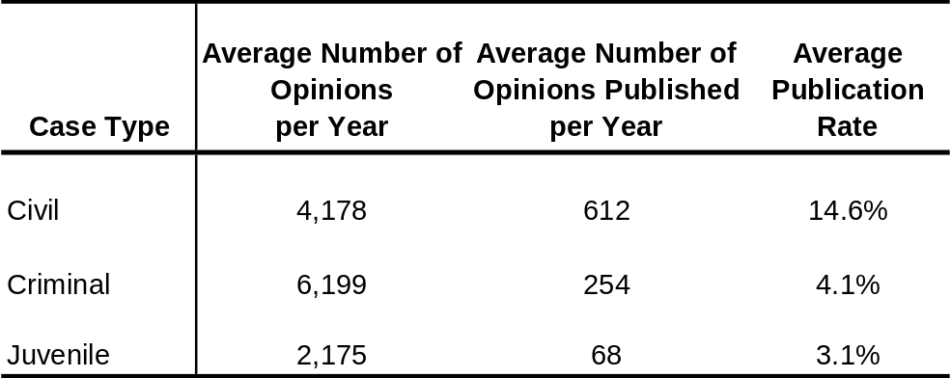

This table shows that three times as many opinions are published in civil cases as in criminal cases and four times as many opinions are published in civil cases as in juvenile cases.

Graph 5 shows the percentages of opinions in civil, criminal, and juvenile cases that were published each year from 1999-2000 through 2004–2005. This graph shows that the publication rate of opinions in civil cases has consistently remained well above the rate in criminal or juvenile cases. In addition, the graph shows that while the publication rates in criminal and juvenile cases have stayed fairly consistent over the six-year span, the percentage of civil cases published has increased.

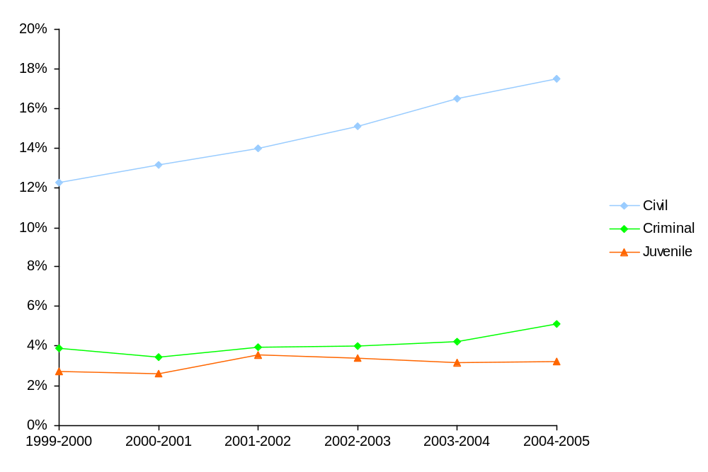
Graph 5
Publication rate by case type,
fiscal years 1999–2000 through 2004–2005

Because civil cases have a much higher publication rate than other case types, districts in which civil filings make up a high proportion of the total filings can be expected to have higher overall publication rates. Graph 6 (next page) shows the proportion of total filings in each district that are civil cases. This graph shows that a high proportion of cases in Districts 1, 2 and 4 are civil cases, while a much lower proportion of the cases in Districts 3, 5 (in particular), and 6 are civil cases. Thus, the lower overall publication rates in districts 5 and 6 appear to correlate, at least in part, with their proportion of civil filings. Further statistical analysis was done to control for these differences in the districts’ case-type mix. Once case type is accounted for by using these statistical methods, District 5’s overall publication rate, although tending to be low, was not consistently below that in the other districts.

Graph 6
Civil filings as a proportion of total filings
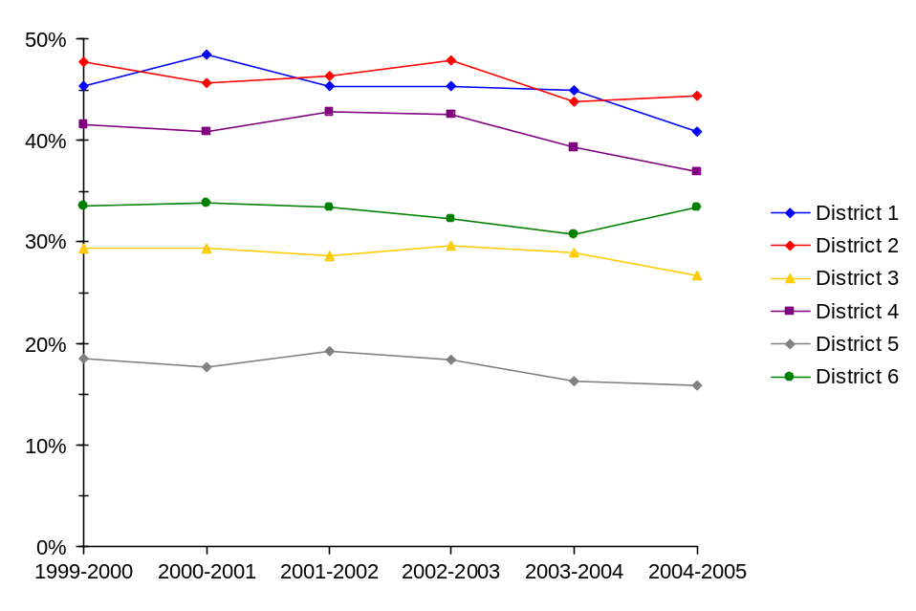

b. Workload

The committee members agreed that justices generally spend more time on opinions that are slated for publication. The committee hypothesized that because more time is needed to prepare these opinions, courts and individual justices facing the time constraints associated with a high workload will likely publish fewer opinions. The committee examined the relationship between several different workload measures and district publication rates to test this hypothesis. There was a significant relationship between each of the measures examined and the districts’ publication rates.

The committee first looked at the total number of filings per justice. The Court Statistics Report for 2006 shows that statewide, over the last six years, overall filings per justice have decreased. This is due in large part to the fact that 12 new justice positions were created in 2000–2001. As table 1 (page 16) shows, during this same period publication rates increased, particularly in 2001–2002, right after the new justice positions were created.

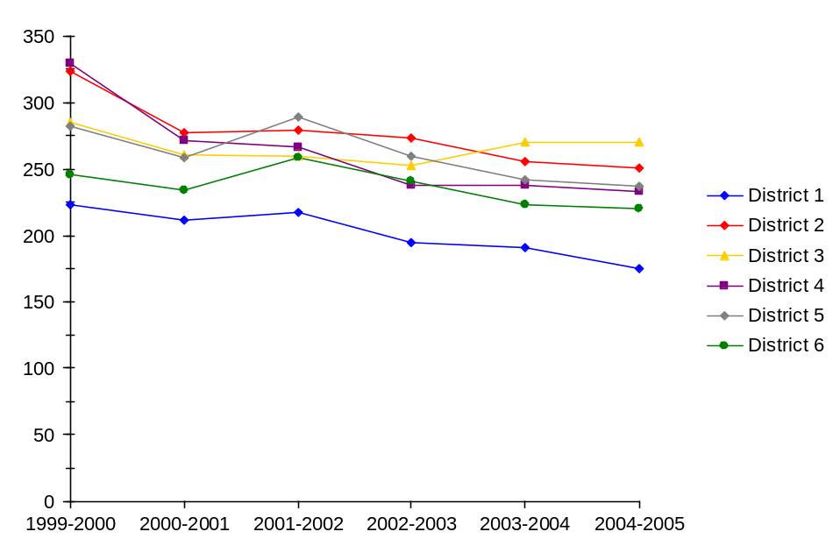
When the data is broken down by district, it also shows that districts with a lower number of total filings per justice tended to have higher publication rates, while districts with a higher number of total filings per justice tended to have lower publication rates. Graph 7 shows that District 1 consistently had the lowest number of total filings per justice over the past six fiscal years. As shown in graph 1 (page 20), District 1 also had the highest publication rate overall during this period. This suggests that the publication rate may be affected by a lower workload as measured by total filings per justice.
Graph 7
Total filings per appellate justice (FTE)

The second workload measure examined by the committee was the number of cases disposed of by written opinion per justice. The data strongly suggests a relationship between the publication rate and this measure of workload. As shown in graph 8 below, districts that disposed of a lower number of cases by written opinion per justice tended to have a higher publication rate, while districts that disposed of a higher number of cases by written opinion per justice tended to have lower publication rates. For example, District 5, which had the lowest average publication rate over the past six years, generally disposed of a higher number of cases by written opinions per justice during this period, while District 1, which had the highest average publication rate, disposed of a lower number of cases by written opinion per justice. Further statistical analysis was done by controlling for differences in the number of cases disposed of by written opinion per justice in each district. Once these workload differences are accounted for, District 1’s overall publication rate is not significantly higher than the rate in other districts, and the size of the difference between the publication rate in District 6 and in the other districts is reduced considerably. In other words, the seemingly higher publication rate in District 1 can be attributed to the lower workload in this district, and the seemingly lower publication rate in District 6 can largely be attributed to the higher workload in this district.
Graph 8
Relationship between publication rate and the number of
cases disposed of by written opinion

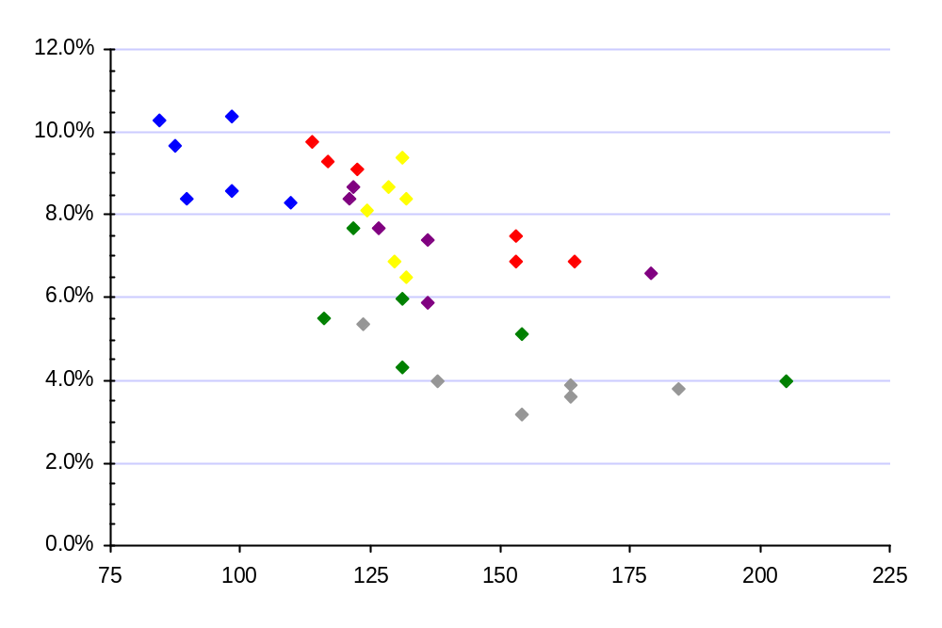
District 4
District 1
District 2
District 3
District 5
District 6
Number of cases disposed of by written opinion per justice
There is a point for
each district and
for each fiscal year
from 1999–2000
through 2004–2005

Publication rate

The third measure of workload examined by the committee was the number of pending cases per justice at the end of the fiscal year. The data shows a relationship between the publication rate and this workload measure similar to that found using the other two workload measures. Graph 9 below shows that districts with a lower number of pending cases per justice tended to have higher publication rates while districts with a higher number of pending cases tended to have lower publication rates.

All three of these analyses indicate that there is a relationship between a district’s publication rate and its workload. Districts with a higher workload (i.e., higher number of filings, higher number of cases disposed of by written opinion, and/or higher number of pending cases) tended to have a lower publication rate, while districts with a lower workload tended to have a higher publication rate. This suggests that workload is an important factor to be considered when analyzing differences in publication rates among districts.
Graph 9
Relationship between publication rate and the number of
cases pending at the end of the fiscal year
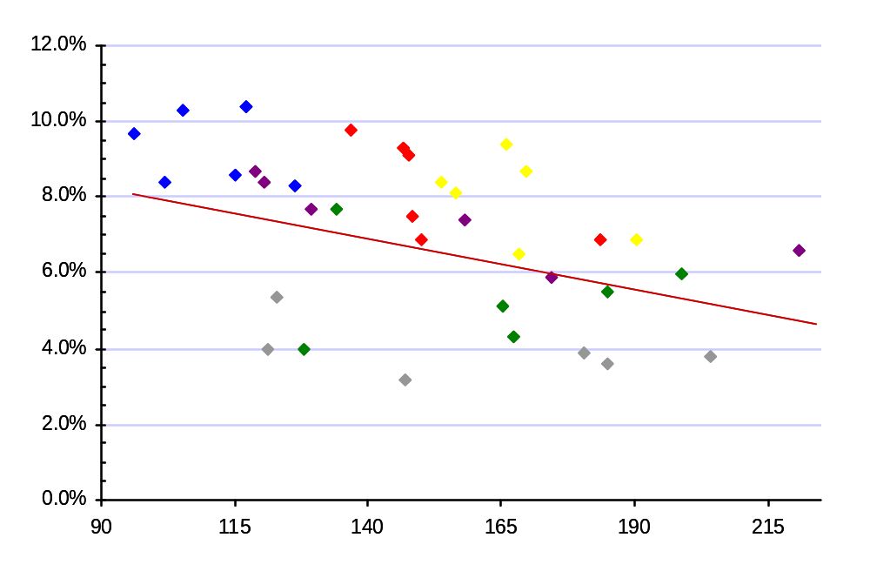

District 4
District 1
District 2
District 3
District 5
District 6

Publication rate

There is a point for
each district and
for each fiscal year
from 1999–2000
through 2004–2005

Pending cases per justice

Workload is also an important factor to consider in comparing publication rates of the divisions within District 4 and between Division 6 and the other divisions within District 2. For the divisions within District 1 and for most of the divisions within District 2, new filings are distributed among the divisions using a rotation system. Thus, the number of new filings per division is equalized over time. Within District 4, however, and for Division 6 (the Ventura branch) in District 2, filings are distributed primarily on a geographic basis, much like they are to the districts. When further statistical analysis was done by controlling for differences in the number of cases disposed of by written opinion per justice in each division within District 4, there were no longer any statistically significant differences in the publication rates of these divisions. In other words, differences in the workload of these divisions accounted for the differences in their publication rates.
Pending cases per justice

c. Other factors

The courts’ case-type mix, workload, and yearly fluctuations in publication rates do not explain all the variation in publication rates across districts and divisions. When statistical measures are used to control for all of these factors, the overall six-year average publication rate in District 3 appears to be about 1.3 percentage points higher than the overall six-year average for all of the appellate districts together. Similarly, while these factors accounted for some of the differences in the publication rates in Districts 5 and 6, the overall six-year average publication rate in District 5 appears to be about 1.9 percentage points lower than the average for all of the districts, and the publication rate in District 6 appears to be about .9 percentage points lower than the average for all of the districts. Similarly, after controlling for these factors, within District 1 the publication rate in Division 1 is lower than that in the other divisions in District 1 (but it should be noted that a large portion of this difference is attributable solely to the fluctuation in Division 1’s publication rate in 2000–2001). Within District 2, the publication rates in Division 1 and Division 2 are lower than in the other divisions in the district, while the publication rates in Divisions 4 and 5 are higher.
Graph 10
Publication rate by appellate district—Civil cases
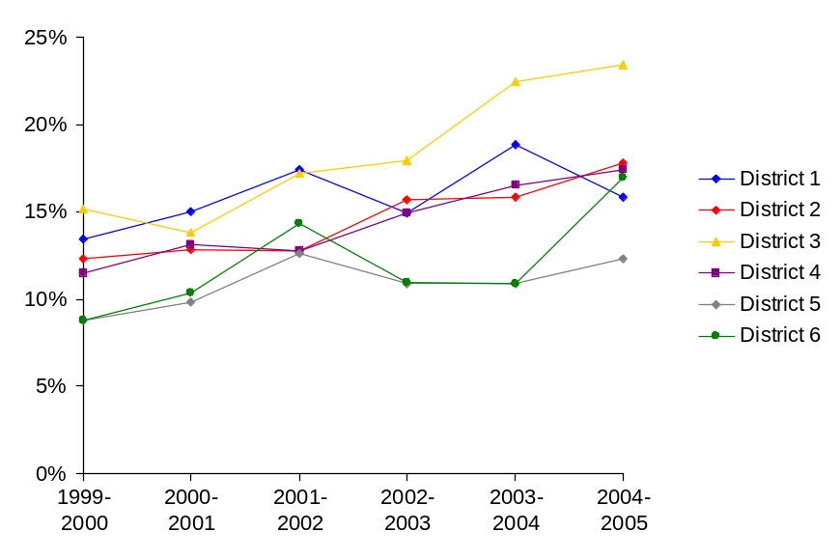
Other factors may account for some of this variation, however. As graph 10 shows, the publication rate for civil cases in District 3 has tended to be higher than in the other districts. A disproportionate number of civil cases involving state government, such as election cases, are litigated in District 3. The committee hypothesized that the opinions in this type of civil case may be published at a higher rate than the opinions in other types of civil cases and that this factor may account for District 3’s higher overall publication rate despite the fact that the district’s overall number of civil cases is not atypical.

In addition, the lower publication rate in District 5 may be explained, in part, by the lower volume of business litigation generated in the Fresno area. Larger, urban districts, such as District 1 in San Francisco and District 2 in Los Angeles, tend to decide cutting-edge issues before smaller districts do, simply by virtue of their larger pools of cases. Smaller, more rural districts, such as District 5, that review the same issues later may be less inclined to publish because another court already has spoken. As discussed further at pages 37–38, the level of deference to the author of the opinion may also affect publication rates. Districts 5 and 6 were the only two districts in which all of the justices indicated that deference to the author is a major factor in the publication decision.

Because data on these factors was not available to the committee and would be difficult, if not impossible, to compile, the committee could not statistically confirm these hypotheses, but considered them logical bases for the differences found in the districts’ publication rates.

VI. Surveys of Court of Appeal Justices and Appellate Attorneys

A. Survey Drafting, Distribution, and Response Rates

1. Justices of the Court of Appeal

As noted above, in 1971 a survey was conducted of all appellate court justices regarding the publication rules. The committee concluded that conducting a similar survey could provide valuable information for completing its charge. Using the 1971 survey as a starting point, the committee developed survey questions designed to explore whether any disparity exists among districts and their divisions in the application of the publication rules and whether there were implied or unspoken addenda to the publication rules. The survey included questions regarding the importance of the publication criteria found in rule 8.1105, the frequency with which the justices had applied each criterion to justify publication, and other factors that may influence decisions on whether to publish an opinion. The committee also sought feedback on various potential reforms in the publication rules.

The survey was distributed to all 101 justices of the Courts of Appeal, both electronically and in hard copy. Each justice also received a list of his or her 10 most recently published opinions. The survey was administered using a double-blind process, which allowed the committee to track which justices submitted their survey responses while allowing the justices to maintain anonymity. The committee concluded that such an approach would elicit the most candid responses. The justices were given the option to identify themselves at the end of the survey, however.
Graph 11
Response rate by appellate district
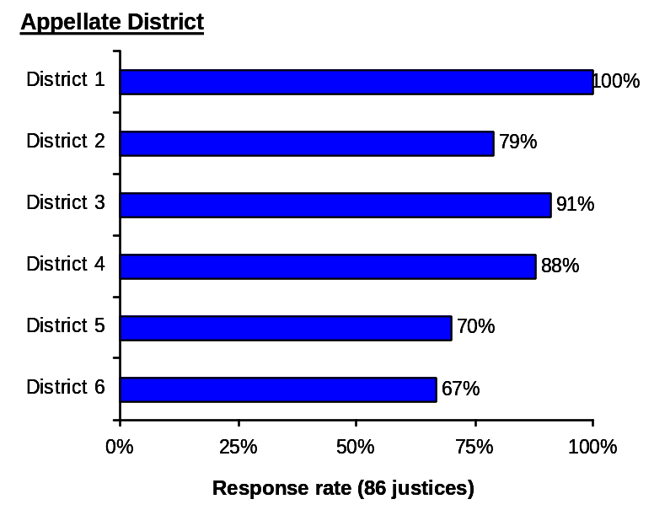
The survey had an excellent 86
percent response rate overall. The response rate was fairly consistent across the six appellate districts, although District 1 had the highest response rate, with all 20 justices responding to the survey. Because Districts 5 and 6 have fewer justices than the other districts, the lower response percentages in these districts can be attributed to a relatively small number of nonrespondents.

2. Appellate attorneys

The committee also conducted a survey of attorneys, focusing especially on those with significant appellate practices. While some of the questions were similar to those on the justices’ survey, others differed because they focused on publication from an attorney’s perspective. In order to achieve substantial participation, the leaders of several appellate attorney organizations were informed about the survey by letter, and the survey was posted on the home page of the California Courts Web site, allowing all attorneys who were interested to respond. The survey was available in hard copy and online. More than 600 persons viewed the online survey and almost 300 completed the entire survey. The attorney survey was not conducted as a random sampling and thus the pool of survey respondents was self-selected, unlike the appellate justice survey, which was submitted to all justices.

B. Survey Results

1. Importance of the rule 8.1105(c) criteria

The justices were asked how important they felt each criterion in rule 8.1105(c) is in persuading them that an opinion should be published. Appellate attorneys were similarly asked how important they believed each criteria in rule 8.1105(c) is in the determinations made by the Courts of Appeal to certify decisions for publication.

Graph 12 (next page) shows the percentages of justices and attorneys, respectively, responding to the survey who indicated that each criterion was either important or extremely important. Both the justices and the attorneys indicated that the most important criterion is that the opinion “establishes a new rule of law.” Both the justices and the attorneys also ranked “resolves or creates an apparent conflict in the law” and “modifies, or criticizes with reasons given, an existing rule” as important criteria. The criterion “makes a significant contribution to legal literature” was ranked the least important by both the justices and the attorneys.

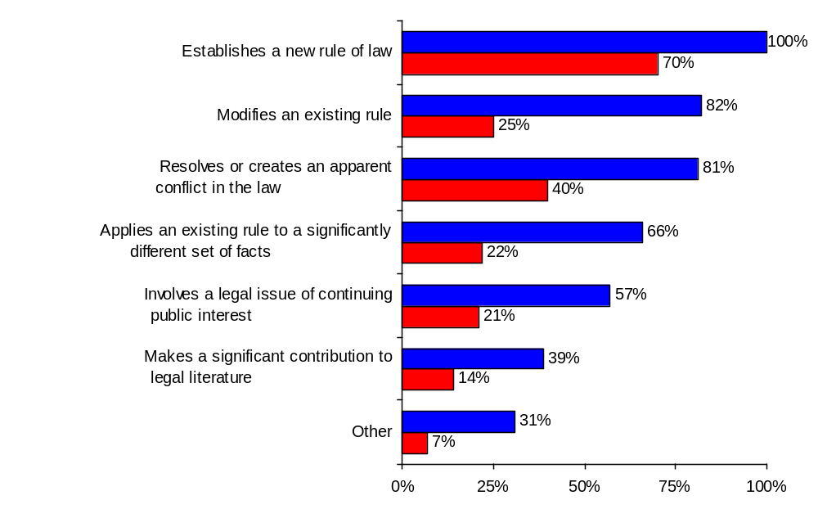
Graph 12
Percent of justices and attorneys responding “4–Important” or
“5–Extremely important” to the rule 8.1105 publication criteria
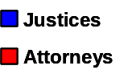

The justices also were asked which criteria formed the basis for their decision to certify for publication each of their 10 most recent published opinions. Graph 13 (next page) shows the justices’ responses to this question. The criterion most frequently cited by the justices was “applies an existing rule to a significantly different set of facts.” The differences between the results shown in graphs 12 and 13 can be explained by contrasting the subjective importance of the criteria with the frequency of their practical application. For example, many justices felt that it is very important to publish opinions that state a new rule of law; however, only a few of the opinions prepared by a justice may actually state such a new rule of law. In contrast, many more opinions prepared by a justice may involve applying an existing rule to a significantly different set of facts.

Graph 13
Percent of justices who indicated the following criteria formed the
basis to certify their 10 most recent published opinions

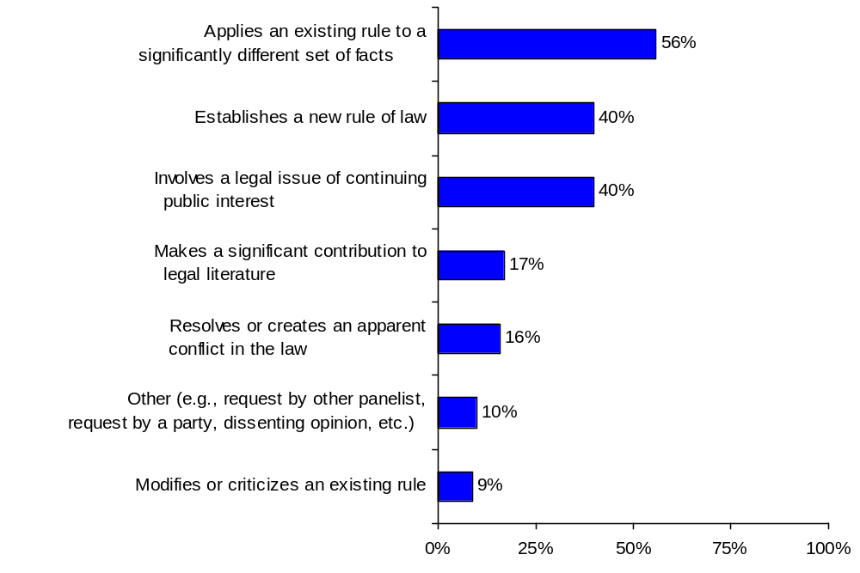

In their answers to these questions, both the justices and the attorneys cited several other criteria as at least somewhat important to the determination of whether an opinion should be published. Graph 14 (next page) shows the other criteria cited most often by the justices as being important in persuading them, over the course of their careers, that an opinion should be published. Top among these was a request by a panelist, closely followed by a request by a party, a request by the author of the majority opinion, and a request by an author of a dissent. With respect to their 10 most recent published opinions, another criterion that many justices indicated played a part in their publication determination was that the opinion interprets a statute.

Graph 14
Numbers of justices who selected “Other” criteria as important to the
decision to certify an opinion for publication and who cited particular criteria

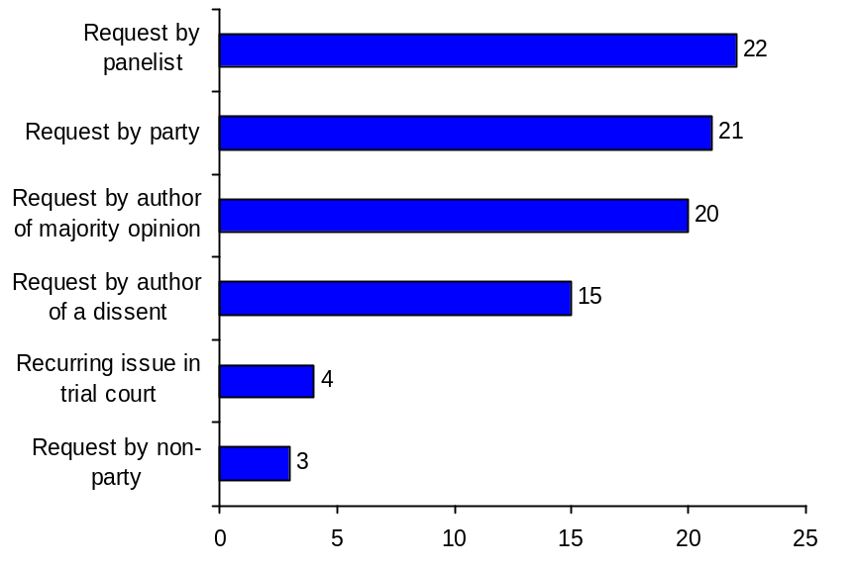

Graph 15
Percent of attorneys who selected “Other” criteria as important to the decision to certify an opinion for publication and who cited particular criteria
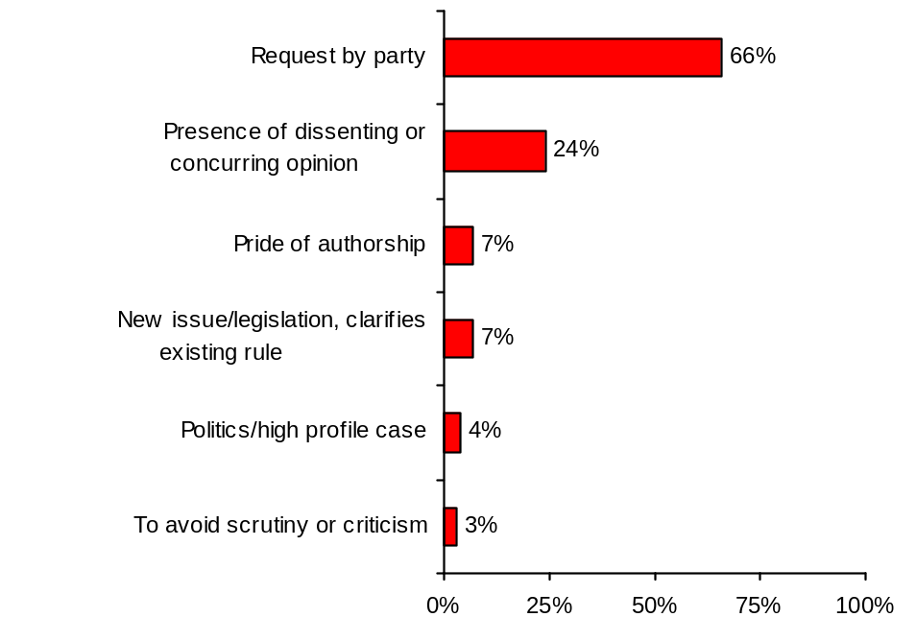
Graph 15 shows the other criteria cited most often by the attorneys as being important to the decision to certify an opinion for publication. For attorneys, the “other” criterion most frequently cited was a request by a party. The attorneys also suggested that the presence of a dissenting or concurring opinion is a criterion used in determining whether to publish an opinion.

2. Publication process

The appellate justices were asked about the procedures followed in their districts in determining whether to publish an opinion, including when this decision is made.

The survey results indicate that the decision to certify an opinion for publication is typically made in one of three ways: (1) a collective decision is made by the entire panel; (2) the author makes a recommendation regarding publication to the panel, but the panel votes whether to publish; or (3) the author primarily determines whether or not to publish.

Districts differ regarding the timing of their decisions on certification. In most cases, a tentative decision is made before oral argument. Some justices, however, prefer to decide after oral argument, and other justices are flexible as to when they make this determination.
Graph 16
“Is deference to an author of an opinion a major factor in the decision whether to certify an opinion for publication?”
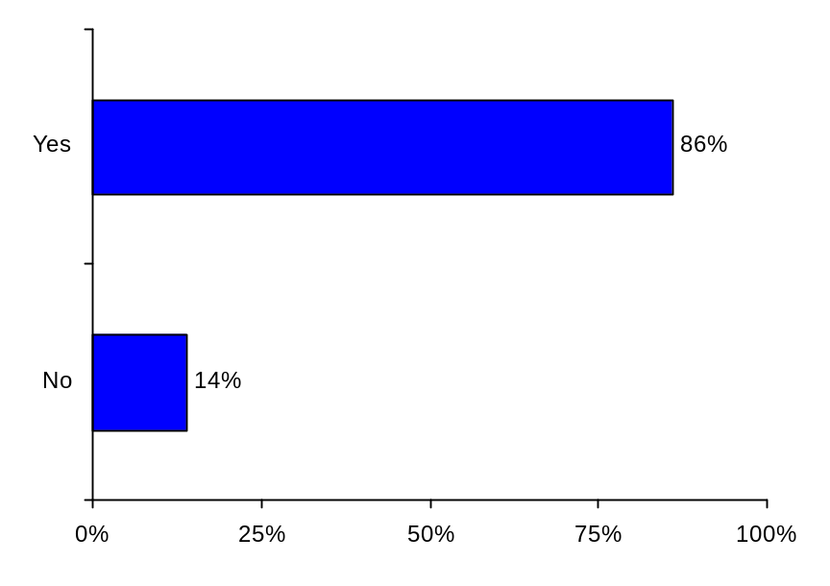
Deference to the author and, to a lesser degree, deference to other panel members were cited by most justices as major factors in the decision to certify an opinion for publication. Graph 16 shows that 86 percent of all the justices responding to the survey indicated that deference to the author is a factor in deciding whether to certify an opinion for publication.

A further analysis of the practices in different districts suggests that there may be a relationship between publication rates and deference to the author. Graph 17 (next page) shows justices’ responses to this question broken down by district. Districts 5 and 6 were the only two districts in which every justice indicated that deference to the author is a major factor in the publication decision. Although the impact of deference is impossible to quantify, these two districts also had the lowest publication rates during the entire period from fiscal years 1999–2000 through 2004–2005 (see graph 1 on page 20) and, as discussed above on page 30, their publication rates remained lower than the other districts even after controlling for case-type mix and workload. In contrast, in District 3, only 50 percent of the justices indicated that deference to the author is an important factor in their decisions to certify an opinion for publication. As discussed on page 30, after controlling for case-type mix and workload, the six-year average publication rate in District 3 was higher than the overall average for all the districts combined.

Graph 17
Percent of justices in each district indicating that deference to an author of an opinion is a major factor in the decision whether to certify an opinion for publication

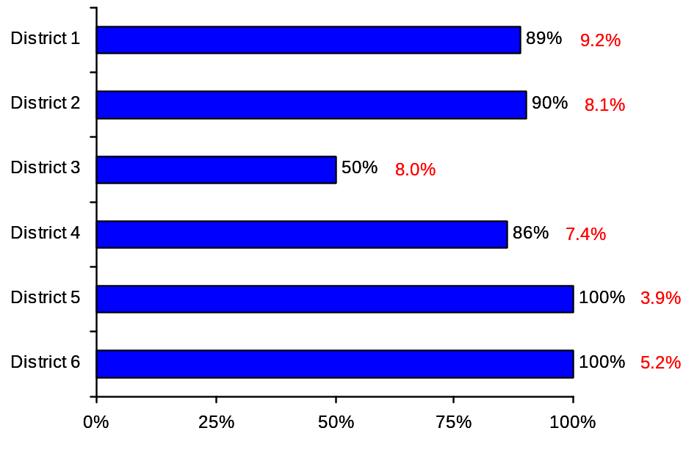
Average publication rate,
fiscal years 1999–2000 through 2004–2005

Several justices observed that deference to the author is a logical approach to making a publication determination because the author has the most familiarity with the circumstances of the case as well as with the state of the law on the relevant issues. In addition, the author is the one responsible for preparing an opinion for publication.

3. The influence of other factors on publication

Both the justices and the attorneys were asked whether they believe anything other than the rules—such as local traditions, standards, or practices—influences the court’s determination whether or not to certify an opinion for publication. Graph 18 (next page) shows their responses to this question. Although the great majority of justices stated that nothing other than the publication rules influences their determinations, 20 percent indicated that other factors may influence their decisions. This finding was consistent statewide; there were no statistically significant differences in the responses received from the districts. Other factors cited by the justices included that the case involves a recurring issue, concern about criticizing an attorney or trial judge, and the pressure of workload.

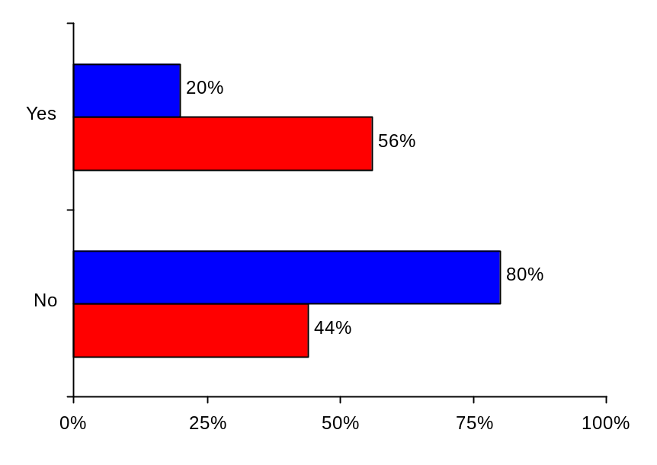
In contrast, a majority of attorneys—56 percent—believed that factors other than the publication rules have an influence on the justices’ publication decisions. Factors that the attorneys suggested influence the courts’ determination of whether to publish included encouraging or avoiding scrutiny or review and a panel’s or district’s preference regarding publication frequency. The attorneys were also asked whether they believe the publication rules are uniformly followed. Here too, the majority of attorneys—67 percent—believed that the publication rules are not uniformly followed.
Graph 18
“Does anything other than the rules—such as local traditions, standards, or practices—also influence the determination whether or not to certify an opinion for publication?”

4. Unpublished opinions
Graph 19
Percent of justices and attorneys who indicated they have been involved in a case with an unpublished opinion that they thought satisfied the rule 8.1105 criteria

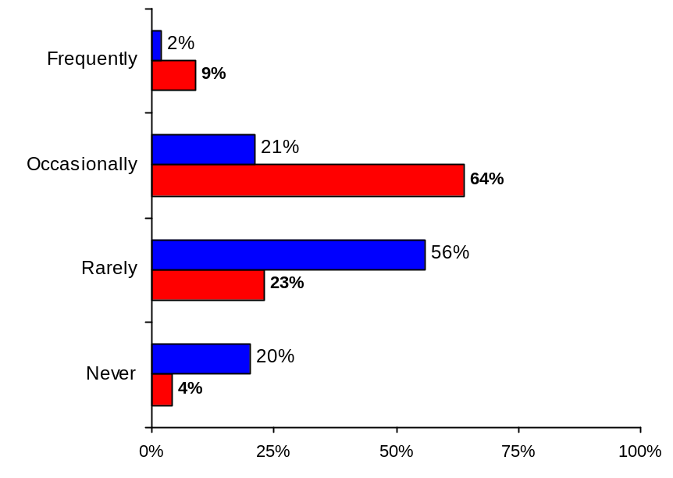
As noted above, rule 8.1105 does not mandate that an opinion be published if it meets the criteria set forth in the rule; thus, some cases that meet the criteria for publication may not be published. In order to explore this aspect of the rule, both the justices and the attorneys were surveyed as to how frequently they have been involved in a case that resulted in an unpublished opinion that they thought should have, or could have, been published because it satisfied the publication criteria. Graph 19 shows both the justices’ and attorneys responses to this question. About one-quarter of the justices indicated that they have either occasionally or frequently been involved in a case that resulted in such an unpublished opinion. In contrast, 73 percent of attorneys indicated that they have been involved in such a case either occasionally or frequently.

The justices also were asked about the importance of certain factors in their decision not to publish a case that appears to meet the rule 8.1105(c) criteria. Graph 20 shows the percentage of the justices who indicated that these factors have some importance to this determination.
Graph 20
Percent of justices responding that the factor has some importance
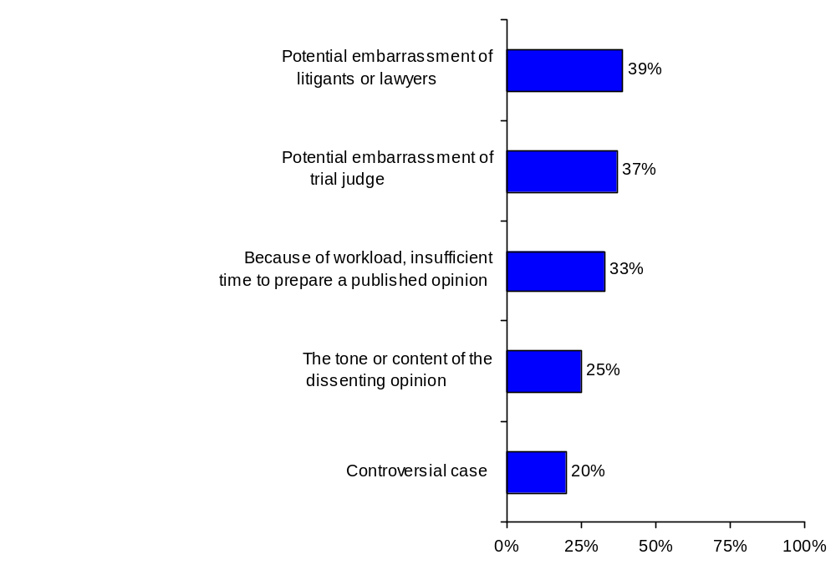

As this graph illustrates, the majority of justices indicated that none of these factors was important to the determination not to publish an opinion, but to a minority these factors have some importance. Similar to the justices’ responses concerning ”other” factors that may influence the determination of whether to certify an opinion for publication, the factors most frequently listed by the justices as having some importance in deciding not to publish were potential embarrassment of litigants, lawyers, or trial judges and workload issues that did not allow enough time to prepare a published opinion. Other factors identified by the justices as influencing a decision not to publish an opinion included a request by a panelist or by a party not to publish the opinion.

With online availability of unpublished opinions, the committee was interested in the extent to which justices and attorneys incorporate these unpublished opinions into their work. To explore this issue, the justices were asked if they ever rely on unpublished opinions when drafting their opinions, and attorneys were asked if they ever use unpublished opinions to assist them in their work. Graph 21 shows the justices’ and attorneys’ responses to these questions.

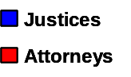
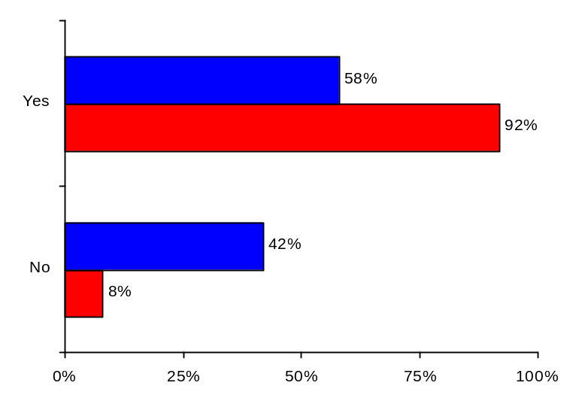
As this graph shows, the majority of both the justices and the attorneys use unpublished opinions in their work. Fifty-eight percent of the justices stated that they have relied on unpublished opinions when drafting opinions. Most of these justices indicated that they do so in order to consider the rationale or analysis used in a similar decision or to ensure consistency with their own prior rulings as well as those within their district or division. Some justices also use unpublished opinions as a source of boilerplate language. A much larger percentage of the attorneys—over 90 percent—indicated that they use unpublished opinions in the course of their practice. Of the 261 survey attorneys who provided some explanation of how they used unpublished opinions, about half indicated that they use them as a research tool, and 42 percent indicated that they use them to understand how a court has previously treated an issue. About one-third of the respondents also indicated that they use unpublished opinions as a source of arguments in their work.
Graph 21
Percent of justices and attorneys who indicated that they use unpublished opinions in their work

Attorneys were also asked how often they find useful material in unpublished opinions that is not otherwise available from a citable source. Forty-eight percent stated that they occasionally do so, and 26 percent said they frequently do so.

5. Limited citation to unpublished opinions

Both justices and attorneys were asked whether parties should be permitted to draw the Supreme Court’s attention to unpublished opinions within the relevant appellate district that arguably conflict with the decision made by the Court of Appeal in their case. Graph 22 (next page) shows the justices’ and attorneys’ responses to this question.

Twenty-eight percent of the justices and 67 percent of the attorneys stated that they think parties should be permitted to draw the Supreme Court’s attention to these unpublished opinions. The main reason cited by justices for allowing parties to draw the Supreme Court’s attention to these unpublished opinions is to let the court know that there are unresolved conflicts. Similarly, attorneys noted that allowing parties to do this would help avoid or resolve hidden conflicts. The justices who answered that parties should not be allowed to draw the court’s attention to these unpublished decisions generally did so because they believe that allowing such limited citation would remove any distinction between published and unpublished opinions and that the practice could be abused. In contrast, the attorneys who answered “no” to this question indicated that they believe published opinions are sufficient.
Graph 22
Percent of justices and attorneys who indicated that parties should be permitted to draw the Supreme Court’s attention to unpublished opinions within the appellate district that arguably conflict with the decision in their case
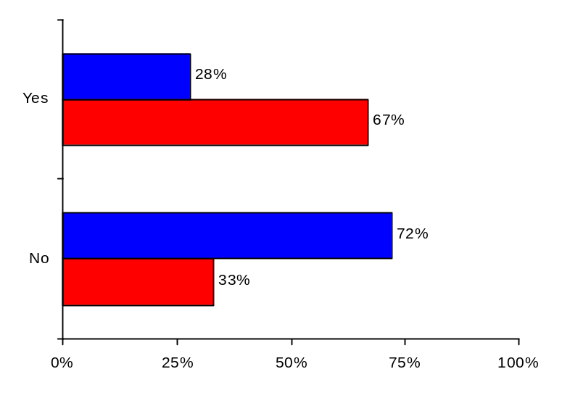
The attorneys were also asked whether parties should be permitted to refer to an unpublished opinion from any appellate district in either a petition for review or an answer. Fifty-nine percent of the attorneys believed that parties should be able to refer to an unpublished opinion from any district. As with the previous question, the main reason given by the attorneys for allowing parties to do this was that it would help avoid or resolve hidden conflicts.

6. Partial publication

The justices were asked whether they had ever certified only a part of an opinion for publication under rule 8.1110. Ninety-six percent of the justices stated that they have certified an opinion for partial publication. Both the justices and attorneys were asked whether rule 8.1110 concerning partial publication should be revised or repealed. The vast majority of both the justices (94%) and attorneys (83%) responded that this rule should not be revised or repealed.

Both the justices and attorneys were also asked for their views on whether the Supreme Court should be able to order partial publication or partial depublication of an opinion of a Court of Appeal. Graphs 23 and 24 show justices’ and attorneys’ responses to these two questions.

Graph 23
Percent of justices and attorneys who indicated that the Supreme Court should be able to order partial publication
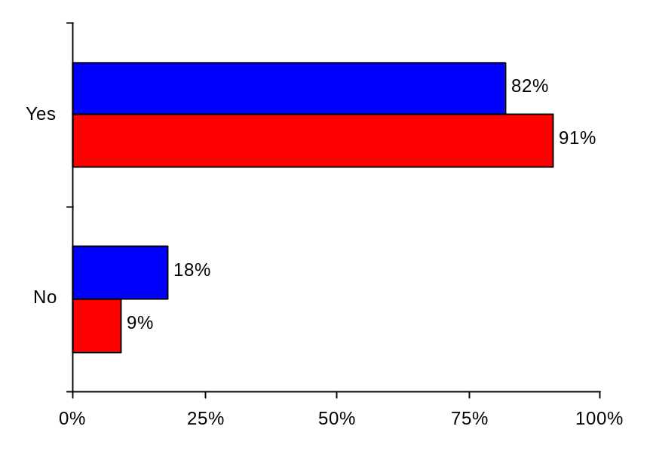
Both the justices and attorneys strongly agree (82% and 91%, respectively) that the Supreme Court should be able to order a partial publication of a Court of Appeal opinion.

A solid majority of justices and attorneys (78% and 81%, respectively) also agree that the Supreme Court should be able to order a partial depublication.

Many of the respondents indicated that they see no distinction in the authority of the Supreme Court to order either a full or partial publication or depublication. But others noted that partial publication or depublication by Supreme Court order could cause the context of the opinion to be lost, creating a potential for inconsistent application in the lower courts.
Graph 24
Percent of justices and attorneys who indicated that the Supreme Court should be able to order partial depublication
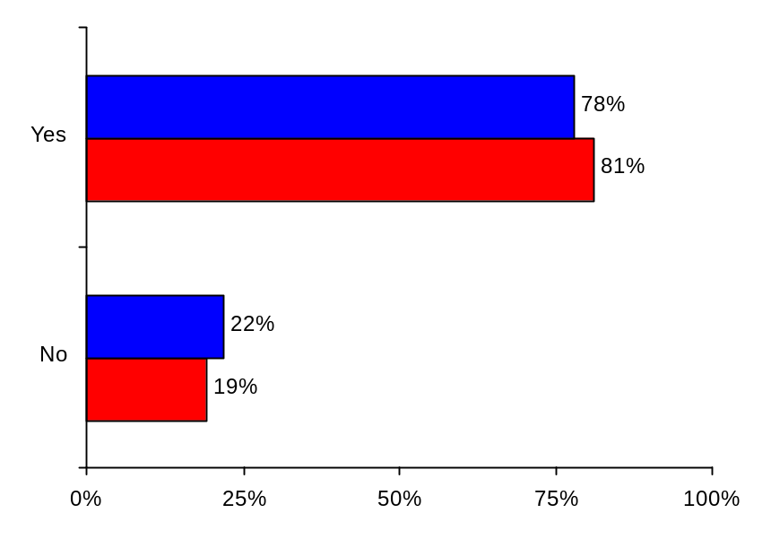
Several justices, regardless of their responses, indicated in their comments that they would like this decision about partial publication or depublication to be a collaborative one involving input from the author. The following comment sums up these concerns: “Partial publication [or depublication] would present serious problems, unless the opinion was sent back to the Court of Appeal first for editing in light of the Supreme Court’s order to [publish or] depublish part. If any part is deleted that was significant to the Court of Appeal’s reasoning, it might alter the meaning or intention of the original authors.”

7. Potential changes to rule 8.1105

Both the justices and attorneys were asked for their views on several potential changes to rule 8.1105.
Graph 25
Percent of justices and attorneys who indicated that changes should be made to existing publication criteria in rule 8.1105
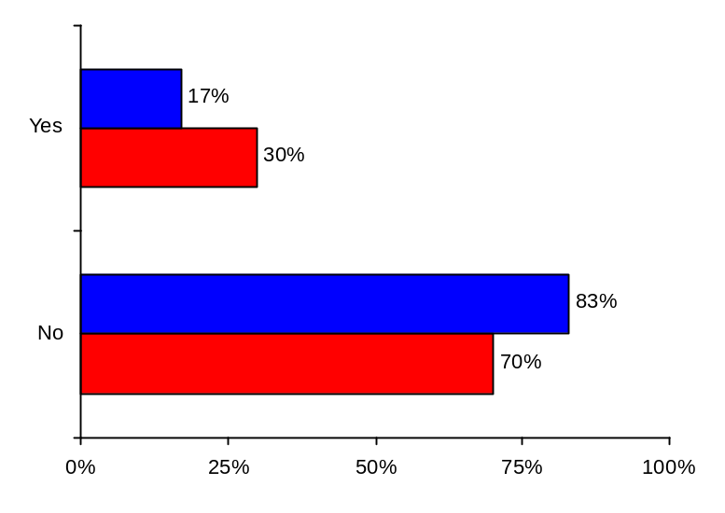
First, they were asked whether any changes should be made to the existing criteria for publication in the rule. Graph 25 shows their responses to this question. Although a large majority of both the justices and attorneys (83% and 70%, respectively) believed that no changes to the existing criteria in rule 8.1105 are needed, a sizable minority, particularly of the attorneys, believed that changes should be considered. In their comments, the justices who believed that no changes should be made indicated that they believe the current rule is clear and works well. Some of the justices who believe changes should be considered suggested that the criteria for publication could be clarified or expanded upon in some manner, such as breaking the criteria in subsection (c)(1) of the rule into separate subsections; more clearly covering opinions that construe statutes, ordinances, or rules; or providing that opinions with dissents should be published. The attorneys who favored changing the existing criteria for publication also suggested clarifying the criteria, as well as adding more criteria and either publishing all opinions or making all or some unpublished opinions citable.

Both the justices and attorneys were asked if any additional criteria for publication should be added to the rule. Again, while a large majority of both the justices and attorneys (76% and 68%, respectively) believed that no additional criteria should be added, a sizable minority believed that the rule should be amended to include new criteria. All respondents were provided with a list containing over 20 publication criteria that are used in other jurisdictions. Table 7 shows the five criteria from that list that were most frequently selected by the justices and attorneys, in order of the number of responses received.

Table 7
Additional Publication Criteria Most Frequently Selected by Justice and Attorneys

Justices | Attorneys
1. The disposition of a matter is accompanied by separate concurring or dissenting expression, and the author of such separate expression desires that it be published. | 1. The opinion reaffirms a principle of law not applied in a recently reported decision.
2. The opinion directs attention to the shortcomings of existing common law or inadequacies in statutes. | 2. The disposition of a matter is accompanied by separate concurring or dissenting expression, and the author of such separate expression desires that it be published.
3. The opinion treats a previously overlooked rule of law. | 3. The opinion treats an issue of first impression.
4. The opinion reaffirms a principle of law not applied in a recently reported decision. | 4. The opinion directs attention to the shortcomings of existing common law or inadequacies in statutes.
5. The opinion treats an issue of first impression | 5. The opinion treats a new constitutional or statutory issue.

Four out of the five publication criteria that the justices and attorneys indicated should be added to rule 8.1105 were the same, albeit in a slightly different order.
Graph 26
Percent of justices and attorneys who indicated that the presumption against publication in rule 8.1105 should be changed to a requirement for publication unless an opinion does not meet the publication criteria
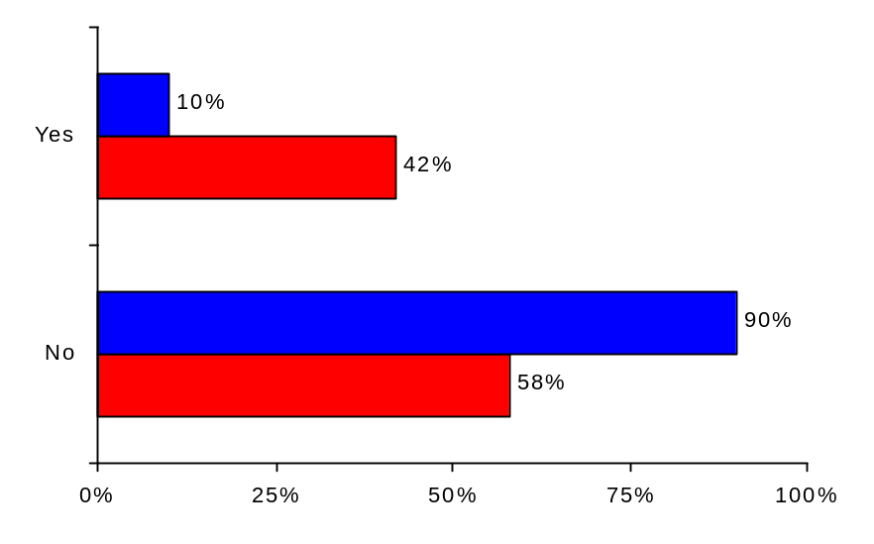
Finally, both the justices and attorneys were asked whether rule 8.1105’s presumption against publication should be changed to an affirmative presumption that requires publication unless the opinion does not meet any of the publication criteria. Graph 26 shows their responses to this question.

A majority of both the justices and the attorneys responded that the presumption should not be changed; however, the percentage of justices who favored keeping the current presumption was much higher (90%) than the percentage of attorneys (58%) who favored keeping this presumption. Among the justices who favored keeping the current presumption, several feared that changing the rule to require publication of all cases meeting the publication criteria would greatly increase the number of published cases by compelling publication of marginally helpful cases.

Others noted that panels would be forced to justify their decisions not to publish a case, which would be unduly time consuming. Among the justices who favored changing the presumption, comments included that changing the presumption might have a beneficial impact on how the integrity of the publication process is viewed. Attorneys who favored keeping the current presumption indicated that the current volume and quality of published opinions are more than adequate and also expressed concern that changing the presumption could lead to the publication of opinions with less value. Those who favored changing the presumption indicated that this change should be made in order to promote publication of all appropriate opinions.

VII. Committee Discussion and Preliminary Recommendations

The committee reviewed and considered all of the information presented to it, including information on publication practices in California and in other states, the publication data from California, and the survey results, in arriving at its preliminary recommendations.

The information gathered and analyzed by the committee suggests that, by and large, the current publication rules and practices have been successful in creating and managing an accessible body of precedential appellate opinions that provide useful guidance for litigants and the public. The committee’s survey results indicate that, in general, both appellate justices and attorneys are fairly satisfied with the current publication rules and procedures, although attorneys are somewhat less satisfied than justices. A large majority of both the justices and attorneys (83% and 70%, respectively) believed that no changes to the existing criteria in rule 8.1105 are needed, and a similarly large majority (76% and 68%, respectively) believed that no additional publication criteria should be added to the rule. A majority of both the justices and the attorneys (90% and 58%, respectively) also believed that the presumption against publication in rule 8.1105 should not be changed. In their comments, justices indicated that they believe the current rule is clear and works well. Attorneys who favored keeping the current presumption against publication similarly indicated that the current volume and quality of published opinions are more than adequate. Both the justices and attorneys also expressed concern that a rule requiring publication of all opinions that meet the rule 8.1105 criteria could lead to the publication of opinions with less value.

The committee found that, when raw publication rates are compared, certain appellate districts and divisions had significantly higher publication rates than others. When these publication rates were analyzed over time and differences in case-type mix and workload controlled for, however, the publication rates were relatively consistent across most districts and divisions. Among the districts, there were small percentage point differences between the publication rates in Districts 3, 5, and 6 and the overall six-year average publication rate that were not completely explained by these factors. There were also some differences from the overall average among some of the divisions within Districts 1 and 2 that were not completely explained by these factors. The committee hypothesized that some additional factors, such as the types of civil cases in Districts 3 and 5 and deference to the opinion’s author in District 5, may also affect publication rates in these districts, but these could not be tested with the data available to the committee. Moreover, the committee observed that the number of cases involved at the division level was relatively small, so that small changes in the number of published cases could produce significant percentage differences in the publication rate.

The responses to the committee’s survey also highlighted important concerns about the publication criteria and their application which the committee concluded should be addressed, however. A sizable minority of both the justices and attorneys (17% and 30%, respectively) suggested that changes to the existing criteria in rule 8.1105 should be considered, and an even larger minority (24% and 32%, respectively) suggested adding new publication criteria to the rule. A substantial minority of attorneys (42%) also believed that rule 8.1105’s presumption against publication should be changed. Furthermore, a majority of attorneys (56%) believed that factors other than the publication rules have an influence on the justices’ publication decisions, and an even larger majority of attorneys (67%) believed that the publication rules are not uniformly followed. A sizable minority of the justices themselves (20%) also indicated that factors other than the rules may affect their publication decisions. Finally, a large majority of attorneys (73%) and a sizable minority of justices (23%) indicated that they had occasionally or frequently been involved in a case that resulted in an unpublished opinion that they thought should have, or could have, been published because it satisfied the publication criteria.

The results of the survey also highlighted several other issues concerning publication practices which were not within the scope of the committee’s current charge, but which the committee believed merit further consideration. For example, survey respondents overwhelmingly supported allowing attorneys in petitions for review to call the Supreme Court’s attention to unpublished opinions for limited purposes.

Based upon its discussion of this information at its January and May 2005 meetings, in November 2005 the committee issued a preliminary report and recommendations which proposed amendments to rule 8.1105 and other actions. The committee’s preliminary recommendations, which are discussed below, were designed to clarify the criteria for publication for both justices and attorneys, better ensure the publication of all those opinions that may assist in the reasoned and orderly development of the law, and improve public confidence in the publication process.

A. Proposed Rule Revisions Recommended in Preliminary Report

The committee concluded in its preliminary report that amending rule 8.1105(c) to clarify and expand the publication criteria would be beneficial, particularly in light of attorneys’ perception that the rules are not uniformly followed. Based upon the responses to the survey, as well as upon the collective experience of its members, the committee concluded that various changes would assist the courts in consistently applying the publication criteria and would encourage the publication of all cases that can provide helpful guidance to the lower courts and practitioners. The committee also believed these changes in the rule could increase public confidence in the publication process while avoiding overwhelming the legal community with thousands of cases that are of limited value as precedent.

The committee’s preliminary recommendations focused on refining the rule’s existing criteria and adding criteria, with particular consideration given to the criteria from other jurisdictions suggested by the justices and attorneys responding to the survey. The committee also concluded that it could be beneficial to emphasize that publication decisions should be based solely on the publication criteria in the rule.

1. Amendments to existing criteria recommended in preliminary report

As suggested by the responses to the survey, the committee’s preliminary recommendations included separating the compound criteria stated in rule 8.1105(c)(1) into three separate subdivisions to emphasize the independent nature of each criterion. In addition, the committee’s preliminary recommendations included adding the words “of law” after the references to “rule” in new (c)(2) and (c)(3). Finally, the committee also preliminarily recommended adding the word “explains” after the word “modifies” in new (c)(3). The committee believed that opinions that explain an existing rule of law may provide valuable guidance to the trial courts and to practitioners. For example, several commentators noted that it is particularly helpful when the Courts of Appeal expand upon the application of a recent ruling of the California Supreme Court.

2. New criteria recommended in preliminary report

The committee’s preliminary recommendations included adding three new criteria to rule 8.1105(c). These three criteria were based on the criteria cited most frequently as desirable additions by both judicial and attorney survey respondents.

Issues involving a constitution, statute, ordinance, or court rule

The first new criterion the committee recommended in its preliminary report would authorize publication if the opinion newly interprets, clarifies, criticizes or construes a provision of a constitution, statute, ordinance, or court rule. The committee believed that explanations and critiques of statutes and other provisions provide valuable information for lower courts and practitioners, and also provide valuable feedback to the Legislature.

While this new criterion arguably is encompassed by the current criterion regarding modifying or criticizing “an existing rule of law,” the committee believed that adding this criterion would be helpful in several ways. First, the committee believed that explicit reference to statutes and other laws would be helpful. Second, while the first case that interprets a statute would almost always be published under the existing criterion, subsequent opinions might not. The committee believed, however, that subsequent opinions can be helpful to clarify the “wrinkles” in a statute or other law. Although this new criterion may appear broadly applicable, the committee did not believe it would lead to publication of an undue number of cases beyond those useful to the legal community.

Overlooked rules of law and law not recently addressed

The second new criterion the committee recommended adding in its preliminary report would authorize publication if the opinion involves overlooked rules of law or laws not recently addressed in a reported opinion, combining two of the additional publication criteria suggested by justices and attorneys. This criterion may be particularly important in criminal cases. Several jurisdictions have a similar criterion in their publication rules, including Arizona and the Ninth Circuit. A current discussion of an older standard or rule of law may be beneficial in terms of reinforcing its continued vitality and placing it in the context of other, subsequent developments in the law.

Separate concurring or dissenting opinion on a legal issue

The final new criterion the committee recommended adding in its preliminary report would authorize publication if the opinion is accompanied by a separate opinion that concurs or dissents on a legal issue. This criterion is not intended to supersede the majority vote requirement stated in rule 8.1105(b). It simply is a criterion that the majority should consider in deciding whether an opinion has value as precedent.

3. Factors not to consider recommended in preliminary report

In addition to modifying the criteria for publication, the committee’s preliminary report also recommended adding a new paragraph to rule 8.1105 setting forth various factors that justices should not consider when deciding whether to certify an opinion for publication. These factors include: workload; the presence of a concurring or dissenting opinion based solely on a different interpretation of the facts; and potential embarrassment for a litigant, lawyer, or trial judge. As noted above, several justices indicated in their responses to the survey that these factors sometimes affect decisions not to publish an opinion that otherwise appears to be worthy of publication under the existing criteria. Attorneys similarly noted that they viewed these factors as affecting some decisions whether or not to publish. The committee believes that the publication decision should be based solely on the value of an opinion as legal precedent. While justices should retain discretion regarding when to publish an opinion, the committee concluded that the factors stated above do not provide an appropriate foundation upon which to base a decision whether or not to certify for publication.

B. Presumption Against Publication

In its preliminary report, the committee did not recommend changing rule 8.1105’s presumption against publication. Instead, the committee’s preliminary recommendation was that the court, as part of its overall evaluation of the publication process, regularly review whether there is any indication that this presumption should be changed in order to achieve the overall goal of publishing all useful Court of Appeal decisions. This preliminary recommendation was based on the facts that the majority of the justices and attorneys responding to the survey recommended not changing this presumption and that the statistics reviewed by the committee indicated that requests for publication have not increased since unpublished opinions have been made more easily accessible. Based on this information, the committee preliminarily concluded that the present presumption, and the system in general, did not require radical change to ensure that a manageable number of appropriate opinions are published for the benefit of the bench, the bar, and the public.

C. Other Preliminary Recommendations

1. Future monitoring

The committee also recommended in its preliminary report that if the proposed amendments were to be adopted, the Supreme Court should periodically evaluate their impact, including regularly reviewing the publication statistics collected and published by the Judicial Council to assess the impact of the recommended rule changes. The committee concluded that such studies could set the stage for further reforms, if necessary.

2. Judicial education

In its preliminary report, the committee recommended that the Supreme Court ask the Education Division of the Administrative Office of the Courts to incorporate in its educational curriculum for appellate justices information concerning the publication rules and related practices. The committee believed that this would make all justices aware of the changes and would assist new justices and remind all justices of the relevant considerations. Such education could cover the processes used in the various Courts of Appeal for determining whether to publish opinions, emphasizing collaborative decision-making. The committee believed that this would contribute to assuring the uniform application of the publication criteria.

3. Consider asking committee to address additional issues

Finally, the committee recommended in its preliminary report that the Supreme Court consider asking an advisory committee (this committee or another one) to evaluate several additional issues in the future.

a. Partial publication or depublication

A majority of respondents to both surveys indicated that they believed the Supreme Court should have the option of ordering a partial publication or a partial depublication of a Court of Appeal opinion. Such an innovation could serve to preserve valuable precedent while retaining the goal of limiting the volume of material that lower courts and practitioners would need to sift through in researching their cases. Adoption of such a procedure raises implementation issues that the committee did not fully assess. The committee therefore recommended in its preliminary report that the court consider having a committee evaluate whether and how this change should be pursued.

b. Unpublished opinions

The committee also recommended in its preliminary report that the Supreme Court consider asking an advisory committee to evaluate the possibility of expanding the circumstances under which parties may draw the Supreme Court’s attention to unpublished opinions. While the issue of citation to unpublished opinions was not contained in the committee’s charge, the committee did ask justices and attorneys about their views on limited citation to unpublished opinions in petitions and answers filed with the Supreme Court. Twenty-eight percent of the justices and 67 percent of the attorneys stated that they thought parties should be permitted to draw the Supreme Court’s attention to unpublished opinions within the relevant appellate district that arguably conflict with the decision made by the Court of Appeal in their case.

c. Appellate divisions of the superior court and other unfinished matters

As noted above, in carrying out its charge, the committee focused primarily on whether a disparity in publication practices exists among the six appellate districts and within their divisions, and on whether rule 8.1105 should be amended to better assist the courts in making their initial determination of whether to certify an opinion for publication. The committee was also asked to consider several other specific items, including the treatment of opinions published by the appellate divisions of the superior court and the criteria applied by the Supreme Court in ordering publication and depublication.

The committee has not yet explored these other matters within its charge. After considering the large amount of statistical data and other information gathered, rather than delaying the submission of its recommendations concerning the criteria for publication of Court of Appeal decisions to the Supreme Court, the committee decided to circulate these proposed amendments although it had not addressed all the issues within its charge. The committee specifically recommended in its preliminary report that the Supreme Court consider having an advisory committee study whether further modification of the rule for appellate division opinions is necessary.
VIII. Public Comment on Preliminary Report and Recommendations

A. Circulation of Preliminary Report and Recommendations

1. The invitation to comment

The committee’s preliminary report and recommendations were circulated for public comment from October 14, 2005, to January 6, 2006. Announcements of this invitation to comment were sent to all justices of the Courts of Appeal, all judges of the superior courts, and a list of all the appellate attorney organizations that the committee could identify. A news release was also issued regarding the invitation to comment.

2. Summary of comments received

The committee received a total of 20 comments on this report and recommendations: four from justices, seven from attorneys, five from attorney organizations, three from professors, and one from a trial court administrator. Eight commentators indicated that they agreed with the changes proposed by the committee; five commentators indicated that they generally agreed with the changes recommended by the committee, but also suggested additional changes; one commentator indicated that she agreed with the changes only if modified; three commentators indicated that they disagreed with the changes; and three commentators did not specify their position on the changes proposed by the committee, but expressed fundamental disagreement with either some aspect of the proposal or with the basic concept of selective publication.

Several commentators suggested minor changes in the proposed wording of rule 8.1105’s criteria for publication. The issue most commonly raised by the commentators, however, was the presumption against publication. Many commentators, including several attorney organizations, suggested that, to more fully achieve the committee’s goals of encouraging the publication of all those opinions that might be helpful and increasing public confidence in the publication process, the committee should consider eliminating this presumption. For example, the State Bar of California Committee on Appellate Courts noted that the current presumption against publication essentially “implies complete indifference toward the publication of opinions which meet the publication criteria,” highlighting the concerns for some that important opinions are not being published. The Appellate Courts Committee of the Los Angeles County Bar Association suggested that the rule’s current presumption “hinders the publication of worthy opinions” and fosters misperceptions that affect the “credibility of the judicial system.” The Academy of Appellate Lawyers commented that amending rule 8.1105 “to provide that all opinions meeting one or more of the criteria for publication should be published would go a long way towards ensuring that opinions that satisfy the publication criteria are treated in a consistent fashion.” The Appellate Court Committee of the San Diego County Bar Association similarly commented that “a presumption favoring publication, with appropriate publication criteria, gives more appropriate guidance to an intermediate appellate court” in deciding whether to certify an opinion for publication.

3. Eliminating the presumption against publication and other changes made in response to the public comments

The committee carefully considered and discussed all of the comments received in response to its preliminary report and recommendations. It determined that, based on these comments, additional amendments to rule 8.1105 were warranted. Most significantly, the committee concluded that it was advisable to delete the rule’s presumption against publication. The committee did not conclude that the presumption should be changed to require publication if an opinion meets the publication criteria. Instead, the new version endorsed by the committee would provide that “an opinion of a Court of Appeal or superior court appellate division should be certified for publication” if the opinion meets one or more of the rule’s publication criteria (emphasis added).

The committee made two other small changes in its proposed amendments to rule 8.1105, in response to the public comments. To address potential concerns that the change in the overall presumption might result in the publication of opinions that do not assist in the reasoned and orderly development of the law, the committee expanded its recommendation concerning future monitoring. The committee’s preliminary recommendation was that, if the proposed amendments are adopted, the court periodically evaluate the impact of the rule changes on Court of Appeal publication rates. As revised, the committee’s recommendation is that the court periodically evaluate the impact of these rule changes and whether additional changes should be recommended. This revised recommendation more clearly encompasses evaluating not just the effect of the proposed amendments on Court of Appeal publication rates, but also their overall effect on both the Courts of Appeal publication practices and on the Supreme Court’s publication orders.

The committee members believed making these additional changes in rule 8.1105 would result in more consistent publication of those decisions that meet the stated criteria, thereby contributing to the development of the law and increasing public confidence in the appellate process. The committee concluded that the proposed changes would help courts to focus on appropriate factors in determining whether to publish a particular opinion, while avoiding the publication of large numbers of cases that would not be helpful to the bench and bar.

No changes were made to the other recommendations that were contained in the committee’s preliminary report at this time. In response to commentators who inquired about the absence of discussion in the preliminary report regarding differences in publication rates among the divisions within districts, however, the committee has included additional discussion of these differences in its final report.

B. Circulation of Revised Recommendations for Amendment to Rule 8.1105 of the California Rules of Court

1. The invitation to comment

Because eliminating the presumption against publication fundamentally changed the committee’s original proposal, the committee’s modified proposal was circulated for further public comment from February 23, 2006 to April 28, 2006. This second invitation to comment was distributed to the same groups and individuals as the first invitation to comment on the committee’s preliminary report and recommendations. It was also sent to all of the individuals and groups who submitted comments in response to that first invitation to comment.

2. Summary of comments received

The committee received a total of 40 comments on its revised proposal for amending rule 8.1105: eight from justices, 11 from trial court judges or commissioners, 10 from attorneys, six from attorney organizations, one from a professor, and four from other individuals. Twenty-eight of these commentators indicated that they agreed with the changes proposed by the committee (three of these commentators also submitted suggested changes to the proposal); four commentators indicated that they agreed with the changes only if modified; five commentators indicated that they disagreed with the changes; and three commentators did not specifically indicate their position on the proposed changes.

3. Changes made in response to the public comments

The committee carefully considered and discussed all of the comments received on its revised proposal to amend rule 8.1105. Based on these comments, the committee made one substantive change to its proposal. Two commentators suggested that special emphasis be placed on publishing cases in which the Court of Appeal reverses the trial court’s decision; one of those commentators suggested that publication of such opinions should be mandatory. The committee declined to mandate publication of all reversals because some reversals are based on lapses or mistakes by the trial court the identification or discussion of which would not add to the body of helpful precedential law. However, committee members did conclude the comments reflected broader public concern about whether reversals that otherwise meet the criteria for publication are being published. While committee members believed that the change in the overall presumption would substantially address this concern, the committee concluded that it would be helpful to further emphasize that opinions reversing a trial court should be given equal consideration for publication. The committee therefore modified its proposed amendment to the presumption to provide that an opinion that meets at least one of the publication criteria, whether it affirms or reverses a trial court order or judgment, should be certified for publication.

Several of the commentators expressed concern that, particularly with the elimination of the presumption against publication, the proposed rule would result in too many cases being published. The committee concluded that the amendments it is proposing to rule 8.1105 will better ensure the publication of all those opinions that may assist in the reasoned and orderly development of the law without vastly increasing the number of published opinions. In eliminating the presumption against publication, the committee carefully used “should” and not “must” in order to retain some discretion on the part of the justices not to certify an opinion for publication if they conclude that the opinion does not assist in the reasoned and orderly development of the law. In the committee’s view, its proposed amendments thus should not result in too many cases being published. The committee also concluded that this concern can be addressed by monitoring the impact of the rule amendments to determine if additional changes are needed, as recommended by the committee.

IX. Conclusion and Final Recommendations

Based on the information that it gathered and analyzed concerning the standards for the publication of Court of Appeal opinions and the comments received on both its preliminary report and the revised proposal to amend rule 8.1105, the Supreme Court of California Advisory Committee on Rules for Publication of Court of Appeal Opinions recommends that the Supreme Court take the following actions:

1. Adopt proposed amendments to California Rules of Court, rule 8.1105, effective April 1, 2007, to:

(a) Replace the presumption against publication with a presumption in favor of publication if the opinion meets one or more of the criteria specified in the rule;

(b) Clarify and expand the criteria that the Courts of Appeal and the appellate divisions of the superior courts should consider when deciding whether to certify an opinion for publication; and

(c) Identify factors that should not be considered in deciding whether to certify an opinion for publication.

2. Assuming the court adopts the proposed amendments, provision should be made to evaluate periodically their impact and whether additional changes should be recommended.

3. Encourage further judicial education regarding the publication rules and related practices.

4. Consider having a committee:

(a) Evaluate the feasibility of procedures whereby the Supreme Court could order the partial publication or partial depublication of a Court of Appeal opinion.

(b) Evaluate the possibility of expanding the circumstances under which parties may draw the attention of the Court of Appeal or Supreme Court to unpublished opinions.

(c) Review and make recommendations concerning the publication of opinions of the appellate divisions of the superior court and other matters within the committee’s charge that were not addressed in this report.

The full text of the amendments to rule 8.1105 recommended by the committee is printed beginning on page 59. The committee believes that making these recommended amendments and implementing the committee’s other recommendations will clarify the criteria for publication for both justices and attorneys, better ensure the publication of all those opinions that may assist in the reasoned and orderly development of the law, and improve public confidence in the publication process.
Rule 8.1105 of the California Rules of Court would be amended, effective April 1, 2007, to read:

Rule 8.1105. Publication of appellate opinions

(a)-(b) * * *

(c) Standards for certification

No An opinion of a Court of Appeal or a superior court appellate division - whether it affirms or reverses a trial court order or judgment - may should be certified for publication in the Official Reports unless if the opinion:

(1) Establishes a new rule of law,;

(2) Applies an existing rule of law to a set of facts significantly different from those stated in published opinions;, or

(3) Modifies, explains, or criticizes with reasons given, an existing rule of law;

(4) Advances a new interpretation, clarification, criticism, or construction of a provision of a constitution, statute, ordinance, or court rule;

(2)(5) Resolves Addresses or creates an apparent conflict in the law;

(3)(6) Involves a legal issue of continuing public interest; or

(4)(7) Makes a significant contribution to legal literature by reviewing either the development of a common law rule or the legislative or judicial history of a provision of a constitution, statute, or other written law.;

(8) Invokes a previously overlooked rule of law, or reaffirms a principle of law not applied in a recently reported decision; or

(9) Is accompanied by a separate opinion concurring or dissenting on a legal issue, and publication of the majority and separate opinions would make a significant contribution to the development of the law.

(d) Factors not to be considered

Factors such as the workload of the court, or the potential embarrassment of a litigant, lawyer, judge, or other person should not affect the determination of whether to publish an opinion.

(d)(e) Changes in publication status

(1) Unless otherwise ordered under (2), an opinion is no longer considered published if the Supreme Court grants review or the rendering court grants rehearing.

(2) The Supreme Court may order that an opinion certified for publication is not to be published or that an opinion not certified is to be published. The Supreme Court may also order publication of an opinion, in whole or in part, at any time after granting review.

(e)(f) Editing

(1) Computer versions of all opinions of the Supreme Court and Courts of Appeal must be provided to the Reporter of Decisions on the day of filing. Opinions of superior court appellate divisions certified for publication must be provided as prescribed in rule 8.707.

(2) The Reporter of Decisions must edit opinions for publication as directed by the Supreme Court. The Reporter of Decisions must submit edited opinions to the courts for examination, correction, and approval before finalization for the Official Reports.

In June 2006, the Supreme Court approved the reorganization and renumbering of the California Rules of Court relating to publication of appellate opinions and other matters within the rulemaking authority of the court, effective January 1, 2007. The Supreme Court’s action was part of an overall reorganization and renumbering of the California Rules of Court and Standards of Judicial Administration, the remainder of which was approved by the Judicial Council of California at its June 30, 2006, meeting. Under this reorganization, the rules relating to publication that were numbered 976 et seq. have been renumbered as rules 8.1100 et seq., and new format conventions were adopted. Rule 976 was renumbered as rule 8.1105. Throughout this report, the rules and proposed rule amendments are shown using the new rule numbers that will become effective January 1, 2007.
Article VI, section 14 of the California Constitution provides in part: “The Legislature shall provide for the prompt publication of such opinions of the Supreme Court and courts of appeal as the Supreme Court deems appropriate, and those opinions shall be available for publication by any person.”
Opinions not certified for publication have always been available to the public at the clerks’ offices at the Courts of Appeal. Today, unpublished opinions are accessible on the California Courts Web site as well as online legal research databases.
The full text of the committee’s charge reads as follows: “The committee is charged with reviewing the existing standards for the publication of opinions of the Courts of Appeal and with recommending to the Supreme Court whether the criteria or procedures set forth in the rules for publication of these opinions should be changed with regard to the practices of the Courts of Appeal and the Supreme Court. “In fulfilling its charge, the committee should consider consistency in practice among the districts and divisions of the Courts of Appeal, whether express or implicit local standards guide the process in any individual district or division of the Courts of Appeal, and whether further standards should be developed to assist those courts in their initial determination whether to certify an opinion for publication. “The committee further should consider what weight the Supreme Court should accord to the preferences of the authoring court when acting upon a request for publication, whether the criteria applied by the Supreme Court for ordering publication should be the same as those applied by the Court or Appeal, whether the Supreme Court should take into account additional criteria in determining whether to order depublication, and the weight, if any, to be given to the issuance of a dissenting opinion by a justice on the Court of Appeal panel or to a request to publish by one justice on the Court of Appeal panel. “The committee also should consider whether doubts as to whether or not an opinion should be certified for publication should be resolved in favor of publication by the Court of Appeal initially, and by the Supreme Court when entertaining a request for publication. “In addition, the committee should consider whether the standards applied to determine whether to certify for publication an opinion of an appellate division of the superior court should remain the same as those governing the Courts of Appeal. “Finally, the committee should consider whether a procedure under which the Supreme Court would transfer a matter to the Court of Appeal for purposes of editing for publication should be available in instances in which the Supreme Court concludes that publication would be appropriate. “The committee shall report to the Supreme Court concerning its findings and conclusions and make recommendations, if appropriate, for improving the standards for publication of opinions to better ensure the publication of those opinions that may assist in the reasoned and orderly development of the law.”
Government Code section 68902 (derived from earlier code sections) provides: “Such opinions of the Supreme Court, of the courts of appeal, and of the appellate divisions of the superior courts as the Supreme Court may deem expedient shall be published in the official reports. The reports shall be published under the general supervision of the Supreme Court.”
As noted above, this rule has been renumbered as rule 8.1105.
As more fully discussed in part V below, the current average is about one volume per month, depending on printing format.
A copy of the 1971 report is attached as appendix B.
A copy of the 1979 Judicial Council report is attached as appendix C.
This rule has been renumbered as rule 8.1110.
A copy of the 2001 white paper is attached as appendix D.
The full text of these rules is attached as appendix A. As noted above, in June 2006, the Supreme Court approved the reorganization and renumbering of the California Rules of Court relating to publication of appellate opinions and other matters within the rulemaking authority of the court, effective January 1, 2007. Under this reorganization, the rules relating to publication, numbered 976 et seq. have been renumbered as rules 8.1100 et seq., and new format conventions have been adopted. The new rule numbers that will become effective January 1, 2007, have been used throughout this report.
The Supreme Court exercises this authority in the form of orders typically reading: “The Reporter of Decisions is directed not to publish in the Official Appellate Reports the opinion in the above entitled appeal filed _____, ___, which appears at ___ Cal.App.4th ___. (Cal. Const., art. VI, section 14; rule 976, Cal. Rules of Court.)”
Barnett, No-Citation Rules Under Siege: A Battlefield Report and Analysis (2003) 5 Journal of Appellate Practice and Process 473, 481–482.
Id. at page 482.
For a comprehensive summary of publication rules from other jurisdictions see Serfass and Cranford, Federal and State Court Rules Governing Publication and Citation of Opinions: An Update (2004) 6 Journal of Appellate Practice and Process 349.
8 New York Practice Series—New York Civil Appellate Practice, section 18:4.
New York Judiciary Law, section 431 provides, in relevant part, “The law reporting bureau shall report . . . every cause determined in the appellate divisions of the supreme court, unless otherwise directed by the court deciding the cause. . Each reported decision shall be published as soon as practicable after it is rendered.” Section 432 in turn, provides that “with the exception of . . . appellate division causes directed not to be reported, . . . the judges or justices of every court of record, including surrogates, shall promptly cause to be delivered to the state reporter, without charge, a copy of every written opinion rendered in causes determined therein.”
Note that these written “opinions” do not include orders summarily disposing of causes, as discussed in part IV.E.2, above.
8 New York Practice Series—New York Civil Appellate Practice, section 18:4.
Ibid.
See appendix E for complete set of publication statistics. For purposes of these statistics, partial publications are treated as published opinions.
The numbers include both requests that the Court of Appeal thought were without merit and those that the Court of Appeal agreed with only after losing jurisdiction to order publication. Please note that these numbers may underrepresent the total number of postfiling publication requests. Both civil and criminal central staffs at the Supreme Court track stand-alone requests for publication (i.e., requests not part of petitions for review), but publication requests intertwined with petitions for review are not reflected in these numbers and there is no practical way to determine how many there have been.
In table 3, the column labeled “Number of postfiling publication orders” is an estimate of the number of opinions that were initially filed by Courts of Appeal as nonpublished but were later ordered published by either the Court of Appeal or the Supreme Court. There was no discernible way for the committee to extract accurate data about postfiling publication orders from the docket databases for the Courts of Appeal or Supreme Court. Instead, the estimate relies upon a daily log for published opinions that has been maintained in the Reporter’s office for Web posting. For each day, the opinions received and posted are listed with name, docket number, filing date, and district and division. If there is any significant gap between the date of the entry and the filing date of the opinion, that factor (with statistically insignificant exceptions) reliably indicates an opinion that was filed as nonpublished and then certified after the court reconsidered. These numbers also include postfiling certifications by the Supreme Court where the Court of Appeal had lost jurisdiction but nonetheless recommended, upon reconsideration, that the Supreme Court grant the request to publish.
These numbers may not be typical; 98 of these grants in which briefing was deferred were pending the outcome in People v. Black (2005) 35 Cal.4th 1238, in which the California Supreme Court was reviewing criminal sentencing law in light of Blakely v. Washington (2004) 542 U.S. 296, 124 S.Ct. 2531.
This total number of opinions excludes death penalty opinions, original proceedings, and certified questions from the Ninth Circuit.
Statistical significance indicates the degree to which an observed difference between comparison groups reflects a true difference between the groups or could simply be due to chance (a “fluke”). The calculation of statistical significance takes into account, among other things, the sample size (in this case the number of opinions) being examined and the range of differences between the samples.
Statistical control is achieved by including in a multiple regression model the variables, such as case-type mix, that capture the variation in factors related to the dependent variable.
As noted above, statistical control is achieved by including in a multiple regression model the variables, such as workload, that capture the variation in factors related to the dependent variable.
A copy of the appellate justices’ survey is included as appendix F.
A complete report of the survey responses received is included in appendix I.
A copy of the attorney survey is attached as appendix G.
A list of the organizations and individuals the committee contacted directly is attached as appendix H.
A complete report of the responses received to the attorney survey is included in appendix I.
See page 6 of appendix I.
Sixty-five percent of the justices said that deference to other panel members also is a major factor.
See page 12 of appendix F for a copy of this list.
A copy of the committee’s preliminary report and recommendations is attached as appendix J.
The standards for publication of Court of Appeal opinions also apply to opinions of the appellate divisions of the superior courts. (See rule 8.1105(b) and (c).). Such opinions are very limited in number; currently about five opinions are published every year.
A copy of the invitation to comment on the committee’s preliminary report and recommendations is attached as appendix K.
A chart summarizing the public comments received on the committee’s preliminary report and recommendations and the committee’s responses to those comments is attached as appendix L.
In response to the public comments, the committee also made a clarifying change in its recommendation regarding additional issues to be considered by this or another committee. As noted above, in this report and set of recommendations, the committee has focused primarily on whether a disparity in publication practices exists among the six appellate districts and within their divisions, and on whether rule 8.1105 should be amended to better assist the courts in making their initial determination of whether to certify an opinion for publication. The committee has not yet explored several other items that were within its charge, including the treatment of opinions published by the appellate divisions of the superior court and the criteria applied by the Supreme Court in ordering publication and depublication. In its preliminary report, the committee specifically recommended that the Supreme Court consider having an advisory committee study whether further modification of the rule for appellate division opinions is necessary. The committee has expanded that recommendation to encompass other matters within the committee’s charge that were not addressed in this report.

