Filed 1/8/24

CERTIFIED FOR PUBLICATION

IN THE COURT OF APPEAL OF THE STATE OF CALIFORNIA
FIRST APPELLATE DISTRICT
DIVISION FOUR

GREEN TREE HEADLANDS LLC et al.,  Plaintiffs and Respondents,  v.  TARA CRAWFORD et al.,  Defendants and Appellants. | A164867  (Marin County Super. Ct.  No. CIV2100342)  ORDER MODIFYING OPINION;  NO CHANGE IN JUDGMENT

BY THE COURT*:
Appellant Crawford has filed a “Motion to Correct Clerical Error in Opinion.” The motion is granted, and we will direct that the requested correction be made to the opinion (#1 below). In addition, the court orders a separate modification on its own motion (#2 below).

The court orders that the opinion filed in this appeal on December 19, 2023, be modified as follows:

- On page 21, in the seventh sentence of the first full paragraph which continues onto page 22, replace the word “Graves’s” and insert the word “Crawford’s” so the sentence reads:

The Declaration of Restrictions is itself a contract (Pinnacle Museum Tower Assn. v. Pinnacle Market Development (US), LLC (2012) 55 Cal.4th 223, 239), and as Crawford’s counsel pointed out at oral argument, contains a continuing enforcement clause that is not temporally limited.

Footnote 10 will remain unchanged and will immediately follow the above sentence, as it currently does in the opinion.

- On page 22, in the paragraph that continues from page 21, delete the following sentence:

McArthur was free to argue waiver of estoppel, or to counter Crawford’s theory that the Declaration of Restrictions controls by presenting his own version of the drafting history—making the Rider the centerpiece of his case—but these responsive moves simply underscore the fact there was an evidentiary and legal conflict to be resolved by trial or dispositive motion.

Insert in place of the deleted sentence indicated above, continuing within the same paragraph, the following substitute language:

McArthur was free to argue waiver or estoppel, or to counter Crawford’s theory by presenting his own version of the drafting history with a focus on the Rider as the centerpiece of his case. But these possible counter moves simply underscore the fact that there was an evidentiary and legal conflict to be resolved by trial or dispositive motion.

The modifications effect no change in the judgment.

Dated: January 8, 2024 BROWN, P. J.
Trial Court: Superior Court of California, County of Marin
Trial Judge: Hon. Andrew E. Sweet
Counsel: Hanson Bridgett, Gary A. Watt, Batya F. Forsyth, and Patrick Burns for Defendant and Appellant Tara Crawford.

Murphy, Pearson, Bradley & Feeney, Timothy J. Halloran and Tyra M. Mendez for Defendant and Appellant Benjamin Graves.

Brekhus Law Partners and Elizabeth A. Brekhus and Paul Kerkorian for Plaintiffs and Respondents.

Filed 12/19/23
CERTIFIED FOR PUBLICATION
IN THE COURT OF APPEAL OF THE STATE OF CALIFORNIA
FIRST APPELLATE DISTRICT
DIVISION FOUR

GREEN TREE HEADLANDS LLC et al.,  Plaintiffs and Respondents,  v.  TARA CRAWFORD et al.,  Defendants and Appellants. | A164867  (Marin County Super. Ct.  No. CIV2100342)

Appellants Tara Crawford and her lawyer Benjamin Graves appeal the denial of their respective motions under the anti-SLAPP statute (Code Civ. Proc. § 425.16 et. seq.) seeking to strike a malicious prosecution complaint against them by respondents Green Tree Headlands LLC and Steven McArthur. We agree the motions were denied in error and will reverse.

BACKGROUND

The Sale of Lot 3 to McArthur
Alan Patterson once owned a group of residential lots in a subdivided area of Sausalito known as Wolfback Ridge Estates. Patterson’s residence, a house with panoramic views of the Golden Gate Bridge, sat on Lot 3, adjacent to undeveloped Lot 4. It is undisputed that, during the time he lived there, a 15-foot easement across Lot 4 allowed access to his garage on Lot 3 (the Driveway Easement).
Patterson sold Lot 3 to Steven McArthur in 2008, and McArthur took title in the name of a limited liability company, Green Tree Headlands LLC. To effectuate the sale, Patterson and McArthur signed a Purchase Agreement dated June 13, 2008 (the Purchase Agreement). The Purchase Agreement included two addenda (collectively the Addenda), one entitled “Addendum – ‘As Is’ Sale,” and the other entitled “Addendum” (the Second Addendum). Most of the agreed terms of the acquisition are undisputed. As pertinent here, they are:
(1) During the 18-month period following the sale of Lot 3 to McArthur (the 18-month post-sale period), Patterson was free to attempt to sell three lots in Wolfback Ridge Estates as a group, and if such a sale took place, McArthur would participate as a seller and receive an agreed premium over the price he paid for Lot 3, (2) Patterson was free to undertake a construction project on Lot 4, but agreed to shape, height, location and size restrictions (the Building Restrictions) on any structure built there so that the views from Lot 3 would remain unimpeded, (3) if Patterson ever sold Lot 4, McArthur would have an optional right of first refusal to buy it, and (4) during the 18-month post-sale period, McArthur would allow Patterson to continue to live in the house on Lot 3, rent free.

The Purchase Agreement and Other Documentation Relating to McArthur’s Acquisition of Lot 3
The form and recorded status of the signed documents relating to McArthur’s purchase of Lot 3 are key here, and of those various writings, the Purchase Agreement is the foundational document. The main body of the Purchase Agreement is on a printed California Association of Realtors form; attached to the form are the Addenda, each manually prepared in typescript, with some handwritten revisions and corrections. The focal point of the dispute in this case is Paragraph 3 of the Second Addendum. The revisions and corrections to the Second Addendum reveal that, in the drafting process, the text of the original Paragraph 3 was deleted and replaced with new text.
A manually crossed out and circled Paragraph 3 of the Second Addendum originally stated: “3. Rights of Purchase. For a period of 18 months following the Closing, Buyer shall have a right of first refusal to purchase Lot #4 on all the terms that have been offered to and accepted by Seller. . . . This right shall expire 5 working days after Seller notifies Buyer of an offer to purchase Lot #4 unless prior to the expiration of that 5 days Buyer notifies Seller of his intent to exercise this purchase right. For a period of 18 months following the Closing, Seller shall have the right to repurchase from Buyer the Property (51 Wolfback Ridge) for the total sum of [price redacted] . . . .” Next to the above crossed out and circled language—evidencing its replacement—is the handwritten annotation, “See attached rider SM.”
There follows a separate and final page to the Second Addendum entitled “Rider to be added to addendum” (the Rider), which replaces the original draft language of Paragraph 3 with the following text: “3) Lot building agreements: Seller and Buyer will before Closing enter into mutually agreed restrictive covenant agreements having the following terms: (i) a building footprint on the existing elevated western portion on Lot# 4, with a one story height restriction on the existing elevated portion of the lot adjacent to the access road and a two story height restriction if such existing elevated western portion of such lot is excavated down to the level of the unelevated portion), and (ii) a one story height restriction on Lot # 5 (with an exception for a second story with the building footprint for that second story to be on the north west side of such lot, running from approximately the [east west] middle [point] of the north [border] to the flat building site to the south tip of such building site. The existing driveway easements over Lot #5, and Lot #4 to access Lot #3 will remain in existence.” (Italics added.)
The Purchase Agreement was not recorded. The only recorded documents relating to the Patterson’s sale of Lot 3 to McArthur were (1) the deed to Lot 3, (2) a “Declaration of Restrictions Regarding Building Height and Location and Easements Wolfback Ridge Estates Lot #4” (the Declaration of Restrictions), and (3) an “Agreement Between Buyer and Seller Granting Buyer the Right of First Refusal to Purchase Lot 4 of Wolfback Ridge Estates” (the Right of First Refusal).
The Declaration of Restrictions, which was mutually executed by Patterson and McArthur and recorded on September 3, 2008, states: “Pursuant to Paragraph 3 of the Rider . . . Declarant as the owner of Lot #4 . . . intends to restrict it in accordance with the following terms and conditions for the benefit of the Buyer [McArthur] and future Owners of the Property.” After specifying in detail the shape, height, location and size of the structure that may be built on Lot 4, the Declaration of Restrictions states that the Driveway Easement “will remain in existence for a limited period as follows: for use by the Buyer of Lot #3 for access of construction equipment and materials for a period of twenty four months commencing on the first month after Seller vacates the residence on Lot #3, and thereafter shall expire.” (Italics added.)

Events Following the Sale of Lot 3 to McArthur, and the Filing of Suit Against McArthur by Crawford
No group sale of the lots in Wolfback Ridge Estates took place, and McArthur had no occasion to exercise his Right of First Refusal for Lot 4. Patterson moved out of the residence on Lot 3 in 2011, and never undertook any construction on Lot 4. After McArthur’s purchase of Lot 3, McArthur claims Patterson knew for years that McArthur and his wife continued to use the Driveway Easement, and never objected. Patterson died in 2017, and his three adult children are the beneficiaries of his estate.
Following Patterson’s death, Crawford, the trustee of a trust holding his assets (the Trust or the Patterson Trust), took over the management of Lot 4. Crawford had been Patterson’s accountant. When this lawsuit was filed, she knew nothing about Patterson’s intent in negotiating the sale of Lot 3 to McArthur. In a declaration, she stated that “The entire universe of my knowledge about the [Driveway Easement] is that it could have some limited value on the building envelope of Lot 4 if extinguished.” And “As trustee, I have a fiduciary duty to preserve the value of trust assets.”
McArthur attempted to negotiate a purchase of Lot 4, and according to him, the parties were close to agreeing on terms of sale. But the negotiations foundered when an issue surfaced concerning the status of the Driveway Easement. Crawford, relying on the Declaration of Restrictions, took the position that the Driveway Easement expired in 2012, some twenty-four months after Patterson moved out of his house on Lot 3. Her counsel, Benjamin Graves, wrote to McArthur’s counsel, Elizabeth Brekhus, demanding a quitclaim deed on November 19, 2018. Brekhus took the position that Patterson had “expressly agreed” to McArthur’s continued use of the Driveway Easement and that, in any event, McArthur enjoyed prescriptive easement rights to continued use of it.
On December 7, 2018, Brekhus advised Graves that McArthur believed a complete copy of the Purchase Agreement, including its Addenda, would prove his and Patterson’s mutual intent. At the time, she said, McArthur was traveling and would not be able to retrieve the relevant files for a couple of weeks. Rather than wait for McArthur to locate and send whatever files he had that evidenced his position concerning the Driveway Easement, Crawford brought suit later that day on behalf of the Patterson Trust, alleging claims for (1) breach of contract, (2) declaratory relief, (3) to quiet title, and (4) for preliminary and permanent injunctive relief. Attached to the complaint was a copy of the Purchase Agreement, without its Addenda or the Rider.

Brekhus Brings the Rider to Graves’s Attention and Graves Takes the Position That, in the Declaration of Restrictions, the Parties Agreed To Extinguish the Driveway Easement At Closing
The first cause of action in the complaint alleged that Brekhus committed a breach of contract for which McArthur is liable by writing a letter to Crawford on November 21, 2018, claiming that the Driveway Easement remains in effect. The second cause of action, for declaratory relief, sought a declaration that the Driveway Easement was temporary and expired according to the alleged terms of the Declaration of Restrictions. And in the third cause of action, a quiet title claim, Crawford alleged that McArthur’s refusal to grant a quitclaim deed acknowledging the expiration of the Driveway Easement breached an agreement to deliver such a deed, entitling her to relief under Civil Code section 3306a.
In meet-and-confer correspondence with Graves preliminary to a demurrer, Brekhus pointed out that, in fact, the Rider—which McArthur had since found in his files—specifically stated that the Driveway Easement shall “remain in existence” post-closing, and that, by failing to allege or attach the Rider, Crawford had violated the sham pleading doctrine.
Before answering the complaint, Crawford filed a first amended complaint (FAC). In the FAC, Crawford realleged her first and second causes of action for breach of contract and declaratory relief; added a new third cause of action for declaratory relief focused solely on the building restrictions; realleged her original quiet title claim as a fourth cause of action; and dropped her cause of action for preliminary and permanent injunctive relief.
Despite the fact that, in further meet and confer correspondence, Brekhus again brought the Rider to Graves’s attention, Crawford attached a copy of the Purchase Agreement to the FAC without including the Addenda, as she had done in the original complaint. Instead of attaching the Addenda, Crawford responded to Brekhus’s contention that the Rider was essential to the Purchase Agreement by alleging that the parties had agreed to cancel the Rider to the extent it was repugnant to the Declaration of Restrictions.
The FAC drew a demurrer from McArthur. The demurrer attacked the FAC on a variety of legal grounds, the most pertinent of which here are that (1) the amended complaint was a sham pleading because it included only a partial copy of the Purchase Agreement and (2) Brekhus’s pre-suit letter to Crawford could not constitute a breach of any contract. Along with the demurrer, McArthur filed a motion to strike Crawford’s Civil Code section 3306a demand, since that demand was not supported by any allegation of a specific agreement requiring him to execute and deliver a quitclaim deed.
In response to the demurrer, Crawford argued that the Rider and anything else inconsistent with the recorded documents was irrelevant under the merger by deed doctrine (see Ram’s Gate Winery, LLC v. Roche (2015) 235 Cal.App.4th 1071, 1079–1083), and that the breach of contract claim in the FAC was actually a claim for repudiation of contractual obligations.
To explain why he omitted any reference to the Addenda when he prepared the FAC, Graves filed a declaration. According to this declaration, the recorded documents—the Declaration of Restrictions in particular—provide a “clear expression” of the parties’ contracting intent, and as a result, McArthur’s reliance on the Rider, with its various interlineations, constitutes an improper “attempt to change the terms of the recorded documents.”
In support of his argument that the Rider contradicts the parties’ final, “clear expression” of intent, Graves also pointed to evidence he claimed is consistent with Crawford’s interpretation of the recorded documents—specifically, a purported third addendum dated June 21, 2008 (the June 21 Addendum), bearing what appears to be McArthur’s signature. The June 21 Addendum, which was produced by Crawford in response to McArthur’s initial document demand in the case, states that “[t]he property being conveyed by this Agreement does not include a certain 15 feet driveway easement across Lot #4 . . . as being appurtenant to Lot #3. Said easement shall be extinguished by Seller at the Closing.”
Graves’s use of the June 21 Addendum in opposing the demurrer proved to be highly controversial. From the moment the June 21 Addendum surfaced in discovery, McArthur has repeatedly insisted it is a forgery. This allegation, however, played no role in the court’s ruling on the demurrer. The court overruled McArthur’s demurrer in part, rejecting his pleading challenge to the sufficiency of the declaratory relief claims and the quiet title claim, but sustained the demurrer with leave to amend the breach of contract claim. And in so ruling, the court made no reference to the June 21 Addendum.
The court’s order on demurrer began by rejecting McArthur’s sham pleading argument and explaining that, at the pleading stage, the court must accept Crawford’s allegations. Under the contract Crawford alleged, “The benefit that the Trust was entitled to receive . . . was to have the Driveway Easement automatically expire and to have its property free and clear of the Driveway Easement.” Even accepting that theory as valid, the court explained, Brekhus’s act of writing a letter disputing Crawford’s legal position did not amount to a breach of contract. The court granted the motion to strike on the ground that Crawford conceded the Civil Code section 3306 demand may be stricken. Graves’s declaration submitted in response to the motion to strike stated that aspect of her prayer for relief was “erroneous” and was “not an essential component of [Crawford’s] legal theory.”

In the Face of a Second Demurrer, Three Motions for Sanctions, and Discovery Focused on the Origin of the June 21 Addendum, Crawford Decides To Dismiss the Action
In an effort to save her breach of contract claim, Crawford added certain allegations in a Second Amended Complaint (SAC), including an allegation that “during 2018, the Patterson Trust became aware, for the first time, of the use by construction vehicles instructed to use the former easement by Defendants Green Tree LLC and McArthur. . . . This use was repugnant to the . . . agreement that the extinguishment of the easement was automatic.” McArthur filed another demurrer, arguing that the SAC failed to cure the deficiencies of the FAC.
Meanwhile, McArthur pursued discovery designed to gather information about the provenance of the June 21 Addendum. He served a set of special interrogatories asking about, among other things, the whereabouts of the original of the document; the identities of anyone who ever had custody of it; when the document came into Graves’s possession; and whether Crawford knew of anyone who had witnessed the purported execution of the document.
In her responses to these special interrogatories, Crawford claimed that all she had in her possession was an unsigned copy of a Word version of the June 21 Addendum; that the document had come from the files of an attorney (Robert Knox), who once represented Patterson in connection with various personal matters; and that to her knowledge, no signed, original version of the document existed. She interposed an attorney-client privilege objection to questions seeking information about the circumstances under which Knox came into possession of the original and Graves came into possession of a copy.
Dissatisfied with what he considered Crawford’s evasive responses to inquiries into an unethical effort to gain advantage in litigation against him by the use of false evidence, McArthur filed a motion to compel further responses to his special interrogatories, accompanied by three motions for sanctions against both Crawford and Graves.
McArthur brought the first sanctions motion under section 128.7 for discovery abuse based on Crawford’s evasive responses to his discovery; the second sanctions motion under section 128.5 for actions or tactics undertaken frivolously and in bad faith; and the third sanctions motion—which asked for issue and terminating sanctions, an order referring Graves for discipline to the State Bar, and for an order appointing a special master to investigate fraud—under the court’s inherent power to punish contempt. These sanctions motions were accompanied by the declarations of four experts, each of whom opined that the copy of McArthur’s signature on the June 21 Addendum was forged.
On January 21, 2020, rather than file responses to McArthur’s second demurrer, motion to compel further responses to his special interrogatories, and sanctions motions, Crawford filed a voluntary dismissal of her action against McArthur. Although at that point all pending motions were taken off calendar, McArthur continued to pursue his sanctions motions, recalendering them for hearing following dismissal of the action and seeking a post-judgment award of prevailing party attorney’s fees under the disputed contract.
In a declaration accompanying her opposition to the sanctions motions, Crawford claimed she decided to dismiss the action against McArthur because the mounting attorney’s fees and costs required to continue with the action had risen to a level that was disproportionate to the value of Lot 4, and that, in addition, she had sought and been presented with architectural plans for building a structure on Lot 4 in a way that would accommodate the Driveway Easement, making further pursuit of the litigation against McArthur unnecessary.
When the sanctions motions came on for hearing, the court’s tentative ruling was (1) to grant in part McArthur’s motion for discovery sanctions under section 128.7 and issue a post-judgment order under section 2023.030, subdivision (a), awarding attorney’s fees and costs against Crawford and Graves jointly in the amount of $63,800 for discovery abuse, but (2) to deny all other sanctions.
At the hearing on the sanctions motions, Brekhus argued that “I would describe the court’s tentative ruling as a bit of a slap on the wrist because it addresses the malfeasance in the discovery abuse, but it does not address the malfeasance in presenting the forged document. [¶] . . . [¶] Now, my clients, since finding out about the forgery, spent a small fortune, and by giving a portion of the money s[p]ent to vindicate that forgery back, that’s not justice.” In an order entered September 23, 2020, the court adhered to its tentative ruling, granting the section 128.7 motion in part and denying all other requested sanctions.
Although the order denying the section 128.5 motion stated no reason for the denial, the tentative ruling explained: “Defendants have not complied with the statutory requirements in order to be afforded relief under Code of Civil Procedure 128.5. Defendants were required to provide 21-days safe harbor notice prior to filing their motion but failed to do so. The allegedly fraudulent document was attached to Plaintiff’s Opposition to the Demurrer and could have been stricken or withdrawn. Plaintiff also could have dismissed the case, as she in fact did, in order to correct the issue. The motion for sanctions is therefore denied.”
With respect to the various forms of contempt sanctions requested by McArthur, the court stated: “Defendants’ requests to dismiss the case with prejudice, for terminating or contempt sanctions, for the court report counsel to the state bar, and for appointment of a special master to manage an inquiry into plaintiff’s alleged fraud, are denied. The court finds monetary sanctions are the appropriate remedy.”
None of the sanctions orders has been appealed by any party.

McArthur Sues for Malicious Prosecution and Crawford and Graves Respond with an Anti-SLAPP Motion
On January 20, 2021, McArthur filed a malicious prosecution action against Crawford and Graves. In response, Crawford and Graves each filed a motion to strike the complaint in its entirety under section 425.16. At issue in this appeal is the trial court’s order denying these two anti-SLAPP motions. In that order, which starts from the premise that, by definition, a malicious prosecution action targets protected petitioning activity under the anti-SLAPP statute, the court focused only on the second step of the two-step anti-SLAPP framework of analysis—whether McArthur produced enough evidence to show a reasonable probability of success on the merits. It found that he did, and ruled for McArthur.
Crawford and Graves filed timely notices of appeal.

DISCUSSION

Applicable Legal Principles
“The anti-SLAPP statute requires a two-step analysis. First, the defendant must establish that the challenged claim arises from his or her act in furtherance of the ‘ “ right of petition or free speech under the [federal or state] Constitution in connection with a public issue . . .” . . . . (§ 425.16, subd. (b)(1).) “The anti-SLAPP statute does not insulate defendants from any liability for claims arising from the protected rights of petition or speech. It only provides a procedure for weeding out, at an early stage, meritless claims arising from protected activity.” ’ ” (Roche v. Hyde (2020) 51 Cal.App.5th 757, 786–787 (Roche), original italics.)
“ ‘ “If the defendant makes the required showing, the burden shifts to the plaintiff to demonstrate the merit of the claim by establishing a probability of success. We have described this second step as a ‘summary-judgment-like procedure.’ [Citation.] The court does not weigh evidence or resolve conflicting factual claims. Its inquiry is limited to whether the plaintiff has stated a legally sufficient claim and made a prima facie factual showing sufficient to sustain a favorable judgment. It accepts the plaintiff’s evidence as true, and evaluates the defendant’s showing only to determine if it defeats the plaintiff’s claim as a matter of law. [Citation.] ‘[C]laims with the requisite minimal merit may proceed.’ ” ’ ” (Roche, supra, 51 Cal.App.5th at p. 787.)
“ ‘We review the trial court’s rulings on an anti-SLAPP motion de novo, conducting an independent review of the entire record.’ [Citation.] In exercising our independent judgment, we ‘may consider affidavits, declarations, and their equivalents if it is reasonably possible the proffered evidence set out in those statements will be admissible at trial.’ [Citations.] And we ‘must draw “every legitimate favorable inference” from the [anti-SLAPP] plaintiff’s evidence.’ ” (Roche, supra, 51 Cal.App.5th at p. 787.)
As the trial court recognized here, “A cause of action for malicious prosecution fits by definition into the scope of the anti-SLAPP statute. [Citation.] Hence, the first step of the analysis is satisfied, and we proceed to the second step.” (Roche, supra, 51 Cal.App.5th at p. 787.) In this case, “[t]he issue” at the second step “is whether [McArthur] provided sufficient evidence to make out a prima facie case of malicious prosecution, which requires a plaintiff to establish three elements: the underlying action was (1) initiated or maintained by, or at the direction of, the defendants, and pursued to a legal termination in favor of the malicious prosecution plaintiff; (2) initiated or maintained without probable cause; and (3) initiated or maintained with malice.” (Ibid.)
The foundational case on the probable cause element of malicious prosecution is Sheldon Appel Co. v. Albert & Oliker (1989) 47 Cal.3d 863 (Sheldon Appel). Applying Sheldon Appel and its progeny in Roche, we explained, “On the question whether there was probable cause to pursue the underlying action, we review the elements of each cause of action individually. [Citation.] The decision on the probable cause element is normally made by the court as a matter of law based on an objective assessment of the merits of the underlying action. [Citations.]” (Roche, supra, 51 Cal.App.5th at pp. 793–794.)
“ ‘[T]he probable cause element calls on the trial court to make an objective determination of the “reasonableness” of the defendant’s conduct, i.e., to determine whether, on the basis of the facts known to the defendant, the institution of the prior action was legally tenable.’ [Citation.] A claim is unsupported by probable cause if any reasonable attorney would agree that it is totally and completely without merit. [Citation.]” (Roche, supra, 51 Cal.App.5th at p. 794.) Stated otherwise, “ ‘[s]uits which all reasonable lawyers agree totally lack merit—that is, those which lack probable cause—are the least meritorious of all meritless suits. Only this subgroup of meritless suits present[s] no probable cause.’ [Citations.]” (Jarrow Formulas, Inc. v. LaMarche (2003) 31 Cal.4th 728, 743, fn. 13, quoting Roberts v. Sentry Life Insurance (1999) 76 Cal.App.4th 375, 382, original italics.)
On appeal, our review is de novo. (Roche, supra, 51 Cal.App.5th at p. 794.) We apply the same legal precepts the trial court does in assessing probable cause. A litigant will lack probable cause if he or she either (1) “ ‘relies upon facts which he has no reasonable cause to believe to be true,’ ” or (2) “ ‘seeks recovery upon a legal theory which is untenable under the facts known to him.’ ” (Soukup v. Law Offices of Herbert Hafif (2006) 39 Cal.4th 260, 292.) We do not literally sit in the same seat the trial court does when making this assessment on appeal, since there can sometimes be antecedent factual issues a trier of fact must decide concerning what the malicious prosecution defendant knew or should have known upon filing suit. (See Roche, supra, 51 Cal.App.5th at p. 795; Sierra Club Foundation v. Graham (1999) 72 Cal.App.4th 1135, 1153–1154.) But where “ ‘the state of the [malicious prosecution] defendant’s factual knowledge is resolved or undisputed’ ” (Leonardini v. Shell Oil Co. (1989) 216 Cal.App.3d 547, 570), as it is in this case, the ultimate legal question of probable cause is for us to decide without deference.
Central to the analysis here is the principle that, in addressing the legal question of probable cause, it is not necessary to conclude the entire lawsuit was filed and maintained without probable cause. A malicious prosecution claim lies if probable cause is lacking for any “ground” or “theory” of liability. (See Bertero v. National General Corp. (1974) 13 Cal.3d 43, 57 (Bertero); Crowley v. Katleman (1994) 8 Cal.4th 666, 679, 683, 686–687, 691 (Crowley).) At first blush, what we will call the Bertero-Crowley rule may seem to stand in some tension to various cautionary statements about the tort of malicious prosecution the Supreme Court has made over the years. As the court explained in Sheldon Appel, “the tort [of malicious prosecution] has traditionally been regarded as a disfavored cause of action.” (Sheldon Appel, supra, 47 Cal.3d at p. 872.) This is so “both because of its ‘potential to impose an undue “chilling effect” on the ordinary citizen’s willingness to report criminal conduct or to bring a civil dispute to court’ ” (Wilson v. Parker, Covert & Chidester (2002) 28 Cal.4th 811, 817) “and because, as a means of deterring excessive and frivolous lawsuits, it has the disadvantage of constituting a new round of litigation itself. [Citation.] A preferable approach is ‘the adoption of measures facilitating the speedy resolution of the initial lawsuit and authorizing the imposition of sanctions for frivolous or delaying conduct within that first action itself.’ [Citation.]” (Ibid.)
But these considerations are subordinate to the importance of providing tort relief where a malicious prosecution defendant pursues “counts and theories” it knows or should know are frivolous, even if other aspects of its litigation are supported by probable cause. (Bertero, supra, 13 Cal. 3d at p. 57; see Crowley, supra, 8 Cal.4th at p. 683 [reaffirming and declining invitation to overrule Bertero].) The Bertero-Crowley rule, by design, frowns on what the Supreme Court has described as “shotgun tactics.” (Bertero, at p. 57; Crowley, supra, 8 Cal.4th at p. 678.) According to the dissent in Crowley, “it is a hard rule that permits the [prevailing] defendant in the first action to then sue the plaintiff in that action in a subsequent malicious prosecution tort suit on the ground that some of the theories supporting a single claim for relief lacked probable cause” (Crowley, at pp. 698–699 (dis. opn. of Arabian, J.), original italics), but “hard rule” or not, that is the policy balance the Supreme Court has struck (id. at pp. 681–692).
The question in this case is how the Bertero-Crowley rule applies on this record, bearing in mind that Sheldon Appel sets a “low standard of probable cause.” (Wilson v. Parker, Covert & Chidester, supra, 28 Cal.4th at p. 826.)

Analysis
McArthur focuses on two aspects of the FAC that he claims were frivolous—the breach of contract claim, and the Civil Code section 3306a demand. He argues he has a viable malicious prosecution claim because these two theories of recovery lacked probable cause, the case as a whole terminated in his favor, and Crawford pursued the action in bad faith. Exercising de novo review, we conclude that the record does not show lack of probable cause. We need not address the other elements of malicious prosecution.
The recorded and unrecorded documents memorializing McArthur’s purchase of Lot 3 from Patterson are fundamentally in conflict: While the Rider provides that the Driveway Easement “will remain in existence,” the Declaration of Restrictions provides that the Driveway Easement shall “expire” after the “limited period” in which Patterson continued to live in the house on Lot 3 after the closing of the sale. It is undisputed that McArthur signed both of these documents. The Declaration of Restrictions, which came later in time, arguably modifies the Rider by subsequent, mutually executed writing.
We emphasize “arguably” because, to resolve this appeal, we need not and do not make any determination that that is the correct interpretation of the written instruments governing this transaction, taken collectively. McArthur argues that the language in the Declaration of Restrictions addresses one specific use of the easement and may be reconciled with the continued existence of the Driveway Easement (i.e., the language merely addresses usage by construction vehicles during the period Patterson contemplated building on Lot 4). This reading of the contract documents strikes us as a reasonable interpretation. Indeed, it may well be the better interpretation, but it is not so clear as to be compelled as a matter of law.
We need only determine that the conflict between the Declaration of Restrictions and the Rider creates an ambiguity, a choice between two readings, each of which is reasonably plausible on the face of mutually executed language, pending a factual determination of the parties’ intent at trial or by dispositive motion. (See Winet v. Price (1992) 4 Cal.App.4th 1159, 1165.) Crawford was entitled to seek judicial resolution of that conflict. The fact that the trial court sustained a demurrer with an invitation to replead does not convince us that she lacked probable cause to sue. Had she unsuccessfully attempted to cure the pleading deficiencies in the FAC, persisting with her breach of contract claim even after suffering a dismissal with prejudice, we might have seen things differently, but that is not the record we have.
In suing for breach of contract, Crawford appears to have made what might be called a category error. A temporally limited right to use the real property of another is properly characterized as a license, not an easement. A license is a personal right granted to the licensee (Golden West Baseball Co. v. City of Anaheim (1994) 25 Cal.App.4th 11, 36), and, unlike an easement, is generally not a servitude that runs with the land (Gamerberg v. 3000 E. 11th St., LLC (2020) 44 Cal.App.5th 424, 429 (Gamerberg).) Under Crawford’s alleged facts, as a legal matter, McArthur’s right to access his garage from Lot 4 has the status of a license because it was limited in time. And at the expiration of any license right held by McArthur on the facts Crawford alleged, her remedy against him was to sue in tort for trespass, not in contract for breach. (Gamerberg, at p. 429.)
But the distinction between easements and licenses is often not obvious. (See Gamerberg, supra, 44 Cal.App.5th at p. 433 [citing French, Toward A Modern Law of Servitudes: Reweaving the Ancient Strands (1982) 55 So.Cal. L.Rev. 1261 [“[t]he law of easements, real covenants, and equitable servitudes is the most complex and archaic body of American property law remaining in the twentieth century”]; see also Gamerberg, supra, at p. 433 [describing the “ ‘system of classification’ ” at common law on which the distinction between licenses and easements rests as a “doctrinal thicket”].) We do not here decide who had the better of the legal argument about the permanent or temporary status of McArthur’s access rights. What is important is that there was an arguable legal basis to seek damages relief on Crawford’s alleged facts, either in tort or in contract. Whether those facts could be proved is another matter, but at the pleading stage her allegations had to be accepted as true.
McArthur’s effort to invoke the sham pleading doctrine having failed, we conclude that the conflict between the language of the Declaration of Restrictions, on the one hand, and the language of the Rider, on the other hand, provided a minimally sufficient basis for Crawford to seek the damages remedy she sought. McArthur insists that Crawford presented the court with a “false and incomplete copy of the Purchase Agreement that omitted” (italics omitted) the Addenda. But that was the basis of his unsuccessful sham pleading argument. It may have been unwise for Crawford not to attach the Rider to her operative complaint because, in the end, omitting any reference to it probably stood to undermine her credibility. But she was not required to include it. She proceeded on the theory that the controlling instrument is the Declaration of Restrictions. The Declaration of Restrictions is itself a contract (Pinnacle Museum Tower Assn. v. Pinnacle Market Development (US), LLC (2012) 55 Cal.4th 223, 239), and as Graves’s counsel pointed out at oral argument, contains a continuing enforcement clause that is not temporally limited. McArthur was free to argue waiver of estoppel, or to counter Crawford’s theory that the Declaration of Restrictions controls by presenting his own version of the drafting history—making the Rider the centerpiece of his case—but these responsive moves simply underscore the fact there was an evidentiary and legal conflict to be resolved by trial or dispositive motion.
McArthur, naturally, focuses only on the aspects of the Purchase Agreement and the Addenda that benefited him, but the undisputed terms of his purchase of Lot 3, when read in light of the Declaration of Restrictions, show that preserving the development potential of Lot 4 was among Patterson’s objectives. It takes no speculation to see that Patterson was interested in building a structure on Lot 4 and that, in doing so, as long as he honored the agreed Building Restrictions, having the freedom to build within the 15-foot encroachment of the Driveway Easement was to his advantage. On demurrer, the trial court concluded that, in focusing on Brekhus’s pre-suit letter, Crawford failed to identify conduct that deprived Patterson’s beneficiaries of this benefit. Crawford claims she had a fiduciary duty to pursue such a theory, if one was legally available. And in representing her interests, we cannot say no reasonable lawyer would have tried to identify a breach of contract on this record, even after the first demurrer was sustained in part.
In the SAC, Graves pleaded a revised breach of contract theory that McArthur’s continued use of the expired Driveway Easement in 2018 deprived Patterson’s beneficiaries of a contractual benefit Patterson and McArthur agreed upon in the Declaration of Restrictions, thus constituting an actionable breach of contract seven years after Patterson moved out of the residence on Lot 3. Because Crawford dismissed her action against McArthur before the second demurrer came on for hearing, the trial court had no occasion to address the viability of her revised theory of breach, but we think it passes the Sheldon Appel tenability test. The theory may have been weak and likely to lose in the face of testimony from McArthur—the only living person who knew what he and Patterson discussed concerning the Driveway Easement—but it was not so “ ‘totally and completely without merit’ ” that no reasonable attorney would have advanced it. (Sheldon Appel, supra, 47 Cal.3d at p. 885.)
We arrive at the same tenability conclusion with respect to the Civil Code section 3306a demand, but for different reasons. In his responding brief, McArthur characterizes Crawford’s Civil Code section 3306a demand as a separate “claim,” but it was pleaded within the quiet title cause of action as requested remedy, not as an affirmative claim or theory of liability. So far as we can discern, the Civil Code section 3306a demand added nothing material to the relief Crawford would have been entitled to receive had she prevailed on her quiet title cause of action, which survived attack on demurrer. It was but another request for relief flowing from the same alleged injury—McArthur’s use of Lot 4 after the Driveway Easement allegedly expired. As we suggested above, Crawford may well have lost the core argument underlying this and all the rest of her claims. In the end, however, we are not convinced that her attempt to seek redundant relief on a cause of action that survived demurrer is enough to trigger malicious prosecution liability. The trial court rejected McArthur’s contention that Crawford lacked probable cause in making the Civil Code section 3306a demand, and so do we.
The tenability standard under Sheldon Appel looks to what a reasonable attorney would have done with the facts alleged. Without question, the legal judgments this attorney (Graves) made were flawed on multiple levels, but that does not mean he lacked probable cause to bring suit, since, objectively, on this set of alleged facts, we cannot conclude no reasonable lawyer would have advanced the claims and theories he put forth. Under the circumstances presented, “it is not unfair to bar . . . [McArthur’s]suit for [malicious prosecution] damages even if [he] can show that [his] adversary’s law firm did not realize how tenable the prior claim actually was, since . . . [McArthur] could properly have been put to the very same burden of defending an identical claim if [his] adversary had simply consulted a different, more legally astute, attorney. This is a classic case of ‘no harm, no foul.’ ” (Sheldon Appel, supra, 47 Cal.3d at p. 882.)
We acknowledge, to be sure, that there is considerable force to McArthur’s complaint that Graves was caught red-handed attempting to use and rely upon a forged document. According to McArthur, rather than try to defend the indefensible, Crawford decided to fold rather than proceed in the face of certain defeat. This argument has visceral appeal, but is overstated. The June 21 Addendum was not essential to Crawford’s case as pleaded. Given the clash between two contradictory, mutually executed documents, the conflict on the face of the Rider and the Declaration of Restrictions was enough to provide probable cause to sue, even though Graves struggled to find that correct legal framework for the claims he pleaded and the relief he sought. While we in no way wish to be understood as condoning conduct that, if true, would be an egregious violation of every lawyer’s obligation never to “offer evidence that the lawyer knows to be false” (Rules of Prof. Conduct, rule 3.3(a)(3)), at oral argument McArthur’s counsel conceded this issue is not relevant to the probable cause analysis. He acknowledged relying on it here only to support the favorable termination and malice elements of his malicious prosecution claim, neither of which we have occasion to address.
It is instructive to contrast what happened here to Roche v. Hyde, supra, 51 Cal.App.5th 757, a recent case involving voluntary dismissal in the face of a sanctions motion. There, as here, a deceitful effort to manipulate the provable facts was alleged. In affirming the denial of an anti-SLAPP motion filed in response to a malicious prosecution claim, we said, “This is not a situation in which an attorney brought suit on thin evidence, hoping his case would grow stronger in discovery, or on a novel legal theory, hoping the law would evolve in his favor, only to suffer a predictable defeat that he cannot be charged with a duty to predict. To the contrary, Roche” (the malicious prosecution plaintiff in that case) “has made a showing that Hyde” (the attorney there who had Graves’s role here) “had no objectively provable case at all, yet proceeded anyway.” (Id. at p. 795.)
That case involved a years-long pattern of discovery abuse so serious that we said a pending motion for terminating sanctions “was almost certainly going to be granted” (Roche, supra, 51 Cal.App.5th at p. 770), something that cannot be said here given the denial of McArthur’s requested sanctions except in an amount Brekhus characterized as a “slap on the wrist.” Unlike the scenario in Roche—where the alleged unethical conduct was so central to the case that, had it not been exposed, it would likely have been outcome-determinative—the controversy sparked by Crawford’s use of the June 21 Addendum was essentially a side-show. Here, the Declaration of Restrictions, by itself, gave Crawford a factual basis to try to prove that the Driveway Easement was temporally limited and had expired, regardless of whether Graves realized how to formulate the correct legal arguments for that position. Litigants should always be mindful that, under the Bertero-Crowley rule, a partially well-founded lawsuit will not ward off malicious prosecution exposure if they bring a case that overreaches even in part. But despite the strictures of that rule, “ ‘Counsel and their clients have a right to present issues that are arguably correct, even if it is extremely unlikely that they will win. . . .’ [Citation.]” (Sheldon Appel, supra, 47 Cal.3d at p. 885, quoting In re Marriage of Flaherty (1982) 31 Cal.3d 637, 650.)

DISPOSITION
The order denying Crawford’s and Graves’s anti-SLAPP motion is reversed and the trial court is directed to enter a new and different order granting the motion. Costs on appeal shall be awarded to Crawford and Graves.
STREETER, J.
WE CONCUR:
BROWN, P. J.
HIRAMOTO, J.*

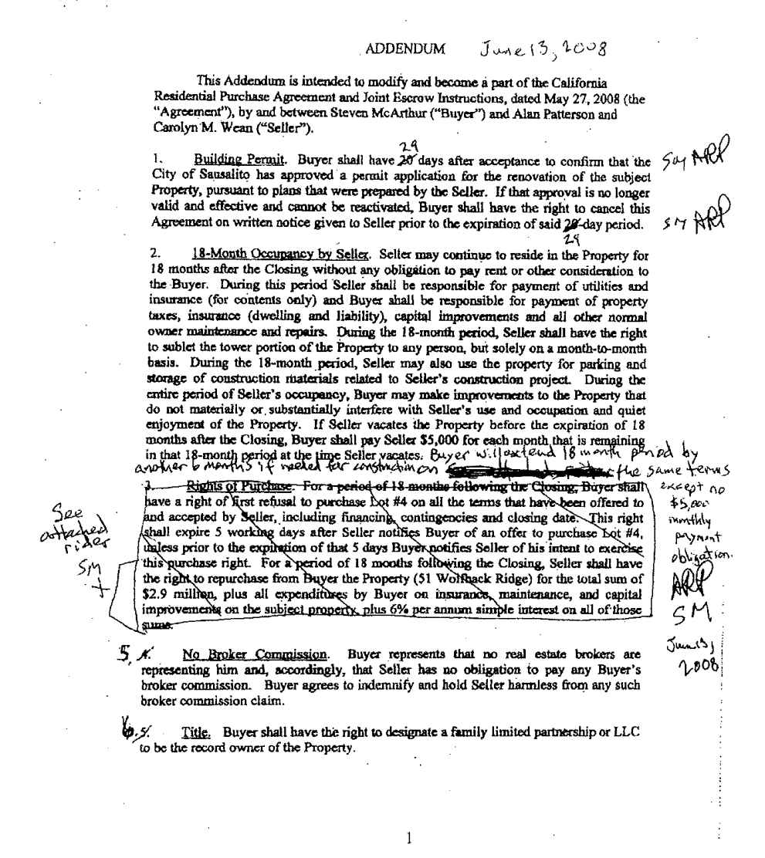
APPENDIX A

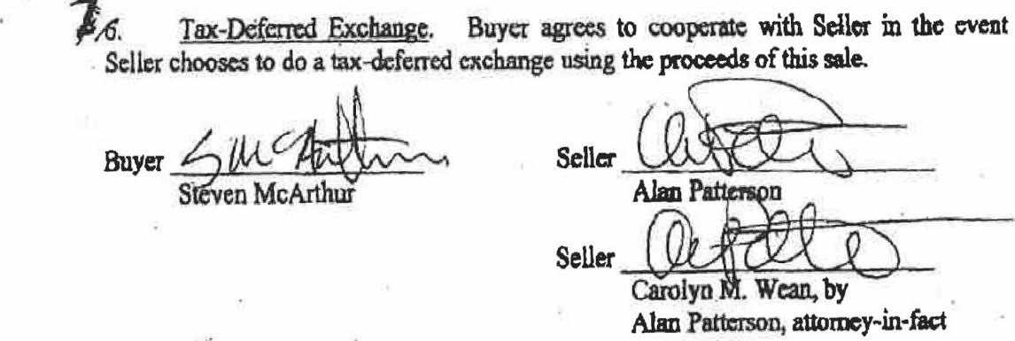

2
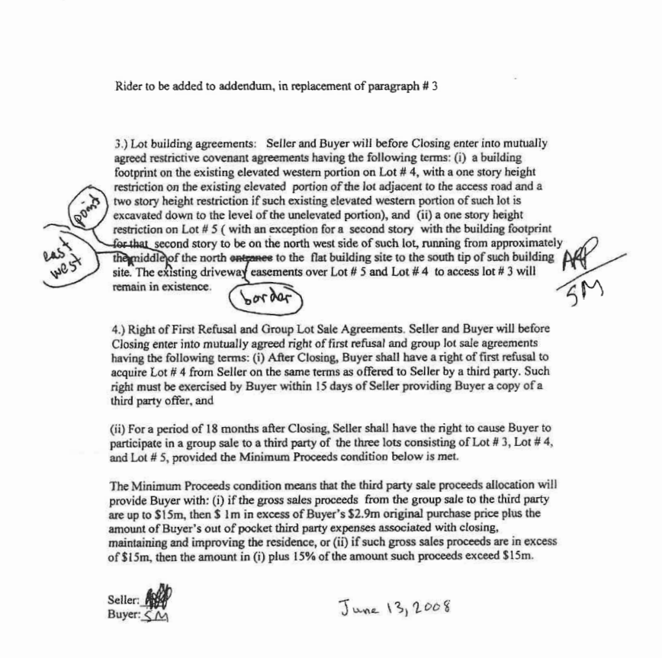

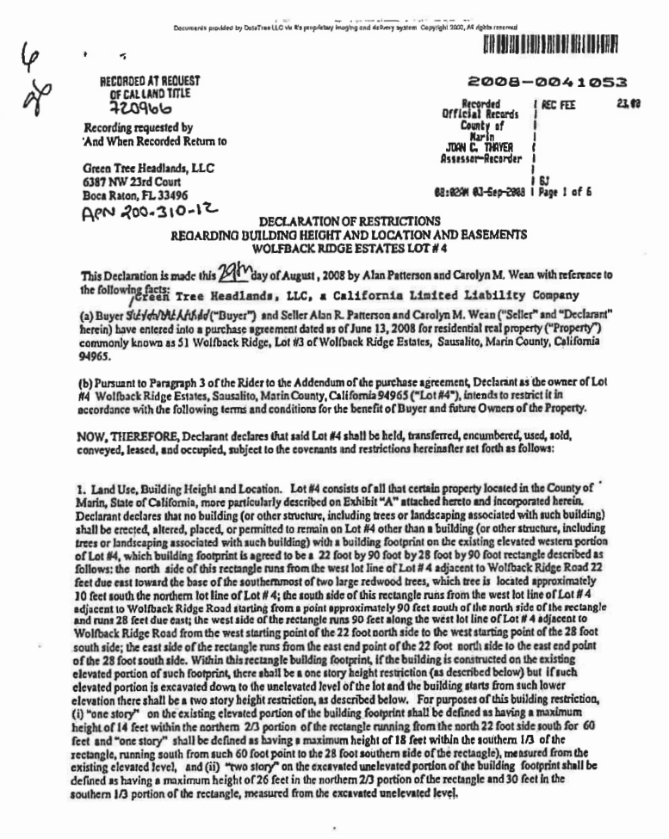
APPENDIX B

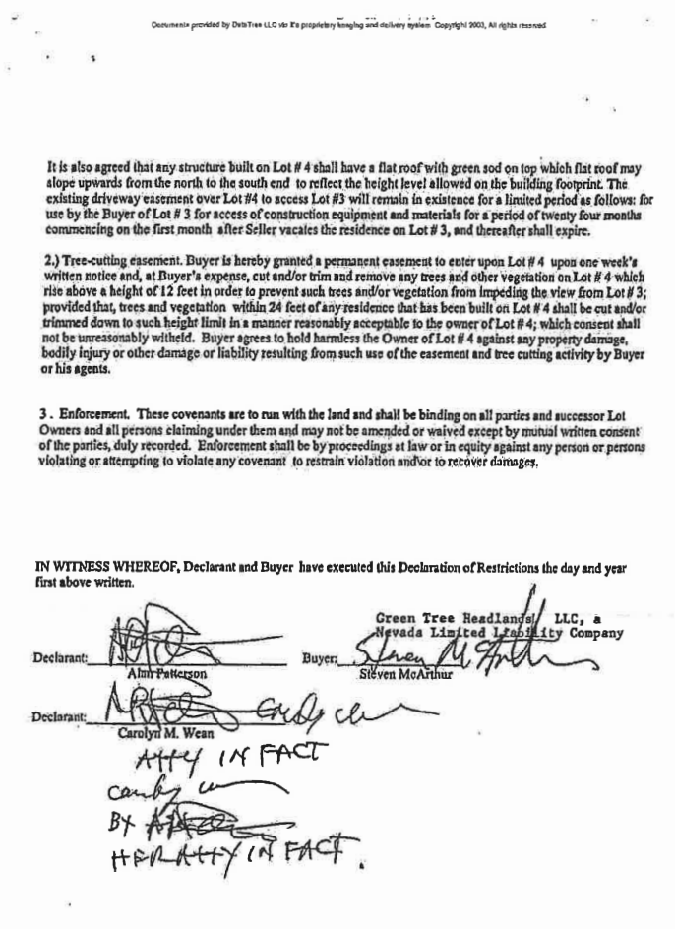

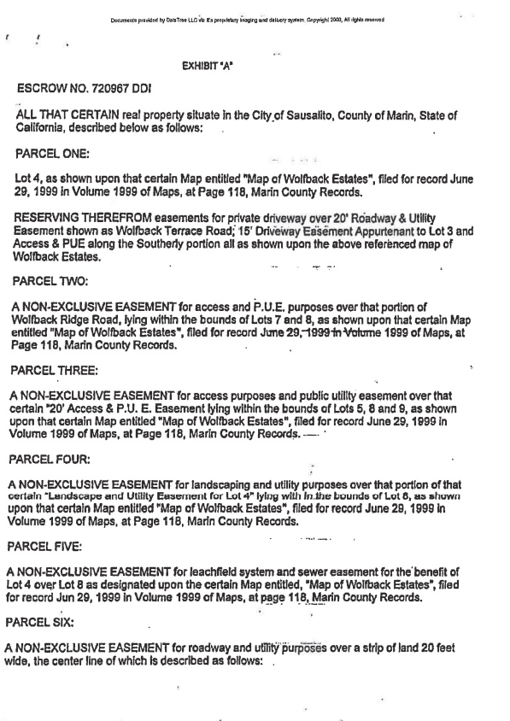
(Remainder of Exhibit “A” omitted.)
Trial Court: Superior Court of California, County of Marin
Trial Judge: Hon. Andrew E. Sweet
Counsel: Hanson Bridgett, Gary A. Watt, Batya F. Forsyth, and Patrick Burns for Defendant and Appellant Tara Crawford.

Murphy, Pearson, Bradley & Feeney, Timothy J. Halloran and Tyra M. Mendez for Defendant and Appellant Benjamin Graves.

Brekhus Law Partners and Elizabeth A. Brekhus and Paul Kerkorian for Plaintiffs and Respondents.

* Brown, P. J., Streeter, J., Hiramoto, J. (Judge of the Superior Court of California, County of Contra Costa, assigned by the Chief Justice pursuant to article VI, section 6 of the California Constitution.)
All further undesignated statutory references are to the Code of Civil Procedure.
For convenience, we refer collectively to McArthur and Green Tree Headlands LLC as “McArthur” since, for purposes of the issues we address here, the difference between McArthur and the title-holding entity is immaterial. Similarly, on Patterson’s side of the transaction, Patterson appears to have held the Wolfback Ridge Estates lots in his name jointly with his wife, Carolyn Wean. For convenience, we refer only to Patterson since the record reflects that he alone negotiated the seller-side of the transaction with McArthur. We mean no disrespect to Ms. Wean.
Attached as Appendix A to this opinion is a copy of the Second Addendum, with its attached Rider.
Attached as Appendix B to this opinion is a copy of the Declaration of Restrictions.
Civil Code section 3306a, entitled “Breach of agreement to deliver quitclaim; minimum detriment,” provides that “The minimum detriment caused by the breach of an agreement to execute and deliver a quitclaim deed to real property is deemed to be the expenses incurred by the promisee in quieting title to such property, and the expenses incidental to the entry upon such property. Such expenses which shall include reasonable attorneys’ fees shall be fixed by the court in the quiet title action.” (West’s Ann. Civ. Code (2023 ed.) foll. § 3306a.)
In a declaration submitted later in opposition to Crawford’s and Graves’s Anti-SLAPP motions, McArthur states that “when I first saw the Forged Addendum, I instantly recognized it as a document that Alan R. Patterson had sent to me (unsigned) by way of proposal prior to the close of escrow, I responded to this proposal by telling Alan R. Patterson that the continued existence of the Driveway Easement was essential to my purchase of Lot 3 and, therefore, I would not sign the document. The Forged Addendum was apparently created by taking that unsigned document and affixing a forgery of my signature on it.”
Crawford and Graves do not admit that MacArthur’s signature on the June 21 Addendum is a forgery, but they do not deny it either. In a declaration submitted in support of Crawford’s anti-SLAPP motion, Graves stated, “Prior to the demurrer hearing, neither Crawford nor I had any evidence to suggest the [June 21 Addendum] was not authentic.” And in a declaration opposing McArthur’s motion for sanctions under section 128.5, Crawford states, “I have no knowledge of any facts about how the document in question was manipulated, changed or forged.”
Although in some circumstance an irrevocable license is the equivalent of an easement (Gamerberg, supra, 44 Cal.App.5th at p. 429; see Rest.3d Property, Servitudes, § 1.2(4) [“[a]s used in this Restatement, the term ‘easement’ includes an irrevocable license to enter and use land in the possession of another”]), that is so only were the document creating it is recorded (Gamerberg, at p. 429). The only recorded document granting what might be construed as an irrevocable easement here is the Declaration of Restrictions, which, as we noted above, is ambiguous.
In the trial court, Graves relied on a more aggressive theory. Citing the merger by deed doctrine, he attempted to argue that the recorded Declaration of Restrictions and the Right of First Refusal were fully integrated and as a matter of law superseded anything in the Purchase Agreement that contradicted them. This theory was advanced in Graves’s declaration opposing McArthur’s demurrer. It was an overreach, among other reasons because neither the Declaration of Restrictions nor the Right of First Refusal is a deed. To win, Crawford did not need to rely on the merger by deed doctrine or otherwise convince the court to accept the Declaration of Restrictions as the sole relevant written instrument here. She only needed to persuade the court that, when resolving the fundamental conflict between the Rider, which favors McArthur’s side of the dispute, and the Declaration of Restrictions, which favors Crawford’s side of the dispute, the text of the Declaration of Restrictions should be taken as the best expression of the parties’ intent.
Paragraph 3 of the Declaration of Restrictions, which expressly permits enforcement “at law” by claim for damages, states that “[t]hese covenants are to run with the land and shall be binding on all successor Lot Owners . . . and may not be amended or waived except by mutual written consent of the parties, duly recorded.”
* Judge of the Superior Court of California, County of Contra Costa, assigned by the Chief Justice pursuant to article VI, section 6 of the California Constitution.

