Filed 2/15/24 (unmodified opn. attached)

CERTIFIED FOR PUBLICATION

COURT OF APPEAL, FOURTH APPELLATE DISTRICT

DIVISION ONE

STATE OF CALIFORNIA

THE PEOPLE,  Plaintiff and Respondent,  v.  KEVIN EUGENE CARTWRIGHT,  Defendant and Appellant. | D080606  (Super. Ct. No. SCD279043)  ORDER MODIFYING OPINION  AND DENYING REHEARING  NO CHANGE IN JUDGMENT

THE COURT:

It is ordered that the opinion filed January 25, 2024 be modified as follows:
- Delete the first sentence at the top of page 7 that begins, “Further, the still images,” and replace it with the following two sentences:
Further, the still images included in the record from the City’s cameras are not dissimilar in scope to the views obtained from the private security camera behind the clothing shop. They effectively capture the same scene from a different angle.

- The two images on page 7 are deleted and replaced with the below images in the following order:

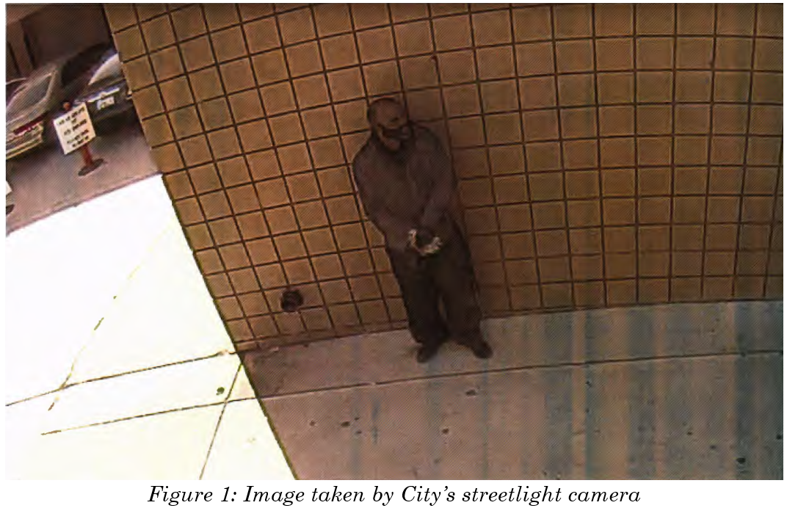

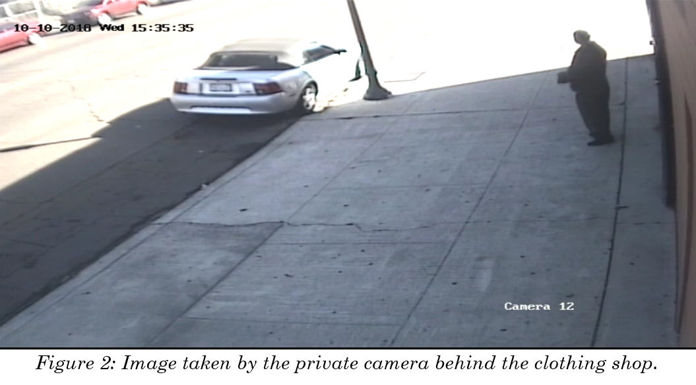

The petition for rehearing is denied.

There is no change in judgment.

HUFFMAN, Acting P. J.

Copies to: All parties

Filed 1/25/24 (unmodified opinion)

CERTIFIED FOR PUBLICATION

COURT OF APPEAL, FOURTH APPELLATE DISTRICT

DIVISION ONE

STATE OF CALIFORNIA

THE PEOPLE,  Plaintiff and Respondent,  v.  KEVIN EUGENE CARTWRIGHT,  Defendant and Appellant. | D080606  (Super. Ct. No. SCD279043)

APPEAL from a judgment of the Superior Court of San Diego County, Frederick L. Link and Eugenia Eyherabide, Judges. Affirmed.
Thomas E. Robertson, under appointment by the Court of Appeal, for Defendant and Appellant.
Rob Bonta, Attorney General, Lance E. Winters, Chief Assistant Attorney General, Charles C. Ragland, Assistant Attorney General, Eric A. Swenson, Junichi Semistu and Felicity Senoski, Deputy Attorneys General, for Plaintiff and Respondent.

A jury convicted Kevin Eugene Cartwright of first degree murder with special circumstances (Pen. Code, §§ 187, subd. (a), 190.2, subd. (a)(17)), robbery (§ 211), burglary (§ 459), being a felon in possession of a firearm (§ 29800, subd. (a)(1)), and being a prohibited person owning or possessing ammunition (§ 30305, subd. (a)(1)). Cartwright admitted to eight strike priors and received a sentence consisting of an indeterminate prison term of life without the possibility of parole plus 50 years to life, and a determinate prison term of 20 years four months.
The sole issue on appeal is whether the trial court erred in denying Cartwright’s motion to suppress video footage from the City of San Diego’s (City) “City IQ” streetlight camera program and evidence derived from that footage. We conclude that it did not and affirm the judgment.

FACTUAL AND PROCEDURAL BACKGROUND
In the early morning on October 9, 2018, Cartwright entered an adult-content store and theater in San Diego with a firearm drawn, directed the cashier to open the register, and stole the money it contained. When he was unsuccessful in restraining the cashier with zip ties, Cartwright sent him into the theater room. There, the cashier opened the emergency exit, ushered customers outside, and called the police.
The following day, October 10, Lorena Espinoza got out of Cartwright’s gold GMC Yukon wearing a purple wig and dark sunglasses. She entered a flooring store in downtown San Diego and led G.R., the owner and operator, towards the back of the store. Shortly thereafter, Cartwright emerged from the Yukon wearing a granny mask and sunglasses. He entered the store and incapacitated G.R. first by kicking him and then shooting him three times, inflicting two gunshot wounds and one graze wound. G.R. died as a result of these wounds.
Cartwright returned to the front of the store with a prybar, which he used to open the register. Cartwright and Espinoza then left the flooring business. Espinoza returned to the Yukon and drove it away. Cartwright walked behind a nearby clothing store and removed his mask, an action captured by the store’s security camera. He then used two different white sedans to leave the area.
An investigating detective accessed the City IQ streetlight camera footage. The cameras are not “situated so they could peer into businesses or residences” and capture only the “public right of way.” They are fixed position and located throughout downtown San Diego and other parts of the city. The devices capture “environmental data, like temperature, humidity, pressure, . . . traffic data, like car speeds, car counts, pedestrian data, bicycle data, and even video data.” The video feature creates high quality wide lens footage, but the devices do not record sound and do not act as gunshot detectors because the City did not “enable the microphones.” Footage is stored on each camera’s hard drive for five days; if it is not retrieved within five days, the camera records over the footage.
Video from the streetlight cameras revealed which vehicle Cartwright and Espinoza drove to the flooring store. Querying Department of Motor Vehicle records disclosed Cartwright as the owner of the vehicle. Police arrested Cartwright and, in a subsequent search, found evidence linking him to both the robbery of the adult store, and the robbery and homicide at the flooring store.
Cartwright moved to suppress the evidence obtained as a result of the streetlight camera footage. The trial court denied his motion.

DISCUSSION
Cartwright contends the police conducted a warrantless search when they accessed streetlight camera footage maintained by City. He further asserts that, but for this alleged improper search, the police would not have learned his identity and, consequently, evidence that resulted from the streetlight camera footage is fruit of the poisonous tree.
The standard of review of a trial court’s ruling on a motion to suppress is well established. (People v. Glaser (1995) 11 Cal.4th 354, 362.) On appeal, we examine whether the trial court’s factual findings are supported by substantial evidence. (Ibid.; People v. Camacho (2003) 23 Cal.4th 824, 830.) We then exercise our independent judgment in determining whether a search occurred and was reasonable under the Fourth Amendment. (Camacho, at p. 830.)
The Fourth Amendment to the United States Constitution protects against unreasonable searches and seizures. (U.S. Const., 4th Amend.) It “protects an individual’s reasonable expectation of privacy against unreasonable intrusion on the part of the government.” (People v. Jenkins (2000) 22 Cal.4th 900, 971.) To successfully claim Fourth Amendment protection, “ ‘a defendant must demonstrate that he personally has an expectation of privacy in the place searched, and that his expectation is reasonable.’ ” (Jenkins, at p. 972.) “ ‘In other words, the defendant must show that he or she had a subjective expectation of privacy that was objectively reasonable.’ ” (People v. Ayala (2000) 23 Cal.4th 225, 255.) Applying these principles, we conclude Cartwright did not have an objectively reasonable expectation of privacy when he traversed a public right of way in downtown San Diego in the middle of a business day.
Cartwright relies upon Carpenter v. United States (2018) 138 S.Ct. 2206 (Carpenter) and Leaders of a Beautiful Struggle v. Balt. Police Dep’t (4th Cir. 2021) 2 F.4th 330 (Beautiful Struggle) to argue that he had an objectively reasonable expectation of privacy. He suggests that accessing the recordings from the City’s streetlight cameras amounted to a search within the meaning of the Fourth Amendment and, consequently, required a warrant. Cartwright’s reliance on this precedent is misplaced.
The United States Supreme Court in Carpenter court addressed the warrantless collection of cell-site location information and its subsequent use in reconstructing a suspect’s movement over the course of 127 days. (Carpenter, supra, 138 S.Ct. at p. 2212.) This information linked Carpenter to a series of robberies and led to his conviction. (Id. at p. 2213.) The Court held that the government’s acquisition of the cell-site records invaded Carpenter’s reasonable expectation of privacy and constituted a search in violation of the Fourth Amendment. (Id. at pp. 2219, 2223.) Maintaining the special level of privacy for cell phones set forth in Riley v. California (2014) 573 U.S. 373, 403, which held cell-site records “hold for many Americans ‘the privacies of life’ ” (id. at p. 2213, quoting Boyd v. United States (1886) 116 U.S. 616, 630), the Court concluded that a person “does not surrender all Fourth Amendment protecting by venturing into the public sphere.” (Carpenter, at p. 2217.)
In Beautiful Struggle, the Fourth Circuit’s en banc decision applied the United States Supreme Court’s reasoning in Carpenter to an aerial surveillance program operated by the city of Baltimore. (Beautiful Struggle, supra, 2 F.4th at pp. 339–345.) The city of Baltimore collected both traditional surveillance data and aerial photographs. (Id. at p. 334.) When combined, the police could effectively track someone’s every movement throughout the city retroactively over a 45-day period. (Id. at pp. 345–346.) This integrated surveillance, the Fourth Circuit concluded, was an incursion into privacy directly comparable to the cell-site location information accessed in Carpenter. (Beautiful Struggle, at pp. 345–348.)
Neither Carpenter nor Beautiful Struggle can be read to indicate that the review of footage from the streetlight cameras in this case amounts to a search subject to a warrant requirement. The United States Supreme Court in Carpenter specifically indicated that its holding was intended to be narrow and did not extend to “conventional surveillance techniques and tools, such as security cameras.” (Carpenter, supra, 138 S.Ct. at 2220.) Recordings from cameras, such as the ones that captured Cartwright’s movements in the downtown urban environment in the middle of a weekday, do not rise to the same “unique nature of cell phone location records.” (Carpenter, at p. 2217.) Indeed, “ ‘[a] person traveling . . . on public thoroughfares has no reasonable expectation of privacy in his movements from one place to another.’ ” (Id. at p. 2215, quoting United States v. Knotts (1983) 460 U.S. 276, 281, 282.) Indeed, as the court in Beautiful Struggle acknowledged, “People understand that they may be filmed by security cameras on city streets.” (Beautiful Struggle, supra, 2 F.4th at p. 345.) This is effectively the same principle Cartwright now argues against.
When Cartwright drove his gold Yukon downtown and parked, “the movements of the vehicle and its final destination had been ‘voluntarily conveyed to anyone who wanted to look,’ ” and Cartwright cannot “assert a privacy interest in the information obtained.” (Carpenter, supra, 138 S.Ct. at 2215.) Further, the still images included in the record from the City’s cameras are remarkably similar in scope to the views obtained from the private security camera behind the clothing shop:
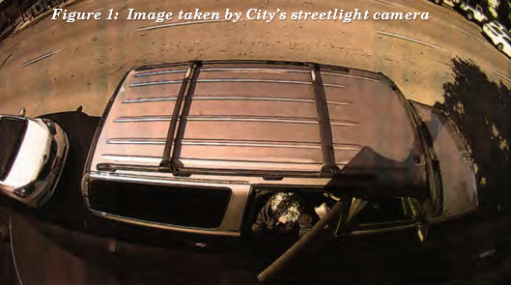
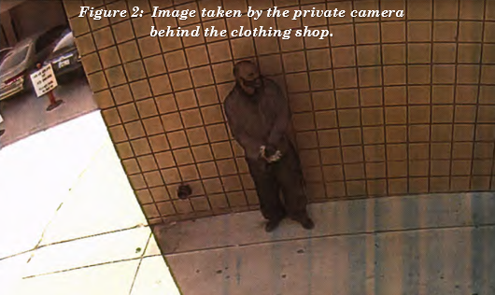
We note this to demonstrate that Cartwright could not maintain an objectively reasonable expectation of privacy in the downtown, urban public spaces when any number of private businesses may have maintained similar cameras that capture similar images.
Stationary pole cameras, much like streetlight cameras, only capture “short term” movements rather than “everyone’s movements across the city.” (Beautiful Struggle, supra, 2 F.4th at p. 345.) They are “fixed in place,” “only capture individual trips,” and do not create “a retrospective database of everyone’s movements across the city.” (Ibid.) Due to these inherent limitations, stationary cameras merely “augment[ ] ordinary police capabilities.” (Ibid.) They modestly supplement and enhance, “to a permissible degree, warrantless capabilities the police had even before the technology.” (Id. at p. 340, citing United States v. Knotts (1983) 460 U.S. 276, 281–282 and Kyllo v. United States (2001) 533 U.S. 27, 33–35.)
We distinguish the cameras in the case before us from both the aerial surveillance images and the integrated Baltimore Police Department systems addressed in Beautiful Struggle. There, Baltimore used software to integrate the “camera network, license plate readers and gunshot detectors” with the challenged aerial surveillance to “reveal where individuals come and go over an extended period.” (Beautiful Struggle, supra, 2 F.4th at p. 346.) Here, the City’s camera program stands alone; there is no aerial surveillance or even audio to integrate with the recordings captured by the streetlight cameras. The cameras, by their very nature and limitations, do not reveal the transit patterns of people throughout the county. The information they capture is all information voluntarily conveyed to anyone in a public space who cares to look—something any police officer could have done without a warrant.
Cartwright had no objectively reasonable expectation of privacy when he used the public streets and sidewalks downtown in a manner readily observable to passersby. We therefore conclude the police did not conduct a “search” when they accessed footage from City’s streetlight cameras and,
accordingly, there was no violation of the Fourth Amendment.

DISPOSITION
The judgment is affirmed.

DATO, J.

WE CONCUR:

HUFFMAN, Acting P. J.

CASTILLO, J.

All undesignated references are to the Penal Code.
Espinoza, Cartwright’s codefendant, entered a plea of guilty to second degree murder and admitted a firearm allegation to be true; the court sentenced her to a term of 15 years to life plus one year.

