Filed 4/21/23; REVIEW GRANTED. See Cal. Rules of Court, rules 8.1105 and 8.1115 (and corresponding Comment, par. 2, concerning rule 8.1115(e)(3)).
CERTIFIED FOR PUBLICATION

IN THE COURT OF APPEAL OF THE STATE OF CALIFORNIA

SECOND APPELLATE DISTRICT

DIVISION EIGHT

MOHAMMAD BASITH,  Plaintiff and Respondent,  v.  LITHIA MOTORS, INC., et al.,  Defendants and Appellants. | B316098  Los Angeles County  Super. Ct. No. 21STCV01725

APPEAL from an order of the Superior Court of Los Angeles County, Michelle Williams Court, Judge. Reversed.
Law Offices of Ramin R. Younessi, Ramin R. Younessi, Samantha L. Ortiz, and Christopher S. Afgani for Plaintiff and Appellant.
Walsworth WFBM, Kellie S. Christianson for Defendants and Respondents.
____________________

A twist of fate brings to us substantially the same Nissan employment arbitration contract in two otherwise unrelated cases. The other case we decide today is Fuentes v. Empire Nissan, Inc. (April 21, 2023, B314490) __ Cal.App.5th __ (Fuentes).
These two cases raise the same vital question in contract law: what exactly is California’s test for unconscionability? More precisely, when there is a very high degree of procedural unconscionability, is there any meaningful content to the second element of substantive unconscionability? In an online world where contracts usually appear only in a take-it-or-leave-it format and where there thus is much procedural unconscionability, this question about substantive unconscionability looms large.
Our holding is that, unless we are to imperil the vast online world of take-it-or-leave-it contracts, substantive unconscionability must retain meaningful independent content. For that reason, the contracts here and in Fuentes are valid and enforceable, despite their procedural unconscionability.
Mohammad Basith signed an online arbitration agreement before starting work at a car dealership. He had to sign if he wanted a job: the car dealership presented it as a take-it-or-leave-it mandatory condition. Basith took the mandatory step, signed the arbitration contract, and the dealership hired him. The employment relationship turned out to be unsuccessful: Basith sued the dealership for firing him. The dealership moved to compel arbitration. The trial court ruled the arbitration contract was unconscionable. This defense requires both procedural and substantive unconscionability. (OTO, L.L.C. v. Kho (2019) 8 Cal.5th 111, 125 (Kho).) We reverse because Basith suffered no substantive unconscionability, which is indispensable to the unconscionability defense.
I
Basith applied to work as general manager for a car dealership doing business as Nissan of Carson. The dealership’s owner, Lithia Motors, Inc., ran a network of dealerships. Lithia’s subsidiary LAD-Carson-N, LLC owned Nissan of Carson. Lithia Motors Support Services, Inc., which had a branch office in Missouri, provided centralized human resources and information technology services for Lithia Motors. We call all defendants Nissan for simplicity.
Basith’s job application was online. On Nissan’s website, Basith created a username and password on August 2, 2018. Then on August 12, 2018, he electronically signed online forms entitled “Agreements.” Basith started his new job on August 13, 2018. On November 30, 2018, Basith signed a paper version of another document: a two-page “General Manager Compensation Plan.” Nissan terminated Basith on October 14, 2020.
Because font size and document appearance are issues in these cases, we will describe the format and text of these documents: “Agreements” on one hand, and “General Manager Compensation Plan” on the other. We take them in reverse order.
We start with the “General Manager Compensation Plan” of November 30, 2018. This document was always a traditional paper document; Basith “wet” signed it in a paper format. Nissan attached this document to its motion to compel arbitration. The trial court treated this document as properly admitted, and there is no dispute on that point.
The font size on this paper document is very small; moreover, our record copy is blurry as well. It looks like a poor photocopy. We attach our record copy as appendix A.
This “General Manager Compensation Plan” document, under a heading of “ACKNOWLEDGEMENTS,” includes a paragraph titled “California Only.” This paragraph is six lines and states in part, “I and the Dealership understand and voluntarily agree that any claims/disputes that I may have regarding the terms of my own Compensation Program, my employment, termination from employment (including claims of discrimination and/or harassment), or any other association I have with the Company that either of us might have against one another will be resolved exclusively in accordance with binding arbitration.” This agreement stated the arbitration would be governed by the Federal Arbitration Act (9 U.S.C. § 1 et seq.) and would be carried out in conformity with the California Arbitration Act (Code Civ. Proc., § 1280 et seq.).
Basith sometimes calls this the “short-form” arbitration agreement.
We now turn to the “Agreements” form of August 12, 2018.
The format of “Agreements” differs in our record from the format in which Nissan offered it and Basith viewed it.
This online “Agreements” form was part of “iCIMS,” Nissan’s internet recruitment and applicant tracking system. The iCIMS system was interactive: it had a New Hire Portal that contained an online orientation process. New employees signed in to the website with their username and password and then proceeded through various screens and tasks the system required. The interactive iCIMS system allowed Nissan to track new employees’ progress and records.
In our record on appeal, however, the documents from this interactive web presence have been downloaded into the PDF format. PDF stands for Portable Document Format, which is a computer file format aiming to present documents in a manner independent of application software, hardware, and operating systems. (See Wikipedia, “PDF”, <https://en.wikipedia.org/wiki/
PDF> [as of Apr. 14, 2023], archived at <https://perma.cc/BYH9-9QFZ>.)
As Nissan presented this “Agreements” document and as Basith signed, the document was visible online to Basith (and other viewers) on whatever screen the viewer was using. The font size and appearance thus would depend on a number of factors: the screen or monitor size, the adjustable screen and magnification settings, and so forth. Technology made the online image adjustable. Viewers could use a bigger monitor or keyboard strokes to magnify the size of the words.
In short, the PDF in the appellate record shows the words of the document but not how the words appeared to online viewers.
We also append a copy of this record document. (See appendix B, post.)
This “Agreements” document had two parts separated by a line. The first part was called “At Will Employment Agreement” and the second was the “Binding Arbitration Agreement.”
The “At Will Employment Agreement” was this:
“At Will Employment Agreement”
“I agree as follows: My employment and compensation is terminable at-will, is for no definite period, and my employment and compensation may be terminated by the Company (employer) at any time and for any reason whatsoever, with or without good cause at the option of either the Company or myself. Consequently, all terms and conditions of my employment may be changed or withdrawn at Company’s unrestricted option at any time, with or without good cause. No implied, oral, or written agreements contrary to the express language of this agreement are valid unless they are in writing and signed by the President of the Company. No supervisor or representative of the Company, other than the President, has any authority to make any agreements contrary to the foregoing. This agreement is the entire agreement between the Company and the employee regarding the rights of the Company or employee to terminate employment with or without good cause, and this agreement takes the place of all prior and contemporaneous agreements, representations, and understandings of the employee and the Company.”
Basith electronically signed this portion on August 12, 2018, at 11:28 p.m.
The “Binding Arbitration Agreement” states:
“Binding Arbitration Agreement”
“I also acknowledge that the Company utilizes a system of alternative dispute resolution which involves binding arbitration to resolve all disputes which may arise out of the employment context. Because of the mutual benefits (such as reduced expense and increased efficiency) which private binding arbitration can provide both the Company and myself, I and the Company both agree that any claim, dispute, and/or controversy that either party may have against one another (including, but not limited to, any claims of discrimination and harassment, whether they be based on the California Fair Employment and Housing Act, Title VII of the Civil Rights Act of 1964, as amended, as well as all other applicable state or federal laws or regulations) which would otherwise require or allow resort to any court or other governmental dispute resolution forum between myself and the Company (or its owners, directors, officers, managers, employees, agents, and parties affiliated with its employee benefit and health plans) arising from, related to, or having any relationship or connection whatsoever with my seeking employment with, employment by, or other association with the Company, whether based on tort, contract, statutory, or equitable law, or otherwise, (with the sole exception of claims arising under the National Labor Relations Act which are brought before the National Labor Relations Board, claims for medical and disability benefits under my state’s workers’ compensation laws, and Employment Development Department claims) shall be submitted to and determined exclusively by binding arbitration. In order to provide for the efficient and timely adjudication of claims, the arbitrator is prohibited from consolidating the claims of others into one proceeding. This means that an arbitrator will hear only my individual claims and does not have the authority to fashion a proceeding as a class or collective action or to award relief to a group of employees in one proceeding. Thus, the Company has the right to defeat any attempt by me to file or join other employees in a class, collective or joint action lawsuit or arbitration (collectively ‘class claims’).
“I further understand that I will not be disciplined, discharged, or otherwise retaliated against for exercising my rights under Section 7 of the National Labor Relations Act, including but not limited to challenging the limitation on a class, collective, or joint action. I understand and agree that nothing in this agreement shall be construed so as to preclude me from filing any administrative charge with, or from participating in any investigation of a charge conducted by, any government agency such as the Department of Fair Employment and Housing and/or the Equal Employment Opportunity Commission; however, after I exhaust such administrative process/investigation, I understand and agree that I must pursue any such claims through this binding arbitration procedure. I acknowledge that the Company’s business and the nature of my employment in that business affect interstate commerce. I agree that the arbitration and this Agreement shall be controlled by the Federal Arbitration Act, in conformity with the procedures of my state’s arbitration laws and procedures (or if my state does not have applicable arbitration laws, the California Arbitration Act (Cal Code Civ. Proc. sec 1280 et seq., including section 1283.05 and all of the Act’s other mandatory and permissive rights to discovery)). However, in addition to requirements imposed by law, any arbitrator herein shall be a retired state court Judge from my state and shall be subject to disqualification on the same grounds as would apply to a judge of such court. To the extent applicable in civil actions in my state’s courts, the following shall apply and be observed: all rules of pleading (including the right of demurrer), all rules of evidence, all rights to resolution of the dispute by means of motions for summary judgment, judgment on the pleadings, and motions for directed verdict.
“Resolution of the dispute shall be based solely upon the law governing the claims and defenses pleaded, and the arbitrator may not invoke any basis (including, but not limited to, notions of ‘just cause’) other than such controlling law. The arbitrator shall have the immunity of a judicial officer from civil liability when acting in the capacity of an arbitrator, which immunity supplements any other existing immunity. Likewise, all communications during or in connection with the arbitration proceedings are privileged in accordance with my state[’]s laws regarding privileged judicial proceedings. The arbitrator may extend the times for the giving of notices and setting of hearings. Awards shall include the arbitrator’s written reasoned opinion.
“The arbitrator’s fees and costs unique to arbitration shall be borne by the Company. Each party shall bear their own attorney fees and costs, unless a statutory cause of action allows the prevailing party to recover attorney fees or costs. The arbitrator, and not any federal, state, or local court or agency, shall have exclusive authority to resolve any dispute relating to the interpretation, applicability, enforceability, or formation of this Agreement, including without limitation any claim that this Agreement is void or voidable.
“Both the Company and I agree that any arbitration proceeding must move forward under the Federal Arbitration Act (9 U.S.C. §§ 3-4) even though the claims may also involve or relate to parties who are not parties to the arbitration agreement and/or claims that are not subject to arbitration: thus, the court may not refuse to enforce this arbitration agreement and may not stay the arbitration proceeding despite the provisions [of] the applicable law of my state, including, without limitation, California Code of Civil Procedure § 1281.2(c).
“Should any term or provision, or portion thereof, be declared void or unenforceable, it shall be severed and the remainder of this agreement shall be enforced.
“I UNDERSTAND BY AGREEING TO THIS BINDING ARBITRATION PROVISION, BOTH I AND THE COMPANY GIVE UP OUR RIGHTS TO TRIAL BY JURY.
“By acknowledging below, you have agreed that you have read and understood the above disclosure.”
Basith signed this provision electronically.
Three features of this arbitration agreement bear emphasis.
First, to some extent this contract seems to be a common form, at least for some car dealerships. Its language is substantially similar to the agreement not only in Fuentes, but also to the agreements in Kho, supra, 8 Cal.5th at page 119 and Davis v. TWC Dealer Group, Inc. (2019) 41 Cal.App.5th 662, 665– 673 (Davis). All these cases involved car dealerships. As here, the employer in Fuentes was a Nissan dealership. Kho and Davis involved Toyota dealers. (Kho, at p. 118; Davis, at p. 665.)
Second, all four agreements containing the arbitration clauses extended for more than a page of print. (Kho, supra, 8 Cal.5th at p. 119; Davis, supra, 41 Cal.App.5th at pp. 666–667.)
Third, the font size and functional readability of the contracts here did not seem to trouble Basith. Two relevant declarations comprise our record facts on this point. We summarize both.
The employer’s declaration was by Director of Recruiting Christine Collinet, who works for Nissan in Missouri. Collinet reported Basith used Nissan’s online site to create a username and password on August 2, 2018. Ten days later, on August 12, 2018, at about 11:28 p.m., Basith electronically signed the online materials, including the arbitration agreement.
Collinet appended a printout of Basith’s agreement to her declaration.
Basith agreed he electronically signed the document Collinet attached to her declaration.
Basith did not state he had trouble reading these documents. Nor did Basith explain how he viewed Nissan’s online materials: whether he used a large monitor that would magnify the contents of the display; whether he used keyboard screen magnification to increase the size of screen images that seemed small; whether he printed out screen images he wanted to examine in a hard copy; whether he took a long or a short time to study the material; and so forth. Basith omitted all this information, which only he would know.
After Nissan terminated Basith, he sued Nissan on employment claims. Nissan moved to compel arbitration. The trial court denied the motion, ruling the arbitration agreement was unconscionable. Nissan appealed.
II
This arbitration agreement was valid because it contained no substantive unconscionability.
The governing law in this case is the same as in the Fuentes case. We incorporate that recitation here, as well as our statement of how these two cases differ from Kho and Davis. (See Fuentes, supra, ___ Cal.App.5th ___ [pp. 7-10, 12, & 19-22].)
We note at the outset that this case poses no issue of small or unreadable font. It is a striking coincidence that, not only do we encounter substantially similar form contracts in two simultaneous and otherwise unrelated cases, but also that font size should be a dominating issue in one case—Fuentes—and entirely absent as an issue in Basith’s case. The difference stems from the media: in Fuentes, the contract was printed only on paper, and was printed in a largely unreadable way, whereas Basith’s main contract was online.
We now examine Basith’s argument about substantive unconscionability, which is fundamentally incorrect. Basith maintains the contract’s wording is so convoluted that uncounseled lay people would not understand whether the agreement meant they were waiving rights. Basith cites this particular sentence and italicizes five words that we italicize as well: “I and the company both agree that any claim, dispute, and/or controversy . . . including, but not limited to, any claims . . . based on the California Fair Employment and Housing Act, Title VII of the Civil Rights Act of 1964 . . . which would otherwise require or allow resort to any court or other governmental dispute resolution forum . . . shall be submitted to and determined exclusively by binding arbitration.”
Basith argues this language implies to lay people that it bars filing a charge with the Department of Fair Employment and Housing or the Equal Employment Opportunity Commission.
Basith’s argument fails on two counts. As Basith himself notes, there is clear language to the contrary: “I understand and agree that nothing in this agreement shall be construed so as to preclude me from filing any administrative charge with, or from participating in any investigation of a charge conducted by, any government agency such as the Department of Fair Employment and Housing and/or the Equal Employment Opportunity Commission.”
This sentence, which we quoted above, is reasonably clear: I may file a charge with the Department of Fair Employment and Housing and/or the Equal Employment Opportunity Commission. It is comprehensible.
More fundamentally, arguments about prolix legalese go to procedural and not substantive unconscionability. Here we incorporate our exposition of this point from Fuentes.
To recite the point briefly, a complaint about prolix legalese is the same type of objection as a complaint about font size. If the substance of a contract is fair, how the contract is expressed cannot change that. Font size, format style, or verbal obscurantism does not affect the fairness of the final allocation of rights and duties. This contention does not address, and cannot establish, substantive unfairness. To rule otherwise would drain the element of substantive unconscionability of meaningfully independent content and effectively would turn the unconscionability doctrine into a one-element test of vast and unsettling sweep.
Basith also makes a second argument that suffers the same shortcoming. He claims the short-form agreement—the one in the “General Manager Compensation Plan”—failed to clarify in plain English that Basith was not waiving his statutory right to file a charge with the Equal Employment Opportunity Commission or the Fair Employment and Housing Administration. This attack on wording rather than on substance again misses the mark.
Moreover, the long-form contract made this point clear. When different contracts relate to the same matter between the same parties, we interpret them together, meaning we aim to make the parts into a consistent and sensible whole. (Civ. Code, § 1642.) We do so with awareness that federal and California law strongly favor arbitration. (9 U.S.C. § 2; Kho, supra, 8 Cal.5th at p. 125.) We search for a lawful and reasonable interpretation. (Civ. Code, § 1643.) The lawful and reasonable interpretation is that the longer contract filled in the gaps of the shorter one. Basith’s second argument is incorrect.
The unconscionability defense requires a party to establish both procedural and substantive unconscionability. (Kho, supra, 8 Cal.5th at p. 125.) Because there is no substantive unconscionability, Basith’s attack on this contract fails. The trial court erred by denying Nissan’s motion to compel arbitration.
- DISPOSITION
We reverse and direct the trial court to enter an order granting the motion to compel arbitration. We award costs to the appellants.

WILEY, J.
I concur:

HARUTUNIAN, J.*
STRATTON, P.J., Dissenting.
I dissent for the reasons expressed in my dissent in Fuentes v. Empire Nissan, Inc. et al., Case No. B314490.

STRATTON, P. J.

APPENDIX A
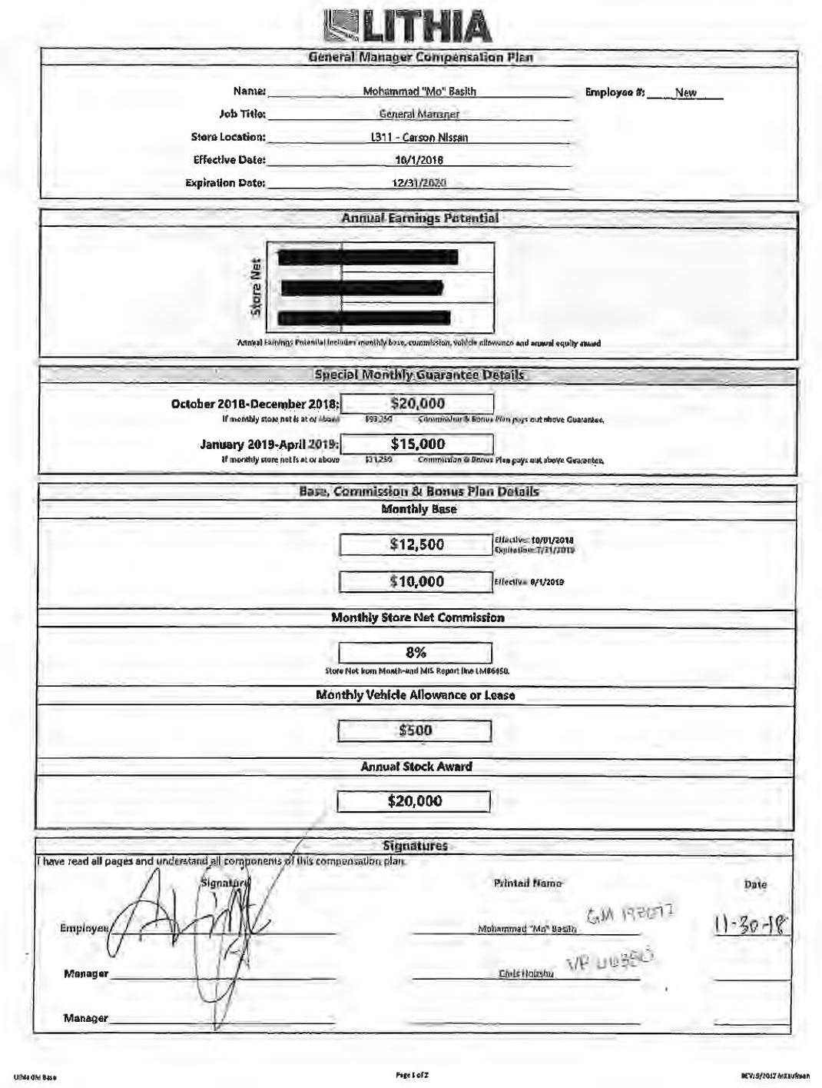
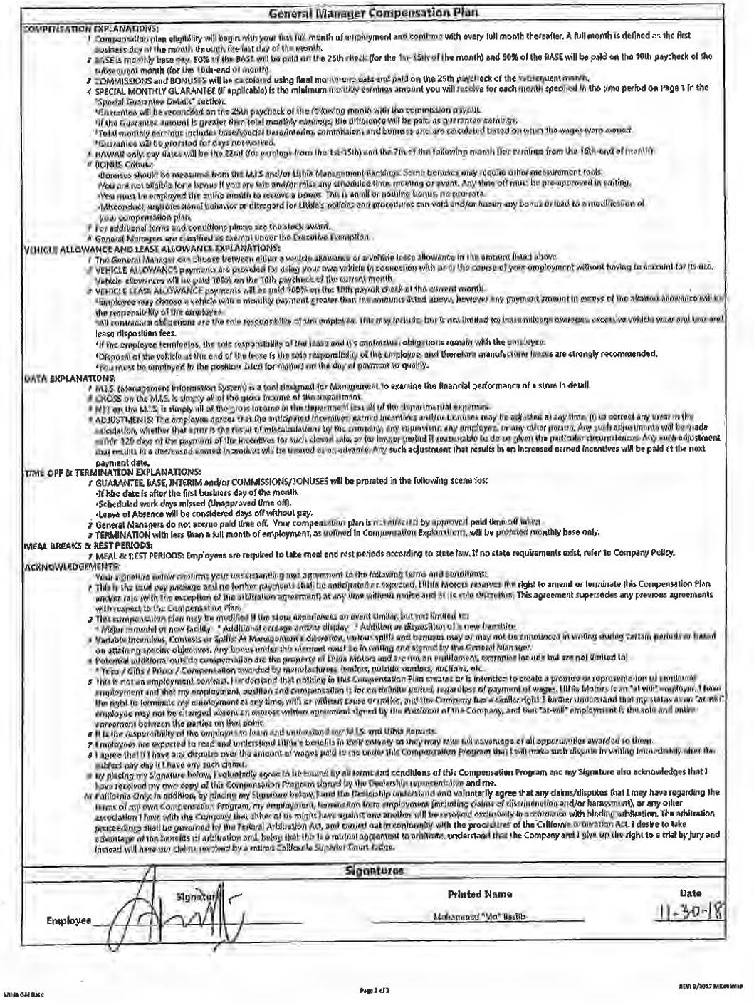

APPENDIX B
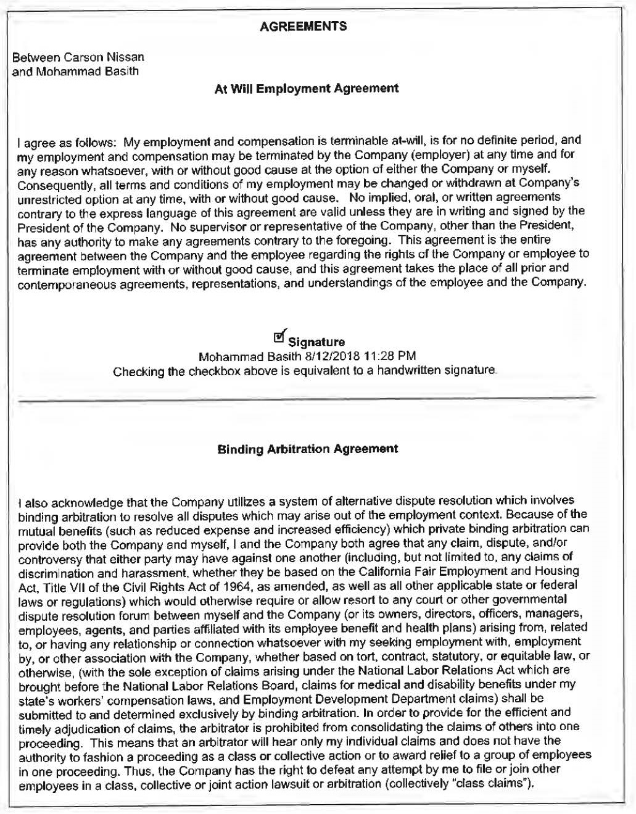

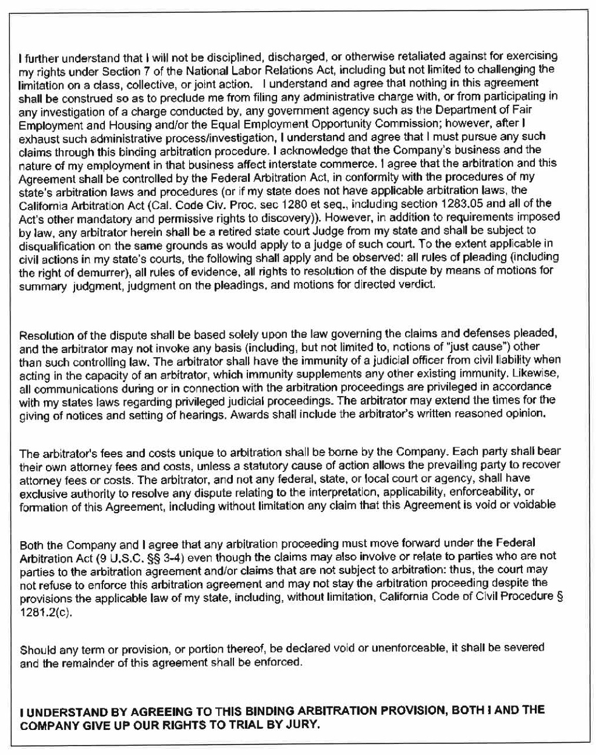

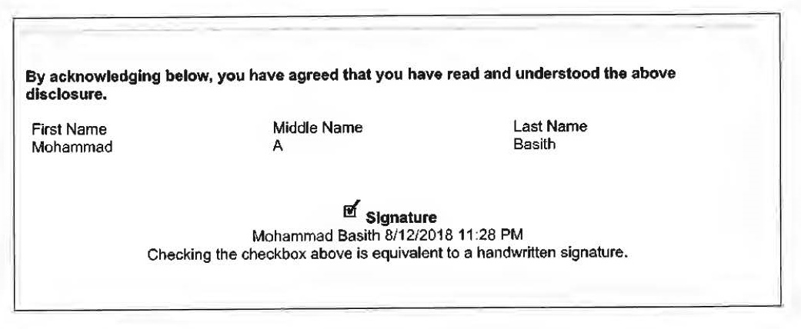

* Judge of the San Diego Superior Court, assigned by the Chief Justice pursuant to article VI, section 6 of the California Constitution

