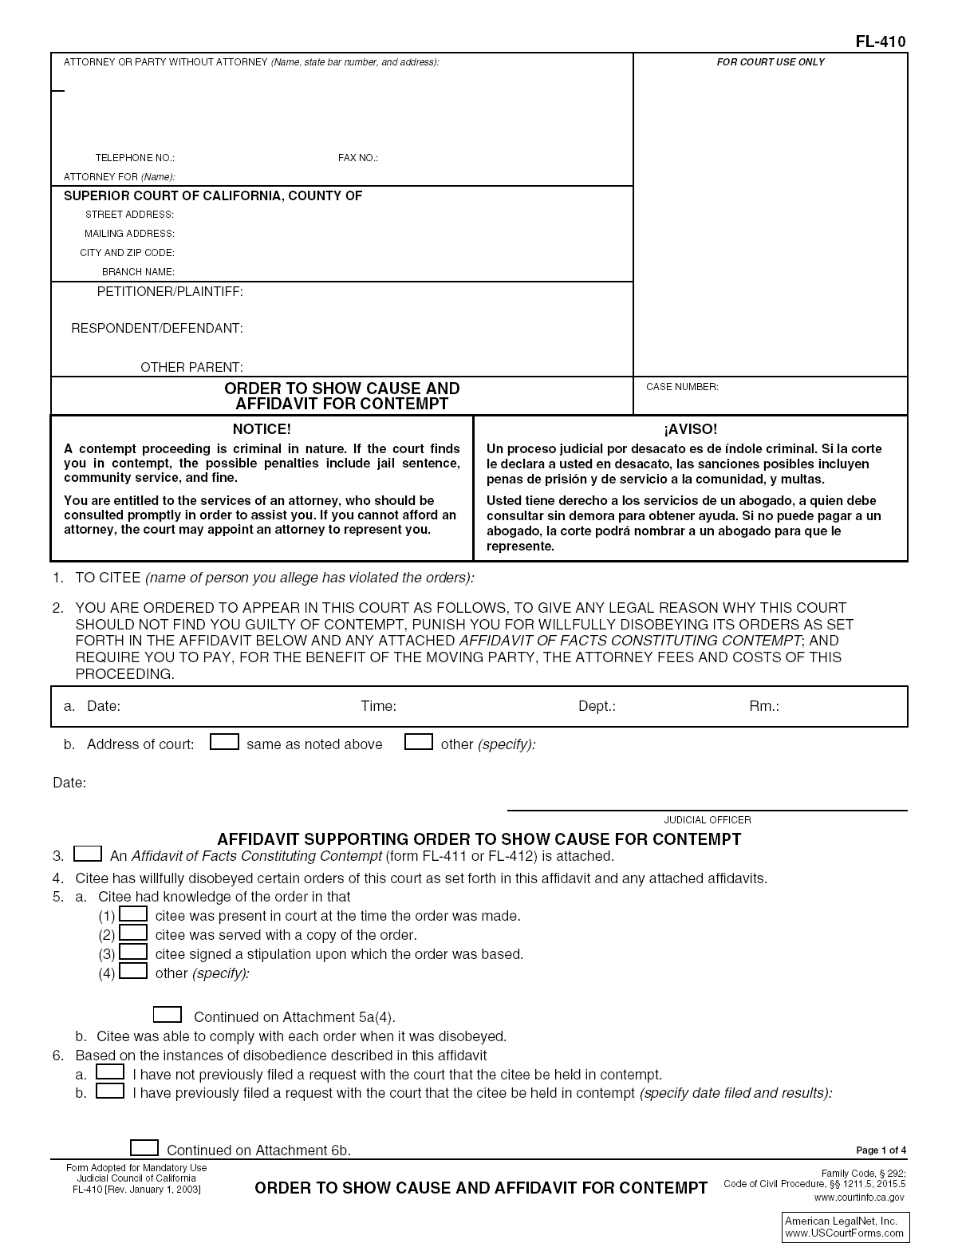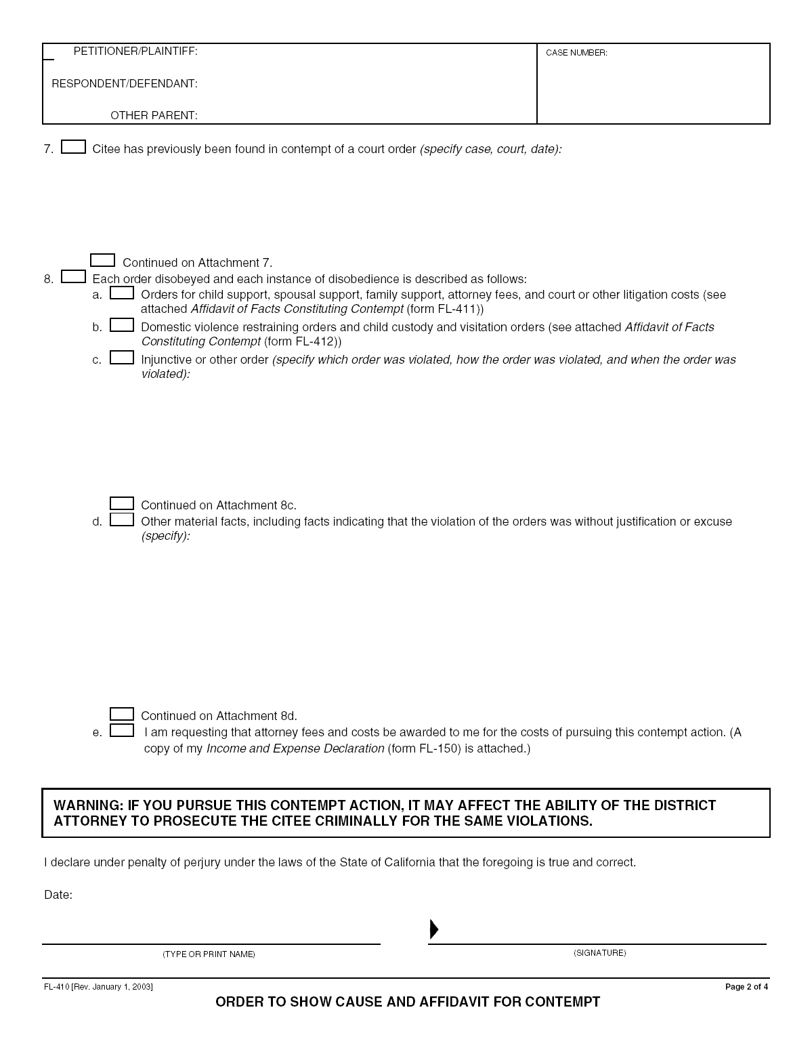
This is the Form Number
Your Name, Street Address, City, State, and
Zip Code
SAMPLE
Type “IN PRO PER”
”
The County Name
Court’s Street Address
Court’s City, State, and Zip Code
Fill out EXACTLY as this information appears on your other documents
Case Number
Other Party’s Name Here
Ask the clerk to obtain this information
Check this box
Check this box
Check ALL Boxes that Apply
Check this box if you have NEVER made a contempt request before
Check this box if you HAVE made a contempt request before and write in the date you made the request
Fill out EXACTLY as this information appears on your other documents
Case Number
Check this box if the other party was ever found in contempt. Write in the case name and number, the Court where the contempt occurred, and the date the contempt occurred.
Check this box
Check the boxes that APPLY TO YOU. Make sure you fill out the appropriate attachment. If you have any other orders that have been violated, write down which order was violated, how it was violated, and when the violation occurred.
Check this box
Write in WHY the violation had no justification and list SPECIFIC REASONS.
Date Here
Print Your Name
Sign Your Name
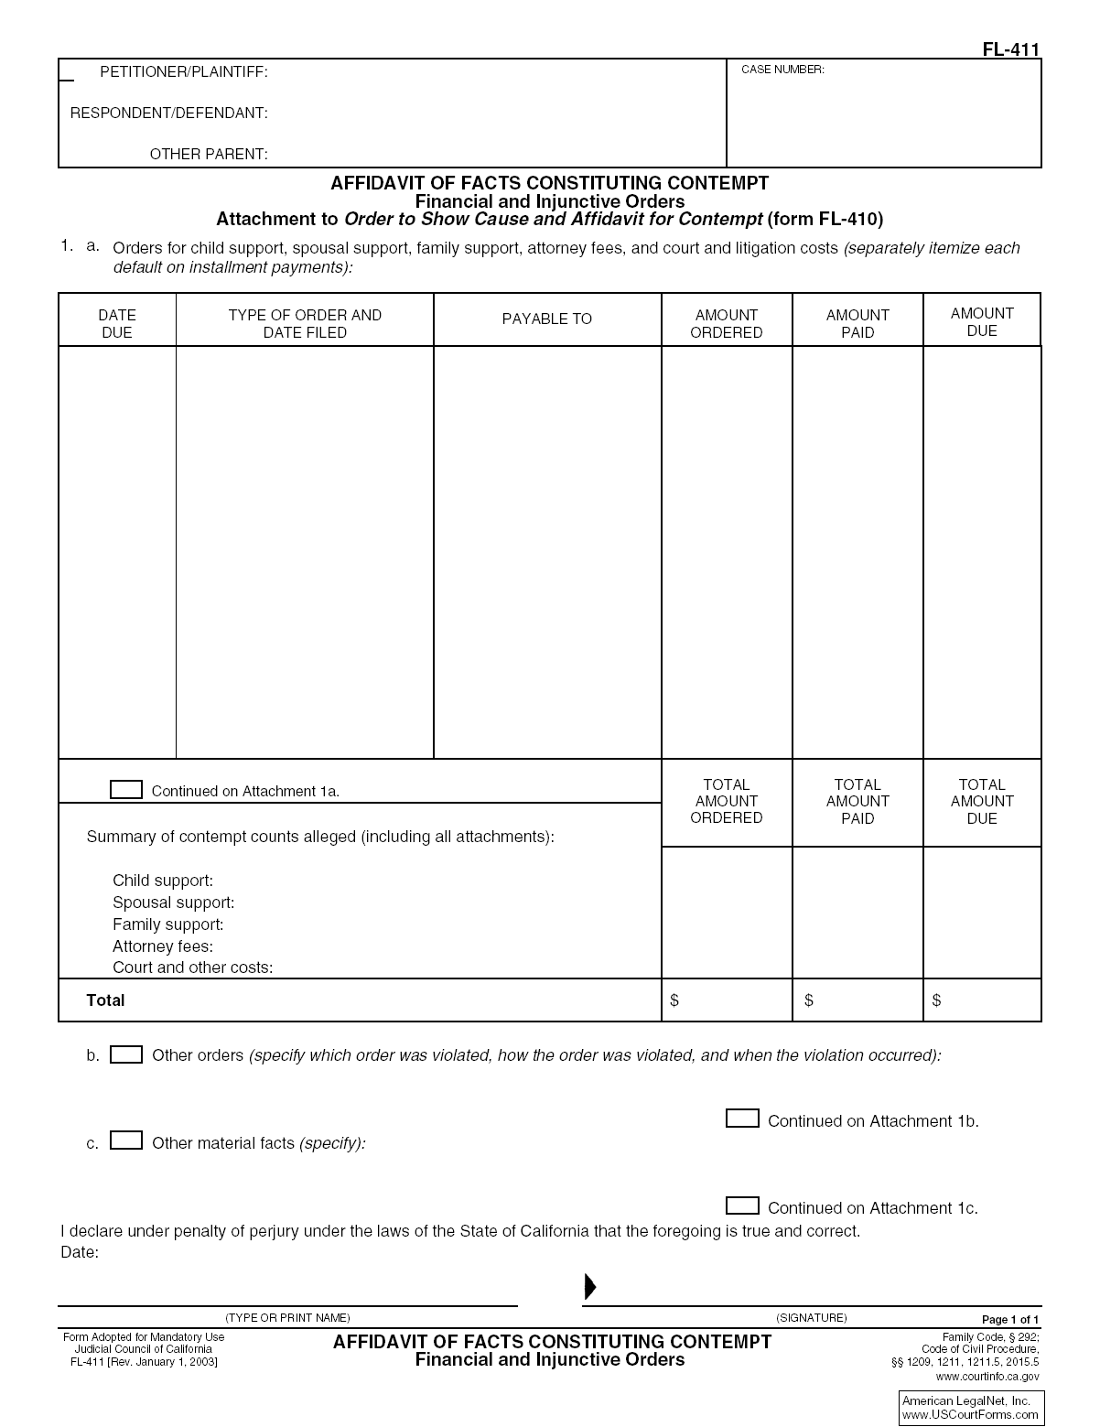
Fill out EXACTLY as this information appears on your other documents
Case Number
Date Here
What Was Ordered & Date Filed
Who Received the Money
Amount of Money Ordered
Amount of Money Paid
Amount of Money Still Owed
Check this box if you need more room. Create an “ATTACHMENT 1a”
How Many Times Have Each of the Items Listed Been Violated?
Total Amount Ordered
Total Amount Paid
Total Amount Still Owed
$ amount for each category regarding each item listed to the left
Check this box if there are any other orders that were violated. Then tell the Court HOW those orders were violated and the DATE of the violation.
Write in any other important facts the Court should know. Create an “ATTACHMENT 1c” if you need more room.
Date Here
Print Your Name
Sign Your Name
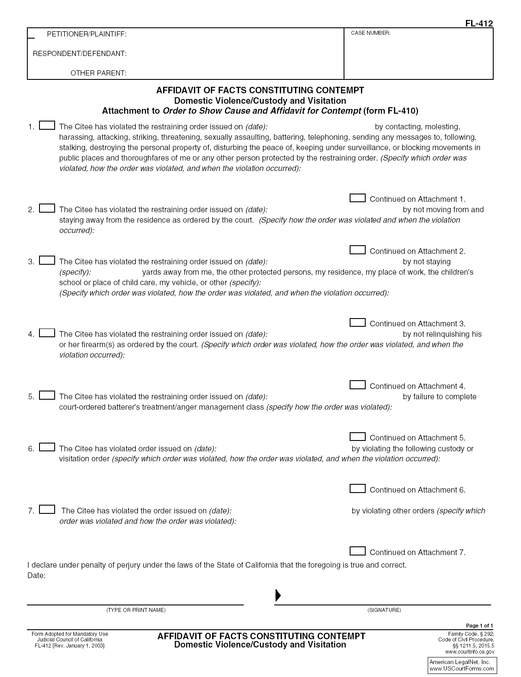
Fill out EXACTLY as this information appears on your other documents
Case Number
Date of Restraining Order
Write down how the order was violated and the date of the violation
Check the box if this item applies to you
Check the box if this item applies to you
Check the box if this item applies to you
Check the box if this item applies to you
Check the box if this item applies to you
Check the box if this item applies to you
Check the box if this item applies to you
Date Here
Print Your Name
Sign Your Name
Date of Restraining Order
Date of Restraining Order
Write down what the order was, how the other party violated the order, and the date the violation occurred
# of yards
Other protected areas
Date of Restraining Order
Write down what the order was, how the other party violated the order, and the date the violation occurred
Date of Restraining Order
Write down what the order was, how the other party violated the order, and the date the violation occurred
Date of Order
Date of Order
Write down what the order was, how the other party violated the order, and the date the violation occurred
Write down what the order was, how the other party violated the order, and the date the violation occurred
Write down what the order was, how the other party violated the order, and the date the violation occurred
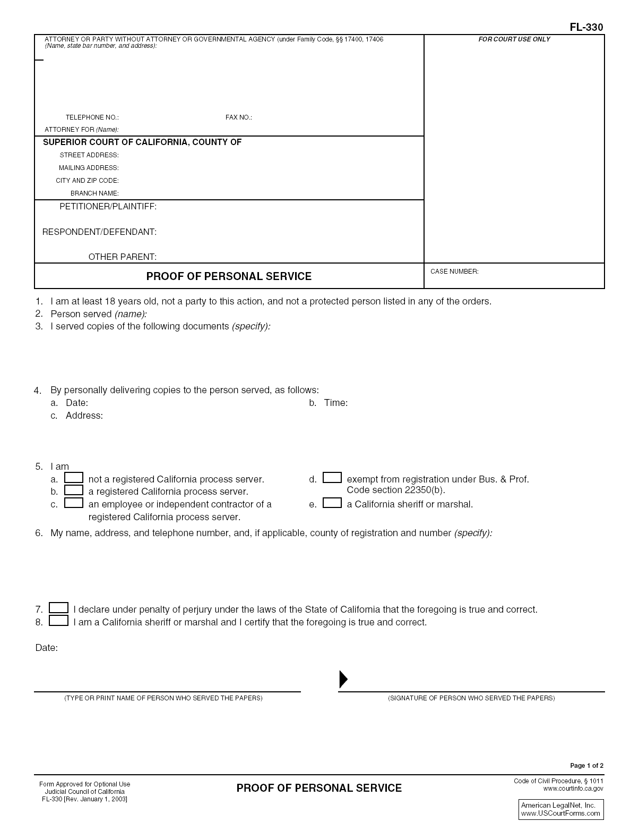
This is the Form Number
Your Name, Street Address, City, State, and
Zip Code
Type “IN PRO PER”
”
SAMPLE
The County Name
Court’s Street Address
Court’s City, State, and Zip Code
Fill out EXACTLY as this information appears on your other documents
Case Number
Name of Other Party
Write in “Order to Show Cause and Affidavit for Contempt; BLANK Responsive Declaration”
Date Person Was Served
Time the Person Was Served
Address Where the Person Was Served
Check this box
The name, address, and telephone number of the person that SERVED the documents for you
Check this box
Date Here
Server’s Printed Name
Server’s Signature

