Satisfaction Survey Testing Information

As you know, we were successful in getting an increase in self-help funding. We would like to assure that the increased amount is sustained and that future increases are considered. To help us do that, your participation in this data collection effort is very important.

As part of the cost-benefit study, all self-help programs are being asked to collect customer satisfaction surveys. The purpose of this statewide effort is to help us demonstrate to the legislature the importance of the work that self-help centers are doing, using the customers’ own feedback and words. Customer satisfaction data can be very useful for programs and may help secure additional future funding for services. This also provides customers the opportunity to have their voices heard, which is often appreciated by those receiving services. The results of the survey can provide programs with useful information about what is working and also identify potential areas for improvement.

We are asking that you do the following:

For in-person encounters:
- If you did not request copies to be pre-printed for you, you will have to make copies of the survey, both in English and Spanish.
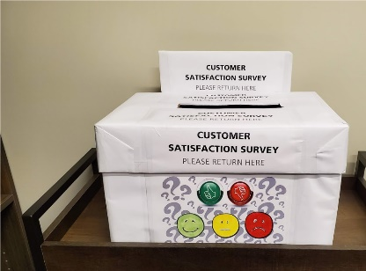
- Create at least one Customer Satisfaction Survey Box and place it somewhere that gives the public a little privacy, but that is easy for everyone to find. We are including graphics and instructions for how to make your box. This is just a suggestion-you can make your collection box to be decorated in any way that suits you.
- Instruct any staff who will be working with the public about the fact that we will be conducting the survey during the week of October 15-19. Tell them why it is important that we get as many surveys collected as possible!
- Make sure there are pens available for the public to use when filling out the survey. Also, they will need some surface space to use when filling out the survey, so if the collection box and pens could be on a table or counter with space for the litigants to use to write on their survey=that would be great!
- Check the boxes periodically-if they get full, you can empty them.
- Once the week is over and you have collected all of the surveys, you can photocopy them if you want a set for your records. We will send you a report that tells you what the surveys say.
- Mail them back to us using the prepaid mailing label(s) we send to you.

For the online survey-
We will post some information and a link on the Equal Access site and send that link to you. You can then just copy what we send and paste it at the end of your email communications.

We realize that this will add to staff workload during the study period; however, this extra effort will allow us to share the public impact of the work being done at self-help centers across the state.

Thank you for your participation!!
Staff Instructions for the Self-Help Customer Satisfaction Survey Week

During the data collection week (Oct 15th-18th) the goal is to obtain feedback from as many customers as possible. Each customer should be provided the opportunity to complete the survey and assured that their responses will be confidential and will not impact their court case in any way. They will not be asked to provide their names or any other identifying information and there will be an enclosed drop box for customers to leave their completed surveys.

1. Data will be collected between Tues, Oct 15th through Friday, Oct 18th

2. Staff completes the back section of the form before handing the survey to the customer.

3. Surveys should be offered to ALL customers at time of service completion.

4. Let customers know that their feedback is important for ensuring services are meeting their needs.

5. Customers should be informed that the survey is optional, responses are confidential, and their participation (or lack of participation) will not influence their case or future assistance at the center in any way.

6. Customers should be allowed to complete the survey as privately as possible (e.g., staff should not be sitting next to them while they are filling out the survey).

7. Instruct customers to drop surveys in enclosed drop boxes that will be provided to the self-help centers. They should NOT hand a completed survey back to the staff.

