 |  | Administrative  Office of the Courts
SUPERIOR COURT OF CALIFORNIA
[County of XYZ]
LOCAL INTEGRATION ASSESSMENT

criminal – phase II

[DATE]


Administrative Office of the Courts

SUPERIOR COURT OF CALIFORNIA
[County of XYZ]
LOCAL INTEGRATION ASSESSMENT

CRIMINAL – PHASE II

[DATE]

Judicial Council of California
Administrative Office of the Courts
Information Services Division
455 Golden Gate Avenue
San Francisco, CA 94102-3688

Copyright © 2008 by Judicial Council of California/Administrative Office of the Courts. All rights reserved.

Except as permitted under the Copyright Act of 1976 and as otherwise expressly provided herein, no part of this publication may be reproduced in any form or by any means, electronic or mechanical, including the use of information storage and retrieval systems, without permission in writing from the copyright holder. Permission is hereby granted to nonprofit institutions to reproduce and distribute this publication for educational purposes if the copies credit the copyright holder.

Contents

Page
I. Introduction 2
A. Local Integration Assistance Methodology Overview 2
B. Document Organization 3
II. Current Environment 5
A. Application Environment 5
B. High-Level Application Inventory 5
III. Direct Data Entry and Inquiry Capabilities 7
A. Justice Partner Inquiry of the Court Systems 7
B. Court Inquiry of the Justice Partner Systems 7
C. Justice Partner Data Entry into the Court Systems 8
D. Court Data Entry into the Justice Partner Systems 8
IV. Automated Data Exchange Capabilities 10
A. To-Court Exchanges 10
B. Exchange Descriptions 10
C. From-Court Exchanges 10
D. Exchange Descriptions 11
E. Exchanges by Conversation 11
V. Reporting Capabilities 15
A. Criminal Reports 15
B. Traffic Reports 15

INTRODUCTION

Introduction
The Superior Court of California, [County of XYZ], is in the process of migrating to a new criminal and traffic case management system (CMS). The court is currently involved in the assessment phase where information surrounding the current environment is being documented and evaluated by the court to determine the best strategies and approaches to use moving forward into future
implementation phases.

This document presents the court’s understanding of the current integration environment and factors surrounding this environment. The information included here will be validated with local justice partners and eventually used to determine and document interface priorities and strategies in later documents.

Local Integration Assistance Methodology Overview
The objective of the Local Integration Assessment Methodology (LIAM) Light is to provide a structured process and approach that will enable judicial branch stakeholders to:

- Provide an approach for organizing the assessment of integration capabilities between justice partners and the court.
- Document the current integration environment between the court and its justice partners.
- Determine a strategy and approach for identifying the integration capabilities to be maintained as part of the court’s transition to a new CMS.
- Document a general plan of action for proceeding.

Achieving these objectives will position the justice partners and their courts in preparing and planning for maintaining needed integration capabilities for inclusion in an overall CMS transition plan.

The diagram below depicts the LIAM Light and the documents related to each phase throughout the process. You will note that this document serves as the Local Integration Assessment deliverable shown under Phase II in the following diagram.
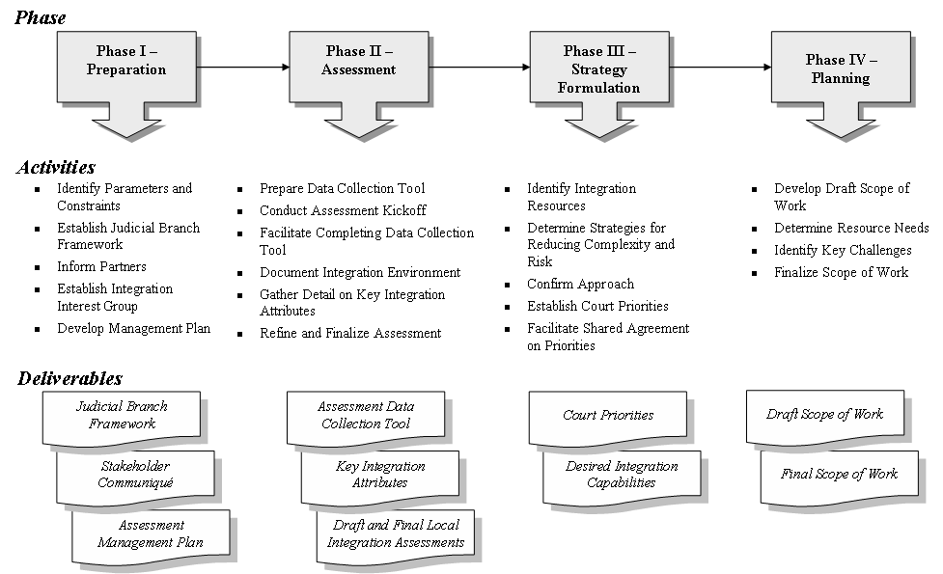

Document Organization
The purpose of this document is to outline the current information exchange environment that is automated with information technology solutions. In order to accomplish this purpose, the document has been divided into the following sections:

- Section II – Current Environment. This section provides a summary of the business applications and current level of automation in place within the court. Further details
surrounding the integration capabilities are provided in later sections.
- Section III – Direct Data Entry and Inquiry Capabilities. This section details the events where manual processes are currently used to make queries or enter data into a software
application.
- Section IV – Automated Data Exchange Capabilities. The information exchange transactions that are automatically communicated between the justice partners and their courts are described in this section. It covers exchanges both to and from the court when interacting with its local justice partners.
- Section V – Reporting Capabilities. Another form of justice partner automation is the generation of reports on a schedule or on-demand basis. Automation through standard
reports is listed and briefly described in this section.

CURRENT ENVIRONMENT

Current Environment
This section presents the court’s understanding of the current applications, tools, and software currently available to the court and its justice partners. Key business applications are discussed, and a summary of integration capabilities that are both available and unavailable is included as well.

Application Environment
[A brief description of the applications as they currently exist, who maintains them and how they interact. Ideally provide a diagram of the application environment in this section as well.]

High-Level Application Inventory
The following table lists the core applications in use within the county that are in some way interconnected with the court:
Agency/Function | Current System
Court:  Criminal CMS | Name/Product/Version: [Application Name]  Vendor/Provider: [Vendor]  Database Platform: [Operating System]  Server Platform: [Server Hardware]
Sheriff:
Jail Management System/Records Management System
Sheriff:
Local Warrants System
District Attorney (DA):
Case Management System
Probation:
Case Management System
Public Defender:
Case Management System
Others?

DIRECT DATA ENTRY AND INQUIRY CAPABILITIES

Direct Data Entry and Inquiry Capabilities
Often, direct data entry and inquiry is used by justice partners and their courts to exchange information. This is common in low-volume transactions where a particular transaction or information exchange event occurs infrequently enough that direct inquiry is a valid approach.

The information contained in this section should be used by the implementation team to determine if the new case management system will address court and justice partner direct inquiry and input needs in a satisfactory manner or take steps to address the need in a different manner.

Justice Partner Inquiry of the Court Systems
This subsection lists and briefly discusses which justice partners currently inquire into the court’s portion of the system and for what purposes. For the purpose of this analysis, inquiry differs from integration in that a justice partner would go into a court-specific screen in order to obtain necessary information rather than relying on the court information to be shown directly in their own portion of the application.

ID | Court System Accessed | Agency/Entity Provided Access | Type of Case and Data | Method of Inquiry | Number of Users | Typical Inquiry Frequency
PI-1
PI-2

Court Inquiry of the Justice Partner Systems
This subsection lists and briefly discusses which parts of the justice partners’ systems the court has access to, as well as methods for obtaining necessary information. For the purpose of this analysis, inquiry differs from integration in that the court would somehow access a justice partner’s screen rather than see the justice partner’s information directly on the court-purposed screens.

ID | Agency Accessed | Agency System Access | Type of Data | Method of Inquiry | Number of Users | Time of Frequency
CI-1
CI-2

Justice Partner Data Entry into the Court Systems

ID | Entering Agency | Data Entered and Purpose | Court System Entered Into | Number of Users
PE-1
PE-2
PE-3

Court Data Entry into the Justice Partner Systems

ID | Entering Agency | Data Entered and Purpose | Court System Entered Into | Number of Users
CE-1
CE-2
CE-3

AUTOMATED DATA EXCHANGE CAPABILITIES

Automated Data Exchange Capabilities
Automated data exchanges are defined as information exchanges that occur automatically based on triggering or scheduled events. Some counties use a single criminal justice information system however the logical exchange of information still occurs based on the business process enforced and where a justice partner begins working with information another justice partner provided. All such information exchanges (whether logical or actual) are listed in this section.

To-Court Exchanges
Exchanges that are inbound to the court are considered to-court exchanges. The transactions may be either a push or pull, but regardless, the information is provided to the court, thereby reducing or eliminating data entry on the part of court staff. The following table lists these exchanges:

ID | Exchange | Logical Exchange Partner
T-01
T-02
T-03
T-04a

Exchange Descriptions

- T-01 – Exchange Name: Exchange description

From-Court Exchanges
Exchanges that provide justice partners information from the court’s system in an automated fashion are considered from-court exchanges. These exchanges may be either a push or pull; regardless, they provide justice partners with information they require and typically reduce or eliminate data entry required by justice partner staff. The following table lists these exchanges:

ID | Exchange | Logical Exchange Partner
F-01a
F-01b
F-02a
F-02b

Exchange Descriptions

- F-01a – Exchange Name: Exchange description.

Exchanges by Conversation
Another way in which to view the information exchanges is within context of the transaction flow. Each business driver or transaction generally consists of several information exchanges, which are also known as conversations.

[Create conversation diagrams for each logical conversation that takes place. The purpose of this section is to express the context of current information exchanges to the future system developers. One example is included below.]

- Arrest and Booking – Prior to becoming a case within the court’s jurisdiction, some information is passed between law enforcement, the court, and prosecution. The first
conversation that takes place surrounds booking where arrest charges and the subject’s core person information are shared with the court. If the booking is for an in-custody individual, the booking also automatically schedules the arraignment on the court calendar.
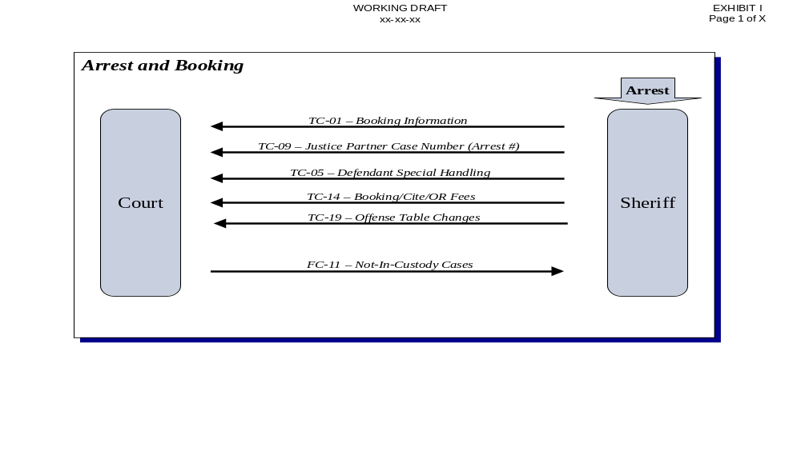

REPORTING CAPABILITIES

Reporting Capabilities
Numerous reports are currently generated by the CMS, today the majority of which rely on court data to be produced. This section provides a list of the reports known at the time of this document’s writing, along with the last date the report was requested and the number of times the report is known to have been produced since it was placed on the menu. In addition, there may be other reports that are being produced by the justice partners and are not on the menu, which also must be addressed prior to implementation.

The information contained in this section should be used by the implementation team to determine if the new case management system will address statewide integration needs in a satisfactory manner or take steps to address the future needs in a different manner.

Criminal Reports
Job/Report Name | Last Date Report Run | Last Department Requesting Report | # Times Requested | Report Is Currently Queued | Notes
Badge List Report | 07/09/2006 | AG | 4382 | Y

Traffic Reports
Job/Report Name | Last Date Report Run | Last Department Requesting Report | # Times Requested | Report Is Currently Queued | Notes
114 PC Charges Filed/Unfiled | 01/28/2003 | DA | 1

Numbers based on IJS user ID count provided to the court by ISD on November 3, 2006.
Please note that ID numbers are no longer sequential, as traffic exchanges were removed from the list and placed into a separate traffic-focused document.
Please note that ID numbers are no longer sequential, as traffic exchanges were removed from the list and placed into a separate traffic-focused document.

