Lesson Plan: Why Do I have to Do jury Duty?

Context of the unit:
This unit is focused on 8th grade History-Social Science. Students will be able to demonstrate a knowledge and understanding of the jury system in the United States (history, process, benefits to the accused, etc.) through participating in mock trials, writing, research, and debate among themselves.
Context of the lesson within the unit:
This lesson will follow an introductory lesson on the history of the jury system (6th Amendment and Due Process Clause of the 14th Amendment). The introductory lesson will be preceded by a brief mock trial illustrating the significance of jury trials in criminal cases. This lesson will be followed by a mock trial on the jury selection process. A subsequent lesson will focus on persuasive writing and internet research. In this subsequent lesson, students will write a persuasive essay and deliver a presentation focused on whether jury duty should be a civic obligation or not.
Standards Addressed: History Social Science
8.2(6) Enumerate the powers of the Government set forth in the Constitution and the fundamental liberties ensured by the Bill of Rights

Standards Addressed: English-Language Arts
Writing Strategies
1.4: Plan and conduct multi-step information research by using computer networks and modems

1.5: Achieve an effective balance between research information and original ideas;

Writing Applications
2.4: Write a persuasive composition:
a. Include a well-defined thesis (i.e., one that makes a clear and knowledgeable judgment)
b. Present detailed evidence, examples, and reasoning to support arguments, differentiating between facts and opinion
c. Provide details, reasons, and examples, arranging them effectively by anticipating and answering reader concerns and counter arguments
Speaking Applications
2.4: Deliver a persuasive presentation:
a. Include a well-defined thesis (i.e., one that makes a clear and knowledgeable judgment)
b. Present detailed evidence, examples, and reasoning to support arguments,
differentiating between facts and opinion
c. Provide details, reasons, and examples, arranging them effectively by anticipating and answering reader concerns and counter arguments
d. Maintain a reasonable tone

Common Core State Standards for ENGLISH LANGUAGE ARTS & Literacy in History/Social Studies, Science, and Technical Subjects
College and Career Readiness Anchor Standards for Writing Grades 6-12
Text Types and Purposes
1. Write arguments to support claims in an analysis of substantive topics or texts, using valid reasoning and relevant and sufficient evidence.
2. Write informative/explanatory texts to examine and convey complex ideas and information clearly and accurately through the effective selection, organization, and analysis of content.

- Use technology, including the Internet, to produce and publish writing and to interact and collaborate with others.

Objective(s):
- Students will be able to demonstrate a knowledge and understanding of the jury system in the United States (history, process, benefits to criminal defendants and litigants, etc.) through mock trials, research, writing, and debate with other students.
- Students will demonstrate an understanding of the jury selection process including the challenges.

Lesson Plan: Why Do I Have to Do jury Duty?
Big Idea(s):
- The strength of a democracy is equal to the strength of its’ citizens.

The Sixth Amendment to the Constitution provides that, "In all criminal prosecutions, the accused shall enjoy the right to a speedy and public trial, by an impartial jury of the State and district where the crime shall have been committed..."This provision originally applied only to federal criminal prosecutions. In 1968, the Supreme Court decided that the right to a trial by jury in most criminal cases is so fundamental that it constituted an element of due process that the state is obligated to provide by the Fourteenth Amendment's Due Process Clause. Students will have an opportunity to look at both sides of the jury system (with and without) and to decide if they feel that jury duty should be obligatory for U.S. citizens.

Higher Order Thinking Questions
- Should all criminal defendants be entitled to a trial by jury?

- Should all citizens be required to participate in jury duty if called?

- Have your ideas changed on these issues from lesson to lesson?

- What additional issues can you raise after doing Internet research?

- Is our society more civilized because of the right to jury trials?

- Would you rather live in a society where there is no jury trial for criminal defendants?

Lesson Plan: Why Do I Have to Do jury Duty?
Assessment: Students will be evaluated through informal checks for understanding, teacher observation, on-line quizzes, journal writing, persuasive writing assignment, and oral presentation of persuasive writing.

Lesson Plan: Why Do I Have to Do jury Duty?
Activity Steps:
Set (Hook): Several students from another class will perform a brief and amusing mock trial in front of the target class wherein there is no jury and overwhelming evidence that the defendant is innocent. (See trial script attached.) The judge will find the defendant guilty (from the bench) immediately following the final arguments. After discussion, the students will be told that this was an exercise to show them the importance of the jury system and that most judges are fair and take the time to consider evidence. Student actors needed: judge, prosecutor, defense attorney, narrator, Miss Lulu, defendant, bailiff
Input/Procedures: Activate prior knowledge: Tell students they do not have to respond, but ask if anyone has been to court and would like to tell about it. Allow students to share their experiences if they want.

Lesson 1: Introduction to the Court System

Using projector connected to Internet, go to http://www.courts.ca.gov/cms/cab/; scroll to "Getting to Court"> Who Are the People in Court (show from judge through witnesses). Explain participants on each page, ask for questions/comments/discuss.

Guided Practice:
After discussion, go to the quiz entitled "Who's Who in the Court" and ask for volunteers to lead the class, control the mouse, and select the correct answers after whole-class discussion on each item. Students may work in pairs at individual laptops while participating in the whole-class discussion.

Assessment:
Students will reflect in their journals about what they learned about the court system and the importance of juries in criminal trials. They will also write about their feelings about jury trials, which arose from the lesson. Students will take today's quiz independently on the day following the lesson.
Lesson 2: Mock Trial: Jury Selection Process (may require two classes)
(See attached Mock Trial Script)
Prior to delivering the lesson, students will be selected to play the various roles in the mock trial. They will be given the script to study. I will use the same scenario as in Lesson 1. The room will be arranged like a courtroom with judge's desk, clerk and reporter's desks, defense tables, and jury box.
Teacher will give a mini-lesson on the psychology of jury selection, i.e., perspective juror's or family members' criminal history/experience, background, employment, feelings about police officers, the court system, witness ability to recall facts, fairness of judges and the system in general, etc.) Mini-lesson will include discussion of juror challenges (peremptory and for cause,) and the history of the jury system and "representative cross-section of the community" concept.
Teacher will explain that the students will be in charge of taking their roles seriously and that teacher will be there to observe and provide assistance where needed only. (All students in this class scored either Proficient or Advanced on the CSTs.)
The trial (jury selection) will begin with the bailiff asking all to rise as the judge enters the courtroom ... (see attached mock trial script and juror information page with "unisex" names for convenience.) Once all parties are seated, Teacher will explain that prospective jurors do not usually have so many facts about a case prior to being interviewed but that for the purposes of this lesson it is helpful to know what the witnesses would say. Teacher (or a student) will then read the Lesson 2 Scenario (attached.) Teacher will also explain and pass out scripted sample juror questions and explain its contents to both attorneys and jurors.

Guided Practice:
Students will follow along with the script and read their parts. Students will assist each other, and teacher will assist where needed.

Assessment:
Students will again reflect in their journals about how their feelings might have changed since their previous reflection and/or what new beliefs or ideas they may have based upon the dialogue in the mock trial. Students will write whether they believe jury duty should be mandatory or not and why.

Anticipatory Set
Mock Trial

The following scenario is read to the class by the Narrator, who will ask students to close their eyes and visualize what is happening:

Narrator: Lulu is walking into the Dollar Tree to buy cookies. Suddenly someone comes up from behind her and knocks her down, ripping her purse from her arm. At that moment, Bob, a clerk inside the Dollar Tree, sees what is happening. He yells at his manager that he's going to take his break, runs out the door, and grabs the purse from the robber. As he does so, the robber punches Bob in the face; and Bob falls to the ground, still clutching the purse in his hand. The robber runs away.
Several people witness the incident and call the police. One witness chases after the would-be robber, but he gets away. When the police arrive, Bob is still on the ground holding the purse. The victim Lulu, not having seen who attacked her, starts screaming and pointing at Bob, shouting, "That's him! That's him! He tried to steal my purse!" She grabs her purse from Bob and hits him over the head with it.
The police officer asks Bob what happened, and Bob replies that he was trying to stop the robber from taking the woman's purse. Several witnesses come forward and confirm that Bob was not the thief. Bob's manager also tells the police officer that Bob was stocking paper plates at the time of the robbery and went to help the victim. The police look around and do not see the robber, and they arrest Bob for robbery and other charges.
At Bob's criminal trial, all of the witnesses show up to testify on his behalf. Unfortunately for Bob, he lives in the twilight zone where criminal defendants are not entitled to a jury trial. This means that, although Bob could be sentenced to serve many years in prison if convicted of the crimes, he has to place his future in the hands of only one person, THE JUDGE!
But let's look at the bright side: The trial will be over in a much shorter time if the attorneys don't have to interview a bunch of people to sit as jurors. And if convicted of the crimes, Bob can go to prison right away so he won't have to worry about paying rent or buying his own food.

Narrator: The trial begins. The prosecutor makes an opening statement:

Prosecutor: This is an “open-and-shut case,” Your Honor. The defendant Bb, if that’s his real name, viciously attacked poor Miss Lulu in front of the Dollar Tree. When the police arrived, the Defendant was holding her purse, and the victim said that he was the person who had robbed her. I don’t know why we’re even having this trial! Thank you. (Sits down)

Judge: Mr./Mrs. Defense attorney, are you going to waste the court’s time with an opening statement? (sighing)

Defense Yes, your honor. Since my client is not entitled to a jury trial, I have to

Attorney: respond to the lies the prosecution told in his/her opening statement. First of all, my client is a hero. That woman (pointing at Lulu) should have given my client a reward instead of bashing his head with her purse. There are sixteen witnesses who will all testify that someone else robbed the victim and that my client stepped in and tried to help her. My client should not be punished just because the victim didn’t see who the real robber was. Nothing further. (sits down)

Judge: How long does everyone think this trial will last? I’ve got a Judge-of-the-Year party to go to at 4:00 this afternoon, and I don’t want to be late accepting my award.

Prosecution: I think we can wrap it up in about 15 minutes.

Defense: Fifteen minutes!! (shouting) I have 16 witnesses to call who will all testify that my client is innocent. Poor Bob has a lot at stake in this trial. I sure wish we had a representative cross-section of the community to decide his fate! Or at least more than just one person who’s in a hurry to get it over with. (sighs)

Judge: Very well, then. Take all the time you need, as long as I am out of here by 3:45. Prosecution, call your first witness.

Prosecution: The People call the poor, pathetic victim, Miss Lulu. (Miss Lulu takes the stand)
Miss Lulu, who robbed you on the date in question?

Miss Lulu: He did! (shouting and pointing at Bob) I found my purse in his hand and boy did I give it to him! (gesturing, hitting Bob over head)

Prosecution: Northing further. Thank you.

Judge: Mr./Mrs. Defense, do you feel a need to cross-examine this witness? (looking at his watch)

Defense: You bet I do!
Miss Lulu, did you see the person who attacked you?

Miss Lulu: Well…no…not exactly…But…

Defense: Then how could you testify before that my client is the robber?

Miss Lulu: Well…I…um…

Defense: No further questions for this witness, Your Honor. (Lulu leaves the witness stand)
The defense calls Witness No. 1

Narrator: Witness number one testifies that another person robbed Lulu and that Bob was actually a hero for trying to help her. The defense then calls his remaining witnesses who all testify that Bob is innocent.

Both sides give closing arguments to the Judge.

Judge: After careful consideration of all the evidence, I find the defendant Bob (if that’s his real name) to be guilty as charged. Besides that, just look at him. He looks guilty. And I’m going to throw the book at you. (glaring at Bob) I hereby sentence you to the maximum sentence allowed by law, 15 years in prison. Bob, did you bring your toothbrush with you to court?

Narrator: The bailiff gleefully hauls the defendant Bob off to jail.

Mock Trial: Jury Selection
Lesson 2

The following scenario is read to the class by a student (reader will ask students to close their eyes and visualize what is happening):

Scenario: Lulu is walking into the Dollar Tree to by cookies. Suddenly someone comes up from behind her and knocks her down, ripping her purse from her arm. At that moment, Bob the clerk inside the Dollar Tree, sees what is happening. He yells at his manager that he’s going to take his break, runs out the door, and grabs he purse from the robber. As he does so, the robber punches Bob in the face; and Bob falls to the ground, still clutching the purse in his hand. The robber runs away.
Several people witness the incident and call the police. One witness chases after the would-be robber, but he gets away. When the police arrive, Bob is still on the ground holding the purse. The victim Lulu, not having seen who attacked her, starts screaming and pointing at Bob, shouting, “That’s him! That’s him! He tried to steal my purse!” She grabs her purse from Bob and hits him over the head with it.
The police officer asks Bob what happened, and Bob replies that he was trying to stop the robber from taking the woman’s purse. Several witnesses come forward and confirm that Bob was not the thief. Bob’s manager also tells the police officer that Bob was stocking paper plates at the time of the robbery and went to help the victim. The police look around and do not see the robber, and they arrest Bob for robbery and other charges.

Lesson 3: Mini-Lesson on Persuasive Thinking/Writing and Internet Research

After mini-lessons, teacher will show students the Internet version of the 14-minute video, Ideals Made Real, which all prospective jurors watch in the jury room prior to being sent to a court room (www.courts.ca.gov/jurybasics.htm). Students will then research the jury selection process (challenges for cause/peremptory challenges. Representative cross-section of the community concept, civic responsibility, etc.) and decide if they believe that all eligible citizens should be required to participate as jurors when called. Teacher will assist in internet search where needed.

Assessment:
Students will write a persuasive essay giving their position on jury duty being a civic obligation and will later participate in a debate against another student who has the opposite view.

Adaption for English Language Learners/Special Education Students:
The lessons in this Unit are designed to reach all learners as they include many visuals, audio presentation/explanations, and hands-on experience for the students.

Extension Ideas:
- Use Courts in the Classroom CD Judicial Council of California, Administrative
Office of the Courts) to do additional research/reporting out
- Use www.courts.ca.gov/juryservice.htm for additional information on jury requirements
- Watch Twelve Angry Men to obtain an interesting viewpoint of the jury deliberation process
- Use attached quotes to do a sorting activity (by person's attitude about juries) and to choose a quote to persuade in writing and in a presentation.

Lesson Plan: Why Do I Have to Do jury Duty?
Materials and Resources Needed:
- Projector connected to Internet
- Mock trial script for Set
- Mock trial script for Lesson 2
- Journal for each student
- Jury service notices for 20 prospective jurors (students in class)
- Wardrobe for each role
- Page of juror info to be copied on card stock and cut into cards (one stack for clerk, another for jurors; juror names page to Judge and attorneys)
- List of sample juror questions
References:
- California Content Standards (www.cde.ca.gov)
- "Courts in the Classroom" CD/web site by Karen Viscia
- www.courts.ca.gov
- www.ajs.org/jcliuries for overview of the history of jury trials

“ I consider trial by jury as the only anchor every yet imagined by man, by which a government can be held to the principles of its constitution.”
Thomas Jefferson
American 3rd US President (1801-09). Author of the Declaration of Independence, 1762-1826
“I’m no idealist to believe firmly in the integrity of our courts and in the jury system – that is no ideal to me, it is a living, working reality. Gentlemen, a court is no better than each man of you sitting before me on this jury. A court is only as sound as its jury, and a jury is only as sound as the men who make it up.”
Harper Lee
American writer b.1926
“It would be enough for me to have the system of a jury of twelve versus the system of one judge as a basis for preferring the U.S. to the Soviet Union. I would prefer the country you can leave to the country you cannot.”
Joseph Brodsk
Nobel Prize for Literateture in 1987. 1940-1996
“Ending racial discrimination in jury selection can be accomplished only by eliminating peremptory challenges entirely.”
Thurgood Marshall
American jurist and lawyer, 1908-1993
“When you go into court, you are putting your fate into the hands of twelve people who weren’t smart enough to get out of jury duty.”
Norm Crosby

“The defendant wants to hide the truth because he’s generally guilty. The defense attorney’s job is to make sure the jury does not arrive at that truth.”
Alan M. Dershowitz
“A jury consists of twelve persons chosen to decide who has the better lawyer.”
Robert Frost
American poet, 1874-1963

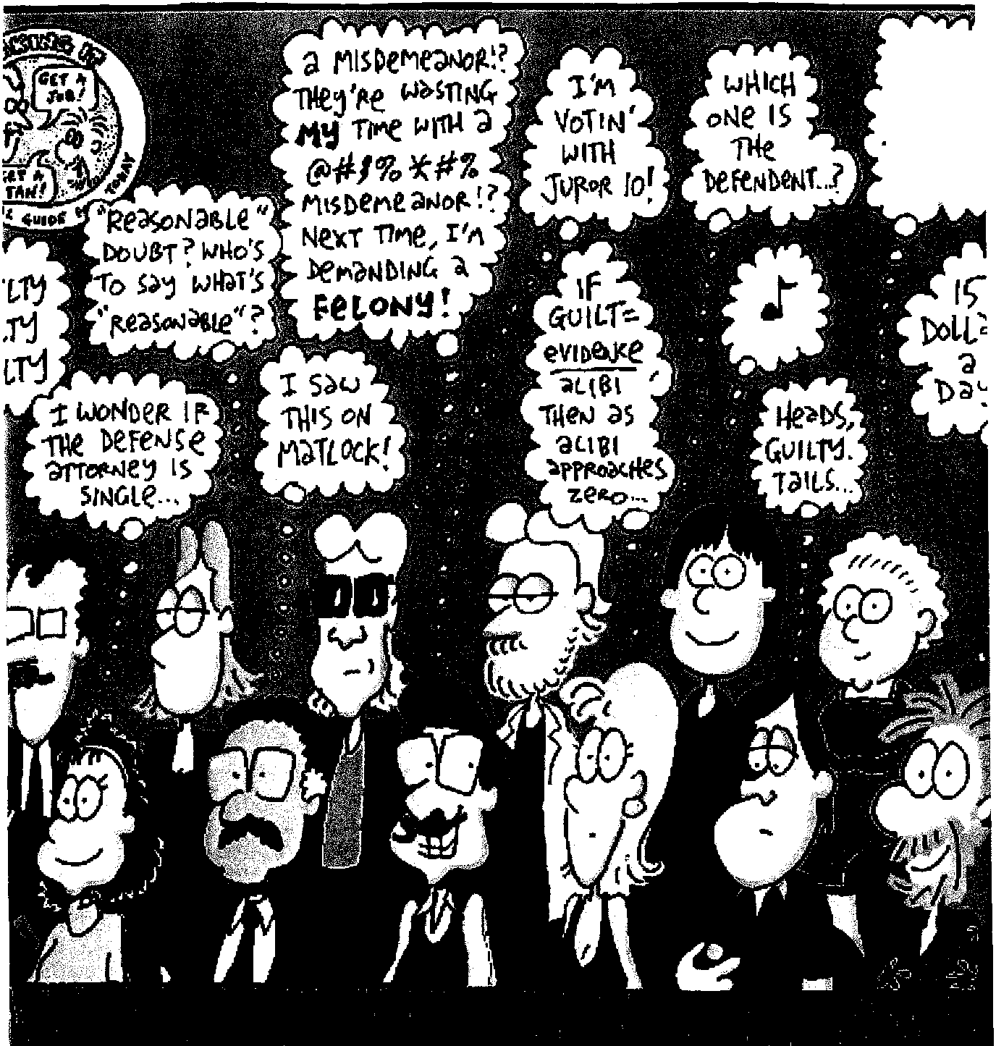
Lesson Plan: Why Do I Have to Do jury Duty?
Student Handouts:
Mock Trial: Jury Selection Process Script

Bailiff: All rise and come to order. (Judge walks onto the bench)
Department 55 of the MicroSociety Superior Court is now in session. The Honorable……………………………………….presiding. You may be seated.

Judge Grudge: Ladies and gentlemen, thank you for taking seriously your civic duty to sit as jurors in this case. My clerk will be calling you names randomly. When she does, please sit in the juror chair indicated by the bailiff. You will be assigned numbers and will be asked to sit in your corresponding chair when called. Juror number one will sit in the back left seat (bailiff pointing) and subsequent jurors will sit along the same row (bailiff gesturing.) Juror number seven will sit in front of juror number one (bailiff gesturing) and so on.
I will now introduce the parties in this case. The People are being represented by the District Attorney ……………………………………………(District Attorney stands and faxed jury, then sits)
The defendant is being represented by ………………………………………(Defense attorney stands)

Defense Attorney (still standing: I would like to introduce my client (Bob Hardluck (defendant stand and faces the jury then both sit)

Judge: This is the part of the trial known as jury selection. Each party will be allowed to ask each of you questions he or she feels are relevant to your serving as a juror. Please answer the questions honestly. Madam Clerk, please draw names and seat the first 12 jurors.

Clerk: Clerk draws a name card from the box and calls the name. Juror number one sits in the appropriate seat. Clerk continues until 12 people are seated (For ease in this lesson, names are in order)

Judge: Thank you. I will now allow the District Attorney to ask questions of the jurors.

Mr./Miss……………………., do you have any questions for Juror No.1?

District Attorney asks questions from the Sample Questions list.
Juror answers consistent with their card information.
After finishing questioning, Say “Thank you, no further questions.”
District Attorney sits.
Judge (to the Defense Attorney):
Mr./Miss…………………….., do you have any questions for juror number 1?
Defense Attorney (standing):
Yes, Your Honor. Thank you
Defense Attorney asks questions from the Sample Questions list.
Juror answers consistent with their card information.
When finished with a juror, both attorneys thank them and say “No further questions” and sit down.
Judge: Mr. Prosecutor, do you have any questions for Juror No. 2?

(Use the same script above for each juror in order until all 12 are seated. Alternate between Prosecution and defense attorney)

Pause for mini-lesson:

After all 12 jurors have been seated, the judge will allow the attorneys to excuse certain jurors either “for cause” or “Just because” which is called a peremptory challenge.

Judge (looking at Prosecutor):
Mr./Miss………………………, do you wish to challenge any of the jurors?

Prosecutor: Yes, Your Honor. I would like the Court to thank and excuse Juror No. 4.

Judge: (Looking at juror list for name of juror):
Mr./Miss Jones, you are excused. (Juror leaved the jury box)

Judge (to defense):
Mr./Miss ……………………, do you wish to challenge any of the jurors?

Defense: Yes, Your Honor, I would like the Court to excuse Juror No. 9.

Judge: Mr./Mrs. Smith, you are excused. (Juror leaves the jury box)

Continue with the same script until all the desired challenges are used.
(No more than 10 peremptory challenges per side)

After all jurors are dismissed, the Clerk will “randomly” call the remaining jurors, from the juror list, who will replace the dismissed jurors in the order called. The questioning process will begin again as to the newly-called prospective jurors.

Terry Brown, 34  Bank teller  Was robbed at work last year  Brother is an attorney | Tony Smith, 59  Store clerk  Was robbed once and beaten  Arrested for shop lifting | Blake Green, 19  College student  One conviction for stealing a car  Thinks all cops are liars | Dale Jones, 38  Car mechanic  Was falsely arrested last year
Keri Tip, 36  Waitress at Olive Garden  One arrest for drunk driving: (found not guilty)  Sister is a law student (1st year) | Ariel Post, 55  Unemployed  Gang member  Many convictions for drug sales  Lulu reminds him of his mother | Gayl Grimes, 43  Secretary for a Private Security Company  Loves cops (wants to marry one) | Dana White, 28  Pool sweep  Thinks it’s okay to take other people’s thinks if you really want them
Alexis Smith, 39  Postal Worker  Mother was robbed last year | Kris Kringle, 85  Works at Macy’s  Wraps Christmas presents | Joey Jordan, 53  Gardener  Son is a prosecutor | Fran Chase, 31  Prison Guard  Has been attacked many times
Billie Gripps, 25  Self-defense instructor  Gives lessons all day Mon.-Fri.  Supports his aging mother | Jody Baker, 61  Night Pastry chef at Dunkin Donuts  Doesn’t like being out during the day | Georgie Good, 68  Retired probation Officer  Dying to sit on a jury and convict someone | Frankie Black, 67  Bar tender  Once stole a ring  Brother is a cop
Bobbie Smith, 38  IRS Auditor  Went to police academy but flunked | Alex Ripp, 24  Middle School history teacher  Spouse is a cop  Cannot distinguish fact from fiction | Sami Gold, 25  Airline pilot  Was hijacked last year | Jamie Jones, 21  Career criminal  Hates all law enforcement

Scripted Sample Questions for Attorneys to Ask Prospective Jurors:

Note: Look at the juror you are questioning so that you will know whether to say "Mr." or "Miss." Always use the juror's name when asking the FIRST question.
Also Note: The following are sample questions. You do not have to ask every juror every question. Ask each juror 3 or 4 questions unless you feel it would be helpful to ask more (such as if the answer to a question leads you to another question)
SAMPLE QUESTIONS FOR THE JURORS:

1 . Have you ever been the victim of a crime?
2. Do you or does anyone close to you work in law enforcement (police, District Attorney, prison guard, etc.)?
3. Have you ever been accused of a crime you did not commit?
4. Do you have any felony convictions?
5. Have you ever had a negative experience with a law enforcement officer?
6. Have you already made up your mind about the guilt or innocence of the defendant Bob?
7. Will you promise to wait until all the evidence is in and you have deliberated with the other jurors to make a decision in this case?
8. Are you able to sit through a week or more of court days listening to evidence in this case?
9. Do you think it is possible for police officers to be wrong in their judgments?

Prospective jurors will be told to make up reasonable answers to each of the questions. They will be given the list of possible questions in advance so that they can plan their responses.

What’s Happening in Court?
An Activity Book for Children Who Are Going to Court in California

Here are fun activities and useful information to help children and their families who may be in court for any reason – whether they are visitors, witnesses, or involved in a case.
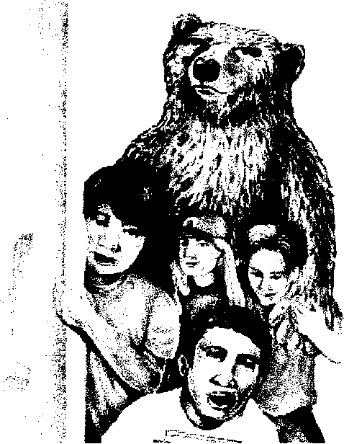
Start Here

Welcome From the Chief
Getting to Court
Court Proceeding Just for Children
Activities
About this Site

Back to Children, Families & the Court Site
Back to Main California Courts Site

Each activity in this site is marked with a bear paw symbol. For each activity, you will be given a lettered clue that will help you receive a “What’s Happening in Court?” diploma.
In some activities you print a page and color or draw something. For these activities, look for the “Click here for your clue” link. For the other activities, when you click “Done!” you get the clue. There are 12 clues in all. As you receive each clue, write it in order on a piece of paper so you can get your diploma! Click for more details.
All of the pictures of this book can be printed so that you can color them. Just click on any picture and print.

Who Are the People in Court?

Jurors
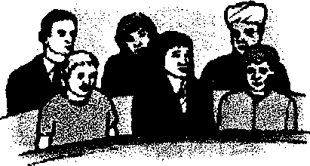
Other times, a group of people decides who wins the argument. These people are called jurors. Jurors are people who come to court to listen to each side of a disagreement. Then the jurors decide how the disagreement will be settled. A group of jurors is called a jury.

Who’s Who In Court?
Now that you know about some of the people in a court, try this match game. Pick the title of the person who does each job.

- These people come to court to tell the truth and talk about what they have seen or heard.
---pick one---

- This person types everything that is said in court into a machine.
---pick one---

- This person organizes all the papers and keeps track of the judge’s decisions.
---pick one---

- This person translates what is said in court.
---pick one---

- This person’s job is to make decisions and make sure that everyone follows the rules in court.
---pick one---

- These people give advice and talk in court for the people who have disagreements.
---pick one---

- This person keeps order in the courtroom and usually wears a uniform.
---pick one---

- These people listen to both sides of a disagreement in court and then decide who wins.
---pick one---

What to Expect from Jury Service

Ideals Made Real

Democracy is made real every day by thousands of jurors across the nation.
Many times, we don’t trust any one official, politician, expert, or other individual to determine another person’s fate. Whether it’s a civil trial, or a criminal trial, there are times when no one person should have so much power. Instead we trust the community to make the right decision. This is our democratic ideal – to impart justice that is truly of the people, by the people, and for the people.

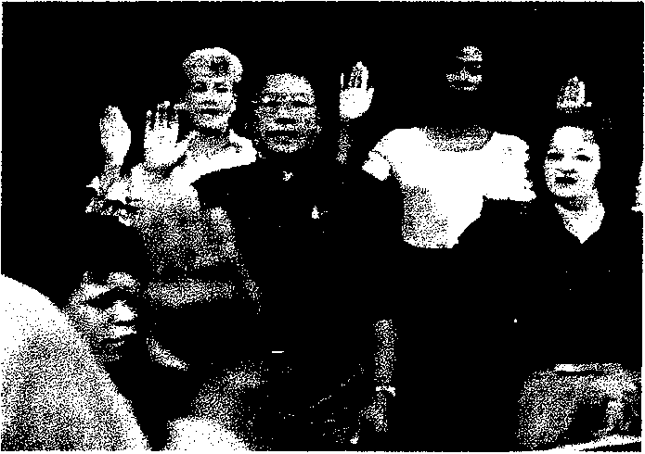
Being a juror is interesting and educational. Most jurors consider it an honor to play a part in the fair administration of justice. The following juror orientation video, “Ideals Made Real,” is typically shown at the courthouse during your service and will help you learn more about your day in court.

