**Lesson Title: *Articles of Confederation…Well, they were trying!***

**Grade Level:** 5th

**Context of the lesson within the unit**: This lesson (which will take place over several class periods) is the 2nd in a seris of three extensive lessons in the unit. It is designed for the students to understand that while individual choice is good, there are times when conformity is necessary and citizens working together can bring about a state of sovereignty. Through this lesson, the students will discover the shortcomings of the Articles of Confederation and the importance of compromise. This lesson transcends back in time to 1777, to learn how and why it was important to replace the Articles of Confederation with the Constitution.

**Social Studies and History Standards Addressed in the lesson:**

**5.7.1.** List the shortcomings of the Articles of Confederation as set forth by their critics.

**English/Language Arts Standards addressed in the lesson**

**Writing**:

* 1. Write a persuasive letter or compositions:

2. a. State a clear position in support of a proposal

2. b. Support a position with relevant evidence

**Common Core State Standards for ENGLISH LANGUAGE ART S & Literacy in History/SocialStudies, Science, and Technical Subjects – Writing**

Text Types and Purposes

Fifth Grade

1. Write arguments to support claims in an analysis of substantive topics or texts, using valid reasoning and relevant and sufficient evidence.
2. Introduce a topic or text clearly, state an opinion, and create an organizational structure

in which ideas are logically grouped to support the writer’s purpose.

**Objective(s):**

Students will list and describe the shortcoming of the Articles of Confederation.

Students will have a *deepened understanding* why the Constitution was written and why it is referred to as a “living document.” (Constitution and components addressed in Lesson 1)

**Lesson Title: *Articles of Confederation…Well, they were trying!***

**Big Idea(s):**

* E Pluribus Unum: out of many, one. *(From a variety of sources and experiences, we have developed a successful government and legal system)*
* Through actions come change, and change in the political process involves participation. *(The political process involves participation; understanding requires student engagement. Integration and application of new learning in multiple learning modalities helps students deepen understanding)*

**Essential Questions/Issues**

* Does social capital strengthen a republic?
* Is citizenship a right or responsibility?

**Lesson Title: *Articles of Confederation…Well, they were trying!***

**Assessment:**

Students will be evaluated through: Informal checks for understanding, teacher observation, writing prompts, class participation, formal assessment task.

**Formal Assessment**: Performance Task (GRASP) with scoring rubric.

**Formal Assessment** ~ Students will write a persuasive letter stating their position to ratify the Constitution. (Formal writing rubric)

|  |  |
| --- | --- |
|  | **GRASP: Your Mission** |
| **GOAL** | *Your first mission: You are a delegate from the state of Virginia. With the help of a travel guide, you both will maneuver through dangerous situations on a journey to Philadelphia. You will create reasonable solutions to conflicts that you encounter, and experience first hand how life was challenging under the Articles of Confederation.  * Your second mission: Having experienced dangerous and frustrating situations, you will write a newspaper article to the people of the State of Virginia explaining why it is important that Virginia agrees to ratify the Constitution. |
| **Role** | Virginia State Delegate |
| **Audience** | People of your state |
| **Situation** | Harrowing travels from Virginia to Philadelphia. This trip will give an opportunity to spread the news about the benefit of ratifying the new Constitution once you return from the Philadelphia Convention. |
| **Performance** | Using a game board and following game rules, you (the delegate) and your guide, will travel from Virginia to Philadelphia, experiencing various scenarios on the journey.  You will create solutions from various situations through 3 kinds of cards.  * **Articles of Confederation…Tough Day!” CONFLICT CARD**  Cards provide solutions to obstacles encountered on your travels  * **Great Day! NO CONFLICT CARD**  Cards reflecting a “smooth sailing day!” You perceive no issues to resolve on your   day of travel  * **$Currency$**  Cards that record currency issues throughout your travels  **Keep the following in mind:** *Your actions are based from the people who lived in 1777  * Military, currency, taxes and trade between states  are all controlled by **each individual state**   *There may be 2 cards created from one scenario  **On the cards:**  **Follow the game instruction sheet to include the pertinent information needed for each card.**  *************************************************************************  **Game over**: The State Delegate (or group) reviews   “**Articles of Confederation…Tough Day**” cards  1. List 4 major issues that occurred during the journey to Philadelphia.  2. For each problem, briefly state how this problem might have been avoided under our *present day Constitution.*  Lists are hung around the room for all groups to view and comment.  Share out personal thoughts on how social capital strengthens our society today. |
| **Standards for Success** | Students identify problems and demonstrate analysis and synthesis of conflicts resulting from the Articles of Confederation. |

**Student comments from game cards will be checked for understanding.** *Student notes will be given point values up to 6 points for each section in the rubric based on: Quality of detail, accuracy of information, and level of critical thinking evident (comprehension, analysis, synthesis, evaluation)*

**Game Card Rubric**

Social Studies and History Standards Addressed:

**5.7.1. List the shortcomings of the Articles of Confederation as set forth by their critics.**

|  |  |
| --- | --- |
| **Faults with Articles of Confederation** | Did the card include:  Comprehension: Brief paraphrase of situation (1/2 point) Application: Briefly state key problem (1/2 point) Analysis: Briefly breaks down problem (1 point) Synthesis: Briefly design a plan to solve problem (2points) Evaluation: Briefly defends reason for problem (2 points) |
| Problems with Taxes |  |
| Problems with Currency |  |
| Problems with Military |  |
| Problems with Law Enforcement |  |
| Problems with Trade |  |

**Persuasive Newsletter Scoring Guide**

**Writing**:  
**2.2** Write a persuasive letter or compositions:  
 **2. a.** State a clear position in support of a proposal  
 **2. b.** Support a position with relevant evidence

|  |  |  |  |  |
| --- | --- | --- | --- | --- |
| **Criteria** | **Advanced** | **Proficient** | **Basic** | **Below Basic** |
| **Content** | Writes 5quality paragraphs. Writing is purposeful and focused with strong voice/point of view, and engages the audience with a clear understanding of 3-4 inadequacies within the Articles of Confederation. There are 3 or more points, supporting evidence, and you easily convince your reader. | Writes 4 quality paragraphs. Uses voice/point of view engages the audience with 2-3 reasons for inadequacies within the Articles of Confederation. There are 3 points of view, and a quote to support your side. Your argument is convincing. | Writing does not clearly communicate knowledge, point of view. Sense of audience is vague with only one inadequate reason mentioned within the Articles of Confederation. At least 2 points of view, and some evidence to support your side. Your side is understood. | Writing is limited in communicating knowledge, voice/point of view with little sense of audience. No mention of inadequacies of Articles of Confederation. Only 1 point to support your argument, and no evidence. |
| **Organization** | Writing includes a strong beginning, middle and end with clear transitions and focused closure. | Writing includes beginning, middle and end with some transitions and good closure. | Writing is confused and loosely organized. Transitions and closure are weak. | Writing is brief and undeveloped with weak or no transitions or closure. |
| **Vocabulary** | Effective and engaging use of word choice. | Uses a variety of word choice to make writing interesting. | Shows some use of varied word choice, but language is vague or flat. | Careless or inaccurate word choice which obscures meaning. |
| **Language**  **Mechanics** | Frequent use of variety of sentence structure throughout. Consistent agreement between parts of speech. Few, if any errors in mechanics. | Uses simple compound and complex sentences. Maintains agreement between parts of speech. Uses correct punctuation, capitalization, etc. | Some run-ons and fragments. Limited variety in sentence structure. Occasional errors between parts of speech. Some errors in mechanics. | Many run-ons or fragments. Little variety in sentence structure. Inconsistent agreement between parts of speech. Many errors in mechanics. |
| **Editing** | Consistent use of spelling strategies. Consistent evidence of editing. Skillfully edited. | Applies basic grade level spelling. Uses structural analysis for phonetic spelling. Incorporates the entire writing process using resources. | Some evidence of spelling strategies, some evidence of editing. | Limited or no evidence of spelling strategies. Limited or lacks evidence of editing. |

**Lesson Title: Articles of Confederation…Well, they were trying!**

**Lesson Activity Steps…**This lesson could be divided into 2-3 class periods depending on student need.

|  |  |  |
| --- | --- | --- |
| **Purpose** | **Teacher** | **Learner** |
| **Hook**  Engage Learners  5 minutes | **Personal story…** *Unintended Crime Life of a 4 Year Old*…  When rocks won’t do….*When I was 4…*I was left empty-handed with only rocks… | Listening on the edge of their seat…. Did she really do this? |
| **Into**  15-20 minutes | **PowerPoint presentation:**  (Slides 1, 2 ,3 ,4)  Quick review of our government today.  **Currency Activity…** Mini buying Spree! (**PowerPoint** slides 5, 6, 7, 8, 9).  Group Shares out problems…  **PowerPoint continued…** (PowerPoint slide 10) Review of Government in 1777 | (See following page with detailed directions on materials and resources needed for Buying Spree and Traveling Game)  **In table groups**: **\***Individuals view items to buy (pictures) **\***List 3 items to buy….  **\***Turn over pictures for prices of items **\***Count personal money in envelope **\***List items actually able to buy based on color of money and cost of item ***\****List problems as a group |
| **Through**  30 minutes | **Activity:** Delegate Traveling to Philadelphia  (PPT Slides 11- 15) ~ Explain the game  Teams work together to respond to 3 types of cards. These are cards in response to situations that the delegate and guide encounter on their trip. The purpose of each card is to reflect problems that occurred under the Articles of Confederation.  Teams will respond to a “**Great Day** **~ NO CONFLICT** card when there is no apparent conflict.  Teams will respond to a **“Articles of Confederation…Tough Day!** **CONFLICT** card when conflicts arise  Teams will keep of running account of money issues using the **“$Currency$** card.  (PPT Slide 16) - Rubric for cards  Game time over….things to think about (**PowerPoint continued…**Slide 17) | Team brainstorms to come up with one or two cards for each scenario.  Students ask questions if necessary from the sample cards shown in the PowerPoint  Students understand the criteria of each card  Self reflection. |
| **Beyond**  10 minutes | **PowerPoint continued…** (Slides 18) Each team creates a list with: 1.) Problems.  2.) Under Constitution, how might this problem been avoided.  Post lists around the room (slide 19) | Students view other teams lists  Discussion amongst individual groups  “Does Social Capital strengthen a republic?”  Class reflective on overall findings. |

**This actual activity should be completed in one class session.  
*Prior*** to this lesson, students will have studied the three branches of government, the preamble, various components of the Constitution and the Bill of Rights to so that they have an understanding that our government is a democracy and is intended to make things fair, safe, and equal for all citizens.

**Lesson Activity Steps:  
Hook**: *Life of Crime begins at 4….*   
**Personal Story**: *Confessions of a 4 year old….*

**STUDENT INTRO ACTIVITY AFTER HOOK:  
Before Activity:** Have six sets of 15-20 pictures of desirable items that a 5th grader would want to own. Each set of pictures is mounted on one of the six colors of which that you will be running off fake money. Label these items/pictures with a reasonable price on the *backside*.Run off “play money” (1’s, 5,s, 10’s, 20’s) in the *same six colors* you mounted your pictures. Cut and divide up the colored money into an envelope for *each* student. Some envelopes will have the same colored currency while others will be an assortment of colors. Give each student the *same mount of money in the envelope* (i.e. $300) regardless of color. Give each student a clipboard and activity worksheet (attached).

1. Make six large table groupings. Spread out desirable priced items (pictures) on the tables….make items enticing such as portable DVD player, Ipod, DVD’s, CD’s, Vacations to Hawaii, sports items, etc. Students are not to turn pictures over…yet.
2. Silently, students are to view all items at each table grouping and write down the top five items they would like to buy. The items they wish to buy can be from ***any*** table.
3. Hand out sealed envelopes with the colored currency to each student. They will discover that they may have enough money to buy one, two, or three of their items (you decide the price of each item) depending on the color of their currency.
4. Students open their envelopes and write down the color and amount of money that they have in their envelope (use clipboard)
5. Tell them they are to go back to the tables of their five choices, turn over the item and write down the price of each item. They can’t spend over their allotted amount of money in their envelope, and they can only purchase items of the same color of currency.
6. What happens? Can some buy everything because they have the correct color and amount of money that goes with the item? Are some frustrated because they can’t use their money on any of the items they wrote down?
7. Have a class discussion…..make a list of student comments.

**Special Needs of students are considered in this lesson:** Heterogeneous groups at tables will allow for stronger process and products. Grouping gifted learners with grade level students and learning challenged students with grade level peers is suggested for best results. Hands on learning through images, words, discussions, and collaborating efforts will help multiple modalities in understanding and help to elevate to higher order thinking scenarios.

**Lesson Title: *Articles of Confederation…Well, they were trying!***

**Materials and Resources Needed For BUYING SPREE game:**

Six tables or six table groupings, each table/group needs 15-20 different, large, laminated pictures of desirable items for 5th graders, six types of currency in denominations of 1’s, 5’s, 10’s and 20’s (money run off in 6 different colors), envelopes, price labels, clipboard, paper, pencils, maps, activity state cards, handouts.

**References:**

California State Standards: <http://www.cde.ca.gov/be/st.ss>

Ben’s Guide to US Government: <http://bensguide.gpo.gov/3-5/indes.html>

The Original 13 Constitutions: <http://theroadtoemmaus.org/RdLb/21pbAr/Hst/US/Orig13ReligHist.htm>

Map of the 13 Colonies: <http://wintektx.com/freeman/13colonies.htm>

Maps of the 13 Colonies: <http://socialstudies.cayenneaper.com/13colonies.GIF>

**Reflections, United States History: Making a New Nation**, Harcourt School Publishers, 2007

**Lesson Title: *Articles of Confederation…Well, they were trying!*Articles of Confederation Warm-up Activity**

Observe *all* of the items at the 6 different tables.  
  
Write down ANY five items that you would like from any of the tables. Be sure to mark down what color the item is, to help you later in this activity.

1. ________________ Color ____________
2. ________________ Color ____________

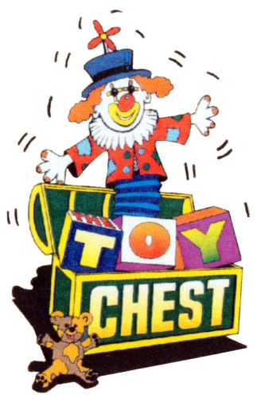

1. ________________ Color ____________
2. ________________ Color ____________
3. ________________ Color ____________

*******************************************************************|  
Total cost of:

Item #1: _____________ Item #2__________ Item #3 __________

Item #4: _____________ Item #5: __________ *******************************************************************  
Look into your envelope. Sort and count your money according to its color. Write down total for each.

Dark Green:____________ Lime Green: ____________

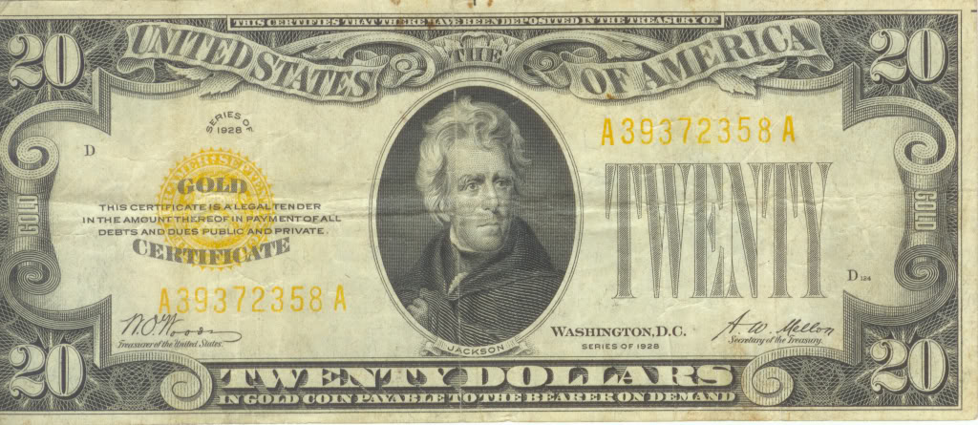

Blue: _________________ Goldenrod: _____________

Peach: ________________ Yellow: ________________

What items *were* you actually able to buy?   
__________________________________________________________________________________________________________________________________________________________________________

What problems did you incur while trying to buy items? __________________________________________________________________________________________________________________________________________________________________________

What’s your opinion on the fact that although you had money, you may not have been able to buy all of your favorite items?   
__________________________________________________________________________________________________________________________________________________________________________

Is this fair? Explain why this is or is not fair. (Be sure to include examples.)  
_________________________________________________________________________________________________________________________________________________________________________  
Cards the group fills out for the Traveling Delegate Game   
**Game board is teacher’s own creation!  
Front side of card Back side filled in by group**

**Conflict card** ~ Game Card # ____  
**Names in group**: __________________________________

What is the situation?______________________________  
________________________________________________   
What is the main problem?__________________________  
________________________________________________What are key issues to the problem?__________________  
________________________________________________How do you plan to solve the problem?________________  
________________________________________________Why do you think your solution will work?_____________  
________________________________________________

**Articles of Confederation……**

**Tough Day!**

**~CONFLICT~**

**NO Conflict card** ~ Game Card # ____

**Names in group**: __________________________________  
What is the situation?_______________________________  
_________________________________________________ Explain why there is no problem to resolve:  
_________________________________________________  
_________________________________________________Give an example of this situation happening today.  
_________________________________________________

**Articles of Confederation……**

**Great Day!**

**~No CONFLICT~**

**Currency Card** ~ Game Card #________  
Names in Group:____________________________________  
  
Fill in the correct lines~ subtract or add to keep a running total. At the bottom of this card, write in the current amount of each color of currency.  
**How much money do you currently have in each color currency?**Yellow __________ Green ___________ Blue _________ ***What*** were you charged for? __________________________  
(Example: Food, store item, medical, hotel, tax fee only)***How much*** were you charged (including tax)? -______________  
Did you have to make a color money exchange or sell something to acquire more money? Y___ N____  
If yes, how many coins are you adding to your financial situation? _________________________________________  
**Total amount of Currency for each:**Yellow ___________ Green ___________Blue ____________

**Articles of Confederation……**

**Money Issues**

**$ Currency $**

**The Traveling Delegate**

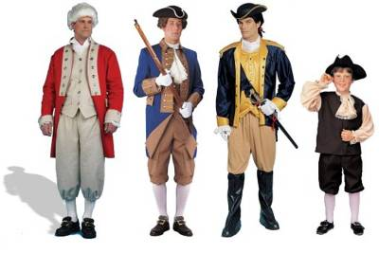

**Game Rules:**

1. Select 2 horses… as a **group** you are making decisions.
2. Begin with the Red Start Card.
3. Take turns in your group reading the directions aloud.
4. The financial situations are based on the 2 characters… guide and delegate (not each of you in the group).
5. Decide if the delegate and travel guide have come upon a problem/conflict or if this was a “smooth sailing” day. Were there any money issues involved?
6. Select the appropriate card(s).
7. If there’s a conflict, briefly discuss.
   1. What is the situation?
   2. What is the main problem?
   3. What are key issues to the problem?
   4. How do you plan to solve the problem?
   5. Why do you think your solution will work?
8. If there isn’t a conflict, state the situation and give your reasoning as to why this was a “smooth sailing day”, and come up with an example of this situation happening today.
9. If there is money involved, fill out the CURRENCY card.
10. Place cards FACE UP on the correct “box” on the game board. You may need to refer to a previous card.
11. Continue to work as a group around the board until you all have arrived at Independence Hall!

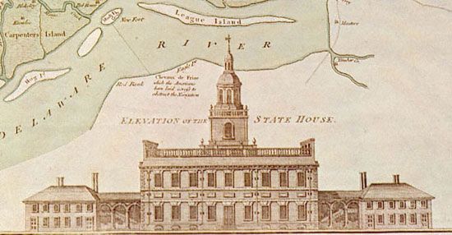

-9-

Activity cards ~

**Start Car**You are a wealthy Presbyterian tobacco farmer that lives in Danville, Virginia. You’ve hired a travel guide to take you safely to Philadelphia for the Constitutional Convention. You’ve taken **100 yellow coins** (currency) to get you to Philadelphia. You and your guide are traveling by horseback. **Good Luck!**

***Place your game board pieces on the two travelers.***

**Card One**You’re heading northeast to Richmond. You’ve come to the James River. You see a shipping dock down the way where there is a barge that can safely take you across. The charge is **2 yellow coins** for you, **2 yellow coins** for your guide. You pay the toll and climb on board. You’ve never been across the James River and are excited to begin your journey.   
 **Conflict or No Conflict**

**Select a board card(s) to fill out**

***Move forward one space.***

**Card Two**You have reached the other side of the James River. Exiting the barge you are told that you must pay a tax to the town’s shipping merchant to exit the barge. You are taxed **1 yellow coin** for you, **1 yellow coin** for your guide, and **2 yellow coins** total for the horses. You were not notified of any merchant tax when you left the other side. Plus the side you left doesn’t charge tax coming or going….

**Conflict or No Conflict  
Select a board card(s) to fill out  
*Move forward one space***

**Card Four**You find the hotel. The charge is **3 yellows coins** for you and **3 yellow coins** for your guide, plus a total hotel **tax of 2 yellow** coins. There’s no hotel tax in your hometown. There’s also a tax of **1 yellow coin** for **each** horse. The horses are in a stable down the street. You’ve been told there have been horses stolen from that stable, and there’s no security. This is the closest stable to your hotel.  
  
**Conflict or No Conflict  
Select a board card(s) to fill out  
Do not move any spaces!**

**Card Five**In the part of town you are staying, the crime rate is high. You are told that the state’s militia is fighting skirmishes against the British in the town 10 miles away. The town sheriff doesn’t like to be disturbed by out-of-towners at night. You and the guide decide to check on your horses. They are there, but you are worried about your horses being there in the morning.  
  
**Conflict or No Conflict  
Select a board card(s) to fill out  
*Move forward one space.***

**Card Three**You and the guide finally reached Richmond. You’re both hungry, still a bit mad about the merchant tax. You see a tavern. You tie up your horses and step inside. Your meal costs **2 yellow coins** for **each** of you. The meal is delicious and you both feel much better. You decide to stay the night in Richmond. You’re told that there’s a hotel down the way.

**Conflict or No Conflict**

**Select a board card(s) to fill out\**

***Move forward one space.***

**Card Eight |** The guide tries to reassure you that the horses will be fine and you really must get to the convention. You and the guide go onboard with the green coins you received from man you encountered. You’ve never been outside of Virginia and think about possible obstacles that may be ahead. Pirates are known to ravage these parts of Chesapeake Bay. You wonder how prepared the crew is for a pirate attack.

**Conflict or No Conflict  
Select a board card(s) to fill out  
*Move forward one space***

**Card Six** You didn’t sleep well last night because you worried about your horses. Your guide checks on the horses and fortunately they are fine. The hotel manager feels badly for your situation so offers you and the guide breakfast on the house. He even provides free hay for the horses. You’re happy to check out and keep moving to Philadelphia.

**Conflict or No Conflict   
Select a board card(s) to fill out  
*Move forward one space***

**Card Seven**You and your guide travel to a city called Mathews on the Chesapeake Bay. From there you plan to head towards Delaware on a steamer. The steamer company is based out of Delaware. Delaware’s currency is green. The charge is **3 green coins** for **each** of you. You only have yellow coins. The steamer is about to leave, there’s no time to go to a bank for a currency exchange. A man walking by says he’ll sign a note ***guaranteeing he’ll care for your horses until you return*** in exchange for 6 green coins. You’re desperate and make the trade because of the urgency to get to Philadelphia.  
 **Conflict or No Conflict  
Select a board card(s) to fill out  
*Do not move any spaces!***

**Card Ten   
|**Traveling over water made your guide very ill. You’re not sure if it’s sea-sickness or food poisoning. You ask the locals in Bombay Hook where to find a doctor. The town has a roving doctor who is currently in another town. It turns out that medical care is a constant problem in the town. All you can do is stay over night in hopes the guide will feel better. You check into the local hotel. The fee is **5 green coins** for the both of you, plus **1 green coin** hotel tax fee.   
 **Conflict or No Conflict   
Select a board card(s) to fill out  
*You’re stuck, do not move any spaces!***

**Card Nine** You have been on the ship for a day and a half, finally landing in Bombay Hook, Delaware. You want to get to Dover. You have **yellow** currency, and must find a bank as soon as possible to exchange your money. As luck would have it, there is one small merchant exchange office where you landed. The office will only exchange **20 of your yellow coins**, and will **tax you 5 additional yellow coins** to receive 20 green coins. Begrudgingly, you make the exchange.

**Conflict or No Conflict   
Select a board card(s) to fill out  
*Move forward one space.***

**Card Eleven** It was a rough night. The next morning you wake agitated. The high costs of your travel, your guide’s health, you don’t have your horses, and you still need to somehow get to Dover. A kind gentleman overheard you in the hotel lobby and has offered to drive you in his horse and buggy to Dover… and at NO charge!

**Conflict or No Conflict  
Select a board card(s) to fill out**

***Move forward one space***

**Card Twelve** Upon arriving in Dover, your kind friend knows a doctor for your guide. The doctor says the guide had a bad case of food poisoning, and prescribes medicine. The cost for the doctor is **3 green coins** and medicine is **1 green coin.** You are relieved that your guide will be alright. It’s been a long day. You find a boarding house to stay the night.

**Conflict or No Conflict  
Select a board card(s) to fill out  
*Move forward one space***

**Card Thirteen**The next morning you hear a loud raucous on the street. You and your guide are afraid to come out of your hotel. You’ve heard that several hotels have been vandalized lately by groups of angry people that don’t agree with the colonies’ independence. They are loyal to Britain. You go back to your room and hope that the angry mob moves on as there is no hotel security.

**Conflict or No Conflict  
Select a board card(s) to fill out  
*You’re stuck…. Do not move***

**Card Fourteen**You were forced to stay an extra day in Dover. Hotels are expensive, and it costs you a total of **6 green coins** for you and your guide. You are running low on green coins, so you make a decision to sell a gold chain you’ve been wearing. The jeweler says the chain is worth 20 green coins, but will only **give you 16.** He tells you there is an out of state tax of 4 green coins so he won’t pay you the full 20 green coins of it is true value.

**Conflict or No Conflict  
Select a board card(s) to fill out *Move forward one space***

**Card Fifteen**You need to continue on to the town of Wilmington, in New Castle County. A local farmer who needs to buy supplies in Wilmington has offered to take you and the guide in his horse and cart. When he hears that you are heading to Philadelphia to help rewrite the Articles of Confederation, he offers to take you and your guide, and only charge you for the cost of feeding his horse…. **3 green coins.**

**Conflict or No Conflict  
Select a board card(s) to fill out  
*Move forward one space***

**Card Seventeen** You all arrive in Wilmington and the farmer drops you off at a small boarding house. The next leg of the trip is to Chester, Pennsylvania. Your guide tells you that traveling through the area is dangerous because there have been conflicts between Delaware’s soldiers and those loyal to Britain. You are worried about your safety. Your guide suggests that you hire a wilderness scout to take you both safely through the areas of where soldiers are fighting.  
  
**Conflict or No Conflict  
Select a board card(s) to fill out  
 *Move forward one space***

**Card Sixteen** Wilmington is a two day trip. You need to pick up food supplies, blankets and two canteens for water, which cost you **10 green coins**. There’s no tax because you gave the money to the farmer to make the purchase. If you had paid for the supplies, the clerk would have charged you tax because you are from out of state. You’ve still got **yellow coins** (Virginia’s currency) if you need to make a currency exchange. But, you know you’ll pay very high out-of-state tax on the exchange, especially as you move farther away from Virginia.

**Conflict or No Conflict  
Select a board card(s) to fill out  
*Move forward one space***

**Card Nineteen**The Wilmington Town Bank is happy to help you, especially since you are from out of town. You hand over **40** of your **yellow coins.** The clerk hands you back **40 green coins**. You are shocked at the even exchange. Then the clerk says you **owe** **8 green coins** for the exchange. Your bank in Virginia would NEVER charge such a high exchange tax. The clerk just smiles at you.

**Conflict or No Conflict  
Select a board card(s) to fill out  
*You’re mad…. Do not move***

**Card Eighteen** In the morning you decide that you need more money. You pay your hotel bill of **4 green coins** for you and your guide. When the hotel clerk realizes you are from Virginia, he charges you **2 green coins** in tax. He says it’s Delaware’s state law. You are low on green coins and must make a currency exchange. The bank is down the street. You are not happy because you know you’re going to be taxed once again.

**Conflict or No Conflict  
Select a board card(s) to fill out *Move forward one space***

**Card Twenty**You find a wilderness guide to take you and your personal guide through the dangerous area. He charges you a total of **18 green coins**…. You feel this is robbery, but there’s no other option as your safety is at risk. You must get to Philadelphia, and you are so close. The road to Chester is dangerous, yet there’s no guarantee that the wilderness guide will be able to avoid any skirmishes.  
 **Conflict or No Conflict  
Select a board card(s) to fill out  
 *Move forward one space***

**Card Twenty-One**Yahoo! You made it to Chester without confronting any British soldiers. What you didn’t realize was that upon entering Pennsylvania, the state’s currency is a blue coin. The wilderness scout, knowing he overcharged you in the first place, offers to help you, and *gives* you 5 blue coins to stay the night at an inexpensive hotel. The next day you are going to have to figure out your finances.

**Conflict or No Conflict  
Select a board card(s) to fill out  
 *Move forward one space***

**Card Twenty-Two**You wish you had taken more money with you to begin this journey, but the worry about having it stolen along the way kept you from bringing more. Sadly, you decide to sell your silver watch. It will bring you more money than a currency exchange. A local shop offers you **35 blue coins**. The owner sees the sad look in your eyes and says, “Forget the tax.”

**Conflict or No Conflict  
Select a board card(s) to fill out *Too sad to move… stay put***

**Card Twenty-Three**From Chester, you and your guide will take a horse-drawn coach to Philadelphia. You’ve been told this is the safest form of transportation due to locals who try to rob those traveling in the area. The driver says it’s going to cost **16 blue coins** for the both of you. What an outrage! You are forced into paying the coachman because you have no other means of safe transportation.   
**Conflict or No Conflict  
Select a board card(s) to fill out  
*Move forward one space***

**Card Twenty-Five** You are traveling as fast as possible when your driver informs you that there have been angry British soldiers shooting at those traveling into the city. The British know that the delegates are convening to rewrite the Articles of Confederation. They are angry at the Independents and still want to control the colonies. You and your guide crouch down low.

**Conflict or No Conflict   
Select a board card(s) to fill out  
*Quickly, move forward 1 space***

**Card Twenty-Four** You have left the town of Chester and have to cross from Chester County into Philadelphia County. There is a toll. The driver tells you it will cost **2 blue coins,** and if you don’t pay, he’ll take you and your guide no further. You hear gunfire off in the distance. You give the coachman the coins and you all speed off.

**Conflict or No Conflict  
Select a board card(s) to fill out  
*Move forward one space***

**Card Twenty-Six** Hurray! You have arrived in Philadelphia in time for the convention. You find a hotel close to Independence Hall. When the hotel clerk realizes you are a delegate from Virginia, you are given a special hotel rate of only **one blue coin per day**. **You pay for two weeks** in advance! This rate will cover your meals, laundry and room at the hotel. You look out your window and see that there is military walking the streets, and you are valued for the job you are about to undertake.

**Conflict or No Conflict  
Select a board card(s) to fill out  
*Move forward one space***

**Card Twenty-Seven** You and 55 other delegates walk into Independence Hall. You see George Washington, Thomas Jefferson, Benjamin Franklin and many more great men! What an honor! You have so much to share with the delegates after your long journey. In your journey you experienced many things that need changing in the Articles of Confederation, if that is even possible. You are ready to create **a new and wonderful Constitution** for our country! In gratitude for your work, you will be paid 150 blue coins to return home…**GOOD LUCK!**

**Select a board card(s) to fill out  
*Move forward one step into Independence Hall!***

Following the Traveling Delegate game, each group lists 3-4 shortcomings of the Articles of Confederation, briefly note how the problem was resolved under the Constitution. These lists will be posted around the room for all groups to view.

|  |  |
| --- | --- |
| **Articles of Confederation** | **Constitution** |
| **Shortcomings** | **Resolutions** |
| 1. ______________________  ________________________  ________________________  ________________________  2. ______________________  ________________________  ________________________  ________________________  3. ______________________  ________________________  ________________________  ________________________  4._______________________  ________________________  ________________________  ________________________ | 1. ___________________  _____________________  _____________________  _____________________  2. ___________________  _____________________  _____________________  _____________________  3. ___________________  _____________________  _____________________  _____________________  4.___________________  _____________________  _____________________  _____________________ |

*Persuasive Letter*

Articles vs. Constitution

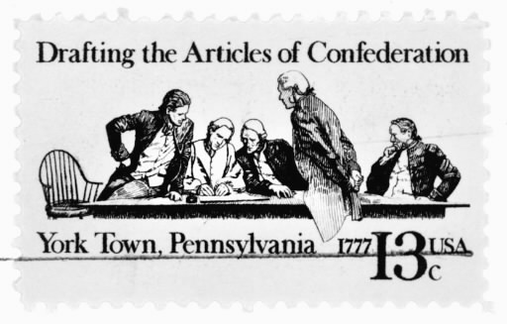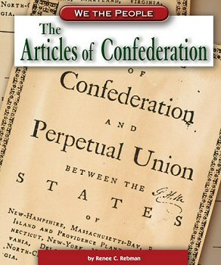

________________________________________________________________________________________________________________________________________________________________________________________________________________________________________________________________________________________________________________________________________________________________________________________________________________________________________________________________________________________________________________________________________________________________________________________________________________________________________________________________________________________________________________________________________________________________________________________________________________________________________________________________________________________________________________________________________________________________________________________________________________________________________________________________________________________________________________________________________________________________________________________________________________________________________________________________________________________________________________________________________________________________________________________________________________________________________________________________________________________________________________________________________________________________________________________________________________________________________________________________________



**Lesson Title: *Articles of Confederation…Well, they were trying!***

Unit Plan: ***From the Articles of Confederation to the Constitution***