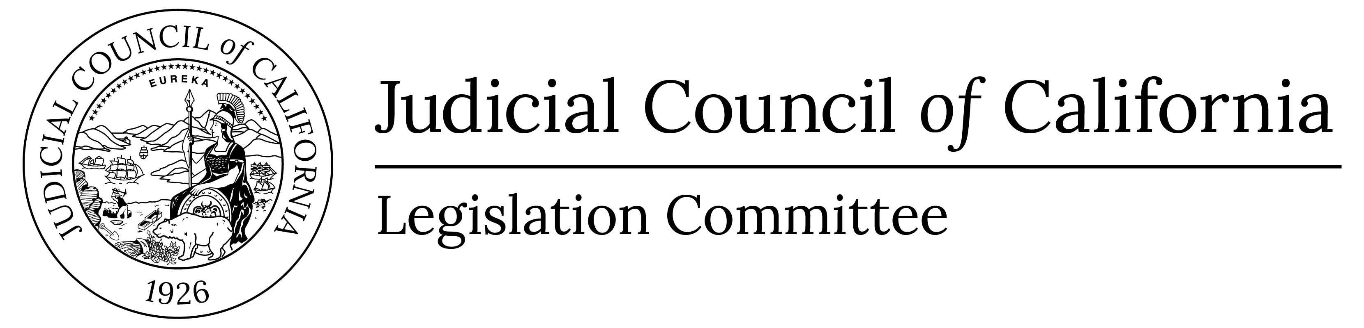 |  | www.courts.ca.gov/legislationcomm.htm  LegislationCommittee@jud.ca.gov

Legislation Committee
Notice and Agenda of Closed Meeting
Closed to the Public (Cal. Rules of Court, rule 10.75(c) or (d) and (e)(1))
Date: | Thursday, April 6, 2023
Time: | 4:30 p.m.
Meeting materials will not be posted on the advisory body web page on the California Courts website. Materials are only posted for open meetings. (Cal. Rules of Court, rule 10.75(h).)
- Closed Session (Cal. Rules of Court, Rule 10.75(d))
Call to Order and Roll Call
Approval of Minutes
N/A

Item 1 (Action Required)
Pursuant to California Rules of Court, rule 10.75 (d)(3). Negotiations concerning legislation.
Action on Pending Legislation
Consent:
N/A
Discussion:
- AB 560 (Bennett), as introduced – Sustainable Groundwater Management Act: groundwater adjudication. (Aviva Simon)
- AB 779 (Wilson), as introduced – Groundwater: adjudication. (Aviva Simon)
- AB 875 (Gabriel), as introduced – Courts: data reporting. (Morgan Lardizabal)

A Legislation Committee member who wishes to request that any item be moved from the Consent Agenda to the Discussion Agenda is asked to please notify the Governmental Affairs advocate on that item at least 48 hours before the meeting at 916-323-3121.

- Adjournment
Adjourn Closed Session

