Attachment 1:

Proposal Submission Form: RFP Number OREFM 2013 JMG 04

For Primary JOC Zone # _______________ (give the number of the Primary JOC Zone from Attachment 5)
Provide the exact legal name (the name under which you are proposing to do business with the AOC) of your organization. Your contract will be drafted in the name of this entity. Be exact.
Company Name:
Street Address:
City/State/Zip:
County:
Telephone: Fax:
Identification of two (2) contact people within the company:
Name | Title | Phone Number | Email Address

Provide the address of the location of your office located in the Primary JOC Zone that is the subject of your Proposal:

Street Address:
City/State/Zip:
County:
Telephone: Fax:

THE NAMES OF ALL PERSONS INTERESTED IN THE FOREGOING PROPOSAL AS PRINCIPALS ARE AS FOLLOWS:

_______________________________________________________________________________________

The name(s) of the individuals given will be used to review the Proposals provided to ensure that no one Contractor is awarded contracts in geographically contiguous JOC Zones.

NOTE: If Contractor or other interested person is a corporation, give legal name of corporation, the State where incorporated, and names of the president and secretary thereof; if a partnership, provide name of the organization, also names of all individual partners composing the organization; if Contractor or other interested person is an individual, provide first and last names in full below:

Type of Organization making this submittal:
Parent Company Subsidiary Division Branch Office
______________________________________________________________________________________________________________________________________________________________________________
Type of Company:
Corporation Partnership Joint Venture Sole Proprietorship
Other:
Year Company was established:
__________________________________________________________________________________________________________________________________________________________________________________
Name, address, and telephone number of parent company (enter N/A if not applicable):
Company Name:
Street Address:
City/State/Zip:
Telephone: Fax:
All former company names (enter N/A if not applicable):

Key Personnel: List officers, Partners and/or Owners
NAME | POSITION OR TITLE IN THE COMPANY | NUMBER OF YEARS WITH THE COMPANY | YEARS OF EXPERIENCE

Joint Venture: If this Qualification Statement is being presented by a Joint Venture, please indicate the participation of each Joint Venture. If not a Joint Venture, indicate Not Applicable (N/A).
NAME OF JOINT VENTURE PARTNER | TYPE OF PARTICIPATION | PERCENTAGE OF FINANCIAL PARTICIPATION | PERCENTAGE OPERATIONAL PARTICIPATION

Questions:
Is Your Organization willing and capable of providing all of the Work and services specified in the Statement of Work given in the Job Order Contracting Agreement that accompanies this RFP?
Yes No
Is Your Organization willing to execute, without modification, the Job Order Contracting Agreement that accompanies this RFP?
Yes No
Is Your Organization capable of meeting the Bonding Requirements specified in the Job Order Contracting Agreement that accompanies this RFP?
Yes No

Prohibitions, Defaults, Bankruptcies, and Terminations:

Has your organization ever been debarred, or otherwise prohibited from performing work for any governmental (includes federal or any state) organization?
Yes No
Has your organization defaulted on a construction contract within the 5 year period prior to the Proposal Due Date?
Yes No
Has your organization declared bankruptcy of been placed in receivership within the 5 year period prior to the Proposal Due Date?
Yes No

Has your organization ever had a contract terminated for cause by any governmental (includes federal or any state) organization?
Yes No

Signature:

I ________________ (Name) am the (official title) of _______________ (Contractor Name), and assert that I have the requisite authority to bind _____________ (Contractor Name) in the making of this Proposal. I am over the age of 18, have personal knowledge of the facts set forth above, and declare that the facts provided in this Background Form and the attached Proposal materials listed below and provided with this form are true and correct in all their representations.

Dated this day of , 2010 at (City),
__________ (State);

By:
 | (Signature) |  | (Print Name)

Provide all of the following materials along with your Proposal Submission Form:

Failure to provide any of the following Materials will render your Proposal noncompliant.

A written summary of your capabilities in accordance with the directives of Attachment 2 - Outline of Requirements for Proposal Submission, in the order and according to the format given, and including a copy of your State of California Contractor’s “B” License as part of Section 2.

Your completed, signed, and notarized Non-Collusion Affidavit in accordance with Attachment 4.

Any other form required by this RFP.

.

Attachment 2 – Outline of Requirements for Proposal Submission

NOTE: It is desirable that Contractors proposing for a JOC Zone, to the degree possible, demonstrate their experience within that Zone and provide a Contract Management Plan that address the geography, character, expected volume of work, and any problematic aspects that serving that Zone may entail, Proposals documenting past experience within the Zone and addressing the elements noted above with Contract Management plans tailored to the Zone will receive preferential ratings to the degree these elements address the AOC’s perceived needs in that Zone.

NOTE: The Contract Management Plan must be limited to twenty-five (25) pages in length, including all exhibits and any other attachments. Please restrict your Proposal to the proper page limits set for each of the three sections that follow, and please utilize a font that is no smaller than 10 point.

INSTRUCTIONS: Provide a written narrative documenting your response with regard to each of the following Sections, arranged in the following order:

SECTION 1: Related Experience and Past Performance
(Limit your response to 9 Pages)
  - List the last five (5) multi-disciplined prevailing wage ID/IQ type or other type of construction contracts your organization has been awarded in the State of California, identifying which contracts, if any, are within the Zone being applied for.
For each contract provide the following:
      - Contract title.
      - Contract number.
      - Owner.
      - Geographic location.
      - Owner contact name, title, address and phone number.
      - Contract amount.
      - Original Contract duration with dates.
      - Total Contract duration with dates.
      - Identify the approximate dollar amount of Work completed.
      - Provide a general description of the Detailed Scope of Work.
  - Describe your organization’s senior management involvement in ensuring your customer’s satisfaction under the agreements you cited in response to Section 1 above. Provide examples of successful intervention by your organization’s senior management where customer dissatisfaction had become an issue or cite examples where your organization went beyond the terms of your contract to deliver customer service. For each example cited, provide a brief description and an Owner contact and phone number so that the evaluation panel may verify the event occurrence and resolution.
  - Provide any additional information or statements that you feel will demonstrate your organization’s ability to successfully manage a general construction contract, with multiple project locations (as many as 10 concurrently), while managing multiple trade subcontractors at each project site. Do not exceed four (4) pages. Tailor the information you present to reflect an expected dollar volume equal to the Estimated Maximum Value of the Zone being proposed for, spread over a 2 year time period.

SECTION 2: License History:
(Limit your response to 1 Page)
Attach a copy of your State of California Contractor’s “B” License Number actual license with this form) and respond to the following questions:

a. Has Your Contractor’s License ever lapsed or been suspended by the State of California at any time during the 5 year period prior to the date of submission of your Proposal?
Yes No

b. If yes, document the periods by date during which your license lapsed or was suspended. Provide reasons for and explain the circumstances surrounding each lapse or suspension here:
_____________________________________________________________________________________________________________________________________________________

SECTION 3: Contract Management Plan:
(Limit your response to 15 Pages)
When developing and submitting the Contract Management Plan, for the purpose of the Technical Qualifications portion of this proposal, assume the following:

- The contract volume will be equal to the Estimated Maximum Value of the Zone being proposed for, including increases in value for the extensions, and spread over a 4 year time period.
- Typical Service Work Orders will range from totals of $15,000 to $500,000 with an average size of approximately $75,000.
- You will receive the additional two 1-year optional Contract Terms, and thus be issued Service Work Orders throughout the four (4) year contract duration.
- Service Work Orders will be issued at a level frequency throughout the four (4) year contract duration.
- The mix of the types of Service Work Orders will be consistent with the weights in the Combined Adjustment Formula provided in Attachment 3 - the Price Proposal Form.
- Each Service Work Order will be for Work performed at a unique project site.
- There will be no concentration of Work in any particular trade.

The AOC feels that the assumptions above reasonably reflect its expectations, based on what is currently known. The Evaluation Committee is interested in being able to make a direct comparison of the various Management Plans received, each made using the same assumptions so that they can evaluate each Contractor’s understanding of the contract requirements and assess the quality of their proposed plan as relates to the delivery of said requirements in the particular Zone in question, all being based on similar assumptions for ease in comparison.
- Provide an organizational chart indicating the functions, responsibilities and identities of the on-site and project management staff you would use to support this contract, including general manager, project managers, estimators, superintendents, and quality control personnel. Include information regarding the chain of supervision that you intend to implement in support of the execution of your responsibilities if selected for the contract. Indicate the extent of their time you anticipate the staff you propose will be assigned to this contract, given the dollar volume and time period noted above. At the bottom of the organizational chart sum the number of man-years, by position description, you assume will be necessary to fulfill your obligations under this contract. Note that manpower data provided should cover the entire contract duration of 4 years. If you are committing to assign certain named individuals to the support of this contract, provide a resume for each individual with their education, work experience, and indicate how long each individual has worked for your organization. If named individuals are proposed, any requested changes by the successful Contractors in such named personnel during the contract duration will have to be approved in writing by the AOC’s Regional Facilities Manager.
- Provide a description of how you intend to supervise your on-site project management staff, and from what geographic location(s).
- Provide a description of how you plan to manage the process for scoping out the details of a Service Work Order request.
- Provide a description of the bonding and insurance requirements that your organization in general imposes on its subcontractors.
- Describe your organization’s policy of making progress payments to subcontractors.
- Describe your organization’s approach in soliciting prices from subcontractors.
- Describe your organization’s intent to self-perform the Work anticipated in the Agreement and what specific trades, if any, you intend to provide.
- Describe your organization’s approach to punching-out and closing projects in a time efficient manner.
- Describe the specific qualifications of each member of your quality control staff. Indicate their levels of authority to redirect or put a stop to work and the basis upon which this is done.
- Describe the detailed procedures to be followed by your quality control staff in visiting the job sites; documenting the progress and quality of the Work; directing subcontractors in the correction of deficiencies; and directing Work in the event of problems, design changes, change orders, etc.
- Describe the procedure your organization intends to implement to ensure that work is ready for inspection by the AOC.
- Describe your management plan for coordinating and controlling subcontractors assuming the volume and characteristics of work given above.
- The AOC is interested in the Contractor demonstrating past experience in subcontracting within the Zone being proposed for. Provide a representative list of subcontractors you have actually used within the Zone during the period of the last 3 years. For each subcontractor, list the name, city and state of its office location, and provide the following information:

  - Approximate number of times your organization has contracted with the trade contractor with your organization serving as prime.
  - Approximate size of each subcontract in total dollars.
  - Contact and phone number for that trade contractor.
- Provide a written description of your organization’s program for managing prevailing wage requirements which comply with California Labor Code, Section 1775.

Attachment 3: Pricing Proposal Form

Name of Proposing Organization: _________________________________________________________

TO: The Administrative Office of the Courts, herein called the AOC:
Pursuant to and in compliance with your Request for Proposals and the Contract Documents posted with that RFP, # OREFM 2013 JMG 04, the undersigned Contractor, having become thoroughly familiar with the terms and conditions of the RFP, the legal Agreement applicable to accepted Proposals, and with local conditions affecting the performance and the costs of the Work and services, hereby proposes and agrees to fully perform the Work and services within the time(s) stated and in strict accordance with the legal Agreement and each Service Work Order, including providing any and all labor and materials, and performing all the work required to construct and to complete said Work in accordance with the requirements of the Legal Agreement, for the following Adjustment Factors:

Submit Adjustment Factors for the Primary JOC Zone and all of the required Alternates to that Primary Zone shown on Attachment 9.
Failure to provide an Adjustment Factor for any Project Description or failure to provide Adjustment Factors for all required Alternate JOC Zones will disqualify your Proposal from further consideration.

Name of Proposing Organization: _________________________________________________________

Primary JOC Zone # ___________ (Enter JOC Zone Number from Attachment 9)

Project Description | Adjustment Factor
(Large Projects $35,000 - $199,999) Normal Working Hours: Work valued from $35,000 to $199,999 performed during Normal Working Hours in the quantities specified in individual Service Work Orders for the Unit Price sum specified in the Construction Task Catalog multiplied by the Adjustment Factor of (carry out to 4 decimal places): | 0.0000
(Large Projects $200,000 - $499,999) Normal Working Hours: Work valued at $200,000 to $499,999 performed during Other Than Normal Working Hours in the quantities specified in individual Service Work Orders for the Unit Price sum specified in the Construction Task Catalog multiplied by the Adjustment Factor of (carry out to 4 decimal places): | 0.0000
(Large Projects $500,000 - $999,999) Normal Working Hours: Work valued at $500,000 to $999,999 performed during Normal Working Hours in the quantities specified in individual Service Work Orders for the Unit Price sum specified in the Construction Task Catalog multiplied by the Adjustment Factor of (carry out to 4 decimal places): | 0.0000
(Large Projects over $1,000,000) Normal Working Hours: Work valued at $1,000,000 or greater performed during Other Than Normal Working Hours in the quantities specified in individual Service Work Orders for the Unit Price sum specified in the Construction Task Catalog multiplied by the Adjustment Factor of (carry out to 4 decimal places): | 0.0000
(Large Projects $35,000 - $199,999) Other Than Normal Working Hours: Work valued from $35,000 to $199,999 performed during Normal Working Hours in the quantities specified in individual Service Work Orders for the Unit Price sum specified in the Construction Task Catalog multiplied by the Adjustment Factor of (carry out to 4 decimal places): | 0.0000
(Large Projects $200,000 - $499,999) Other Than Normal Working Hours: Work valued at $200,000 to $499,999 performed during Other Than Normal Working Hours in the quantities specified in individual Service Work Orders for the Unit Price sum specified in the Construction Task Catalog multiplied by the Adjustment Factor of (carry out to 4 decimal places): | 0.0000
(Large Projects $500,000 - $999,999) Other Than Normal Working Hours: Work valued at $500,000 to $999,999 performed during Normal Working Hours in the quantities specified in individual Service Work Orders for the Unit Price sum specified in the Construction Task Catalog multiplied by the Adjustment Factor of (carry out to 4 decimal places): | 0.0000
(Large Projects over $1,000,000) Other Than Normal Working Hours: Work valued at $1,000,000 or greater performed during Other Than Normal Working Hours in the quantities specified in individual Service Work Orders for the Unit Price sum specified in the Construction Task Catalog multiplied by the Adjustment Factor of (carry out to 4 decimal places): | 0.0000
(Small Projects < $35,000) Normal Working Hours: Work valued at less than $35,000 performed during Normal Working Hours in the quantities specified in individual Service Work Orders for the Unit Price sum specified in the Construction Task Catalog multiplied by the Adjustment Factor of (carry out to 4 decimal places): | 0.0000
(Small Projects < $35,000) Other than Normal Working Hours: Work valued at less than $35,000 performed during Other Than Normal Working Hours in the quantities specified in individual Service Work Orders for the Unit Price sum specified in the Construction Task Catalog multiplied by the Adjustment Factor of (carry out to 4 decimal places): | 0.0000
Non-Prepriced: Work performed that is not included in the Construction Task Catalog but which is within the general scope and intent of this Agreement in the quantities specified in individual Service Work Orders multiplied by the Adjustment Factor of (carry out to 4 decimal places): | 0.0000

Name of Proposing Organization: _________________________________________________________

1st Alternate JOC Zone # __________ (Enter the appropriate JOC Zone Number required in Attachment 9)

Project Description | Adjustment Factor
(Large Projects $35,000 - $199,999) Normal Working Hours: Work valued from $35,000 to $199,999 performed during Normal Working Hours in the quantities specified in individual Service Work Orders for the Unit Price sum specified in the Construction Task Catalog multiplied by the Adjustment Factor of (carry out to 4 decimal places): | 0.0000
(Large Projects $200,000 - $499,999) Normal Working Hours: Work valued at $200,000 to $499,999 performed during Other Than Normal Working Hours in the quantities specified in individual Service Work Orders for the Unit Price sum specified in the Construction Task Catalog multiplied by the Adjustment Factor of (carry out to 4 decimal places): | 0.0000
(Large Projects $500,000 - $999,999) Normal Working Hours: Work valued at $500,000 to $999,999 performed during Normal Working Hours in the quantities specified in individual Service Work Orders for the Unit Price sum specified in the Construction Task Catalog multiplied by the Adjustment Factor of (carry out to 4 decimal places): | 0.0000
(Large Projects over $1,000,000) Normal Working Hours: Work valued at $1,000,000 or greater performed during Other Than Normal Working Hours in the quantities specified in individual Service Work Orders for the Unit Price sum specified in the Construction Task Catalog multiplied by the Adjustment Factor of (carry out to 4 decimal places): | 0.0000
(Large Projects $35,000 - $199,999) Other Than Normal Working Hours: Work valued from $35,000 to $199,999 performed during Normal Working Hours in the quantities specified in individual Service Work Orders for the Unit Price sum specified in the Construction Task Catalog multiplied by the Adjustment Factor of (carry out to 4 decimal places): | 0.0000
(Large Projects $200,000 - $499,999) Other Than Normal Working Hours: Work valued at $200,000 to $499,999 performed during Other Than Normal Working Hours in the quantities specified in individual Service Work Orders for the Unit Price sum specified in the Construction Task Catalog multiplied by the Adjustment Factor of (carry out to 4 decimal places): | 0.0000
(Large Projects $500,000 - $999,999) Other Than Normal Working Hours: Work valued at $500,000 to $999,999 performed during Normal Working Hours in the quantities specified in individual Service Work Orders for the Unit Price sum specified in the Construction Task Catalog multiplied by the Adjustment Factor of (carry out to 4 decimal places): | 0.0000
(Large Projects over $1,000,000) Other Than Normal Working Hours: Work valued at $1,000,000 or greater performed during Other Than Normal Working Hours in the quantities specified in individual Service Work Orders for the Unit Price sum specified in the Construction Task Catalog multiplied by the Adjustment Factor of (carry out to 4 decimal places): | 0.0000
(Small Projects < $35,000) Normal Working Hours: Work valued at less than $35,000 performed during Normal Working Hours in the quantities specified in individual Service Work Orders for the Unit Price sum specified in the Construction Task Catalog multiplied by the Adjustment Factor of (carry out to 4 decimal places): | 0.0000
(Small Projects < $35,000) Other than Normal Working Hours: Work valued at less than $35,000 performed during Other Than Normal Working Hours in the quantities specified in individual Service Work Orders for the Unit Price sum specified in the Construction Task Catalog multiplied by the Adjustment Factor of (carry out to 4 decimal places): | 0.0000
Non-Prepriced: Work performed that is not included in the Construction Task Catalog but which is within the general scope and intent of this Agreement in the quantities specified in individual Service Work Orders multiplied by the Adjustment Factor of (carry out to 4 decimal places): | 0.0000

Name of Proposing Organization: _________________________________________________________

2nd Alternate JOC Zone # __________ (Enter the appropriate JOC Zone Number required in Attachment 9)

Project Description | Adjustment Factor
(Large Projects $35,000 - $199,999) Normal Working Hours: Work valued from $35,000 to $199,999 performed during Normal Working Hours in the quantities specified in individual Service Work Orders for the Unit Price sum specified in the Construction Task Catalog multiplied by the Adjustment Factor of (carry out to 4 decimal places): | 0.0000
(Large Projects $200,000 - $499,999) Normal Working Hours: Work valued at $200,000 to $499,999 performed during Other Than Normal Working Hours in the quantities specified in individual Service Work Orders for the Unit Price sum specified in the Construction Task Catalog multiplied by the Adjustment Factor of (carry out to 4 decimal places): | 0.0000
(Large Projects $500,000 - $999,999) Normal Working Hours: Work valued at $500,000 to $999,999 performed during Normal Working Hours in the quantities specified in individual Service Work Orders for the Unit Price sum specified in the Construction Task Catalog multiplied by the Adjustment Factor of (carry out to 4 decimal places): | 0.0000
(Large Projects over $1,000,000) Normal Working Hours: Work valued at $1,000,000 or greater performed during Other Than Normal Working Hours in the quantities specified in individual Service Work Orders for the Unit Price sum specified in the Construction Task Catalog multiplied by the Adjustment Factor of (carry out to 4 decimal places): | 0.0000
(Large Projects $35,000 - $199,999) Other Than Normal Working Hours: Work valued from $35,000 to $199,999 performed during Normal Working Hours in the quantities specified in individual Service Work Orders for the Unit Price sum specified in the Construction Task Catalog multiplied by the Adjustment Factor of (carry out to 4 decimal places): | 0.0000
(Large Projects $200,000 - $499,999) Other Than Normal Working Hours: Work valued at $200,000 to $499,999 performed during Other Than Normal Working Hours in the quantities specified in individual Service Work Orders for the Unit Price sum specified in the Construction Task Catalog multiplied by the Adjustment Factor of (carry out to 4 decimal places): | 0.0000
(Large Projects $500,000 - $999,999) Other Than Normal Working Hours: Work valued at $500,000 to $999,999 performed during Normal Working Hours in the quantities specified in individual Service Work Orders for the Unit Price sum specified in the Construction Task Catalog multiplied by the Adjustment Factor of (carry out to 4 decimal places): | 0.0000
(Large Projects over $1,000,000) Other Than Normal Working Hours: Work valued at $1,000,000 or greater performed during Other Than Normal Working Hours in the quantities specified in individual Service Work Orders for the Unit Price sum specified in the Construction Task Catalog multiplied by the Adjustment Factor of (carry out to 4 decimal places): | 0.0000
(Small Projects < $35,000) Normal Working Hours: Work valued at less than $35,000 performed during Normal Working Hours in the quantities specified in individual Service Work Orders for the Unit Price sum specified in the Construction Task Catalog multiplied by the Adjustment Factor of (carry out to 4 decimal places): | 0.0000
(Small Projects < $35,000) Other than Normal Working Hours: Work valued at less than $35,000 performed during Other Than Normal Working Hours in the quantities specified in individual Service Work Orders for the Unit Price sum specified in the Construction Task Catalog multiplied by the Adjustment Factor of (carry out to 4 decimal places): | 0.0000
Non-Prepriced: Work performed that is not included in the Construction Task Catalog but which is within the general scope and intent of this Agreement in the quantities specified in individual Service Work Orders multiplied by the Adjustment Factor of (carry out to 4 decimal places): | 0.0000

* Proposals will be rejected, as noncompliant with the terms of this RFP if the ‘Other than Normal Working Hours’ Adjustment Factors are not equal to or greater than the ‘Normal Working Hours’ Adjustment Factors for each respective category of Work.

** Proposals will be rejected as noncompliant with the terms of this RFP if the Adjustment Factors for Small Projects are not equal to or greater than the respective Adjustment Factors for Large Projects.

Combined Adjustment Factor Calculation
The Combined Adjustment Factor Formula percentages given below are for the purpose of Pricing Evaluation purposes only. The AOC is not obligated to issue Service Work Orders in the stated percentages. Utilize this Spreadsheet to provide the Combined Adjustment Factor you submit. Submit a complete copy of the entire worksheet showing all calculations, in the form of a PDF file, not in the form of an Excel file, in your Proposal.

The Combined Adjustment Factor Calculation Sheet is posted on the website page pertaining to this solicitation

Attachment 4 - NONCOLLUSION AFFIDAVIT

In accordance with Public Contract Code §7106. __________________________________
(Contractor’s full name)
being first duly sworn, deposes and says that he or she is ____________________________
(Contractor’s title)
of _______________________________________________________________________
(Company’s name)
the party making the foregoing Proposal that the Proposal is not made in the interest of, or on behalf of, any undisclosed person, partnership, company, association, organization, or corporation; that the Proposal is genuine and not collusive or sham; that the Contractor has not directly or indirectly induced or solicited any other Contractor to put in a false or sham Proposal, and has not directly or indirectly colluded, conspired connived, or agreed with any Contractor or anyone else to put in a sham Proposal, or that anyone shall refrain from proposing; that the Contractor has not in any manner, directly or indirectly, sought by agreement, communication, or conference with anyone to fix the price submitted by the Contractor or any other Contractor, or to fix any overhead, profit, or cost element of the Proposal price, or of that of any other Contractor, or to secure any advantage against the public body awarding the contract of anyone interested in the proposed Contract; that all statements contained in the Proposal are true; and further, that the Contractor has not, directly or indirectly, submitted his or her Proposal price or any breakdown thereof, or the contents thereof, or divulged information or data relative thereto, or paid, and will not pay, any fee to any corporation, partnership, company association, organization, Proposal depository, or to any member or agent thereof to effectuate a collusive or sham Proposal.

I declare under penalty of perjury under the laws of the State of California that the foregoing is true and correct.

This form must be notarized prior to submission with Proposal.

Signature:

I assert that I have the requisite authority to bind _____________ (Contractor Name) in the making of this Affidavit. I am over the age of 18, have personal knowledge of the facts set forth above, and declare that the facts provided in this Affidavit are true and correct in all their representations.

Dated this day of , 2010 at (City),
__________ (State);

By:
 | (Signature) |  | (Print Name)

Attachment 5 Map of JOC Zones

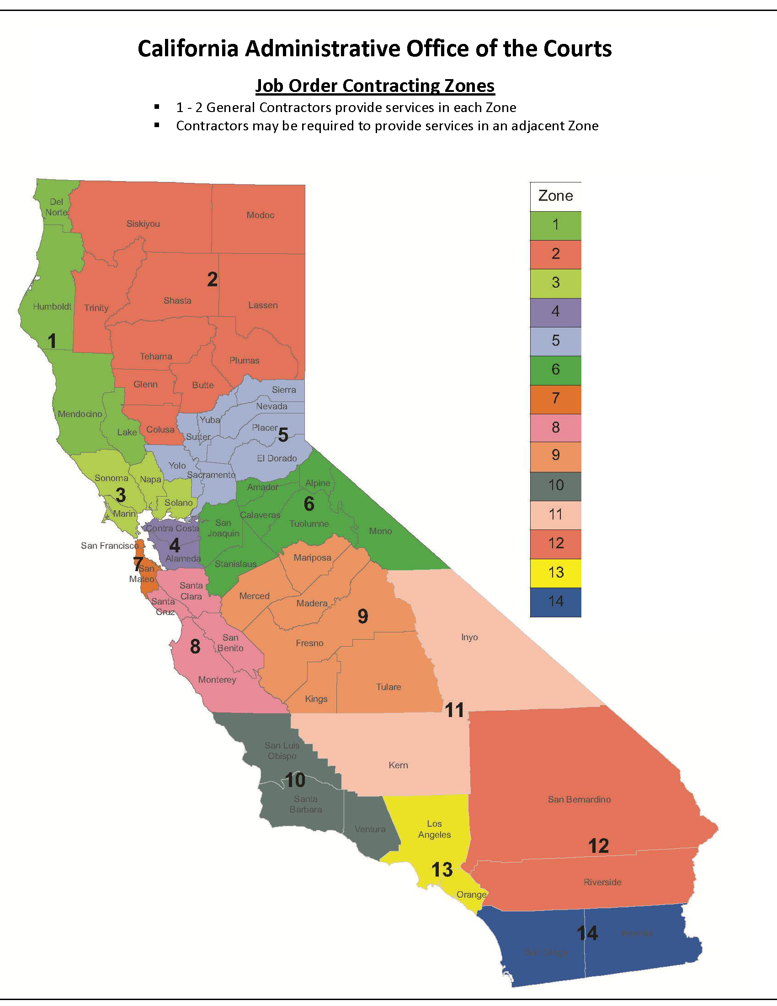

Attachment 6 Form for Submission of Questions

Request for Proposals Form for Submission of Questions
RFP Number: OREFM 2013 JMG 04
 | Your Organization’s Name:
# | Solicitation Reference | Question | Response
1
2
3
4
5
6
7
8
9
10
11
12

End of Attachment

Attachment 7

DVBE Participation Form
Propser Name:
RFP Project Title:
RFP Number:

The State of California Executive Branch’s goal of awarding of at least three percent (3%) of the total dollar contract amount to Disabled Veterans Business Enterprise (DVBE) has been achieved for this Project. Check one:

Yes_____ (Complete Parts A & C only)

No______ (Complete Parts B & C only)

“Contractor’s Tier” is referred to several times below; use the following definitions for tier:

0 = Prime or Joint Contractor;
1 = Prime subcontractor/supplier;
2 = Subcontractor/supplier of level 1 subcontractor/supplier

PART A – COMPLIANCE WITH DVBE GOALS
Fill out this Part ONLY if DVBE goal has been met; otherwise fill out Part B.

PRIME CONTRACTOR

Company Name: _________________________________

Nature of Work _____________________________ Tier: _______

Claimed Value: DVBE $ ___________
Percentage of Total Contract Cost: DVBE ______%

SUBCONTACTORS/SUBCONTRACTOR/PROPOSERS/SUPPLIERS

1. Company Name: ___________________________________________
Nature of Work: ______________________________ Tier: _______
Claimed Value: DVBE $ ___________

Percentage of Total Contract Cost: DVBE __________%

2. Company Name: _________________________________
Nature of Work ________________________________ Tier: _______
Claimed Value: DVBE $ ___________

Percentage of Total Contract Cost DVBE______%

3. Company Name: _________________________________
Nature of Work _________________________________ Tier: _______
Claimed Value: DVBE $ ___________

Percentage of Total Contract Cost DVBE______%

GRAND TOTAL: DVBE____________%

I hereby certify that the “Contract Amount,” as defined herein, is the amount of $____________. I understand that the “Contract Amount” is the total dollar figure against which the DVBE participation requirements will be evaluated.

Firm Name of Contractor
Signature of Person Signing for Contractor
Name (printed) of Person Signing for Contractor
Title of Above-Named Person
Date

PART B – ESTABLISHMENT OF GOOD FAITH EFFORT
Fill out this Part ONLY if DVBE goal will not be met but you have made a good faith effort to meet such goal.

1. List contacts made with personnel from state or federal agencies and with personnel from DVBEs to identify DVBEs.
Source | Person Contacted | Date

- List the names of DVBEs identified from contacts made with other state, federal, and local agencies.
Source | Person Contacted | Date

- If an advertisement was published in trade papers and/or papers focusing on DVBEs, attach proof of publication.
Publication | Date(s) Advertised

4. Solicitations were submitted to potential DVBE contractors (list the company name, person contacted, and date) to be subcontractors. Solicitation must be job specific to plan and/or contract.
Company | Person Contacted | Date Sent

5. List the available DVBEs that were considered as subcontractors or suppliers or both. (Complete each subject line.)
Company Name:

Contact Name & Title:

Telephone Number:

Nature of Work:

Reason Why Rejected:

Company Name:

Contact Name & Title:

Telephone Number:

Nature of Work:

Reason Why Rejected:

Company Name:

Contact Name & Title:

Telephone Number:

Nature of Work:

Reason Why Rejected:

PART C – CERTIFICATION (to be completed by ALL Contractors)
I hereby certify that I have made a diligent effort to ascertain the facts with regard to the representations made herein and, to the best of my knowledge and belief, each firm set forth in this bid as a Disabled Veterans Business Enterprise complies with the relevant definition set forth in Section 1896.61 of Title 2, and Section 999 of the Military and Veterans Code, California Code of Regulations. In making this certification, I am aware of Section 10115 et seq. of the Public Contract Code that establishes the following penalties for State Contracts:

Penalties for a person guilty of a first offense are a misdemeanor, civil penalty of $5,000, and suspension from contracting with the State for a period of not less than thirty (30) days nor more than one (1) year. Penalties for second and subsequent offenses are a misdemeanor, a civil penalty of $20,000 and suspension from contracting with the State for up to three (3) years.

IT IS MANDATORY THAT THE FOLLOWING BE COMPLETED ENTIRELY.

Firm Name of Contractor:
Signature of Person Signing for Contractor
Name (printed) of Person Signing for Contractor
Title of Above-Named Person
Date

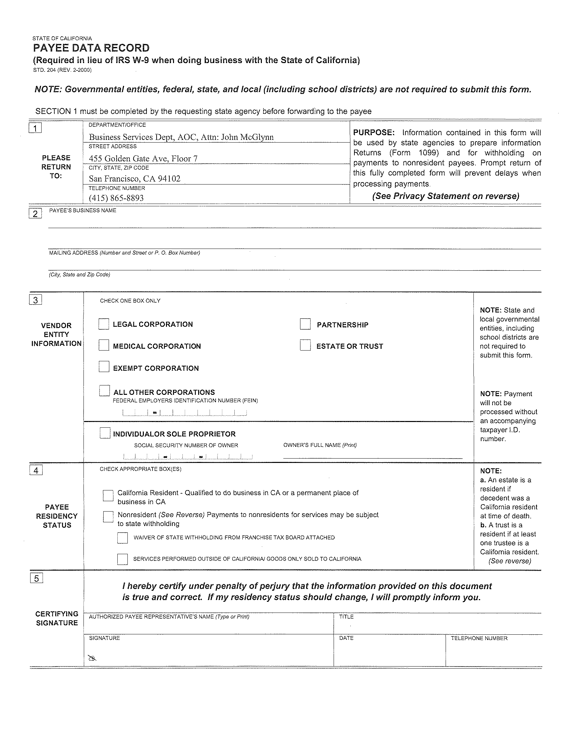

Attachment 11: Bonding Requirements and Safety Record

Bonding Requirements:
Provide your original Proof of Bonding Letter in accordance with the requirements of Section 3.0 F of this RFP.

Safety Record:
In the case of a joint venture submission, include all information required below, for each parent company if the joint venture entity does not have at least a three (3) year experience base.

Respond to the following question:
Has the Contractor, or any officer of the Contractor or any employee of the Contractor who has a proprietary interest in the making of this Proposal, ever been disqualified, removed, or otherwise prevented from bidding on or completing any federal, state, or local governmental project because of a violation of law or safety regulations:

No Yes

If your answer is yes, explain the circumstances here:

A. Attach a copy of the company’s OSHA Form 300 – Log and Summary of Occupational Injuries and Illnesses for the past two (2) calendar years.

B. Recent Incidence Data:

Complete this chart, or attach one with the same format. Following OSHA reporting guidelines, provide incidence data for the two (2) most recently completed projects listed under.

 | A | B | C | D | E | F | G
 | # OF WORK RELATED INJURIES | # OF WORK RELATED ILLNESSES | LOST DAYS OF WORK (CONVERT TO HOURS) | TOTAL HOURS WORKED BY COMPANY EMPLOYEES | INCIDENCE RATE FOR INJURIES  (A)x(200,000)  (D) | INCIDENCE RATE FOR ILLNESSES  (B)x(200,000)  (D) |  | INCIDENCE RATE FOR LOST DAYS  (C)x(200,000)  (D)
PROJECT #1:
PROJECT #2:
COMPANY TOTALS

C. Recent OSHA Citation and Disciplinary Action

Complete this chart, or attach one with the same format, with your company’s federal and state OSHA citation and disciplinary action, and Experience Modification Ratio (EMR) for the current and past two (2) years. If your EMR is greater than 1.0, you must provide a written explanation.
YEAR | EMR | NO. OF FEDERAL/STATE CITATIONS | NO. OF FEDERAL/STATE CITATIONS RESOLVED WITHOUT PENALTY | NO. OF FEDERAL/STATE CITATIONS RESOLVED WITH PENALTY | NO. OF FEDERAL/STATE CITATIONS PENDING
CURRENT:
1 YEAR AGO:
2 YEARS AGO:

D. Describe your organization’s program to ensure the safety of your staff, and the safety of your subcontractors, court staff, members of the public, and the building upon which work is being performed.

E. Submit a copy of the Table of Contents of your organization’s “Project Safety Manual” or its equivalent.

