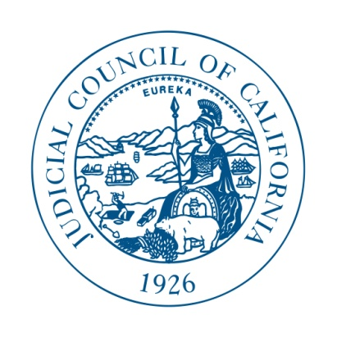
PROPOSED Scope of Work
RFP No: REFM-2016-11-RP

The Judicial Council is seeking services for the following:

- U/AST On-going Compliance and Maintenance
This includes the required activities and deliverables to ensure full compliance of U/ASTs, as well as evaluation, assessment and recommendations for future compliance or preventative maintenance services.

- Hazardous Material Management
This includes the development or updating of existing facility-specific Hazardous Material Business Plans and evaluation, assessment and recommendations for future compliance and on-going management practices.

- Hazardous Waste Management
This includes on-call services as needed during emergency hazardous waste scenarios, assessment and recommendation for management hazardous waste during routine maintenance activities and training for on-site staff and service providers.

Proposers should complete the table below to describe the proposed scope of work. Please add lines if additional tasks are required for compliance or maintenance purposes. The Judicial Council expects Proposers to identify all the necessary services, tasks and deliverables for compliance purposes. Please use bullet format to describe the tasks and deliverables.

BE BRIEF.

Underground Storage Tank (UST): Required Compliance Activities

Task | Description | Reporting & Documentation Deliverables (if applicable)
Monthly Designated Operator Inspection and Test
Annual Designated Operator Inspection and Test
Triennial Test and Certification
Certification of Financial Responsibility
Underground Storage Tank (UST): Maintenance/On-Going Compliance

Task | Description | Reporting & Documentation Deliverables (if applicable)
Identification of single-walled UST/system and recommendation on how to meet future compliance requirements.
Non-compliance related maintenance and testing recommended for USTs.

Aboveground Storage Tank (AST): Required Compliance Activities

Task | Description | Reporting & Documentation Deliverables (if applicable)
Spill Prevention Control and Countermeasure Plan (SPCC)
SPCC Annual Training
SPCC Annual Inspection and Review
Aboveground Storage Tank (AST): Maintenance/On-Going Compliance

Task | Description | Reporting & Documentation Deliverables (if applicable)
Non-compliance related maintenance and testing recommended for ASTs.

Hazardous Material Management (HAZMAT): Required Compliance Activities

Task | Description | Reporting & Documentation Deliverables (if applicable)
Develop or Update facility-specific Hazardous Material Business Plan
Hazardous Material Management (HAZMAT): Maintenance/On-Going Compliance

Task | Description | Reporting & Documentation Deliverables (if applicable)
Review of existing Hazardous Material Business Plans.
Review of existing hazardous material management practices (including storage and labeling practices, training requirements, record keeping, and reporting).
Standardization of HAZMAT reporting documents.
On-Site HAZMAT audit.
Development and delivery of training scenarios, including preparing for inspections.

Hazardous Waste Management: Required Compliance Activities

Task | Description | Reporting & Documentation Deliverables (if applicable)
Review of manifest tracking and management program.
Provision of 24-hour emergency hotline for hazardous waste emergencies.
Hazardous Waste Management: Maintenance/On-Going Compliance

Task | Description | Reporting & Documentation Deliverables (if applicable)
On-call technical services related to hazardous waste disposal and emergencies.
Development and delivery of training scenarios, including responding to a hazardous waste scenario.

