|  |  |  |
| --- | --- | --- |
| RC2 |  | Request for Information |
| DISPOSITION OF THE San Diego COUNTY Courthouse site  RFI#OREFM-2014-02-BR |

**TABLE OF CONTENTS**

1. **OPPORTUNITY 1**
2. **OVERVIEW 2**
3. **PROPERTY DESCRIPTION 3**
4. **POSSIBLE TRANSACTION STRUCTURES 5**
5. **STATEMENT OF LIMITATIONS 6**
6. **KEY EVENTS/ADDITIONAL INFORMATION 7**
7. **SUBMISSION OF RESPONSES 8**
8. **REQUEST FOR INFORMATION QUESTIONNAIRE 9**

*For planning and information purposes only*

1. **THE OPPORTUNITY**

After the passage of the Trial Court Facilities Act of 2002, (Escutia) the Judicial Council of California, Administrative Office of the Courts (AOC) has been responsible for the ongoing operations and maintenance of court facilities that were transferred to the state from the 58 counties. In 2009, the AOC took over the ownership and responsibility for the courthouse locally known as County Courthouse, located at 220 West Broadway, San Diego, California. The County Courthouse building straddles more than two city blocks from Broadway on the south, over C Street (County Courthouse site), and partially into the city block north of B Street, all between Union and Front Streets. Also at this location is the former jail facility of the County of San Diego (County) with a street address of 222 Front Street, San Diego, California (Old Jail). The Old Jail occupies a portion of one of the city blocks (between B and C Streets) in conjunction with the County Courthouse. The land beneath the County Courthouse site and Old Jail bounded by Broadway, Union, B and Front streets are referred to herein as the Property.

Pursuant to rule 10.184(b) of the California Rules of Court the AOC is responsible for the acquisition, space programming, construction, and design of court facilities. The AOC will begin construction of a new court building (the San Diego Central Courthouse) for the Superior Court of California, County of San Diego to be located on the city block bounded by B and C Streets and Union and State Streets in March 2014. The new court building will replace the County Courthouse as well as other existing court buildings.

The AOC’s Office of Real Estate and Facilities Management is considering various approaches to leverage the Property and to engage the private sector to strengthen the portfolio of public buildings. Through this Request for Information (RFI), AOC is exploring potential strategies that may foster the private-sector development of the Property.

AOC’s key strategic objectives are to:

• Engage the expertise of the private sector real estate development industry for ideas on the prospective future use(s) of the Property;

• Within the requirements set forth below; maximize financial return to the government and taxpayers;

• Contribute to the vitality of the downtown Civic Center area of San Diego;

* Demolish the existing San Diego Courthouse complex upon completion of the new facility.

AOC invites investors, development teams, and other parties (Respondents) to submit ideas that could assist AOC to attain these objectives. With AOC’s interest in contributing to the vitality of the downtown and supporting the local community, a vibrant reuse of the Property could be accomplished with your input and vision.

AOC intends to use the information submitted by Respondents for planning purposes only and to help it make strategic decisions regarding the Property. AOC will not enter into a conveyance agreement as a result of this RFI. AOC will not reimburse Respondents for any expenses associated with responding to this RFI, although AOC sincerely appreciates Respondents' efforts and input. The AOC may issue a Request for Qualifications (RFQ) or a Request for Proposals (RFP), or both, at some point in the future, if AOC determines that redevelopment or repositioning the Property provides value to the state.

For additional information on the submission process, see Sections VII and VIII.

1. **OVERVIEW**

The AOC is issuing this RFI to obtain responses from real estate developers, construction entities, joint ventures, and other members of the real estate development community who are potentially interested in acquiring the Property. In considering such options, AOC may exercise its authorities under Government Code section 70391, as possibly augmented in the future by additional special legislation to sell, exchange or otherwise leverage the Property.

The purpose of this RFI is to elicit private sector market perspectives of a possible sale, exchange or other transaction, and suggestions to ensure success. Such market perspectives will assist in informing AOC’s strategic decisions to enable it to maximize the value of the Property.

Upon review of the responses, AOC will determine if there is sufficient interest from Respondents to proceed with an open, competitive RFQ and/or RFP from the best qualified respondents.

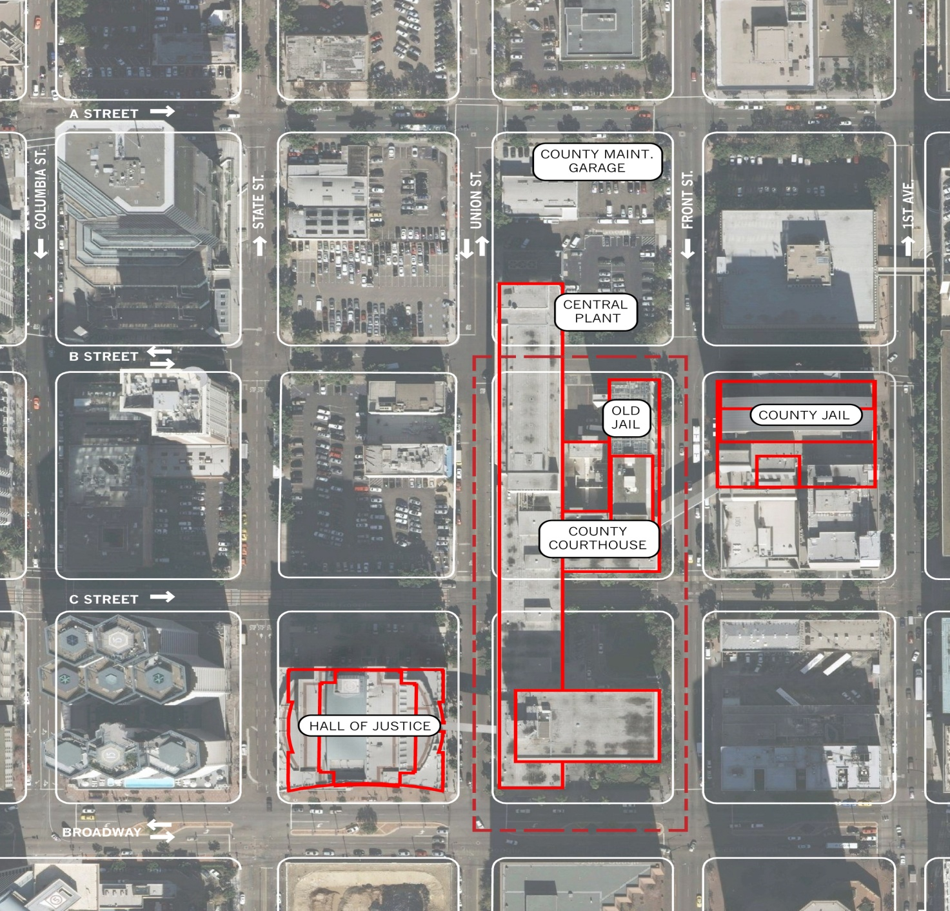

1. **PROPERTY DESCRIPTION**

The subject Property encompasses two full city blocks, and is bordered by Front Street, Broadway, Union Street and B Street, in downtown San Diego, California. It comprises approximately 2.75 acres (+ 120,000 square feet) and includes a courthouse and a jail facility (Assessor’s Parcel Number: 533-517-01). The City has classified the Property as CBD with FAR of 12; FAR of 20 w/incentives

The County Courthouse building is located at 220 West Broadway and straddles the entirety of the Property, as well as a portion of the block just north of B Street. The Old Jail building is located at 222 Front Street and shares the block located between Front, C Street, Union and B Street with the County Courthouse.

The County Courthouse contains 59 courtrooms; holding cells, office and administrative space, and includes 67 parking spaces. The building is 503,305 + gross square feet and occupies the majority of the site. The County Courthouse is currently fully operational and is occupied by the Superior Court of California, County of San Diego. The jail contains 140,138+ gross square feet and is currently leased to the County and subleased to a private sector jail operator. The lease is scheduled to terminate January 6, 2016 unless the lease is renewed.

The portion of the Property between B and C Streets is traversed by an easement in favor of the County giving the County the right, but not the obligation, to construct, operate and maintain an underground pedestrian tunnel for the transport in-custody prisoners to and from the existing County Central Jail located on Front Street between B and C Streets and the new San Diego Central Courthouse.

**Structures**

The County Courthouse building, built in 1961, includes several units separated by four inch joints: a North Block, a South Block and an eight story jail facility. In 1962 an Annex was constructed adjacent to the North Block.

The site is flat with a slight slope along the north-south axis of the building.

The South Tower has eight stories (including a Mezzanine) plus one basement level, the North Tower has four stories (including a Mezzanine) plus one basement level, and the Annex has five stories and one basement level. The top floor of the Annex is used for mechanical equipment. The North Tower contains a bridge over C Street and the Annex contains a bridge over B Street.

Floor heights vary between 10 and 15 feet.

The structural system is steel frame with concrete shear walls; the lateral force resisting system is solid/punched concrete shear walls, cantilever shear walls and shear yielding steel piers.

The foundation includes concrete spread footings and wall strip footings.

Exterior walls are precast concrete shear panels with punched window openings.

An initial geotechnical investigation suggests that surface fault rupture and surface displacement may occur at the block bounded by C, Union, B, and Front Streets. If this occurs, the foundation of the building would be subjected to large differential movements that may induce large forces in the building superstructure. This could result in a significant life safety risk. The initial geotechnical investigation does not indicate a surface fault under the block bounded by Broadway, Union, C, and Front Streets.

**Existing Condition**

The County Courthouse is generally in poor but serviceable condition. The building contains various hazardous materials, including asbestos. Any inquiries regarding necessary additional information should be directed to the Project Manager.

The Old Jail is generally in good condition. The lessee has expended funds in building improvements during its lease term; however this building may also contain various hazardous materials.

**Zoning/Entitlements**

The Property is within the Centre City Planned District (CCPD).

The City of San Diego 2006 Downtown Community Plan envisions a public park with parking below ground on the C St. to B Street block.

Downtown Community Plan – <http://civicsd.com/images/stories/downloads/planning/dcp/Downtown_Comunity_Plan_All.pdf>

Centre City Planned District Ordinance – http://civicsd.com/images/stories/downloads/meetings-and-events/event-calendar/2013/Final_CCPDO_with_adopted_Coastal_Suggested_Mods.2013.

**“AS-IS” Condition**

Respondents should assume that the Property, including supporting building infrastructure, will be conveyed “AS-IS” and “WHERE-IS” without representation, warranty or guaranty as to quantity, quality, title, character, condition, size, or kind, or that the same is in proper condition or fit to be used for the Respondent’s purpose.

Respondents should rely on their own independent research and conclusions for all demolition, development, financing, and construction costs.

1. **POSSIBLE TRANSACTION STRUCTURES**

Under its existing authorities, AOC may sell, lease or exchange all or a portion of the Property. AOC is interested in receiving any/all prospective proposals. However, the below Required Items must be included in all Respondent proposals.

**Required Items**

* The AOC, or its successor, has and will have a contractual obligation to the County to demolish and remove the entire County Courthouse building (including that portion north of B Street) and Old Jail building within 30 days after the Superior Court of California, County of San Diego ceases all court operations in the County Courthouse building, though it may be possible to negotiate with the County a modification of that obligation with respect to the Old Jail. Demolition is to be conducted in accordance with all applicable laws and regulations including CEQA. (See section 3.5.4 *et seq* of the Amended and Restated Transfer Agreement between the Judicial Council of California, Administrative Office of the Courts and the County of San Diego for the Transfer of Responsibility for and Transfer of Title to Court Facilities, Transfer of Title to the Old Jail, and Conveyance of Title to Stahlman Block (the ARTA), a copy of which is included herewith).
* The AOC, or its successor, has and will have a related contractual obligation to the County to demolish and remove two bridges: (1) across Union Street, between the County Courthouse building and the County-owned Hall of Justice (located at 330 West Broadway, San Diego); and (2) across Front Street, connecting the County-owned Central Jail (located at 1173 Front Street) to the Old Jail building, and to restore those portions of the facades of the two County-owned buildings to which those bridges were attached (See section 3.5.4 *et seq* of the ARTA).
* The AOC, or its successor, has and will have a contractual obligation to the County to provide to the County a replacement chilled water delivery system currently running from and between the County’s Central Plant (located north of B Street), to the Hall of Justice and the County’s Central Jail (See section 3.5.4 *et seq* of the ARTA).

**Beneficial Items**

The below listed item would be beneficial (but not required) to include in Respondents proposal:

* New space for the Court of Appeal, Fourth Appellate District to replace existing leased space. Approximately 65,000 RSF of secured space to include appellate courtroom; chambers for 10 justices, mediation center; conference room; office and administrative space; clerk’s office; and 14 secured parking spaces.

See AOC Design Guidelines for specifications: <http://www.courts.ca.gov/documents/Guidelines_Appellate.pdf>

1. **STATEMENT OF LIMITATIONS**

1. AOC represents that this RFI, submissions from Respondents to this RFI and any relationship between AOC and Respondents arising from or connected or related to this RFI, are subject to the specific limitations and representations expressed below, as well as the terms contained elsewhere in this RFI. By responding to this RFI, Respondents are deemed to accept and agree to this Statement of Limitations. By submitting a response to this RFI and without the need for any further documentation, the Respondent acknowledges and accepts AOC’s rights as set forth in the RFI, including this Statement of Limitations.

2. AOC reserves the right, in its sole discretion, without liability, to use any or all of the RFI responses in its planning efforts, and to develop and operate the Property, in whole or in part, outside of the RFI process. AOC reserves the right to retain all the materials and information, and the ideas and suggestions therein, submitted in response to this RFI. All such material, information, ideas, and suggestions will become the property of AOC.

3. This RFI does not create an obligation on the part of AOC to enter into any agreement, nor to implement any of the actions contemplated herein, nor to serve as the basis for any claim whatsoever for reimbursement for any costs for efforts associated with the preparation of responses submitted to this RFI.

4. The submission of an RFI response is not required to participate in any potential future conveyance process, nor does submission of a response preclude Respondents from participating in any actual future conveyance.

5. To the best of AOC’s knowledge, the information provided herein is accurate. However, AOC makes no representations or warranties whatsoever with respect to this RFI or the Property, including representations and warranties as to the accuracy of any information or assumptions contained in this RFI or otherwise furnished to Respondents by AOC, site and environmental conditions on the Property or the suitability of the Property, or any portion thereof, for any specific uses or development.

Respondents should undertake appropriate investigation in preparation of responses. A site inspection may be coordinated to give all respondents the opportunity to examine existing conditions.

6. This RFI is issued solely for information and planning purposes and does not constitute a solicitation. Responses to this notice are not an offer and cannot be accepted by AOC to form a binding contract.

7. No claims for broker’s fee will be paid by AOC.

8. All information submitted by Respondents that they consider confidential and not releasable to third parties outside of AOC, and its employees, agents, consultants, and representatives, must be clearly and conspicuously so marked.

1. **KEY EVENTS/ADDITIONAL INFORMATION**

| No. | Key Events | Key Dates |
| --- | --- | --- |
| 1 | AOC issues RFI | 2/4/14 |
| 2 | Tour of the Property | 2/21/14 |
| 3 | Deadline for respondents to submit questions, requests for clarifications to [capitalprogramsolicitations@jud.ca.gov](mailto:capitalprogramsolicitations@jud.ca.gov) (3:00 PM, PDT) | 2/28/14 |
| 4 | Post respondents’ Questions and AOC Answers | 3/7/14 |
| 5 | **Submittal due date and time (3:00 PM, PDT)** | **3/20/14** |

**Pre-submittal Briefing and Tour**

AOC may schedule a pre-submittal briefing for interested parties in early 2014 (not yet confirmed). The date will be posted on <http://www.courts.ca.gov/rfps.htm>

A tour of the Property will be conducted on February 21, 2014 beginning at 10:00 a.m. Please contact [capitalprogramsolicitations@jud.ca.gov](mailto:capitalprogramsolicitations@jud.ca.gov) via email to sign up to attend the tour. Please sign-up for the tour no later than February 19, 2014. Meet inside of security screening area, near antique clock in lobby.

**Project Inquiries**

Written questions must include the requestor’s name, e-mail address and the Respondent represented. Oral questions also will be accepted from Respondents during the pre-submittal conference. Regarding questions not received in a timely manner, the Project Manager will decide, based on the amount of research needed to answer the question, whether an answer can be given before the proposal due date.

1. **SUBMISSION OF RESPONSES**

All interested parties should submit a cover sheet, company description and the attached completed questionnaire with appropriate supporting information clearly marked “Response to RFI –San Diego Courthouse Property" by submittal due date and time to the following Point of Contact:

Nadine McFadden

Business Services, Fiscal Services Office

455 Golden Gate Avenue

San Francisco, CA 94102

Fax: 415-865-4962

[nadine.mcfadden@jud.ca.gov](mailto:nadine.mcfadden@jud.ca.gov)

AOC would like to thank you in advance for reviewing this RFI and assisting us in our efforts to plan for the future disposition of the Property.

**Response Format**

1) Cover Sheet, including:

• Company Name

• Company Address

• Name and Contact Information for Company Representative, including:

• Telephone Numbers

• E-mail Address

• Signature of Representative

2) Brief company description; size of company; years in business; type of entity.

3) Response to RFI items in numerical order followed by any additional materials (see section VIII. Request for Information Questionnaire).

**Oral Presentations**

AOC may seek to engage in follow-up discussions with any or all Respondents. The Project Manager will arrange with Respondents for the time, date and location of the discussions. Submission of a response does not guarantee the opportunity to participate in the discussions.

1. **REQUEST FOR INFORMATION QUESTIONNAIRE**
2. Describe the transaction structure(s) that would address each of the Required Items set forth in Section IV above, provide the maximum amount of cash that might applied to help offset the cost of constructing and operating the new Central Courthouse, and contribute to the vitality of the downtown Civic Center area of San Diego
3. Please identify any concerns or risks that would affect your potential interest in the Property.
4. What level of detail would be needed to reduce transaction risks to the point of not materially affecting the value you are willing to provide for the Property?
5. Does the requirement to demolish the existing County Courthouse and Jail buildings make you more likely or less likely to participate in a solicitation? Why or why not?
6. Does the requirement to replace the delivery system for chilled water between the County’s Central Plant (located north of B Street), the Hall of Justice and the County’s Central Jail make you more likely or less likely to participate in a solicitation? Why or why not?
7. Does the inclusion of providing a new appellate court facility make you more likely or less likely to participate in a formal solicitation? Why or why not?

End of RFI