REQUEST FOR PROPOSALS

AOC jUDICIAL AND COURT ADMINISTRATIVE SERVICES DIVISION
TRIAL COURT ADMINISTRATIVE SERVICES OFFICE

Regarding:
Phoenix SAP System Support Consultants

RFP Number: SAPC 2013-01-JMG

PROPOSALS DUE:
See Project Schedule Posted to the RFP website

1.0 BACKGROUND INFORMATION

1.1 VISION
The objective of the Phoenix Program is to maintain a statewide finance and human resources system, with the same core configuration, for the 58 superior courts in California. The system is supported on a single SAP software system called Phoenix on which all 58 superior courts maintain their financial data, and 7 superior courts maintain their Human Resources and payroll data. See Attachment 2 for program information including current program organization; deployment footprint; court employee and user counts; key system usage and support metrics; and current environment and system support requirements including brief descriptions of main support organization processes and responsibilities.
1.2 ORGANIZATION
The Phoenix Program is maintained by a State of California entity- the Judicial Council, Administrative Office of the Courts (AOC), Judicial and Court Administrative Services Division, Trial Court Administrative Services Office. The data in the system and the primary system users are from the 58 superior courts.
The Trial Court Administrative Services Office is comprised of two main units:
- The Phoenix Shared Services Center consists of staff that are super-users of the Phoenix SAP system, who provide day-to-day operational support of the courts.
- The Phoenix Center of Excellence consists of staff that is proficient in functional configuration ABAP, and Basis, who provide analytical, configuration, and technical support of the Phoenix SAP system.

1.3 SERVICES AND RESPONSIBILITIES

1.3.1 SHARED SERVICES CENTER

The Shared Services Center provides centralized administrative services to the courts on the Phoenix System and promotes best practices and operational consistency statewide. The center provides a diverse range of Financial and Human Capital Management operational services on a daily basis.

1.3.1.1 SSC Overview
The Shared Services Center (SSC) is the central point of contact for courts using the Phoenix System.

1.3.1.2 SSC Services and Responsibilities

Financial Services provided by the SSC include:
    - General ledger management, reconciliation, and reporting
    - A centralized treasury, including bank account management and investments
    - Trust accounting, which consists of money collected and held in trust on individual cases by the trial courts
    - Procurement services, including supporting all the courts in using the system, and smaller courts in the entire procurement process
    - Accounts payable which includes vendor, employee, and jury payments
    - Production of a standardized set of monthly, quarterly, and annual financial statements that comply with existing statutes, rules, and regulations.

Human Resources/Payroll Services provided by the SSC include:
    - Personnel administration, which includes employee hiring and separation, classification and pay, and organization management.
    - Benefits, which includes the proper deduction and payments, such as, health, dental, vision, etc.
    - Time management, which includes the proper recording of time and leave based on an individual’s work schedule, representation status, etc.
    - Payroll, which includes the processing of time records against pay and benefit records to produce employee payments, vendor payments, and updating of accounting records.
    - Payroll reconciliation, which includes validating the accounting records against the payroll records to ensure payments have been properly collected, disbursed, and accounted.
    - Employee and manager self-service, which includes access to self service options, such as, timesheets for entry and verification, benefit information, contact information, etc.

1.3.1.3 SSC Goals
    - Ensure uniformity of financial records.
    - Provide consistency of accounting and financial data.
    - Produce trial court monthly, quarterly, and annual financial statements.
    - Ensure compliance with existing statutes, rules, and regulations.
    - Monitor process compliance with service level agreements.

1.3.1.4 SSC Organization

The Shared Services Center is comprised of two major sections:
1.3.1.4.1 Phoenix Financial Services
- Trust Accounting Unit
- Phoenix Purchasing Support Services Unit
- General Ledger and Reports Unit
- Accounts Payable Unit

1.3.1.4.2 Phoenix Human Resources Services
- Payroll Financial Services Unit
- Payroll Services Unit
The Phoenix Shared Services Center is housed solely in the Sacramento office of the Administrative Office of the Courts.

1.3.2 CENTER OF EXCELLENCE

The Center of Excellence (COE) is responsible for the systematic deployment, maintenance, and operation of the Phoenix System to the trial courts. Currently, all 58 courts have implemented the Phoenix Financial System. The Phoenix Human Resources System has been deployed to seven courts – further deployment efforts are contingent upon additional resources.

1.3.2.1 COE Overview
The COE performs complex studies of accounting and human resource/payroll processes, business procedures, and court administrative operations. It also assists in formulation of new or revised policies and/or procedures to meet court administrative and business operations needs, and implements automated processes where possible. The COE also includes a unit from Information Technology Services Office that provides the technology support to the Phoenix Program.

1.3.2.2 COE Services and Responsibilities
Continually direct project teams of AOC and court representatives in the development of new and revised Financial and HR/Payroll processes and configuration for continuous improvement.
    - Develop and modify reports for Financial and HR/Payroll activities specific to court operations and budgeting.
    - Prepare reports with recommendations based on studies and surveys to improve or change accounting and HR/Payroll policies, processes, and procedures.
    - Continually manage the work of contracted system support consultants involved in support of the Phoenix System on behalf of the courts.
    - Design and build reports to satisfy requests from third parties including California Legislature, Bureau of State Audits, the Judicial Council and other branch entities.
    - Provide day-to-day user support and break fix services.
    - Develop requested enhancements; implement system patches and upgrades for hardware as well as software.
    - Provide daily monitoring of system, tools and interfaces.
    - Provide ongoing Maintenance and Operations services (M&O Support) to the Phoenix Program.

1.3.2.3 COE Goals

    - Design, develop, enhance and maintain a quality integrated system of financial, human capital, and payroll processes within the Phoenix System.
    - Continually improve AOC staff knowledge, skills, and abilities, as well as, review processes and configuration, to reduce the cost of delivering an integrated finance/HR/payroll system for the trial courts.
    - Design and develop training curriculum to support the trial court financial and human resources system.
    - Provide timely response to all system trouble tickets, and enhancement requests.
    - Assist the AOC in realization of the benefits of a fully integrated financial and HR system
    - Provide opportunities for greater efficiency by the restructuring and redesign of business processes by leveraging the value of the ERP systems capabilities
    - Elimination of duplication of efforts
    - Minimizing of manual reconciliations
    - Provide a foundation for the AOC and the courts to explore additional functional improvement opportunities, such as:
      - Deployment of HCM functionality to additional courts
      - Public Sector Budget Planning
      - e Procurement
      - Fixed Assets Management
      - Inventory Management
      - Learning Management Solution
      - Applicant Tracking
      - Performance Management
      - Expanded Self-Service functionality
      - Increased use of automated system support tools such as
        - automated testing tools and
        - advanced Solution Manager functions

1.3.2.4 COE Organization

The Center of Expertise is comprised of three major sections:

    - HR Production Support
    - Finance Production Support, including Process Support and Reporting.
    - Phoenix Information Systems Enterprise Resource Planning
Phoenix Program Unit
Phoenix Infrastructure/BW Unit

Phoenix Center of Excellence units are housed in both the Sacramento office of the Administrative Office of the Courts (HR and Finance functional analysis and configuration staff); and the San Francisco office (ABAP Development and Basis support staff).

2.0 DESCRIPTION OF SERVICES

2.1 Overview
2.1.1 The AOC seeks to contract with a single organization that will provide experienced and knowledgeable consultants to the AOC to assist the AOC in providing the services and fulfilling its responsibilities as described in Section 1.3 above and further elaborated upon in Attachment 2 of this RFP.
2.1.2 The consultants to be provided must have expertise and experience in support of a mature SAP installation substantially equivalent to the AOC’s current installation. The consultants will, in addition and when requested, engage in knowledge transfer activities to promote AOC’s goal of achieving AOC independence in maintaining and developing the Phoenix System.
2.1.3 The Consultants to be provided may come from the Contractor’s own organization, or may be under subcontract to the Contractor.
2.1.4 When this RFP refers to the M&O Support Team, unless otherwise noted, the M&O Support Team refers to a combination of Contractor supplied consultants and AOC employee resources.

2.2 Staffing
2.2.1 Currently Utilized Resources - Position Titles and Descriptions:
2.2.1.1 It is expected that at a minimum the current (AOC Fiscal Year July - 2012/ June - 2013) consultant resource levels (see 2.2.1.2) will continue to be required through the life of the Legal Agreement resulting from this RFP.
2.2.1.2 The currently utilized consultant resource positions (“Currently Utilized Consultant Resource(s)’) are:
1 SAP Financial Functional Analyst – (1 Full Time Equivalent (FTE)) with approximately 10 years work experience
1 SAP Human Capital Management (HCM) Functional Analyst (1 FTE) with approximately 10 years work experience
1 SAP ABAP Developer (1 FTE) with approximately 10 years work experience
1 SAP Basis Consultant (1 FTE) with approximately 10 years work experience

2.2. 1.3 Position Descriptions - Currently Utilized Consultant Resources:
Below are the position descriptions of the Currently Utilized Consultant Resources. These resources will be in place when the legal agreement resulting from this RFP is initiated.

2.2.1.3.1 SAP Financial Functional Analyst
Performs professional-level analytical and functional work maintaining system configuration. Will coordinate the functional/business unit activities related to the requirements gathering, use cases, process documentation, development, training, testing and use of the Phoenix Financial System. This position provides the subject matter expertise to support the development and configuration updates in support of AOC’s SAP implementation for the courts. In addition, provides lead direction and senior level subject matter expertise, and work review of project staff and/or performs and coordinates complex and specialized work to include defining test plans, training plans and recommendations for business process reengineering. Preferable skills would include expertise using SAP Solution Manger, SAP Productivity Pak, and AOC’s support tools (see Attachment 2 for list of complementary third party software tools used by the Program). The SAP Senior Financial Functional Analyst’s skill set required may include any of or a combination of the following or similar areas.

- Team Lead
- Integration Manager
- General Ledger
- Accounts Payable
- Accounts Receivable
- Cash Management
- Controlling (Cost Center and Internal Order Accounting)
- Project Systems (Project Accounting)
- Funds Management Budget Control System
- Grants Management
- Public Sector Collections and Disbursements
- Materials Management (Procurement)
- Public Sector Budgeting
- Workflow
- eProcurement
- Fixed Assets Management
- Inventory Management
The regular location to which this individual would report is the AOC Sacramento office.

2.2. 1.3.2 SAP HCM Functional Analyst
See SAP Financial Functional Analyst for preferred experience and expectations. The SAP HCM Functional Analyst’s skill set required may include any of or a combination of the following or similar areas–
- Team Lead
- Integration Manager
- Personnel Administration
- Organizational Management
- Payroll (HR and Finance)
- Time Management
- Benefits Administration
- Organization Management
- HR/Payroll Financials
- Employee and Manager Self-Service
- Workflow
- Learning Management Solution
- Performance Management
The regular location to which this individual would report is the AOC Sacramento office.
2.2. 1.3.3 SAP ABAP Developer
Performs professional-level analytical ABAP design, review and development. Senior developer has ability to lead ABAP development staff, with Finance and/or HCM development expertise on Reports, Interfaces, Enhancements, Forms, etc. - designs, codes, configures, tests and debugs ABAP programs. Performs code review/analysis, requirements analysis, quality assurance, and performance tuning. Supports, maintains, and documents Phoenix SAP custom functions and routines. Analyzes support issues in interaction with functional team members, participates in design and develops viable solutions. Develops and provides production support of the Phoenix SAP application using best practices and complies with AOC development standards. The ideal candidate will support existing and new interfaces, thus would have a good understanding of integration with 3rd party tools using Web Services, SFTP, etc
The regular location to which this individual would report is the AOC San Francisco office.

2.2.1.3.4 SAP Basis Consultant
Provides basis consulting, system administration and operation control for Support and Maintenance and Implementation Projects. Should have strong technical skills in SAP support, which includes
- Upgrades, system copy, performance tuning, authorization setup, TMS admin, applying patches, backup and restore processes
- Support for ECC, Netweaver, BW, and Enterprise Portal, experience supporting add-on tools such as Solution Manager, Productivity Pack, EPI-USE HR data migration tools, BSI Taxfactory, Secude/NetWeaver SSO and FileNet
- Understanding of ESS/MSS configuration and portal content management
- Knowledge of Oracle database administration, Linux OS and application and infrastructure security.

The regular location to which this individual would report is the AOC San Francisco office.
2.2.2 Additional Consultant Resources – Position Titles and Descriptions:
2.2.2.1 Additional consultant resources (“Additional Consultant Resources”) will at times be needed by the AOC. The selected contractor must be able to provide these additional resources, if and when needed, for durations of time that will be specified by the AOC when the resource is needed.
These Additional Consultant Resources include the position descriptions in section 2.2.2.3 below, as well as, the four (4) position descriptions listed in section 2.2.1.3 above. The vendor is expected to be able to provide resources that have the skills described in sections 2.2.1.3 and 2.2.2.3 with either approximately 10 years experience, or approximately 3 years experience.
These consultant resources will usually be located at locations noted in the position descriptions, however, remote support may at times be appropriate.
The AOC requires a contractor that will be able to provide consultants of various work experience levels. For this reason, the AOC is requesting separate rates for ‘senior’ (at least 10 years of relevant work experience) and ‘less-senior’ (approximately 3 years of relevant work experience) resources having the same job descriptions.

2.2.2.2 The Additional Consultant Resources positions include:
SAP Project Manager
SAP Quality Assurance Analyst
OCM/Training Consultant
SAP Business Warehouse Architect/Developer
SAP Security Analyst
The positions described in section 2.2.1.3

2.2.2.3 Position Descriptions - Additional Consultant Resources:
Below are the position descriptions of the Additional Consultant Resources:
2.2.2.3.1 SAP Project Manager
Lead and participate in project planning and monitoring, and vendor resource management, including tasks such as:
- Develop or assist in development and monitoring of detailed project work plans using Microsoft Project and other tools
- Review and provide assistance in managing the support process and specific incident handling using SAP Solution Manager and other tools
- Support Quality Assurance process
- Review support needs and ensure proper resources are assigned and functioning at a high level.
- This position would primarily be located in the Sacramento office.
2.2.2.3.2 SAP Quality Assurance Analyst
- Design, automate, and execute test plans, scripts, and test data creating to ensure the quality of software applications and enhancements; supports research, triage and resolution for both production and testing incidents; performs related work as assigned. This position would primarily be located in the Sacramento office.

2.2.2.3.3 OCM/Training Consultant
Leads and participates in project training and communication planning and execution, including tasks such as:
- Assist in Training Curriculum and Material development and review using SAP Productivity Pak and Microsoft Office tools
- Provide and support in-person and online End-User Training
- This position would primarily be located in the Sacramento office.

2.2.2.3.4 SAP Business Warehouse Architect/Developer
- Supports existing SAP Business Warehouse solution and assists with design, development, configuration and tuning of new and existing Business Warehouse extractors, data providers, cubes and reports. This position would primarily be located in the Sacramento office.

2.2.2.3.5 SAP Security Analyst
- Supports maintenance of existing catalog of user roles, identifies and provides recommendations for mitigating risk. Work with technical and functional support staff on design of new roles and user maintenance.
- This position would primarily be located in the Sacramento office.

2.2.3 Consultant Resource Utilization:
2.2.3.1 While the AOC expects to utilize Consultant Resources as described in Sections 2.2.1.2 and 2.2.2.1 above, the actual number of Consultant(s) and the type of Consultant(s) utilized will vary depending upon the AOC’s needs throughout the duration of the term of the Legal Agreement.
2.2.3.2 The AOC shall not be obligated to use any number or type of Consultant(s) except as authorized by the Work Authorization Process given in the Legal Agreement.
2.2.3.3 The AOC shall have the right under the Legal Agreement to utilize any number of Consultants of any type for any time period and the selected Contractor will be obligated to provide such Consultants when needed.
2.2.3.4 The actual numbers and types of Consultants to be used will be specified via the Work Authorization process given in the Legal Agreement.

2.3 SPECIFICS OF A RESPONSIVE PROPOSAL

Prospective Contractors are required to submit their Proposals in accordance with the directions and in the format specified in this RFP, without modifications or additions, in order that the Proposals of different parties may be compared on the same basis.

All prospective Contractors are hereby apprised that their Proposal shall constitute an irrevocable offer available for acceptance by the AOC at any time within the ninety (90) days period following the Proposal due date.

The following information must be provided in order for a Proposal to be regarded as responsive and receive further evaluation by the AOC. All of the following must be provided as specified below.

2.3.1 Organization Background and Experience

Provide a written document describing your organization and specifying its number of years in business. Include a description of up to 3 business engagements where you have provided consultants that provided services substantially similar or identical to those requested here. Describe the dates and duration of these engagements and name the consultants provided. Provide at least one reference name and the contact information for an individual from the organization you serviced who is knowledgeable with the details of the engagement at and who is willing to talk to the AOC regarding this engagement.

Describe your organization’s methodology for managing similar engagements, including what characteristics of your organization’s support methodology and internal management processes distinguish you from other vendors that provide these services. Of particular interest are your organization’s internal processes to manage:

- Filling AOC requests for resources, including identifying and securing resources and normal internal timelines to do so.
- Time tracking against specific work items; for example, what vendor tools are available to show billable hours and specific work completed.
- Billing concerns, in the case of discrepancies identified on periodic billing reports.
- Resource concerns, in the case of a complaint or issue with an individual consultant.

Along with the above provide evidence of the financial solvency or stability of your organization (e.g., balance sheets and income statements from the last 3 years).

2.3.2 Consultants Proposed

2.3.2.1 Currently Utilized Resource Consultants

Provide a list identifying by name a single individual that you are proposing to fill each of the 4 Currently Utilized Resource Consultant positions (see Section 2.2.1.2). Submit the list in the format given in the “Proposed Consultants and Titles Form” posted to the RFP website. Separately provide a résumé for each individual, providing his or her name and detailing that individual’s educational background, professional qualifications, and actual work experience. Describe the actual roles and responsibilities that that individual has had in providing services identical or substantially similar to those described here in the position descriptions. Résumés to be submitted should endeavor to demonstrate the proposed individual’s ability to provide services identical or substantially similar to the services to be provided for the AOC.

Following submission of your Proposal but prior to the AOC’s execution of the Legal Agreement resulting from this RFP, if a consultant that you have proposed for one of the four Currently Utilized Resource Consultant positions leaves your organization or is otherwise rendered unavailable to work, notify the AOC immediately in writing and provide the name and résumé of a replacement consultant you propose and their hourly rate. If the identity of your proposed consultant changes prior to the AOC’s signing of the Legal Agreement, the AOC shall reevaluate and rescore the Work Experience and Educational Qualifications and Price Proposal area of your Proposal, and modify your score. If the change in scoring so dictates, the AOC shall withdraw and revise the posted notice of intent to award.

Following execution of the Legal Agreement, changes in Consultant personnel are governed by the terms and conditions of the Legal Agreement.

2.3.2.2 Additional Consultant Resource(s):

Provide a single resume for each of the 5 Additional Resource Consultant positions (see Section 2.2.2.2).
SAP Project Manager
SAP Quality Assurance Analyst
OCM/Training Consultant
SAP Business Warehouse Architect/Developer
SAP Security Analyst
The resumes you provide should provide a representative sample of the senior (approximately 10 years of experience) individuals that you might provide should the AOC require them. If and when the AOC requires Additional Consultant Resources, you will not be required to provide the exact named individuals identified on the resumes you provide, but you will be expected to provide individuals of substantially similar education and work experience at the rates you propose in your Price Proposal (see below)

2.3.3 Price Proposal:

Submit your price Proposal in the format of the form posted on the RFP website as “Pricing Proposal Form”.

For all types of the Consultant positions described (See Sections 2.2.1.2 and 2.2.2.2), provide a firm fixed hourly rate for that consultant that will be charged the AOC for the performance of the Consultant’s services.

The AOC is requesting that your submit rates for both a senior resource (Greater than 10 years of work experience) and a junior Resource (Greater than 3 but less than 10 years of work experience) for all types of Consultants, and prospective Contractors must provide rates for all 9 types of Consultants at the levels of experience requested. Failure to do so will render your Proposal nonresponsive and your organization will not receive further consideration for an award.

The rates you quote will not be subject to change during the 3 year term of the Legal Agreement. Be advised that the AOC does not pay at a higher rate for overtime, weekend, or holiday work and do not include any provisions to this effect in your pricing. Any language in your proposal that qualifies or seeks to modify your hourly rate in any manner or impose overtime or other additional charges or fees will be disregarded when your Price Proposal is evaluated.

In determining your hourly rates, please take the following into consideration. The AOC will not reimburse the selected Contractor for any travel and/or living charges incurred by Contractor’s consultants when such charges are accrued for travel to or from the consultant’s residence to their regularly assigned location. The AOC will reimburse the selected Contractor for travel and/or living expenses incurred for travel to locations other than the consultant’s regularly assigned location, but only if such travel is authorized in accordance with the Legal Agreement. All such travel is subject to the AOC’s Travel and Living Expense Guidelines and will be reimbursed only in the amounts specified in those guidelines. See the Legal Agreement posted with this RFP for the details of the policy and amounts that will be reimbursed.

2.3.4 Certifications, Attachments, and Other Requirements.

2.3.4.1 As part of their Proposal proposers must include a signed original document, executed by a properly authorized individual from proposer’s organization, providing the following certification:

“Proposer has no interest that would constitute a conflict of interest under California Public Contract Code sections 10365.5, 10410 or 10411; Government Code Sections 1090 et seq. or 87100 et seq.; or rule 10.103 or rule 10.104 of the California Rules of Court, which restrict employees and former employees from contracting with judicial branch entities”
2.3.4.2 If proposer is a corporation, provide documented proof that Proposer is in good standing and qualified to conduct business in California.

2.3.4.3 Proposer must complete the separately posted “Iran Contracting Act Certification Form” posted to the RFP website. Submit a completed and signed original of the certification.

2.3.5 Proposal Materials to be Submitted:

2.3.5.1 In a single sealed envelope labeled with the name of your organization and the words “Company Background and Resumes” provide

- Six (6) printed copies of the materials described in Sections 2.3.1 and 2.3.2;
- Provide 1 set of documents to evidence of the financial solvency or stability of your organization (e.g., balance sheets and income statements from the last 3 years).

Do not include any other materials in this envelope.

2.3.5.2 In a separate single sealed envelope different from the one above, and labeled with the name of your organization and the words “Price Proposal and Certifications” provide

- A single printed copy of your Price Proposal prepared as specified in Section 2.3.3 above;
- A single copy of the documents required in Section 2.3.4 above;
- One printed, completed, and signed original of the “Payee Data Record Form” provided on the RFP website for this RFP. The Payee Data Record Form must be completed in the exact legal name under which you are proposing to enter into the Legal Agreement with the AOC.

Do not include any other materials in this envelope.

2.3.5.3 Provide a single disk labeled with the name of your organization, the title of this RFP “Phoenix SAP System Support Consultants”, and the RFP Number: “SAPC 2013-01-JMG”. The disk must contain

- A single PDF file entitled “Entire Proposal” which contains copies of all of the written materials you have provided in response to RFP Sections 2.3.5.1, and 2.3.5.2,
- A single PDF file, different from the one above, entitled “Technical Proposal” which contains copies of all of the written materials you have provided in response to Section 2.3.5.1;
- A separate MS Word file entitled “Price Proposal” containing the same information you have provided in writing in response to Section 2.3.5.2 (1) above.

No other information or materials are requested, and any received will be discarded without evaluation.

The due date and time deadline for the submission of Proposal materials can be found in the most recently published version of the Project Schedule posted to the web page of the California Courts’ website (http://www.courts.ca.gov/ ) on which this RFP is posted.

Proposal materials received after the due date and time deadline will not be evaluated or considered for an award.

Proposals to be submitted may be sent by US mail, express mail, courier service of the prospective Contractor’s choice, or by hand delivery to the AOC.

E-mail or fax submissions are not acceptable.

Proposal Materials must be sent to:

Judicial Council of California
Administrative Office of the Courts
Attn: Ms. Nadine McFadden
455 Golden Gate Avenue, 6th Floor
San Francisco, CA 94102
(Indicate”RFP Number SAPC 2013-01-JMG” and Name of Your Organization at lower left corner of outer packing of your Proposal)

If a Proposal is to be submitted by hand delivery to the AOC, it must be submitted at the reception desk of the AOC on the 6th floor, 455 Golden Gate Avenue, San Francisco, CA 94102, between the hours of 9 AM and 5 PM, Monday through Friday, AOC work days. Prospective Contractors are advised to obtain a handwritten receipt for their Proposal from the AOC receptionist when submitting in this manner. Submissions made at other AOC locations or in any other manner will not be evaluated.

With the exception of the handwritten receipts furnished for Proposals delivered by hand, the AOC does not provide acknowledgement of receipt of Proposals. Please refrain from contacting the AOC for this information and consult your delivery service for this information.

3.0. INITIAL RFP PROCESS:

3.1 The AOC has the right to modify any element of this RFP, including the RFP schedule, at any time, and without notice other than a modification to the website posting pertaining to this RFP. Prospective Contractors are urged to consult the website frequently to remain apprised of any such changes. Staying abreast of changes in the RFP is the sole responsibility of the prospective Contractor and not the AOC.

3.2 A teleconference will be held on the date specified in the RFP Project Schedule to explain and answer preliminary questions regarding this RFP. A verbal Question and Answer session will be conducted at this teleconference. Do not submit written questions prior to this teleconference. The AOC representatives present shall make their best efforts to answer any questions raised at the teleconference, however, due to the nature of this forum the answers provided verbally by the AOC shall not be binding upon the AOC unless a prospective Contractor follows up with a written question via the written Questions and Answers procedure of this RFP, which is described immediately below.

3.3 Following the teleconference prospective Contractors may, if they wish, submit written questions regarding this RFP to the AOC via e-mail, which must be sent to

occm.solicitations@jud.ca.gov@jud.ca.gov.

Please include the words “Q&A, RFP Number SAPC 2013-01-JMG” in the subject line of your email.

3.4 All written questions must be submitted no later than the date and time specified in the RFP schedule. Utilize the “Questions and Answers Form” posted to the RFP website as the format in which to submit your questions. The AOC will post answers to the questions submitted as well as any necessary clarifications and addenda to this RFP or the agreement on the California Courts’ website (http://www.courts.ca.gov/) on which this RFP is posted on or before the date specified in the most current RFP schedule.

3.5 On or before the due date and time for proposals specified in the RFP Schedule, prospective Contractors who wish to participate in this procurement must provide the Proposal Materials specified in Section 2.3.5 to the AOC.

3.6 It is the sole responsibility of the prospective Contractor to ensure that their Proposal reaches the AOC on or before the date and time specified. Submittals received after the deadline will be rejected without review. With the exception of Proposals delivered by hand, the AOC provides no receipts nor makes any notification of its receipt or failure to receive any Proposal, and prospective Contractors are requested to refrain from inquiring about this matter. If you require proof of delivery, please consult your express mail carrier or delivery service.

4.0 EVALUATION AND AWARD OF PROPOSALS

4.1. The AOC will evaluate and score the Proposal materials received as follows.

4.2 The subject areas to be evaluated, and the percentage weights accorded each subject area in scoring the Proposals are given below.

4.3 An evaluation committee composed of individuals from the AOC will evaluate the Organization Background and Consultant List and Resumes received and score these parts of the Proposals.

4.4 Prior to scoring of the Organization Background, Consultant List and Resumes, the AOC evaluation committee will schedule and initiate calls to interview the business references and proposed consultants of all prospective Contractors. Prospective Contractors shall ensure the availability of such references and consultants throughout the evaluation period.

4.5 This evaluation committee may, if it deems necessary, contact prospective Contractors to request clarifications or additional information pertaining to the subject areas being evaluated, and prospective Contractors shall endeavor to promptly provide any such information. Failure to provide such information with the time frames set forth by the AOC will result in down scoring of the area being evaluated.

4.6 Note that the evaluation of Proposals is to be performed on a best value basis, as specified below; the prospective Contractor offering the lowest rates will not necessarily be the Contractor selected.

4.7 The AOC will evaluate the proposals in the subject areas given below and weights will be given in accordance with the below: The award will be made to the organization having the highest-scored proposal.

Possible  Points | Subject Area Being Evaluated
10  40 | Organization Background and Experience:  Experience of the proposing organization based upon evaluation of the description of support methodology, internal management processes and similar projects provided in your Proposal.  List of Consultants Proposed and Resumes:  The quality of the consultants proposed to provide the services as judged by their educational background, training and past work experience.
50 | Price:  Comparison of the expected total prices of proposers, based upon the expected hours for the first engagement of consultants by the AOC priced at Contractor’s quoted hourly rates.

4.8 Following the completion of the scoring of the subject areas regarding Organization Background / Experience and List of Consultants Proposed / Resumes, the AOC will publish the compiled scores of these subject areas to the RFP website.

4.9 Following the publishing of the compiled scores. The AOC will conduct a public opening of the sealed Price Proposals. Prospective Contractors and the general public may attend the opening.

4.10 Following the public opening of the Price Proposals, the Price Proposals will be evaluated and scored, and the final scoring of all subject areas will be published to the RFP website, accompanied by the announcement of the name of the prospective Contractor to whom the AOC intends to award the Legal Agreement.

4.11 The contractual basis for the provision of the consultants to the AOC as a result of this procurement shall be the posted as a separate document to the RFP website for this RFP. The AOC will contact the prospective Contractor awarded the Legal Agreement to initiate completion and execution of the Legal Agreement for the work.

4.12 Should the AOC be unable to execute a Legal Agreement acceptable to the AOC within ten (10) business days following submittal of the Agreement to the awarded proposer, the AOC shall have the right to rescind its notice of award and proceed with an award to other prospective Contractors in accordance with their respective scores.

5.0 COMPENSATION

5.1 Compensation for hours actually worked will be invoiced to the AOC monthly and payment will be made at the hourly rates specified in the awarded Proposal. Consultant’s actual activities performed for the hours invoiced must be described in sufficient detail for the AOC to satisfactorily verify the work actually performed. The existing vendor accomplishes this by referencing an issue number in a tracking database where the consultant has described the actions taken. Providing such information is a contractual requirement.

5.3 Compensation for Travel and Living Expenses authorized in accordance with the process established in the Legal Agreement resulting from this RFP will be made, but payment is subject to the AOC’s Travel and Living Expense Guidelines as specified in that agreement.

5.4 In no event will a Prospective Contractor be compensated or reimbursed for any costs, expenses, efforts, or lost opportunities incurred or otherwise experienced as a result of their participation in the this procurement.

6.0 OTHER INFORMATION:

A. The AOC has the right to cancel or reschedule this RFP at any point prior to Legal Agreement execution, without cause and without prior notice.

B. The AOC has the right to issue RFPs for the same or similar services in the future.

C. If, prior to contact execution, the proposing entity changes its business ownership, or if the AOC determines that a proposal contains a misrepresentation, the AOC has the right to reevaluate that entity’s Proposal, and, if necessary, rescind the award, effective upon written notice.

D. This RFP and the Proposals provided as a result of it, in no way act to form an agreement or contract between the AOC and proposer.

E. In any event and regardless of circumstances in no way shall the AOC, the State of California, or any Judicial Branch entity be held responsible for any loss of profit or any costs or expenses incurred or experienced as a result of a prospective Contractor’s efforts and costs incurred in preparation and provision of its Proposal, participation in interviews, or any other effort, cost, or expense expended in regard to this RFP.

7.0 JUDICIAL BRANCH CONTRACTING MANUAL

This RFP/ Solicitation is being conducted in accordance with the Judicial Branch Contracting Manual. See http://www.courts.ca.gov/documents/jbcl-manual.pdf for additional information.

8.0 ADMINISTRATIVE RULES GOVERNING THIS RFP

This solicitation (the “RFP”) (including, without limitation, any modification made thereto in the course of the solicitation), the evaluation of materials to be submitted in response to this solicitation (the “Proposal(s)”), the selection of any prospective Contractor, and any issues to be raised with regards to this solicitation or to the Administrative Rules Governing Requests for Proposals themselves (the “Administrative Rules”) are governed solely by these Administrative Rules. By the act of submission of a Proposal, prospective Contractors agree to be bound by these Administrative Rules. If a prospective Contractor has objections to the Administrative Rules or any other objections to this RFP, they must be dealt with in accordance with the provisions of the Administrative Rules, which are attached hereto as Attachment 1.

9.0 DVBE Program:

The AOC has a Disabled Veterans Business Enterprise (DVBE) program with a participation goal of three percent (3%) of the total amount paid to the Contractor under the Legal Agreement that will be issued the awarded Contractor. the selected Contractor will be required to either participate in this program, or provide written documentation demonstrating that such participation is not possible despite a good faith effort made on the selected Contractor’s part.

The AOC does not require that your DVBE program be developed, or that your DVBE compliance forms be submitted with your Proposal, nor will an early submission influence the evaluation of your Proposal.

Submission of your DVBE commitment and the forms documenting it or the provision of written documentation detailing your good faith effort to provide such a program will be required following notification of intent to award and prior to the signing of the agreement resulting from this RFP. DVBE Forms are provided with this RFP to familiarize you with this requirement and for your later convenience in submitting the forms. See the “DVBE Participation Form“ posted to the RFP website for additional details regarding DVBE participation. Information about DVBE resources can be found on the Executive Branch’s internal website at http://www.dgs.ca.gov/default.htm, or by calling the Office of Small Business and DVBE Certification at 916-375-4940.

10.0 CONFIDENTIAL OR PROPRIETARY INFORMATION

One copy of your Proposal will be retained by the AOC for official files and will become a publicly available record. California judicial branch entities are subject to rule 10.500 of the California Rule of Court, which governs public access to judicial administrative records (see www.courtinfo.ca.gov/cms/rules/index.cfm?title=ten&linkid=rule10_500).
If information submitted in a proposal contains material noted or marked as confidential and/or proprietary that, in the AOC’s sole opinion, meets the disclosure exemption requirements of Rule 10.500, then that information will not be disclosed upon a public request for access to such records. If the AOC finds or reasonably believes that the material so marked is not exempt from disclosure, the AOC will disclose the information regardless of the marking or notation indicating confidential content.
Notwithstanding the above, the California Public Contract Code requires the public inspection of certain proposals. If required to do so by the Public Contract Code, the AOC may disclose all information contained in a proposal, including information marked as confidential or proprietary.

11.0 PROTESTs
Any protests will be handled in accordance with Chapter 7 of the Judicial Branch Contract Manual (see www.courts.ca.gov/documents/jbcl-manual.pdf). Failure of a Proposer to comply with the protest procedures set forth in that chapter will render a protest inadequate and non-responsive, and will result in rejection of the protest. The deadline for the AOC to receive a solicitation specifications protest is 5 AOC business day prior to the proposal due date.

Protests should be sent to:

John McGlynn
Senior Contracts Manager
Fiscal Services Office
Judicial Council of California - Administrative Office of the Courts
455 Golden Gate Ave, Floor 6
San Francisco, CA 94102-3688
415 865-8893, Fax 415 865-4326, John.McGlynn@jud.ca.gov
www.courts.ca.gov

ATTACHMENT 1

Administrative Rules Governing RFPS

(IT goods and SERVICES)

- COMMUNICATIONS WITH AOC REGARDING THE RFP
Except as specifically addressed elsewhere in the RFP, Prospective Service Providers must send any communications regarding the RFP to occm.solicitations@jud.ca.gov (the “Solicitations Mailbox”). Prospective Service Providers must include the RFP Number in subject line of any communication.
- QUESTIONS REGARDING THE RFP
A. If a Service Provider’s question relates to a proprietary aspect of its Proposal and the question would expose proprietary information if disclosed to competitors, the Service Provider may submit the question via email to the Solicitations Mailbox, conspicuously marking it as "CONFIDENTIAL." With the question, the Service Provider must submit a statement explaining why the question is sensitive. If the AOC concurs that the disclosure of the question or answer would expose proprietary information, the question will be answered, and both the question and answer will be kept in confidence. If the AOC does not concur regarding the proprietary nature of the question, the question will not be answered in this manner and the Service Provider will be notified.
B. Prospective Service Providers interested in responding to the RFP may submit questions via email to the Solicitations Mailbox on procedural matters related to the RFP or requests for clarification or modification of the RFP no later than the deadline for questions listed in the timeline of the RFP. If the Service Provider is requesting a change, the request must set forth the recommended change and the Service Provider’s reasons for proposing the change. Questions or requests submitted after the deadline for questions will not be answered. Without disclosing the source of the question or request, a copy of the questions and the AOC’s responses will be made available.
- ERRORS IN THE RFP
A. If, before the Proposal due date and time listed in the timeline of the RFP, a Service Provider discovers any ambiguity, conflict, discrepancy, omission, or error in the RFP, the Service Provider must immediately notify the AOC via email to the Solicitations Mailbox and request modification or clarification of the RFP. Without disclosing the source of the request, the AOC may modify the RFP before the Proposal due date and time by releasing an addendum to the solicitation.
B. If a Service Provider fails to notify the AOC of an error in the RFP known to Service Provider, or an error that reasonably should have been known to Service Provider, before the Proposal due date and time listed in the timeline of the RFP, Service Provider shall propose at its own risk. Furthermore, if Service Provider is awarded the contract, Service Provider shall not be entitled to additional compensation or time by reason of the error or its later correction.
- ADDENDA
A. The AOC may modify the RFP before the Proposal due date and time listed in the timeline of the RFP by issuing an addendum. It is each Service Provider’s responsibility to inform itself of any addendum prior to its submission of a Proposal.
B. If any Service Provider determines that an addendum unnecessarily restricts its ability to propose, the Service Provider shall immediately notify the AOC via email to the Solicitations Mailbox no later than one day following issuance of the addendum.
- WITHDRAWAL AND RESUBMISSION/MODIFICATION OF PROPOSALS
A Service Provider may withdraw its Proposal at any time before the deadline for submitting Proposals by notifying the AOC in writing of its withdrawal. The notice must be signed by the Service Provider. The Service Provider may thereafter submit a new or modified Proposal, provided that it is received at the AOC no later than the Proposal due date and time listed in the timeline of the RFP. Modifications offered in any other manner, oral or written, will not be considered. Proposals cannot be changed or withdrawn after the Proposal due date and time listed in the timeline of the RFP.
- ERRORS IN THE PROPOSAL
If errors are found in a Proposal, the AOC may reject the Proposal; however, the AOC may, at its sole option, correct arithmetic or transposition errors or both on the basis that the lowest level of detail will prevail in any discrepancy. If these corrections result in significant changes in the amount of money to be paid to the Service Provider (if selected for the award of the contract), the Service Provider will be informed of the errors and corrections thereof and will be given the option to abide by the corrected amount or withdraw the Proposal.
- RIGHT TO REJECT Proposals
  - Before the Proposal due date and time listed in the timeline of the RFP, the AOC may cancel the RFP for any or no reason. After the Proposal due date and time listed in the timeline of the RFP, the AOC may reject all Proposals and cancel the RFP if the AOC determines that: (i) the Proposals received do not reflect effective competition; (ii) the cost is not reasonable; (iii) the cost exceeds the amount expected; or (iv) awarding the contract is not in the best interest of the AOC.
  - The AOC may or may not waive an immaterial deviation or defect in a Proposal. The AOC’s waiver of an immaterial deviation or defect shall in no way modify the RFP or excuse a Service Provider from full compliance with RFP specifications. Until a contract resulting from this RFP is signed, the AOC reserves the right to accept or reject any or all of the items in the Proposal, to award the contract in whole or in part and/or negotiate any or all items with individual Service Providers if it is deemed in the AOC’s best interest. A notice of intent to award does not constitute a contract, and confers no right of contract on any Service Provider.
  - The AOC reserves the right to issue similar RFPs in the future. The RFP is in no way an agreement, obligation, or contract and in no way is the AOC or the State of California responsible for the cost of preparing the Proposal.
D. Service Providers are specifically directed NOT to contact any AOC personnel or consultants for meetings, conferences, or discussions that are related to the RFP at any time between release of the RFP and any award and execution of a contract. Unauthorized contact with any AOC personnel or consultants may be cause for rejection of the Service Provider’s Proposal.
- EVALUATION PROCESS
A. The AOC will follow the following process in evaluating Proposals.
1. The AOC will first open the non-cost portion of each Proposal received by the appropriate deadline to confirm that it meets the format requirements specified in the RFP.
2. The AOC will complete its evaluation of the non-cost portions of all such Proposals using the methods specified in the RFP.
3. The AOC will publish the results of the completed non-cost evaluation on the website for this RFP.
4. The AOC will publicly open the cost portion of the Proposals as specified in the RFP. The AOC will not, however, open the cost portion of any Proposal determined to have a material deviation in the non-cost portion.
5. The AOC will evaluate the cost portion of the Proposals opened in item A.4 above. All figures entered on the cost portion must be clearly legible.
B. Proposals that contain false or misleading statements may be rejected if in the AOC’s opinion the information was intended to mislead the evaluation team regarding a requirement of the RFP.
C. During the evaluation process, the AOC may require a Service Provider's representative to answer questions with regard to the Service Provider’s Proposal. Failure of a Service Provider to demonstrate that the claims made in its Proposal are in fact true may be sufficient cause for deeming a Proposal non-responsive.
E. In the event of a tie, the contract will be awarded to the winner of a single coin toss. The coin toss will be witnessed by two AOC employees. The AOC will provide notice of the date and time of the coin toss to the affected Service Providers, who may attend the coin toss at their own expense.
- DISPOSITION OF MATERIALS
All materials submitted in response to the RFP will become the property of the AOC and will be returned only at the AOC’s option and at the expense of the Service Provider submitting the Proposal.
- PAYMENT
A. Payment terms will be specified in any contract that may ensue as a result of the RFP.
B. THE AOC DOES NOT MAKE ADVANCE PAYMENT FOR SERVICES. Payment is normally made based upon completion of tasks as provided in the contract between the AOC and the selected Service Provider.
C. AWARD AND EXECUTION OF AGREEMENT
A. Award of contract, if made, will be in accordance with the RFP to a responsible Service Provider submitting a Proposal compliant with all the requirements of the RFP and any addenda thereto (including any administrative or technical requiremnts), except for such immaterial defects as may be waived by the AOC.
B. A Service Provider submitting a Proposal must be prepared to use the AOC Legal Agreement, rather than its own contract form, a the legal means to enter into an agreement with the AOC.
C. The AOC will make a reasonable effort to execute any contract based on the RFP within forty-five (45) days of selecting a Proposal that best meets its requirements. However, exceptions taken by a Service Provider may delay execution of a contract.
D. Upon award of the contract, the contract shall be signed by the Service Provider in two original contract counterparts and returned, along with the required attachments, to the AOC no later than ten (10) business days of receipt of contract form or prior to the end of June if award is at fiscal year-end. Agreements are not effective until executed by both parties and approved by the appropriate AOC officials. Any work performed before receipt of a fully-executed contract shall be at Service Provider’s own risk.
- FAILURE TO EXECUTE THE AGREEMENT
The period for execution set forth in Section 11 (“Award and Execution of Agreement”) may only be changed by mutual agreement of the parties. Failure to execute the contract within the time frame identified above constitutes sufficient cause for voiding the award. Failure to comply with other requirements within the set time constitutes failure to execute the contract. If the successful Service Provider refuses or fails to execute the contract, the AOC may award the contract to the next qualified Service Provider.
- NEWS RELEASES
News releases or other publicity pertaining to the award of a contract may not be issued without prior written approval of the AOC’s Assistant Director, Accounting and Business Services Unit, Fiscal Services Office, or her or his designee.
- anti-trust claims

A. In submitting a Proposal to the AOC, the Service Provider offers and agrees that if the Proposal is accepted, Service Provider will assign to the AOC all rights, title, and interest in and to all causes of action it may have under Section 4 of the Clayton Act (15 U.S.C. Sec. 15) or under the Cartwright Act Chapter 2, commencing with Section 16700, of Part 2 of Division 7 of the Business and Professions Code), arising from purchases of goods, materials, or services by the Service Provider for sale to the AOC pursuant to the Proposal. Such assignment shall be made and become effective at the time the AOC tenders final payment to the Service Provider. (See Government Code section 4552.)

B. If the AOC receives, either through judgment or settlement, a monetary recovery for a cause of action assigned under this section, the Service Provider shall be entitled to receive reimbursement for actual legal costs incurred and may, upon demand, recover from the AOC any portion of the recovery, including treble damages, attributable to overcharges that were paid.

C. Upon demand in writing by the Service Provider, the AOC shall, within one year from such demand, reassign the cause of action assigned under this section if the Service Provider has been or may have been injured by the violation of law for which the cause of action arose and (a) the AOC has not been injured thereby, or (b) the AOC declines to file a AOC action for the cause of action. (See Government Code section 4554.)
- AMERICANS WITH DISABILITIES ACT

The AOC complies with the Americans with Disabilities Act (ADA) and similar California statutes. Requests for accommodation of disabilities by Service Providers should be directed to the AOC’s assigned Project Manager named in the Legal Agreement.
- feasibility studies and acquisition recommendations

Proposals in response to procurements for assistance in the preparation of feasibility studies or the development of recommendations for the acquisition of IT goods and services must disclose any financial interests (e.g., service contracts, original equipment manufacturer (OEM) agreements, remarketing agreements) that may foreseeably allow the Service Provider to benefit materially from the AOC’s adoption of a course of action recommended in the feasibility study or of the acquisition recommendations.

End of Attachment

Phoenix Program Deployment Map

Business Area / Personnel Area | Court | Total Active Users | # Users FI (ECC) | # Users HR (ECC) | # XSS Users (non-ECC) | # BW Users
 | AOC | 172 | 172 | 63 |  | 115
01 | Alameda | 42 | 42 |  |  | 16
02 | Alpine | 5 | 5 |  |  | 1
03 | Amador | 5 | 5 |  |  | 1
04 | Butte | 9 | 9 |  |  | 5
05 | Calaveras | 3 | 3 |  |  | 1
06 | Colusa | 4 | 4 |  |  | 2
07 | Contra Costa | 19 | 19 |  |  | 3
08 | Del Norte | 5 | 5 |  |  | 3
09 | El Dorado | 12 | 12 |  |  | 12
10 | Fresno | 13 | 13 |  |  | 6
11 | Glenn | 5 | 5 |  |  | 2
12 | Humboldt | 16 | 16 |  |  | 3
13 | Imperial | 14 | 14 |  |  | 3
14 | Inyo | 3 | 3 |  |  | 1
15 | Kern | 18 | 18 |  |  | 5
16 | Kings | 6 | 6 |  |  | 4
17 | Lake | 49 | 4 | 3 | 45 | 4 | 3 users with FI & HR
18 | Lassen | 8 | 8 |  |  | 2
19 | Los Angeles | 653 | 653 |  |  | 31
20 | Madera | 6 | 6 |  |  | 5
21 | Marin | 10 | 10 |  |  | 4
22 | Mariposa | 5 | 5 |  |  | 4
23 | Mendocino | 8 | 8 |  |  | 3
24 | Merced | 8 | 8 |  |  | 2
25 | Modoc | 5 | 5 |  |  | 2
26 | Mono | 3 | 3 |  |  | 2
27 | Monterey | 19 | 19 |  |  | 10
28 | Napa | 7 | 7 |  |  | 2
29 | Nevada | 7 | 7 |  |  | 3
30 | Orange | 223 | 223 |  |  | 94
31 | Placer | 7 | 7 |  |  | 1
32 | Plumas | 5 | 5 |  |  | 2
33 | Riverside | 1112 | 66 | 32 | 1030 | 28 | 16 users with FI & HR
34 | Sacramento | 761 | 51 | 35 | 695 | 5 | 20 users with FI & HR
35 | San Benito | 5 | 5 |  |  | 3
36 | San Bernardino | 1057 | 32 | 112 | 933 | 26 | 20 users with FI & HR
37 | San Diego | 205 | 205 |  |  | 51
38 | San Francisco | 26 | 26 |  |  | 5
39 | San Joaquin | 18 | 18 |  |  | 5
40 | San Luis Obispo | 7 | 7 |  |  | 3
41 | San Mateo | 33 | 33 |  |  | 9
42 | Santa Barbara | 25 | 25 |  |  | 6
43 | Santa Clara | 166 | 166 |  |  | 10
44 | Santa Cruz | 154 | 7 | 5 | 145 | 3 | 3 users with FI & HR
45 | Shasta | 12 | 12 |  |  | 3
46 | Sierra | 4 | 4 |  |  | 2
47 | Siskiyou | 59 | 8 | 3 | 51 | 3 | 3 users with FI & HR
48 | Solano | 9 | 9 |  |  | 4
49 | Sonoma | 11 | 11 |  |  | 1
50 | Stanislaus | 268 | 25 | 15 | 238 | 9 | 10 users with FI & HR
51 | Sutter | 8 | 8 |  |  | 3
52 | Tehama | 5 | 5 |  |  | 2
53 | Trinity | 2 | 2 |  |  | 2
54 | Tulare | 11 | 11 |  |  | 4
55 | Tuolumne | 6 | 6 |  |  | 4
56 | Ventura | 30 | 30 |  |  | 1
57 | Yolo | 14 | 14 |  |  | 5
58 | Yuba | 5 | 5 |  |  | 3
Yellow highlighted rows denote deployment of HR Payroll at Court. #XSS Users is also number of employees.

System Use Metrics - To Support the Trial Courts, Phoenix Shared Services annually:
  - Processes 253,000 payments worth approximately $2.5 billion
  - Issues 239,000 operations and trust checks
  - Issues 277,000 jury checks
  - Issues 15,800 electronic payments
  - Issues 5,500 IRS Tax Form 1099-MISC to court vendors
  - Reconciles over 55,000 deposits totaling more than $3.8 billion
  - Processes over 8,173 non-sufficient fund transactions and bank adjustments
  - Processes 12,300 trust and interest disbursements totaling almost $38 million
  - Processes over 1,200 electronic fund transfers
  - Assists courts with 14,250 PO purchases with value of over $395 million
  - Creates 365 Purchase orders for 20 Virtual Buyer courts worth $5 million
  - Maintains over 54,000 vendor master data records with an average of 550 requests each month
  - Processes an average of 23 vendor garnishments each month
  - Process 176 main payrolls for the 7 HR courts; Processing includes:
    - 77,020 employee payments.
    - 1,600 payroll reconciliations and recordings
    - 18,000 payroll vendor payments
    - 370 Benefit Reconciliations
    - 55 Payroll Quarterly Tax Filings
    - 33,600 Wage and Tax Statement (W-2) reconciliations
    - 2,800 Wage and Tax Statement (W-2) distributions
  - Process payroll for 118 assigned judges
  - Respond to approximately 15,000 inquiries from a combination of e-mails and phone calls

System Support Metrics - To Support the Trial Courts, Phoenix COE annually:
  - Process over 2,400 Maintenance and Functional Change Requests
  - Maintain catalog of more than:
    - 500 Test Scripts
    - 4,000 Process Definition and System Specification Documents
    - 800 On-line Help Files
  - Manage document inventory of over 400 court MOUs, Side Letters and Personnel Policies
  - Distribute dozens of informational bulletins and periodic updates as needed to keep courts informed of changes to administrative processes and in compliance with regulations
  - Named Users: 5573 Active users: 442
  - Avg. Response Time for Dialog Tasks: 857 ms
  - Current DB Size: 750GB
    - Growth in DB Size: 10GB per month

Following is a brief discussion of Phoenix Program current environment: Support Methodology, Tools and Landscape.
  - Introduction
The Phoenix Program utilizes SAP software and various complementary tools to provide the Superior courts in the State of California with integrated financial and human resource system functionality, financial reporting and interface to Courts and vendors.
The Phoenix Program has received primary SAP CCOE certification and as such, generally follows all SAP recommendations for methodology. AOC staff in the Phoenix Program are sufficiently knowledgeable, and Change Request reporting, review and approval process sufficiently defined, that Vendor provided consultants are generally called upon to either
- Augment staff by completing work that is planned in the place of AOC staff or
- Supplement staff by considering a request and alternatives for handling and implementing a change along with AOC staff.
Phoenix Program staff are located at two AOC offices.
- Functional Analysts, Program Executive and Project Management are located in the Sacramento office at 2850 Gateway Oaks Drive 3rd Floor, Sacramento Ca 95833
- Technical Staff and Project Management are located in the San Francisco office at 455 Golden Gate Avenue 3rd Floor, San Francisco Ca 94102.
The Phoenix technical landscape is housed at three primary technology center locations:
- Production, located in Tempe, Arizona.
- Non-Production, located in Omaha, Nebraska.
- Development and Sandbox located on site at AOC, San Francisco, California.

AOC Center of Excellence (COE) /Maintenance and Operations (M&O) Team Phoenix Support Functions
The primary daily function of the Phoenix COE/M&O Team is to ensure the system operates at optimal performance and meets the availability standards set forth by Phoenix user community.
Maintenance and operation tasks can generally be categorized as:
- On-going support & enhancement of the SAP Finance and Human Resource system: The implementation of bug fixes and new functionality is supported by a functional, ABAP, and change management team which works closely with AOC and Court Subject Matter Experts (SMEs) to analyze requirements, design, develop, document, test, and deploy break-fixes and new functionality. Functionality is deployed following ASAP methodology.
- Maintenance of AOC and CCTC physical environments: This activity is supported by a BASIS Team and Application Architect. It consists of applying patches, monitoring of systems, pro-actively tuning and optimizing performance, system security, deployment to the CCTC (California Courts Technology center) of new SAP and complimentary tools. These support tasks are normally project based and require extensive deployment packages which require interaction with the AOC Network, Security, and Architecture teams, as well as, the CCTC technical support staff including their BASIS, Middleware and Security personnel.
- Support and deployment of multiple vendor and Court interfaces: Phoenix currently has 35 + interfaces to various Courts and vendors. The supports of these interfaces use both FTP transfers as well as more complicated TIBCO transactions. These activities are project based and require change management, operational training for the Courts and business support staff. Interaction with Court IT staff, AOC Network, Security, and Architecture teams, as well as.CCTC technical support staff including their BASIS, Middleware and Security personnel are required.
- CCTC Disaster Recovery (DR) Program: This is a yearly exercise designed to simulate complete Production environment failure and execution of emergency recovery procedures and fail over to the Staging environments. Activities require failover and testing of all SAP and complimentary tools, types of interfaces, data recovery, network connectivity and user access. This event requires coordination with all Phoenix CCTC support staff, Courts, SME testers, and AOC technical resources.

AOC Technical Team Phoenix Support Projects
In addition to the daily support function the technical support teams are involved in project work which supports innovation, cost savings, and enterprise goals, standard and initiatives. The proposing vendor should be prepared to provide individuals with expertise and experience in the support and maintenance of SAP through configuration, ABAP/JAVA development, BASIS system administration. The vendor should be prepared to use and/or support the other third party software noted below as well as in section 1.7, all in support of the following responsibilities and activities:
- Support and Deployment of an SAP Compatible Encryption Solution: AOC Security policy requires data encryption from desktops to the CCTC. This project supports as a replacement for Secude encryption service, which is currently deployed, to a compatible encryption service and integrated with Siteminder and Active Directory.
- Transition of Current Production Interfaces from Titian FTP to Axway: This project is an enterprise initiative which migrates all current Phoenix interfaces (35+) from Titian services to Axway. This requires interaction with Courts, CCTC and AOC Network and Security Teams.
- Support Activities for the Siteminder Upgrade Project: This enterprise initiative is designed to move all AOC CCTC applications to the upgraded Siteminder software. It will require implementation support and testing.
- Refresh of all Phoenix CCTC environments: This project is a multi-year, two phased effort with the primary goals of; transition from Solaris to Linux equipment, movement wherever possible to a virtualization strategy and data consolidation and optimization.

  - Application Components Supported
Component | Description
SAP Functional Components
SAP ECC 6.04; EhP5; Netweaver 702 with Enterprise Extension Public Services | Provides the core functionality for the Finance, HR and Trust Accounting functional streams.
SAP Business Intelligence (BI) 7.01 | Provides data cubes and reports to meet Trust Accounting and Financial Management reporting requirements.
Enterprise Portal (EP) 7.3 | - Runs the portal based ESS and MSS functionality required for HR. Is a primary tool for user authentication against Siteminder and active Directory  - Runs the BI Front End required for Trust Accounting and Financial Management reports
SAP Solution Manager 7.1 | - Meets mandatory SAP technical requirements going forward;  - Service Desk used extensively for functional issue tracking and resolution;  - Comprehensive business process structure and document repository;  - Currently investigating other Project Management, process monitoring capabilities.
Additional Complementary Components
EPI-USE Labs products - Data Sync Manager including regular use of:  - Object Sync  - Pay Recon  - Variance Monitor  - Query Manager | Used for data migration, testing and system updates; also for reconciliation and query development.
SAP Productivity Pack (uPerform) | Training and On-line help tool for recording, publishing and presentation of system- and process-related user guides, work instructions, transaction simulations.
Rational Testing Tool Set | Application Stress Testing
Secude Encryption Services | SAPGUI Data Encryption software deployed to meet AOC security requirements
BSI Tax factory | Payroll tax calculation application
Enterprise Managed FTP servers | Used for inbound and outbound interfaces from SAP
ISB - Tibco | Internet Services Backbone - Middleware to support inbound and outbound interfaces from SAP
Siteminder 12 | Authentication service integrated with the CCTC Active Directory.

  - Current Technical Landscape

  - Current Application Landscape Architecture
    - Environments (Instances) and Clients
The SAP application provides structured application architecture referred to as the client/instance landscape. The landscape is implemented for each SAP component described in the previous section. The SAP Transport Management System provides rigorous capabilities used to move objects between environments (as well as between clients).
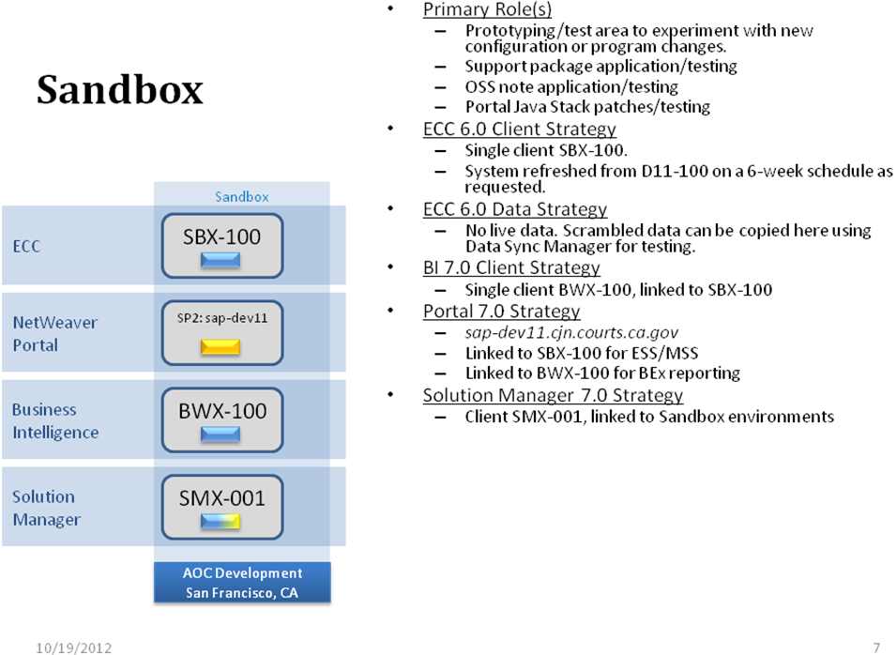

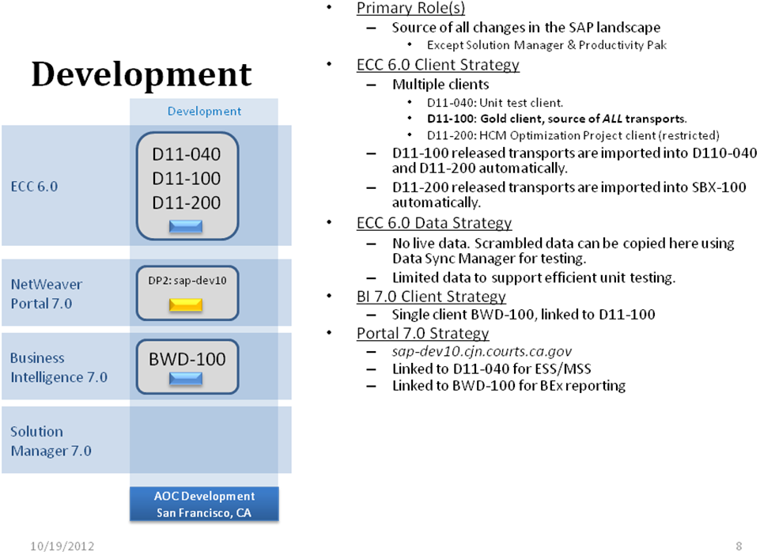
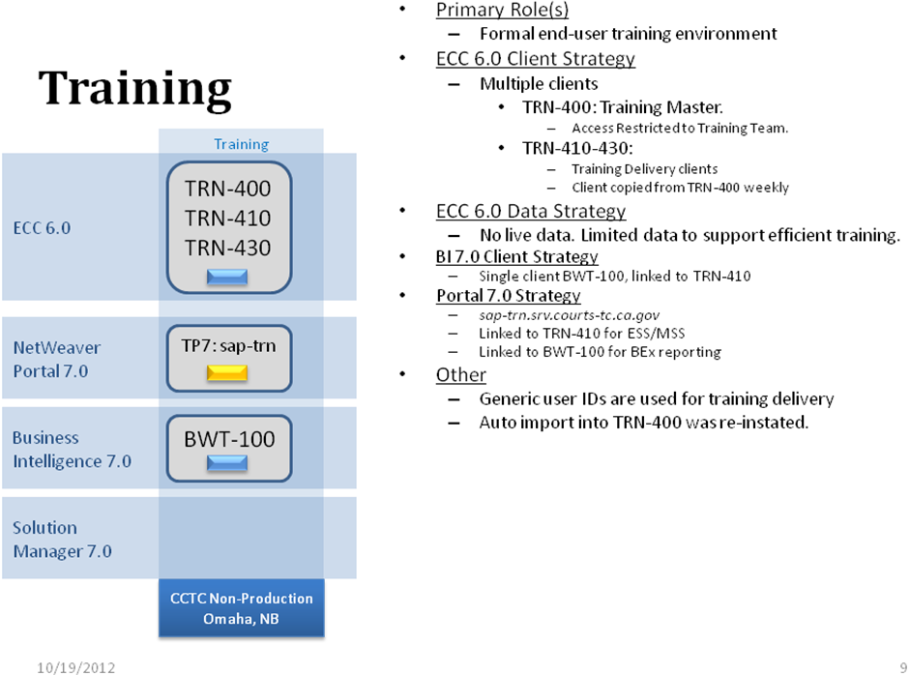
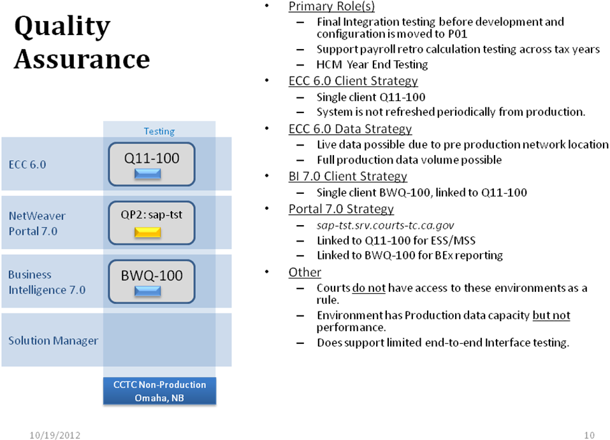
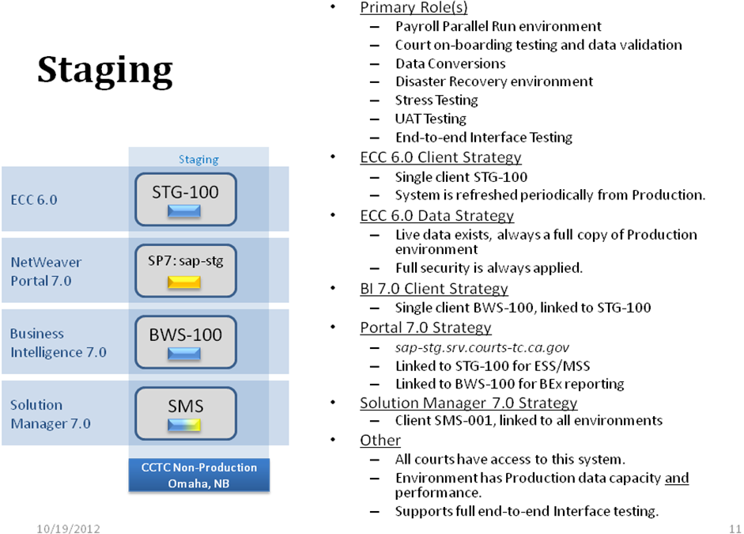
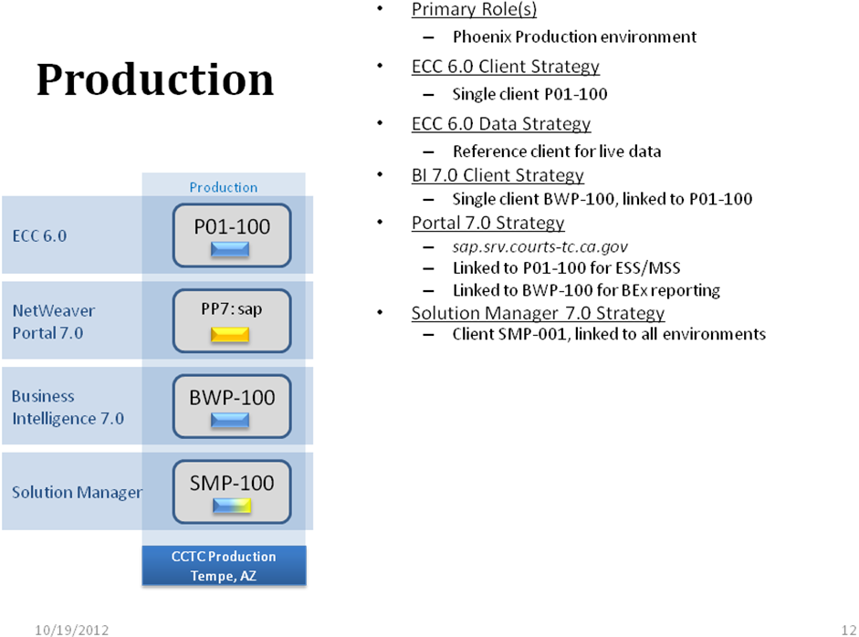

  - Current Physical Server Architecture
All the environments (sandbox, Development, Testing, Training, Staging and Production) in the landscape are implemented in physically separate servers. For the three-tier environments (ERP Production and Staging), there are separate servers for the database, application and presentation tiers.
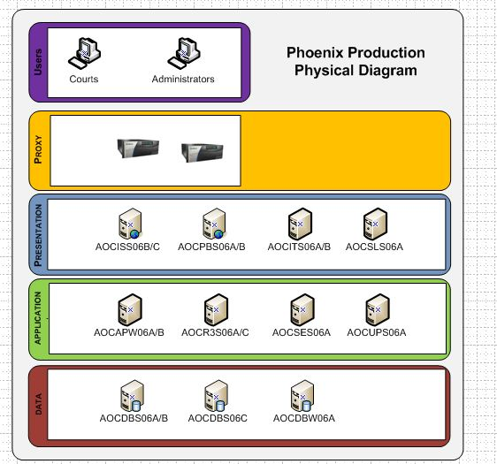
    - Technology Standards
All SAP servers, with the exception of the uPerform Application and Search Severs (which are Wintel), are Sun UltraSparc technology running the Solaris 10 operating system. The database technology is Oracle 11.2.0.3. Storage for all database data is provided by SAN attached enterprise class storage. Local server disk is used for operating system and related file systems only.
All database servers and central instance environments in Staging and Production are clustered for high availability, as are the Portal servers, and proxy servers. BI servers are not clustered.

  - Current Logical Network Architecture
The current overall technical network architecture consists of distinct areas, each on its own set of VLANS. These separated VLANs provide network-level access security to the SAP environments in the landscape and has been used to address security requirements around HR data in QA-level environments. The areas included in the technical network architecture are as follows:
AOC Data Center includes:
- Development and Sandbox
Pre-Production (Omaha) include:
- Staging environments
- Test / Training – QA and Training
Production (Tempe) includes:
- Production SAP environments are located here.
Within each of these areas, multiple network layers, each with separate VLANS, have been implemented.
Proxy Layer includes:
- Proxy servers, firewalls and the DMZ
Presentation Layer includes:
- Enterprise Portal (EP)
Application Server Layer includes:
- SAP application servers are located on this VLAN.
Database Server Layer includes:
- Clustered SAP Production database servers are located on this VLAN.
  - SAP Authentication Architecture

Authentication for the end user is via a middleware – Siteminder. Users have Single Sign On (SSO) from the Siteminder to the EP portal. User credentials are provided by the Active Directory (AD). SSO between Siteminder, Portal, Secude and ECC backend systems provides a seamless user logon experience.
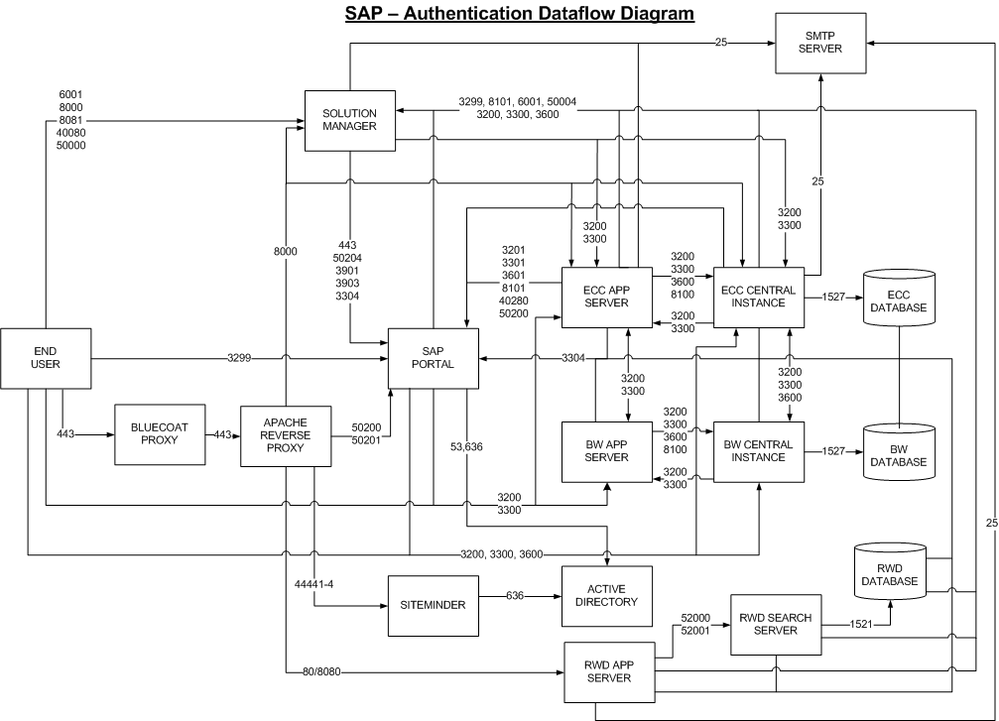

END OF ATTACHMENT
END OF RFP

