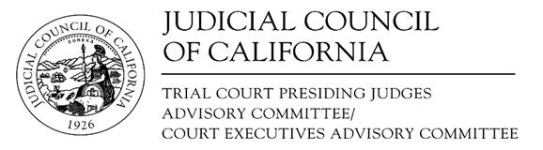
www.courts.ca.gov/tcpjac.htm
www.courts.ca.gov/ceac.htm
tcpjac_ceac@jud.ca.gov

Trial Court Presiding Judges Advisory Committee (TCPJAC)/ Court Executives Advisory Committee (CEAC)

Joint Legislation Subcommittee (JLS)
Notice and Agenda of Closed Meeting
Closed to the Public (Cal. Rules of Court, rule 10.75(c) or (d) and (e)(1))
Date: | February 2, 2023
Time: | 12:10 - 1:00 p.m.
Meeting materials will not be posted on the advisory body web page on the California Courts website. Materials are only posted for open meetings. (Cal. Rules of Court, rule 10.75(h).)
- Closed Session (Cal. Rules of Court, Rule 10.75(d))
Closed pursuant to California Rules of Court, rules 10.75(d)(3) and 10.75(d)(10).
Call to Order and Roll Call
Discussion Agenda

Item 1
SB 75 (Roth) as introduced January 11, 2023
Courts: Judgeships

- Adjournment
Adjourn Closed Session

