Filed 8/23/22; REVIEW GRANTED. See Cal. Rules of Court, rules 8.1105 and 8.1115 (and corresponding Comment, par. 2, concerning rule 8.1115(e)(3)).
CERTIFIED FOR PUBLICATION

IN THE COURT OF APPEAL OF THE STATE OF CALIFORNIA

SECOND APPELLATE DISTRICT

DIVISION SIX

In re E.L. et al., Minors. | 2d Juv. No. B316261  (Super. Ct. No. T000117)  (Ventura County)
AIDA R.,

Petitioner and Respondent,

v.

E.O. et al.,

Objectors and Appellants.

California Code of Civil Procedure section 909 allows a reviewing court to admit evidence not adduced at trial.
In re Zeth (2003) 31 Cal.4th 396, 405, cautions that such authority should be exercised sparingly. But Code of Civil Procedure section 909 also mandates it shall be liberally construed where a cause may be disposed of in a single appeal. That is the case here where the interests of justice do not require a new trial or further hearings in the trial court.
This is an appeal from an order terminating parental rights of both parents pursuant to Probate Code section 1516.5. We determine that the application of Code of Civil Procedure section 909 is appropriate based on additional evidence which we take on appeal. We affirm.
FACTS
D.L. (Mother) is the biological mother of four children: E.L., Child 1, now 15 years old; E.R.O., Child 2, now 11; L.O., Child 3, now 10; and E.O.O., Child 4, now 7. E.O. (Father) is the presumed father of Child 1 and the biological father of the other children.
Aida R. met the children when her nephew became friends with Child 1. In 2014, Mother asked Aida R. to help her care for Child 4. By 2016, Aida R. was caring for all the children. When the children’s paternal grandmother tried to take the children from Aida R.’s home without her consent, Aida R. filed for guardianship. On January 10, 2017, Aida R. was appointed legal guardian of the children.
Originally Mother visited her children several times per week. By early 2017, Mother was visiting only once or twice per week. In March 2017, Aida R. stopped the visitation out of concern for the children’s safety. Mother responded by petitioning to terminate the guardianship. Mother’s petition was denied, and she was allowed contact only in writing. Since July 2019, Mother has written to the children only twice.
In January 2015, Father began a two-year term in the Ventura County jail. His mother brought the children on visits every other week. Further incarceration ensued in state prisons in Wasco and Susanville beginning in January 2017. Father was released in August 2020. From January 2017 when Father went to state prison until his release, letters and phone calls were the only contact with his children. Since Father’s release in August 2020, he did not contact Aida R. to see his children.
HSA REPORT
The Ventura County Human Services Agency (HSA) filed a report with the court. When interviewed by HSA, Child 1 said he knew Aida R. wanted to adopt him and his siblings. HSA told Child 1 that because he was older than 12, he could not be adopted without his consent. Child 1 said he did not know how he felt about being adopted. He did not want Mother to be mad at him. He wanted to stay together with his siblings, so if they wanted to be adopted, he was willing to be adopted. Child 2 and Child 3 said they liked living with Aida R. and wanted to be adopted.
The report concluded: “It appears that the petitioner [Aida R.] has acted as the subject minors’ parent in every way since the subject minors began living with [Aida R.] in August of 2016. The subject minors deserve a safe, stable, and nurturing home environment, which the natural parents have been unable or unwilling to provide. [Aida R.] has addressed their special education needs as well as mental health needs consistently, and provides the love and support they need. Although the eldest sibling, [Child 1], has not agreed to be adopted, it is the opinion of [HSA] that it is in his best interest for him to be adopted. Furthermore, it is in the best interest of his half siblings . . . to be adopted regardless of [Child 1’s] choice. These children are in the best place they can be, and they [are] safe. They have no relationship with their parents. They need to know they are not going to be separated and they will have the stability and knowledge that they are in a forever home, when they are adopted.”
TRIAL
(a) Children
Child 1 testified that he is 14 years old. He has lived with Aida R. and her family for about five years and considers them to be his family. He has a normal mother-and-son relationship with Aida R. He has not seen Mother or Father for about two years and has only received one letter from each since seeing them. He wants to be adopted by Aida R.
Child 2 testified that she is 10 years old. She has lived with Aida R. and her family for about five years. She views them as her family and Aida R. as a mother. She has not seen Mother in two years and Father in six or seven years except to visit him in jail. She wants to be adopted by Aida R.
Child 3 testified that she is 10 years old. She has lived with Aida R. and her family for five years and calls Aida R. “mom.” She feels safe with Aida R. and wants to be adopted.
Child 4 did not testify.
(b) Aida R.
Aida R. testified that when the children first came to her they did not relate to each other as siblings. Instead, they took care of each other as parents. In the last five years, their bond as siblings has grown.
Aida R. discussed with the children what would happen if they were not adopted. She assured them that they would not go back to family services but would remain with her as their legal guardian. Aida R. described how the children have progressed with their mental health and behavior.
(c) Father
Father testified that he is wiser and more mature than the man who went to prison. He earned his GED while in prison and received vocational training in facility maintenance and repair. He learned plumbing, tile, and fixture repair. He uses these skills in his current job as a handyman. While in prison he obtained certificates for attending classes in health education, alternatives to violence, “criminal thinking,” anger management, and substance abuse. He attended weekly meetings of Alcoholics Anonymous and Narcotics Anonymous. Father said he is in compliance with the conditions of parole, including monthly drug testing.
Father said he had not contacted Aida R. to see his children since he was released from prison in August 2020. He said he was advised by his attorney not to and was following that advice. He said he knew that he would have his day in court. Father said the last time he saw his children in person was in January 2017 before he went to prison in Wasco.
Father said his goal was to have his children placed in his care as soon as possible. He did not have a timeline because he did not know the process. He believed it had been beneficial for the children to stay with Aida R. for the last five years, where they had been thriving.
(d) Mother
Mother did not testify at the hearing. On October 6, 2021, the trial court interrupted Aida R.’s testimony to note for the record that Mother had abruptly left the courtroom. Mother’s counsel explained that Mother left because she “had to catch an earlier bus.” Mother did not appear on October 7 or 8 for the next two days of trial. Mother’s counsel told the court that Mother was ill. On the final day of trial, October 8, Mother’s counsel requested a continuance. The court denied the request. The parties rested and the matter was continued to October 12 for argument.
Mother appeared on October 12, 2021, stated she had been ill, and asked the trial court to reopen the evidence so she could testify. Aida R., Father, and the children objected. The court denied the motion, stating Mother had failed to show good cause.
DISCUSSION
I.
Statutory Authority and Standard of Review
Section 1516.5, subdivision (a) provides:
“A proceeding to have a child declared free from the custody and control of one or both parents may be brought . . . in an adoption action, or in a separate action filed for that purpose, if all of the following requirements are satisfied:
“(1) One or both parents do not have the legal custody of the child.
“(2) The child has been in the physical custody of the guardian for a period of not less than two years.
“(3) The court finds that the child would benefit from being adopted by his or her guardian. In making this determination, the court shall consider all factors relating to the best interest of the child, including, but not limited to, the nature and extent of the relationship between all of the following:
“(A) The child and the birth parent.
“(B) The child and the guardian, including family members of the guardian.
“(C) The child and any siblings or half siblings.”
Section 1516.5 “requires the court to consider ‘all factors relating to the best interest of the child,’ . . . includ[ing] the circumstances leading to guardianship, the parent's efforts to maintain contact with the child, any exigencies that might hamper those efforts, and other evidence of commitment to parental responsibilities.” (Guardianship of Ann S. (2009) 45 Cal.4th 1110, 1132.) Section 1516.5 does not require, however, a showing of parental unfitness or that terminating parental rights is the least detrimental alternative for the child. (In re Noreen G. (2010) 181 Cal.App.4th 1359, 1383.)
The trial court’s findings are reviewed under the clear and convincing evidence standard. (Guardianship of Ann S., supra, 45 Cal.4th at p. 1127, fn. 9.) The question is whether the record as a whole contains substantial evidence from which a reasonable fact finder could have found it highly probable that the fact was true. (Conservatorship of O.B. (2020) 9 Cal.5th 989, 1011.) In conducting our review, we must view the record in a light most favorable to the prevailing party below and give appropriate deference to how the trier of fact may have evaluated the credibility of witnesses, resolved conflicts in evidence, and drawn reasonable inferences from the evidence. (Id. at pp. 1011-1012.)
Here the first two elements of section 1516.5 – the parents do not have legal custody over the children and the children have been in the physical custody of the guardian for not less than two years – are undisputed. The only issue is the best interest of the children.
II.
Substantial Evidence and Abuse of Discretion
Father contends the trial court’s order is not supported by substantial evidence and constitutes an abuse of discretion.
The evidence shows that for more than five years Aida R. has provided a loving, nurturing, and stable home for the children. The children’s parents have been unable or unwilling to provide such a home. The children now view Aida R. and her family as their family. They want to be adopted by Aida R. That alone is sufficient to support the trial court’s order.
Father challenges the conclusion of the HSA report that the parents have no relationship with their children. Father points to biweekly visits with the children while he was in jail and correspondence with the children while he was in prison. Suffice it to say that biweekly visits to jail and correspondence with the children while he was in prison do not constitute the parent and child relationship the children need.
Father points out that our Supreme Court in Ann S. required the trial court to consider exigent circumstances. (Guardianship of Ann S., supra, 45 Cal.4th at p. 1132.) Father claims his incarceration constitutes an exigent circumstance. If so, it is a circumstance of Father’s own making. At one time, Father chose criminality over being a responsible parent. We are quite sure the trial court considered Father’s incarceration in deciding to order the termination of his parental rights.
Father points out that HSA did not interview him for its report. But Father was in prison when the report was made. More importantly, Father, with the guidance of his counsel, testified at trial. Father does not suggest what he could have said to HSA that he could not have said at trial.
Father points out that HSA could not recommend adoption for Child 1. That is because Child 1 was over 12 years old and had to make his own decision. In fact, Child 1 testified at trial that he wanted to be adopted.
Father has by his own account made great progress in becoming a responsible member of society. This is commendable. But that progress does not make up for the more than five years he spent away from his children due to his own choices. Father attempts to convince us otherwise by viewing the evidence in a light most favorable to himself. But that is not how we view the evidence. We view the evidence in a light most favorable to the judgment. (Conservatorship of O.B., supra, 9 Cal.5th at pp. 1011-1012.) Father points to no evidence that would compel the trial court to conclude Father’s relationship with his children, to the extent such a relationship exists, is more important than providing a stable and nurturing home with Aida R. through adoption. It is Aida R., not Father, who has been a parent to the children since 2016.
III.
MOTHER’S APPEAL
Denial of Mother’s Request to Testify
Mother contends the trial court abused its discretion in denying her request to reopen the evidence to allow her to testify.
In denying Mother’s request, the trial court stated that Mother failed to show good cause for her absence. In its order the court said: “With respect to the respondent mother, . . . her absence from court, as reflected in the record, was noteworthy. She abruptly left without prior notice during the testimony of the first witness (unflattering testimony about her) and was thereafter absent throughout the majority of the proceeding, without any compelling justification.”
In other words, the trial court did not believe Mother was prevented from attending the hearing by illness. The court’s disbelief in Mother’s excuse is well supported. Mother began her absence by leaving the hearing without good cause; that is, to catch an earlier bus. Mother cannot absent herself from the hearing without good cause and expect the court to reopen the evidence portion of the trial so she can testify at her convenience.
Moreover, Mother made no offer of proof. When faced with the prospect of permanently losing custody of her children, she left the hearing to catch an earlier bus. No testimony that Mother could possibly give speaks more eloquently than that.
IV.
ICWA
Mother contends the trial court failed to comply with the Indian Child Welfare Act of 1978 (ICWA). (25 U.S.C. § 1901 et seq.; Welf. & Inst. Code, § 224.2.)
ICWA provides: “In any involuntary proceeding in a State court, where the court knows or has reason to know that an Indian child is involved, the party seeking the foster care placement of, or termination of parental rights to, an Indian child shall notify the parent or Indian custodian and the Indian child’s tribe, by registered mail with return receipt requested, of the pending proceedings and of their right of intervention.” (25 U.S.C. § 1912(a).)
An “Indian child” is “any unmarried person who is under age eighteen and is either (a) a member of an Indian tribe or (b) is eligible for membership of an Indian tribe.” (25 U.S.C. § 1903(4).)
ICWA does not itself impose a duty to inquire whether a child is an Indian child. That duty is imposed by federal regulation. (25 C.F.R. § 23.107(a).) In Welfare and Institutions Code section 224.2, California has enacted a statute that parallels the federal regulations.
Welfare and Institutions Code section 224.2, subdivision (c) provides: “At the first appearance in court of each party, the court shall ask each participant present in the hearing whether the participant knows or has reason to know that the child is an Indian child. The court shall instruct the parties to inform the court if they subsequently receive information that provides reason to know the child is an Indian child.” Subdivision (d) of the section lists six circumstances, any one of which constitutes reason to know. The only circumstance that is potentially applicable here is in subdivision (d)(1): “A person having an interest in the child, including . . . a member of the child’s extended family informs the court that the child is an Indian child.”
Welfare and Institutions Code section 224.2, subdivision (e) provides, in part: “If the court, social worker, or probation officer has reason to believe that an Indian child is involved in a proceeding, but does not have sufficient information to determine that there is a reason to know that the child is an Indian child, the court, social worker, or probation officer shall make further inquiry regarding the possible Indian status of the child, and shall make that inquiry as soon as practicable.”
We need not cite the profusion of cases that in myriad ways interpret Welfare and Institutions Code section 224.2, subdivision (e). To what extent are social workers required to comb the nether reaches of the land to find relatives who may shed light on a child’s possible Indian heritage? We can only hope these varying interpretations will be resolved soon. But here we have the evidence that answers this question.
Mother filled out an ICWA-020 form, but it is not part of the record. At trial, Mother’s counsel represented that Mother had no Indian ancestry, and the trial court found that ICWA did not apply.
Mother argues that ICWA is a substantial right, and her counsel may not waive a substantial right without her consent. (Citing In re Josiah Z. (2005) 36 Cal.4th 664, 678 [attorney not authorized to impair the child’s substantial rights].) Mother states the law correctly, but here the child’s substantial rights are protected. It is not disputed that Mother submitted an ICWA-020 form to the Tohono O’odham Nation.
Aida R. requests that we take additional evidence pursuant to Code of Civil Procedure section 909. The evidence consists of an ICWA-020 form completed and signed by Mother stating she is or may be a member of the Tohono O’odham Nation, and letters from the tribe stating the children are not members of the tribe for the purposes of ICWA. Included is an affidavit from Aida R.’s attorney stating he obtained the ICWA form and tribal letters from Mother’s trial attorney.
Mother objects that taking such evidence on appeal is an inappropriate use of Code of Civil Procedure section 909. The circumstances here, however, warrant application of Code of Civil Procedure section 909. Remand would unnecessarily delay the likelihood of adoption of the children and would achieve the same result we do here. We admit into evidence Mother’s ICWA-020 form and the tribe’s response pursuant to Code of Civil Procedure section 909 as appendices A-1, A-2, and A-3, post, to this opinion.
We achieve now what the trial court would do on remand – find that ICWA does not apply.
As our colleagues pointed out in In re Allison B. (2022) 79 Cal.App.5th 214, 219: “When, however, postjudgment evidence is offered to an appellate court in support of a motion to dismiss a juvenile dependency appeal, it is ‘routinely consider[ed]’ because, if the motion is granted, it will have ‘the beneficial consequence’ of ‘ “expedit[ing] the proceedings and promot[ing] the finality of the juvenile court's orders and judgment.” ’ ”
Although the facts are different, the analysis in In re Dezi C. (2022) 79 Cal.App.5th 769, 779, is instructive here.
“[T]he price that would be paid for” the “added incentive” of “treating [an] error as . . . structural” (and hence automatically reversible), “in the form of needless reversals of dependency judgments, is unacceptably high in light of the strong public interest in prompt resolution of these cases so that the children may receive loving and secure home environments as soon as reasonably possible.” (In re James F. (2008) 42 Cal.4th 901, 918.) The automatic reversal rule gives rise to the “very evil the Legislature intended to correct”–namely, “lengthy and unnecessary delay in providing permanency for children.” (In re Marilyn H. (1993) 5 Cal.4th 295, 310.)
To this we add, ICWA’s laudable goal is to preserve Indian culture. But ICWA should not be abused to thwart legitimate adoptions.
DISPOSITION
The orders terminating the parental rights of Mother and Father are affirmed.
CERTIFIED FOR PUBLICATION.

GILBERT, P. J.
We concur:

YEGAN, J.

PERREN, J.*
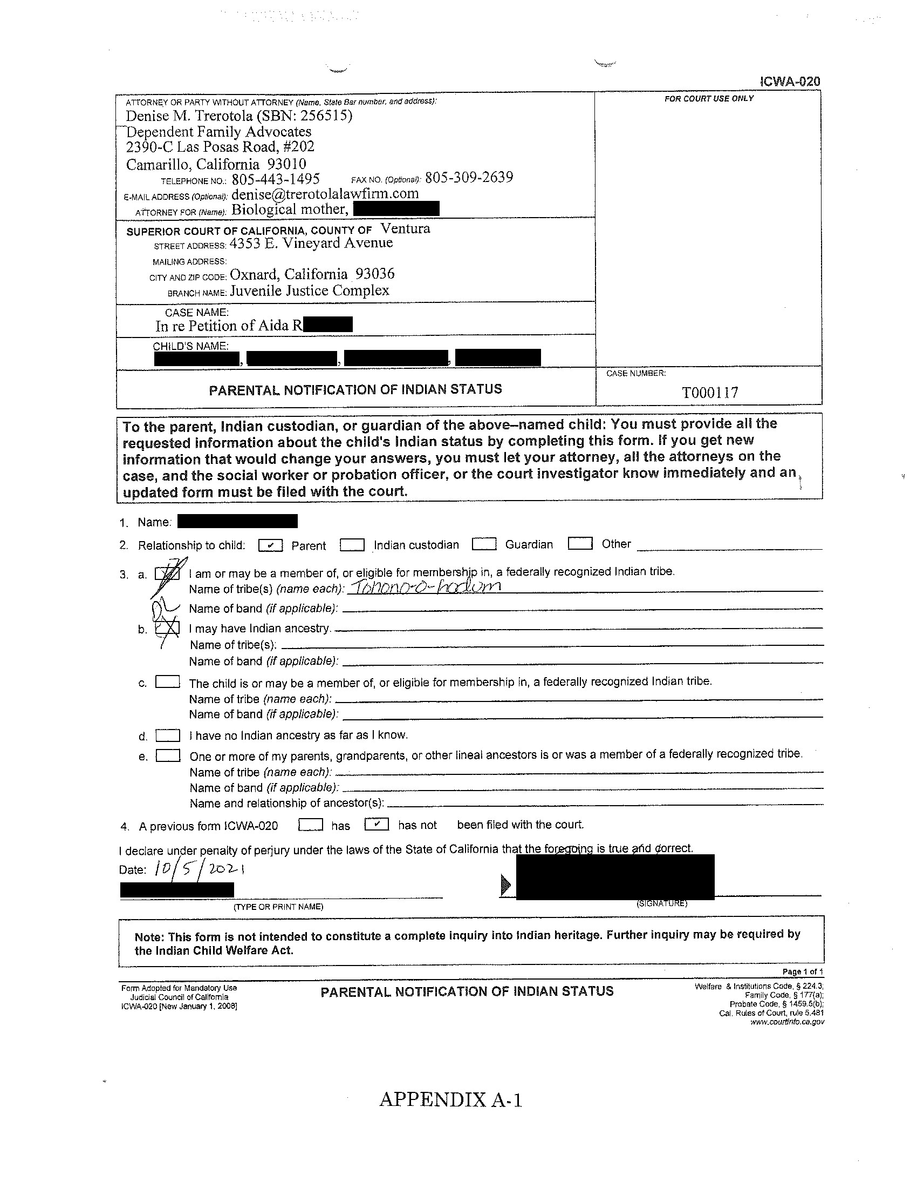
E.R.O.
L.E.O.
E.O.O.
E.B.L.

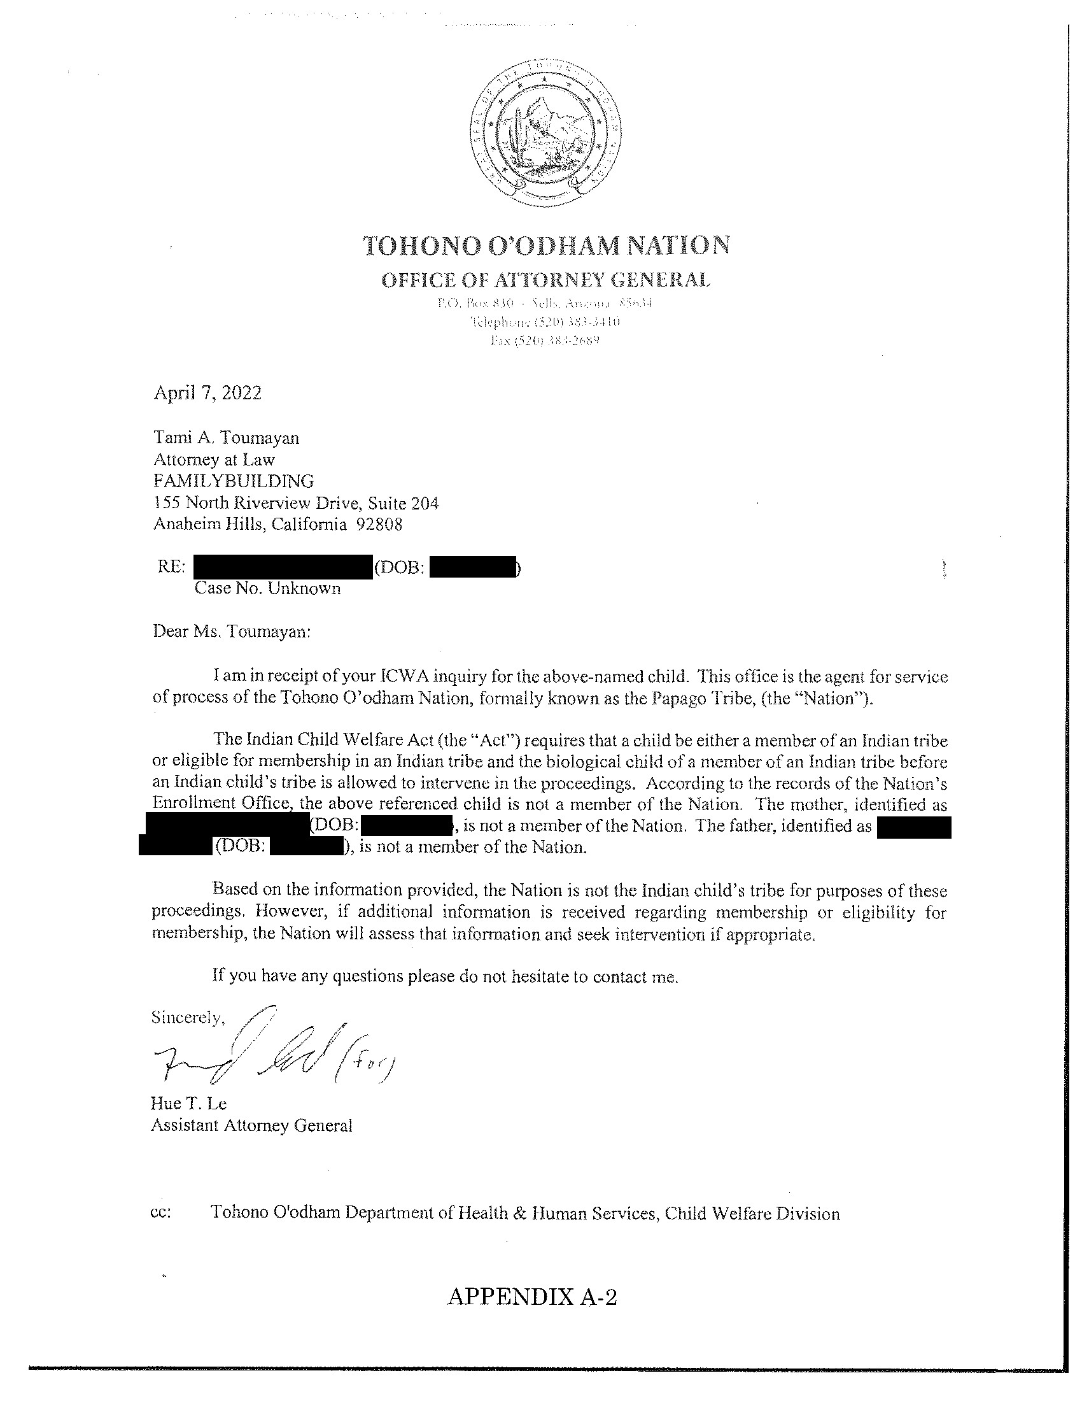
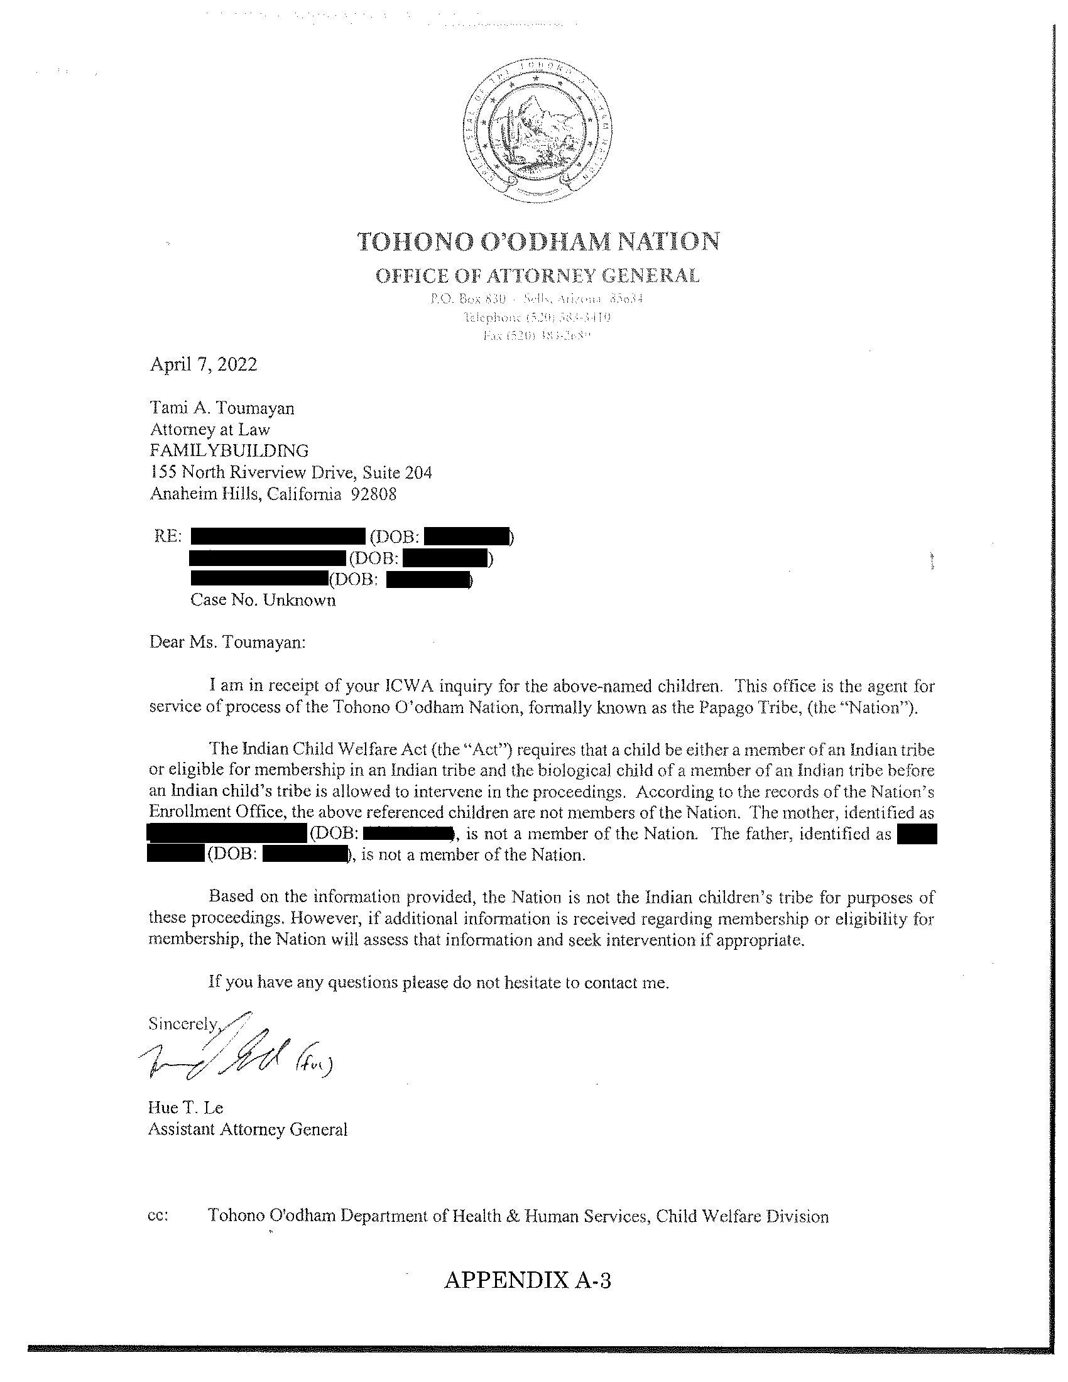

Benjamin F. Coats, Judge

Superior Court County of Ventura

______________________________

Janette Freeman Cochran, under appointment by the Court of Appeal, for Objector and Appellant E.O.
Christopher Blake, under appointment by the Court of Appeal, for Objector and Appellant D.L.
Family Building, Tami A. Toumayan, Ted R. Youmans; Leslie A. Barry for Petitioner and Respondent Aida R.

Code of Civil Procedure section 909 reads, “In all cases where trial by jury is not a matter of right or where trial by jury has been waived, the reviewing court may make factual determinations contrary to or in addition to those made by the trial court. The factual determinations may be based on the evidence adduced before the trial court either with or without the taking of evidence by the reviewing court. The reviewing court may for the purpose of making the factual determinations or for any other purpose in the interests of justice, take additional evidence of or concerning facts occurring at any time prior to the decision of the appeal, and may give or direct the entry of any judgment or order and may make any further or other order as the case may require. This section shall be liberally construed to the end among others that, where feasible, causes may be finally disposed of by a single appeal and without further proceedings in the trial court except where in the interests of justice a new trial is required on some or all of the issues.”
All further references are to the Probate Code unless otherwise indicated.
Aida R.’s request to take additional evidence dated April 11, 2022, is granted.
* Retired Associate Justice of the Court of Appeal, Second Appellate District, assigned by the Chief Justice pursuant to article VI, section 6 of the California Constitution.

