Filed 7/15/15; pub. order 7/31/15 ( see end of opn.)

IN THE COURT OF APPEAL OF THE STATE OF CALIFORNIA

FOURTH APPELLATE DISTRICT

DIVISION TWO

THE PEOPLE,  Petitioner,  v.  THE SUPERIOR COURT OF  SAN BERNARDINO COUNTY,  Respondent;  JOHNNY MORALES,  Real Party in Interest. | E061754  (Super.Ct.No. FVA015456)  OPINION

ORIGINAL PROCEEDINGS; petition for writ of mandate. Ingrid Adamson Uhler, Judge. Petition granted.
Kamala D. Harris, Attorney General, Julie L. Garland, Senior Assistant Attorney General, Holly D. Wilkens and Michael T. Murphy, Deputy Attorneys General, for Petitioner.
No appearance for Respondent.
Michael J. Hersek, State Public Defender, and Cheryl Delaine Renard, Senior Deputy State Public Defender, for Real Party in Interest.
On request of real party in interest Johnny Morales, the trial court entered an order requiring multiple public agencies and departments to “preserve” 22 categories of documents and other materials allegedly to pertain in some way to the criminal proceedings which resulted in a judgment of death against petitioner.
The People sought review by way of petition for writ of mandate from this court, arguing that the trial court had no jurisdiction to make such an order in the absence of any pending proceeding. We agree that the order is erroneous, and will grant the relief requested.
STATEMENT OF THE CASE
Morales’s motion requested that “materials potentially relevant to his case be kept intact so that future litigation can center on the fairness of his conviction and death sentence, and not on tangential issues such as whether materials should have been destroyed or whether destroyed materials would have favored the prosecution or appellant [Morales].” It appears that Morales was sentenced in 2005 and his appeal is pending before the Supreme Court of California. Morales asserted, without contradiction, that although he has been appointed appellate counsel (who prepared the motion), he has not yet been appointed counsel to pursue any habeas corpus remedy.
It was also asserted in the motion that “the duty falls to appellate counsel to preserve all materials arguably governed by [Penal Code] section 1054.9[] so that the Legislature’s intention to provide condemned people like appellant with postjudgment discovery can be given full force and effect.”
The People opposed the motion on the primary ground that the trial court lacked jurisdiction to grant the requested relief in the absence of some pending recognized proceeding. The People also argued that the request imposed an undue burden on the various agencies and departments specified.
After hearing argument, the trial court made the order set out above. The People sought a writ of mandate to vacate the order and this court issued an order to show cause.
DISCUSSION
First, we have no quarrel with Morales’s description of the delays in the death penalty review process. However, the issue is not whether the procedure sought by Morales is desirable, but whether it is authorized by law.
In addition to arguing that writ review is unnecessary (see fn. 4, post), Morales focuses on procedural challenges to the People’s attempt to overset the ruling. He argues first that the People failed to “specifically [] allege, or allege sufficient facts to make even a prima facie showing, that it has a beneficial interest or substantial right that will be substantially damaged if writ relief is denied . . . .” The gist of this argument is that the public agencies and departments listed in the motion did not object and therefore the People may not do so.
There are two flaws in this argument. The first is that consent (and a fortiori inaction) cannot confer jurisdiction where none exists. (See People v. Alanis (2008) 158 Cal.App.4th 1467, 1473 [also involving postjudgment trial court proceedings while
defendant’s appeal was pending].) The second is that the People are an interested party as multiple categories do impose a duty on the People to preserve evidence. For example, item “c.” describes “[a]ll prosecutorial and law enforcement reports, notes, tape recordings, . . .” while item “f.” specifies “[a]ll writings or other records relating to the decision by the San Bernardino County District Attorney’s Office to seek the death penalty, . . .” and “t.” refers to “[a]ll criminal files relating to other suspects and/or witnesses related to this case including the following: [names] whether in the possession or control of the San Bernardino County Superior Court, the San Bernardino County District Attorney’s Office . . . .” Thus, the People, acting through the district attorney, were directly affected by the order and were entitled to appear and oppose it both in the trial court and before this court. Furthermore, the order would inevitably oblige the affected departments and entities to conduct a search of records and devise some method of segregating any materials which might conceivably fall within the order.
Morales also complains that the People inadequately allege the justification for extraordinary relief as set out in Code of Civil Procedure, sections 1085 and 1086. To the extent that this reflects the position that the People are not a party “beneficial[ly] interest[ed]” and that they have an adequate remedy at law, we have explained our disagreement. To the extent that Morales challenges the technical adequacy of the pleading with respect to alleging these elements, we are unpersuaded. First, any such objection to the pleading is properly raised by demurrer, not argument. (See Gong v. City of Fremont (1967) 250 Cal.App.2d 568, 573.) Second, where the petition contains sufficient facts from which the omitted facts can be gleaned, we have discretion to consider it despite technical inadequacies. (Chapman v. Superior Court (2005) 130 Cal.App.4th 261, 271-272.) The district attorney’s apparent unfamiliarity with pleading formats does not require us to refuse relief where warranted.
Morales then argues that the petition must be denied because the People cannot plead and prove that the trial court had a clear duty to deny his motion for lack of jurisdiction. It is true that it is often said that mandate issues to compel a lower court or officer to perform a “clear duty” (Code Civ. Proc., § 1085; see City of King City v. Community Bank of Central California (2005) 131 Cal.App.4th 913, 925) and of course it cannot control the exercise of discretion. (City of Oakland v. Superior Court (1996) 45 Cal.App.4th 740, 751.) But mandate is available to correct abuses of discretion (Alejo v. Torlakson (2013) 212 Cal.App.4th 768, 780) and an error of law is an “abuse of discretion” correctable by mandate. (People v. Superior Court (Humberto S.) (2008) 43 Cal.4th 737, 746.) As we find a clear error of law, mandate will lie.
We now explain our reasoning on the merits. First, it must be noted that this is not a request for actual postconviction discovery under section 1054.9. It is quite true that although that statute refers to such discovery “ ‘[u]pon the prosecution of a postconviction writ of habeas corpus or a motion to vacate a judgment,’ ” (In re Steele (2004) 32 Cal.4th 682, 690-691) this does not mean that an actual petition or motion must have been filed at the time discovery is sought. It is sufficient if such a request for collateral relief is proposed or in preparation. However, since this is not a request under section 1054.9 the permissiveness of that statute does not govern this case.
Before the enactment of section 1054.9, the Supreme Court in People v. Gonzalez (1990) 51 Cal.3d 1179 (Gonzalez) dealt with an effort by a capital defendant, pending resolution of his appeal, to obtain official file information about a jailhouse informant who had testified against him at trial. In that case, the court held that “[t]he trial court lacked jurisdiction to order ‘free-floating’ postjudgment discovery when no criminal proceeding was then pending before it.” (Gonzalez, at p. 1256.) Quoting from previous authority, it explained that “ ‘a discovery motion is not an independent right or remedy. It is ancillary to an ongoing action or proceeding. After the judgment has become final, there is nothing pending in the trial court to which a discovery motion may attach.’ . . . [¶] [This] reasoning applies equally where, as here, an appeal remains undecided.” (Id. at p. 1257.) Stressing the presumptions of validity applicable to a collateral attack on a criminal judgment, the court held that “[t]he state may properly require that a defendant obtain some concrete information on his own before he invokes collateral remedies against a final judgment.” (Id. at p. 1260.) Thus, discovery would only be available once the reviewing court (the Supreme Court) issued an order to show cause upon a finding that a habeas corpus petition stated a prima facie case for relief. (Id. at pp. 1260-1261.) Gonzalez was then followed by People v. Johnson (1992) 3 Cal.4th 1183, 1258, and in People v. Picklesimer (2010) 48 Cal.4th 330, 337 (Picklesimer), the court again confirmed that a motion is not an independent remedy but implies the pendency of an ongoing action.
The court in In re Steele, supra, 32 Cal.4th 682 recognized that section 1054.9 affected the rule of Gonzalez to the extent covered by the statute. But the court’s comment was that section 1054.9 “modifies” and reflects a “modification” of the rule, not that Gonzalez retains no further validity. (In re Steele, supra, at p. 691.) The court stressed that, in the language of Gonzalez, even the new legislation “does not allow ‘free-floating’ discovery asking for virtually anything the prosecution possesses.” (In re Steele, supra, 32 Cal.4th at p. 695.) It also commented that section 1054.9 “imposes no preservation duties that do not otherwise exist.” (In re Steele, supra, at p. 695.)
Morales argues that the order was authorized by Wisely v. Superior Court (1985) 175 Cal.App.3d 267, 270, in which the appellate court found it “fundamentally unfair” to deny discovery to a defendant who had been granted a new trial, while the People’s appeal of that order was pending. The reasoning of Wisely clearly did not impress the Supreme Court in Gonzalez, which found it “inapposite,” “whatever its merits,” (Gonzalez, supra, 51 Cal.3d at p. 1257) because the new trial order at least provided an arguable basis for continuing jurisdiction. Here, although Morales claims that the preservation order is essential to protect his right to pursue collateral relief by habeas corpus, there is simply no pending case or proceeding to which the motion can attach. Accordingly, the trial court had no subject matter jurisdiction.
We recognize that if Morales had chosen to proceed by filing a barebones habeas corpus petition, there would at least have been a proceeding to which his request could have attached, and the trial court could have reached the merits. However, counsel has carefully observed the boundaries of his role as counsel on appeal and elected not to file a collateral proceeding. We also recognize that some of the materials which he seeks to have preserved and which are not subject to any statutory preservation obligation may be of value to him in presenting a claim for relief on habeas corpus. However, our decision is guided by two points: first, that this is not a legislatively authorized motion under section 1054.9, and second, that Supreme Court precedent otherwise forbids trial courts from ruling on such a “free-floating” motion as was presented here. We are not at liberty to ignore Gonzalez, especially as the court in Steele noted the limited extent to which section 1054.9 altered Gonzalez’s rule.
Accordingly, we find that the trial court exceeded its jurisdiction in issuing the preservation order and we will issue the writ.
DISPOSITION
Let a peremptory writ of mandate issue, directing the Superior Court of San Bernardino County to vacate its order for preservation of evidence, and to enter a new order denying real party in interest’s motion.
Petitioner is directed to prepare and have the peremptory writ of mandate issued, copies served, and the original filed with the clerk of this court, together with proof of service on all parties.

KING
J.
We concur:

McKINSTER
Acting P. J.

CODRINGTON
J.
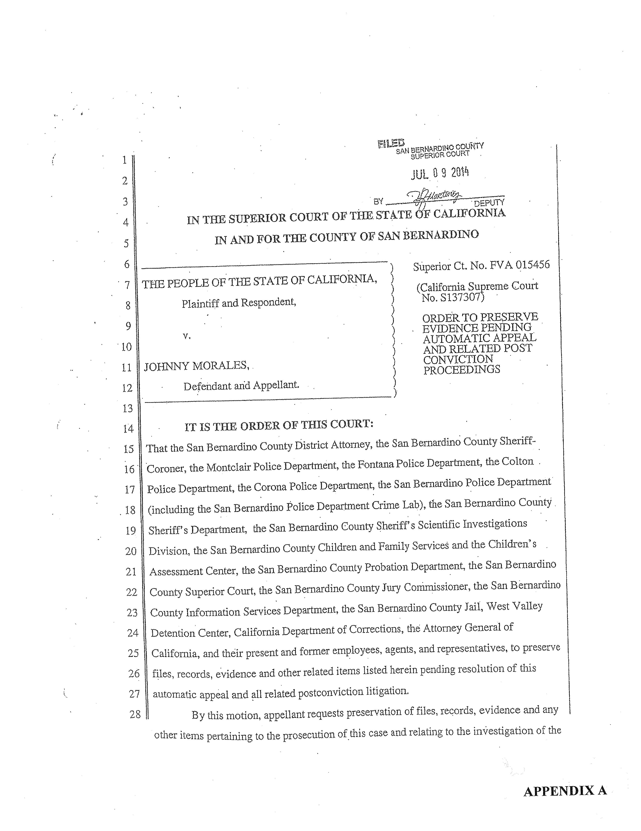
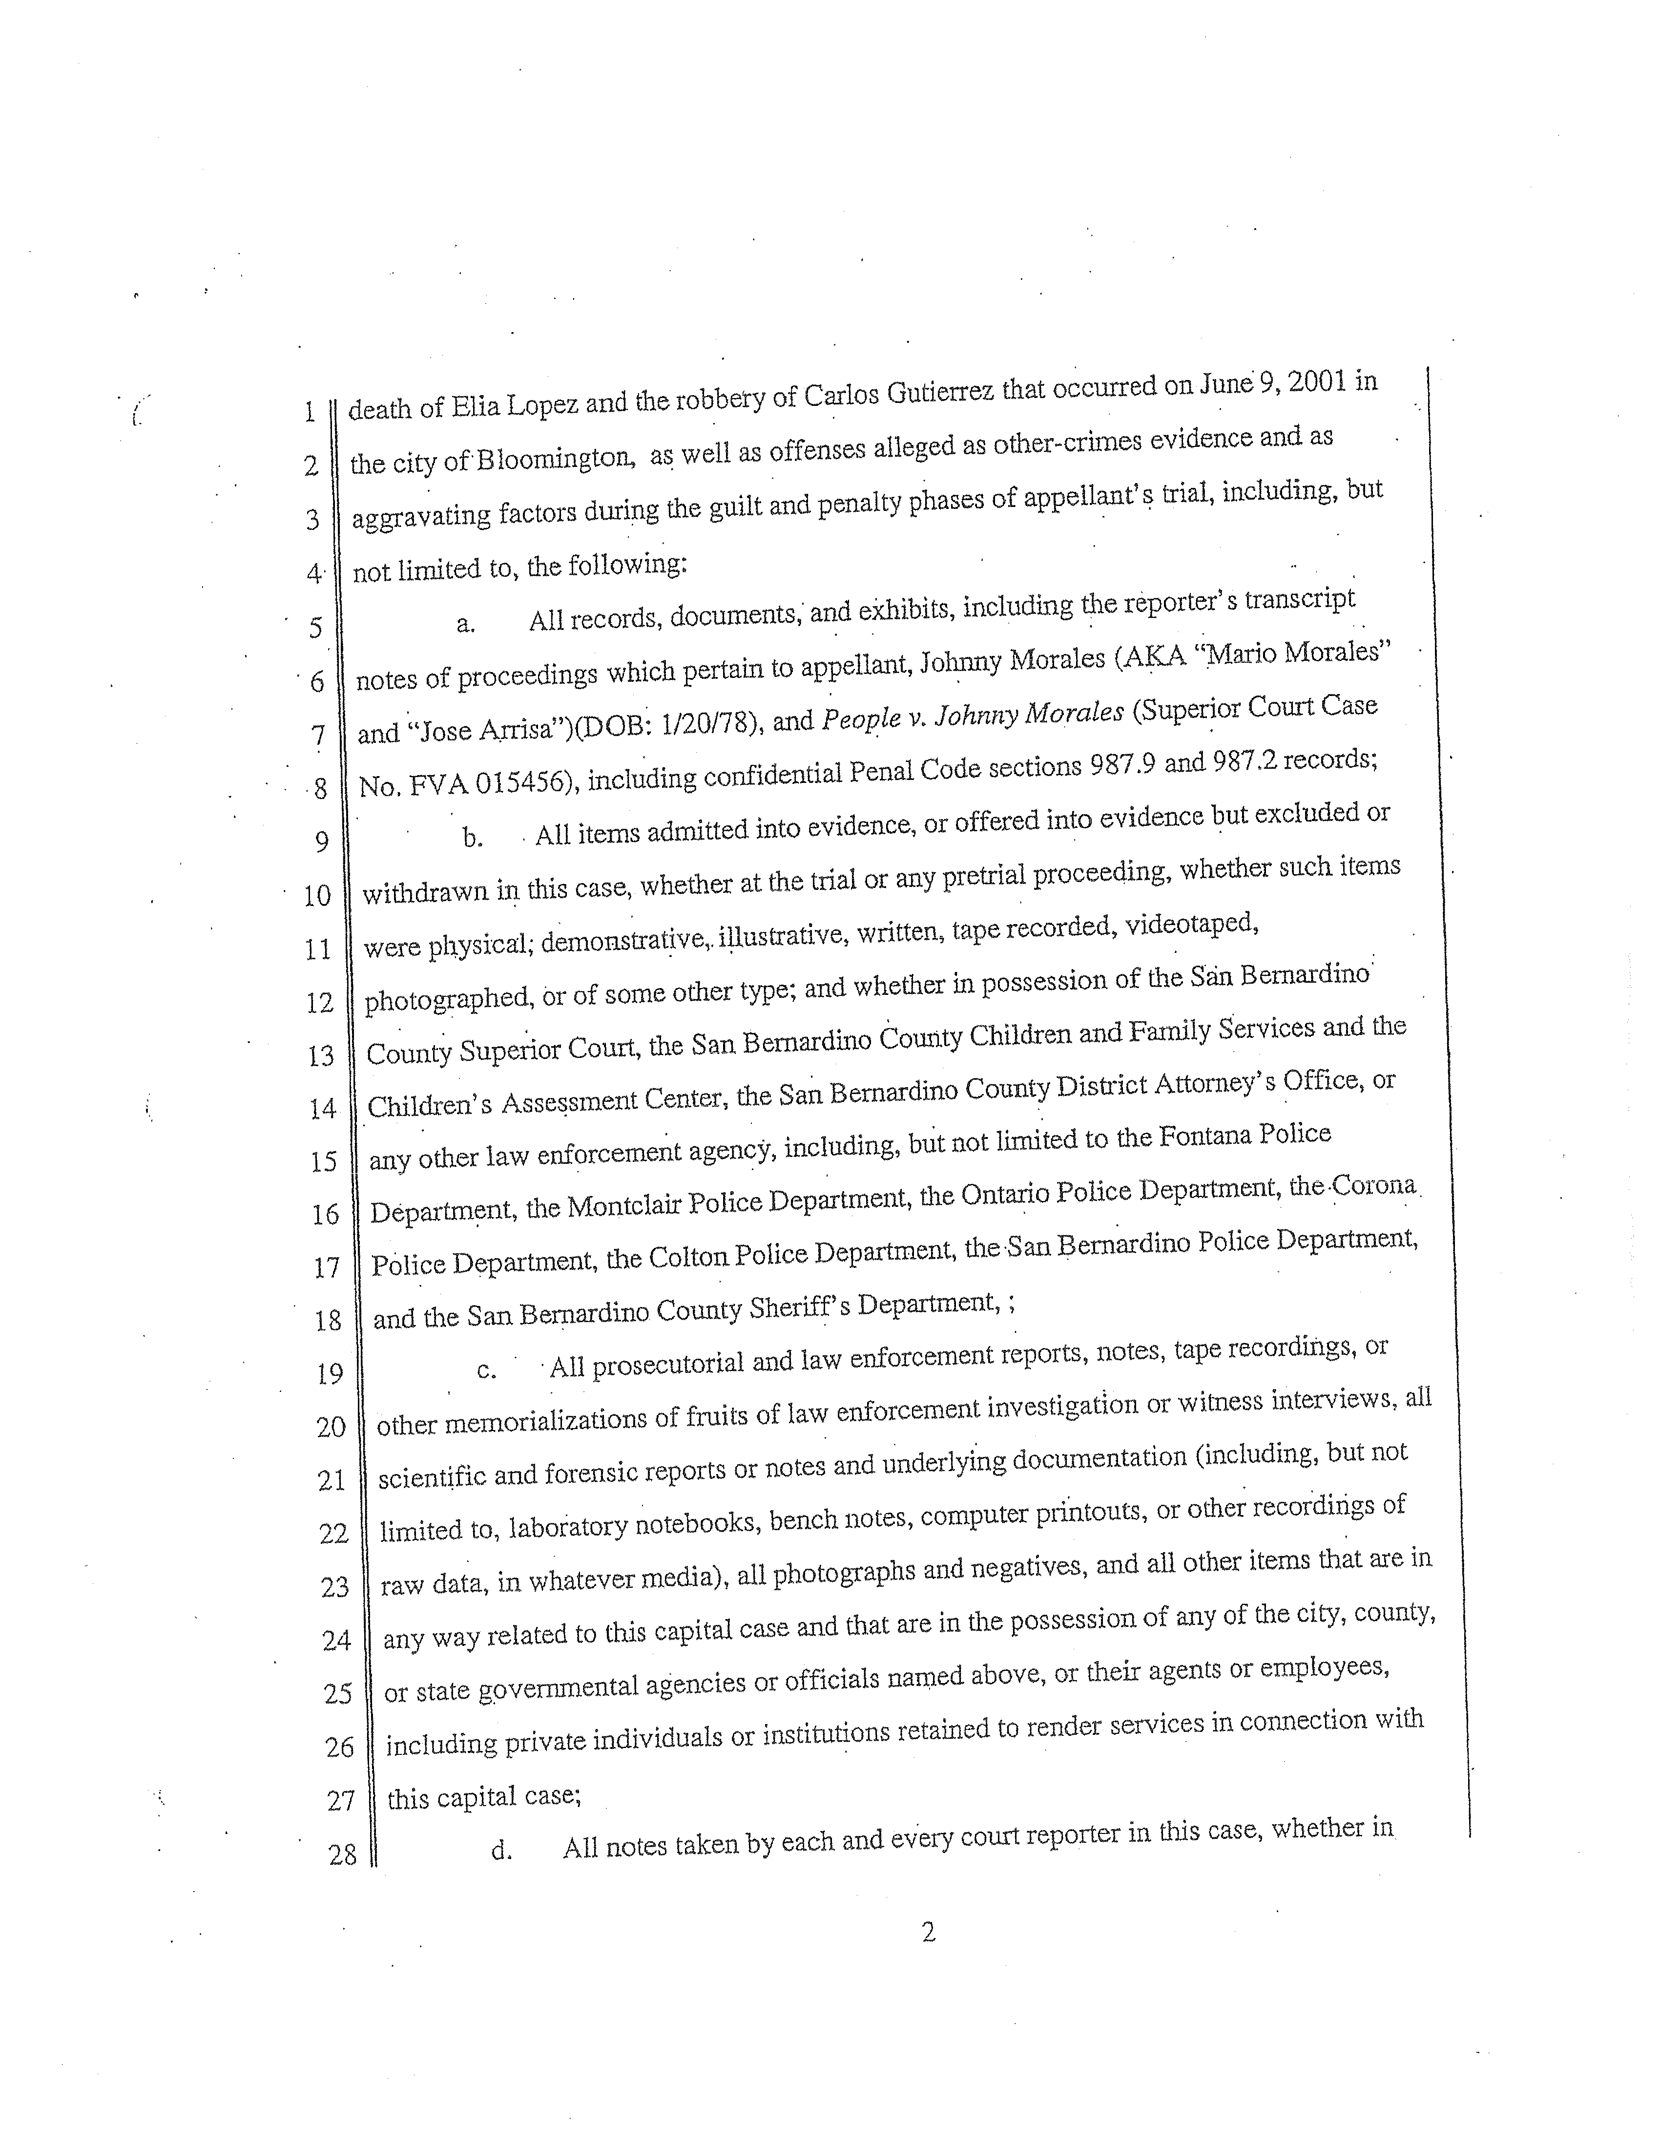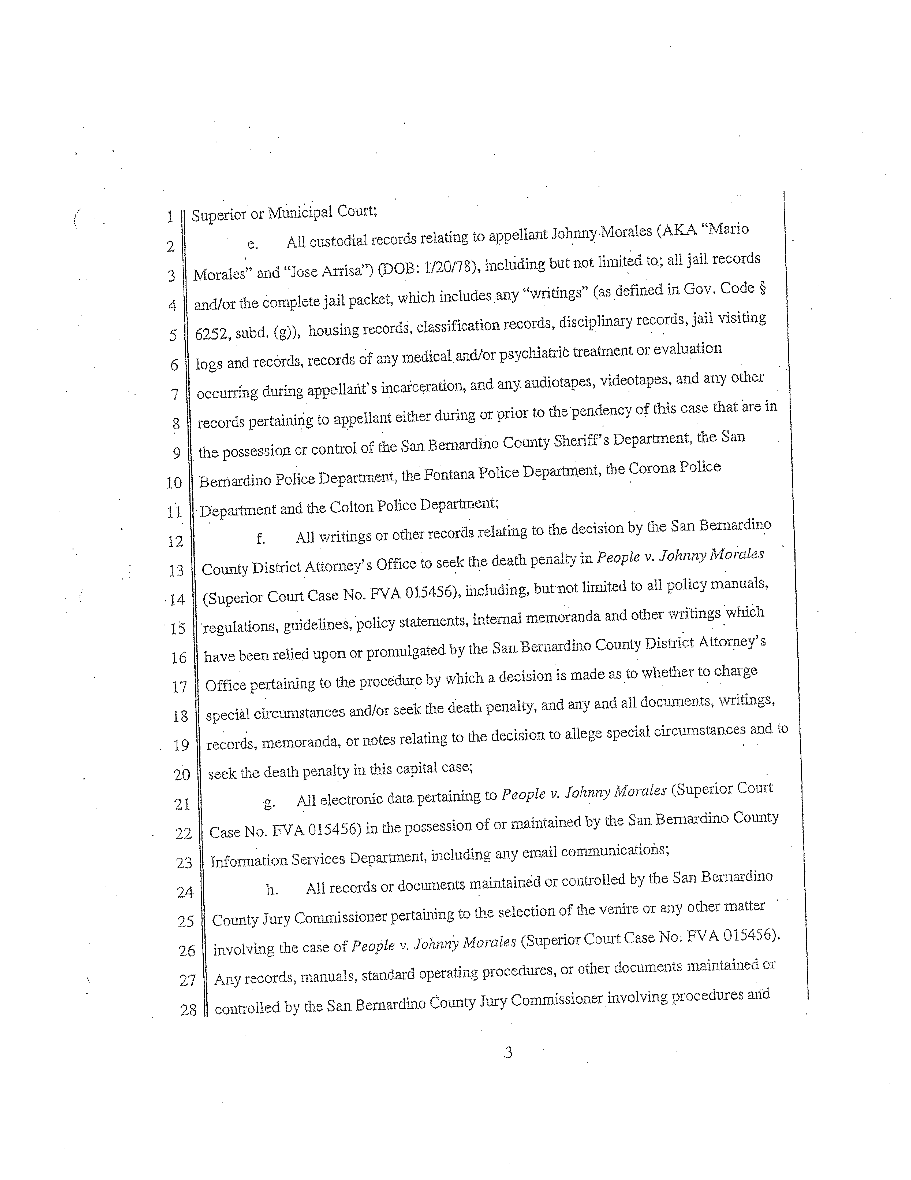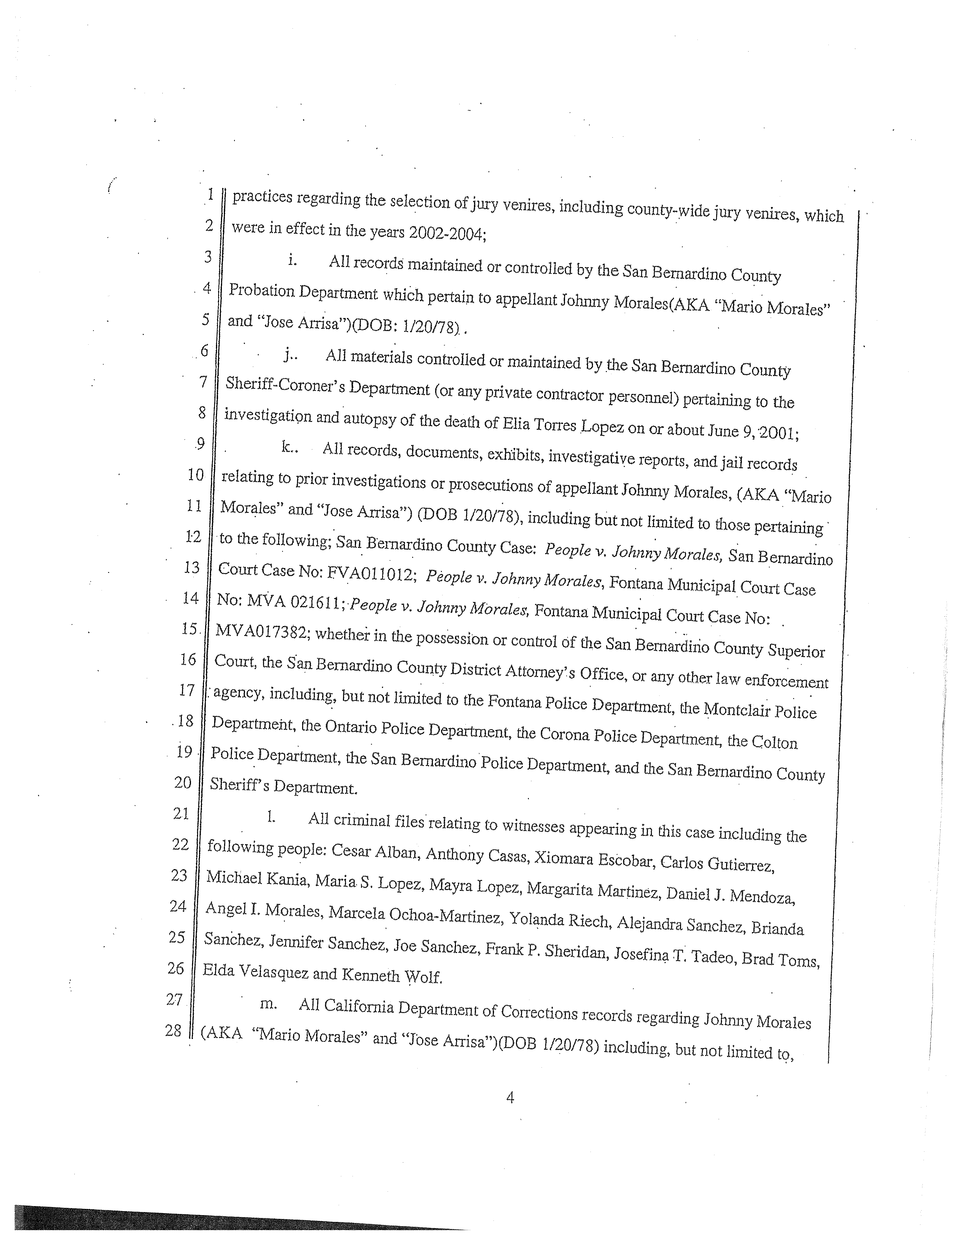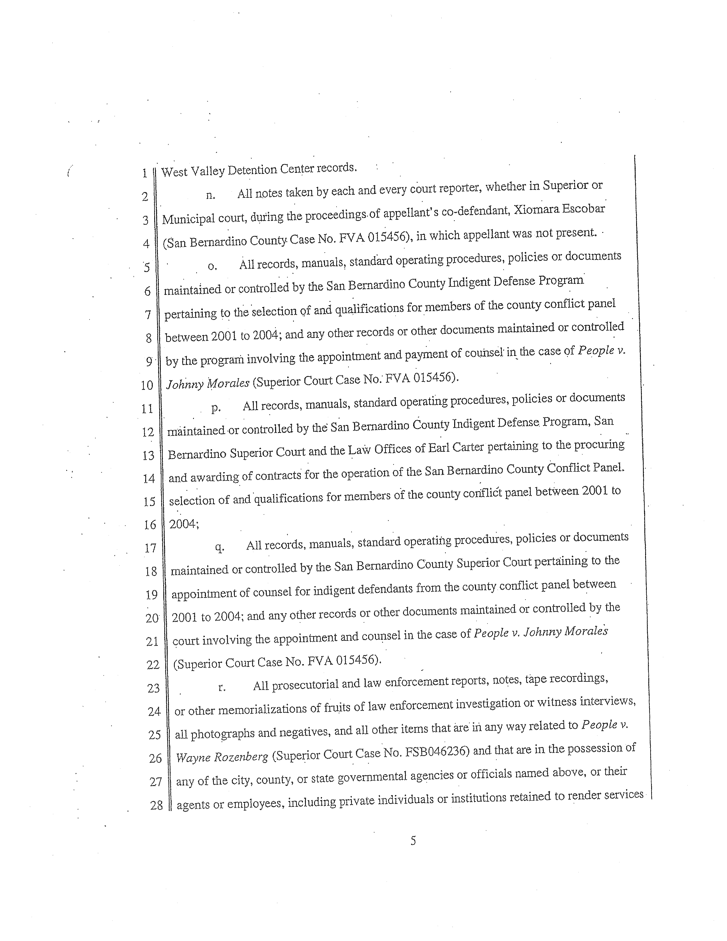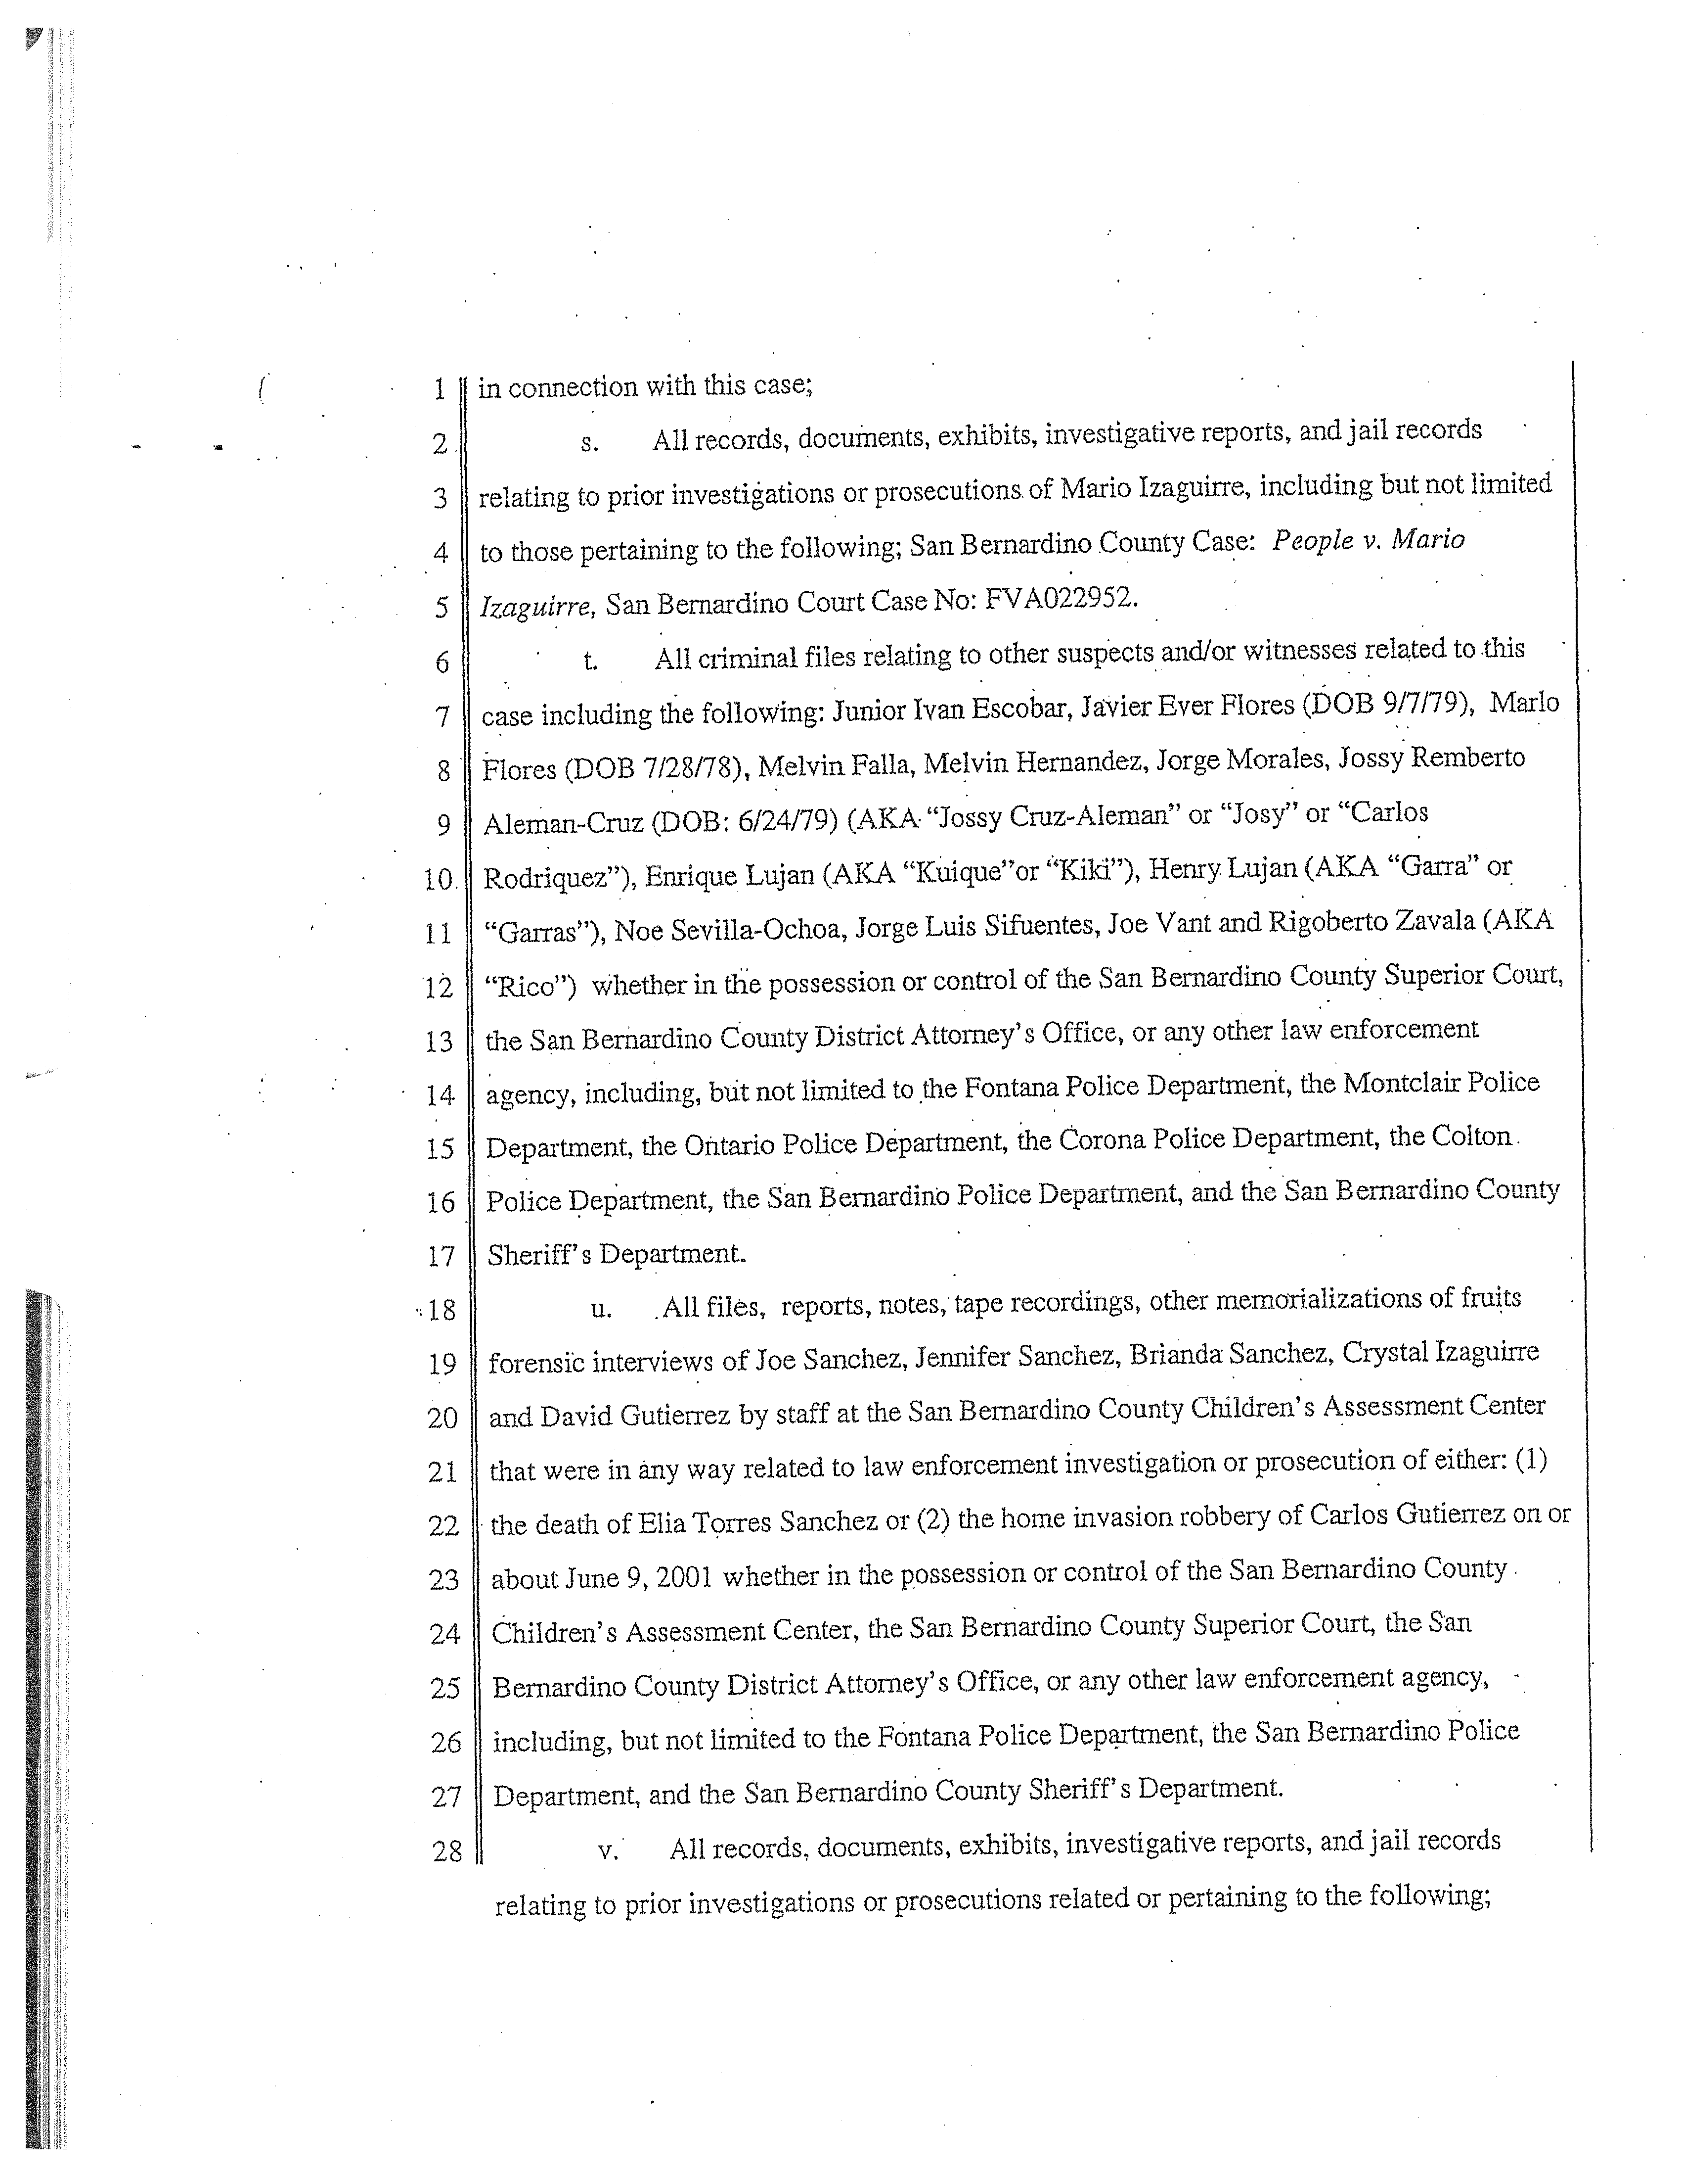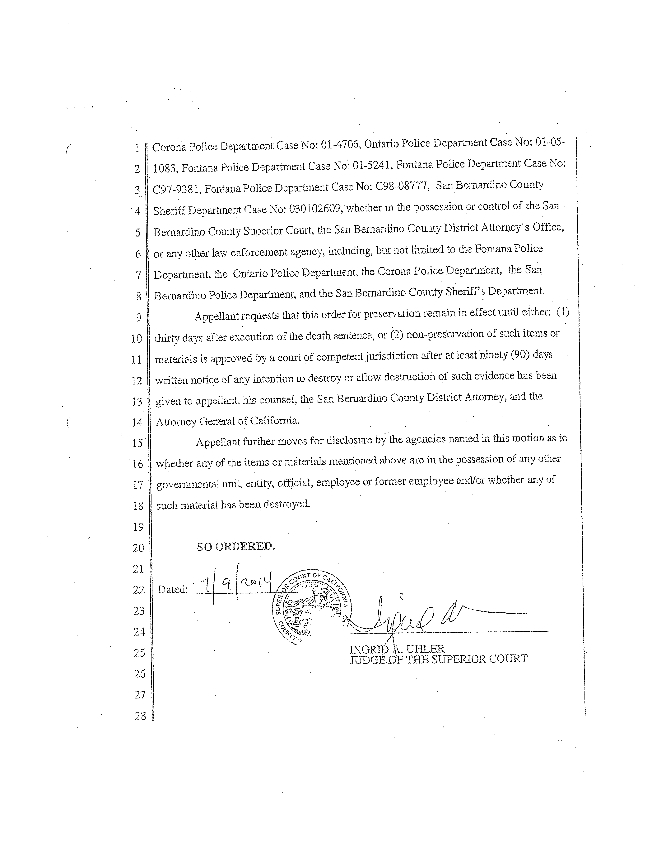
Filed 7/31/15
CERTIFIED FOR PUBLICATION

IN THE COURT OF APPEAL OF THE STATE OF CALIFORNIA

FOURTH APPELLATE DISTRICT

DIVISION TWO

ORDER

THE PEOPLE,  Petitioner,  v.  THE SUPERIOR COURT OF  SAN BERNARDINO COUNTY,  Respondent;  JOHNNY MORALES,  Real Party in Interest. | E061754  (Super.Ct.No. FVA015456)

THE COURT

A request having been made to this court pursuant to California Rules of Court, rule 8.1120(a), for publication of a nonpublished opinion heretofore filed in the above matter on July 15, 2015, and it appearing that the opinion meets the standards for publication as specified in California Rules of Court, rule 8.1105(c),
IT IS ORDERED that said opinion be certified for publication pursuant to
California Rules of Court, rule 8.1105(b).
KING
We concur: J.

McKINSTER
Acting P. J.

CODRINGTON
J.

? A copy of real party in interest’s order, consisting of seven pages, listing the 22 categories of documents he wishes to preserve is attached as Appendix A, post.
? All subsequent statutory references are to the Penal Code unless otherwise specified.
? Penal Code section 1054.9 provides that “(a) Upon the prosecution of a postconviction writ of habeas corpus or a motion to vacate a judgment in a case in which a sentence of death or of life in prison without the possibility of parole has been imposed, and on a showing that good faith efforts to obtain discovery materials from trial counsel were made and were unsuccessful, the [trial] court shall, except as provided in subdivision (c), order that the defendant be provided reasonable access to any of the materials described in subdivision (b). [¶] (b) For purposes of this section, ‘discovery materials’ means materials in the possession of the prosecution and law enforcement authorities to which the same defendant would have been entitled at time of trial.”
? MORALES asserts that writ review is not necessary because the People have an adequate remedy at law by appeal. Our issuance of the order to show cause reflects our determination that the remedy at law is not adequate, and we decline to revisit the issue. (See Marron v. Superior Court (2003) 108 Cal.App.4th 1049, 1056.) We will discuss his other procedural objections below.
? It may also be questioned whether the mailed notice of the motion was sufficient to subject the various agencies and departments to the court’s authority. The usual way of acquiring personal jurisdiction is by personal service; in the somewhat analogous context of compelling the attendance of a witness or the production of evidence, a subpoena must be personally served. (Code Civ. Proc., § 1987.)
? Morales also sets up a straw man by reasoning that the People’s opposition is based upon the notion that they (and the other agencies) have a “ ‘substantial right’ to destroy the subject materials . . . before any discovery order can be made,” and then argues that this “subverts” the purposes of section 1054.9 and is “incompatible with RPI’s most basic fundamental rights to fairness and heightened reliability in the death judgment against him.” We do not read the People’s arguments as evincing any zeal to destroy any evidence, but merely as objecting in principle to the court’s attempt to issue an unjustified order imposing not-insignificant burdens.
? Such a request must show that the materials either were provided to the defendant at trial, or should have been provided pursuant either to a discovery order in the case or the prosecution’s constitutional obligations. (See In re Steele, supra, at p. 697.) It must also show “that good faith efforts to obtain discovery materials from trial counsel were made and were unsuccessful . . . .” (§ 1054.9, subd. (a).)
? Picklesimer, supra, 48 Cal.4th 330 involved the efforts of a petitioner long ago convicted of voluntary oral copulation with a 16- or 17-year-old minor (§ 288a, subdivision (b)(1)) to remove the requirement of mandatory sex offender registration after the court found an equal protection violation in People v. Hofsheier (2006) 37 Cal.4th 1185. Picklesimer holds that relief must be sought by a petition for writ of mandate.
? The standard rule, of course, is that an appeal deprives the court of jurisdiction going to the merits of the case—that is, anything that might interfere with the appellate court’s effective resolution of the case. (People v. Alanis (2008) 158 Cal.App.4th 1467, 1472.)
? We do not determine whether the issuance of a preservation order would be proper. The scope of the motion appears to have gone far beyond the limits of section 1054.9; it was not established that the materials sought could not be obtained from counsel or should have been turned over by the prosecution. Nor was any effort made to explain what information Morales ever hoped to find in more obscure categories which did not visibly fall within the ambit of materials to which he would have been entitled at trial. However, we need not, and do not, attempt to establish the level of “good cause,” if any, which could support a preservation order—again, assuming that one could be made.

